**S3**

**Home Pack for Miss Wilson and Mr Heaney’s Classes**

**Week Beginning : Monday 27th April**

Task 1 : Sumdog

Aim for 4, 20 minute sessions a week. Remember your teachers can check your progress.

Task 2 :

More practise of calculating the areas of quadrilaterals. If you need to remind yourself of the formulas look at the work set for week beginning 20th April. You will find worked examples there too.

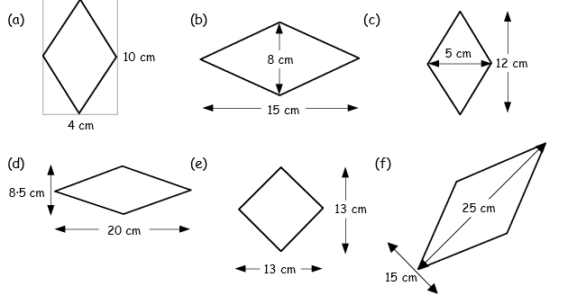Try these questions. Answers are included at the end of each section.

1. 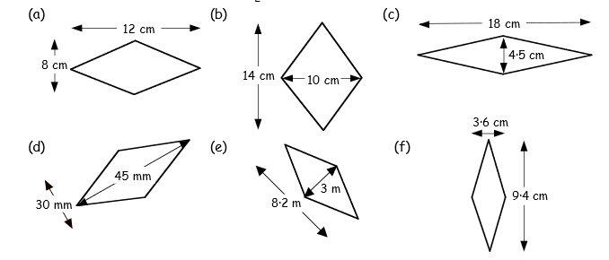
2. 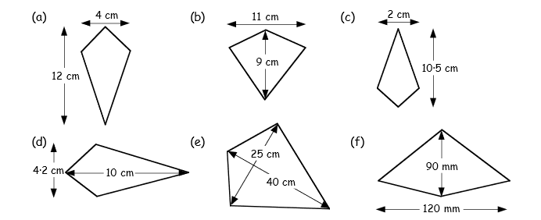

4. 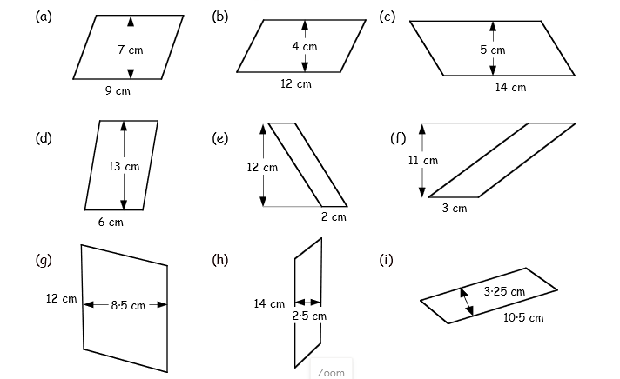

5. 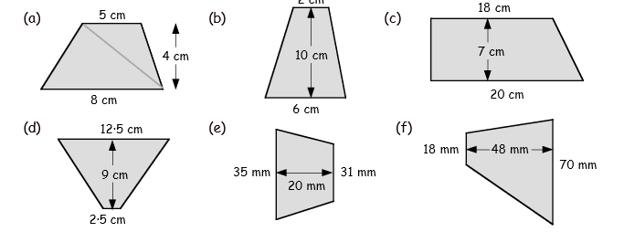

2cm

6. 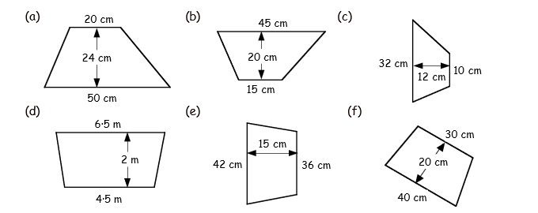

7. 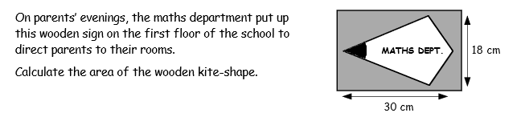

8. 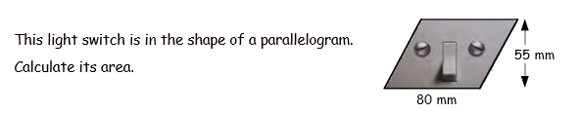

9. 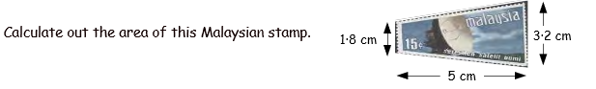

10. 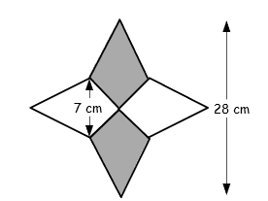



**Answers:**

1. **a)20 ${cm}^{2}$ b)60 ${cm}^{2}$ c)30 ${cm}^{2}$ d)85 ${cm}^{2}$ e) ${84.5cm}^{2}$ f) ${187.5cm}^{2}$**
2. **a) ${48cm}^{2}$ b) ${70cm}^{2}$ c) ${40.5cm}^{2}$ d) ${675mm}^{2}$ e) ${12.3m}^{2}$ f) ${16.92cm}^{2}$**
3. **a) ${24cm}^{2}$ b) ${49.5cm}^{2}$ c) ${10.5cm}^{2}$ d) ${21cm}^{2}$ e) ${500cm}^{2}$ f) ${5400mm}^{2}$**
4. **a) ${63cm}^{2}$ b) ${48cm}^{2}$ c) ${70cm}^{2}$ d) ${78cm}^{2}$ e) ${24cm}^{2}$ f) ${33cm}^{2}$ g) ${102cm}^{2}$ h) ${35cm}^{2}$**

**i) ${34.124cm}^{2}$**

**5. a) ${26cm}^{2}$ b) ${40cm}^{2}$ c) ${133cm}^{2}$ d) ${67.5cm}^{2}$ e) ${660mm}^{2}$ f) ${2112mm}^{2}$**

**6. a) ${840cm}^{2}$ b) ${600cm}^{2}$ c) ${252cm}^{2}$ d) ${11m}^{2}$ e) ${585m}^{2}$ f) ${700cm}^{2}$**

**7. ${270cm}^{2}$ 8. ${4400mm}^{2}$ 9. ${12.5cm}^{2}$ 10. ${196cm}^{2}$**

Task 3 – Introduction to the next topic.

The Cirlce

In this topic we will

● learn some circle terminology

● learn how to find the perimeter of a circle

● learn how to find the area of a circle

● solve circle problems

In order to get us started I have drawn a circle for you below and labelled some important measurements/lines. Copy this diagram including all the labels and definitions. These will help us with our lessons next week.

**Radius**

●

**Diameter**

**Circumference**

**Radius – the distance from the centre to the edge of the circle.**

**Diameter – the distance from one edge of the circle to the other passing through the middle (the width or height of the circle)**

**Circumference – the length of the edge around a circle. The distance round the outside of a circle. The perimeter of a circle.**