**Week Beg 27th April**

S2 classes

Over the next few weeks we will continue to focus on completing the course, revising topics and improving our skills on Sumdog.

I would like you to continue spending at least 2 hours on Sumdog improving your skills, this will give us a diagnostic assessment of the topics which we need to improve and consolidate.

I hope you are enjoying the Circle topic and have a good idea of what Pi is and how we can use a formula to find the Circumference of ANY circle even the planets.

* Introduction into Pi
* Circumference of a circle
* Area of a circle
* Extend to semi-circles and quarter circles
* Mixed questions

We will spend the next 2 hours on : TextbooksTJ level F Ch 29 Page 123 to 126

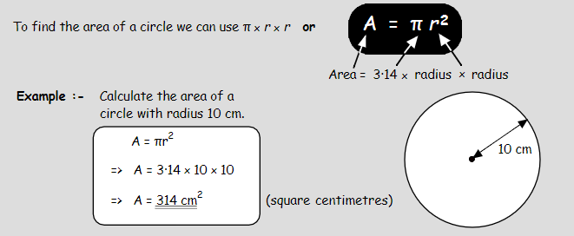

* Area of a circle (remember to half the Diameter to find the Radius)
* Extend to semi-circles and quarter circles ( Find the Area of Circle and half or quarter)
* Mixed questions (Remember to use a Calculator) 