**S1**

**Home Pack for Mrs Barr and Mrs Paton’s Classes**

**Week Beginning : Monday 27 April**

Task 1 : Sumdog

You should all have your Sumdog logins and passwords.

If you don’t have these please get in touch with the school and we will give you them.

Your aim is to work on this for a total of 2 hours. You should break this up into 4 sessions of 30 minutes each or whatever timescale suits you best.

Your teachers will be able to monitor this.

Task 2 : Angles in a Triangle

First, an investigation.

1. Using a ruler, draw a triangle on a piece of blank paper. Make sure it’s about the size of half a jotter page.
2. Carefully cut it out.
3. Tear off the three corners, make sure the corner you tear off isn’t too small.
4. Arrange the 3 corners along a straight edge, a ruler is ideal for this. It should look like this:

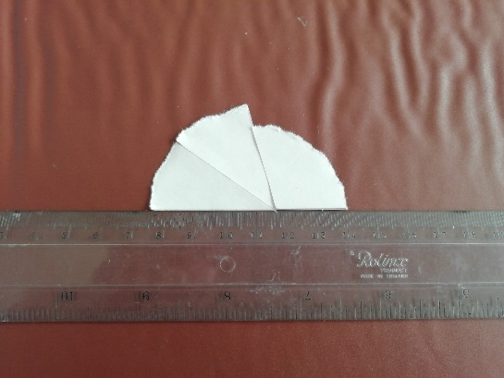

1. Try it with a different sized triangle. You should find that the corners will always fit on a straight line.
2. We know that angles on a straight line always add to 180 $°$, this means that the angles in a triangle will also add to 180 $°$.

We can use this information to find the size of an unknown angle in a triangle, if we know the size of the other two angles.

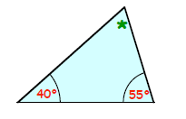E.g. The angles we know total 95 $°$ (40 $°$ + 55 $°$ = 95 $°$)

If all 3 angles add to 180 $°$, the third angle must be 85 $°$ (180 $°$- 95 $°$ = 85 $°$)

Work through the textbook pages, the answers are at the bottom for you to check your work.

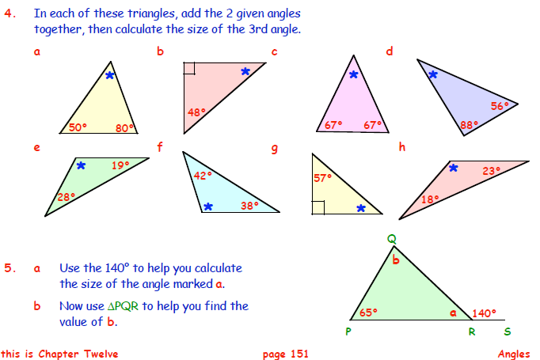

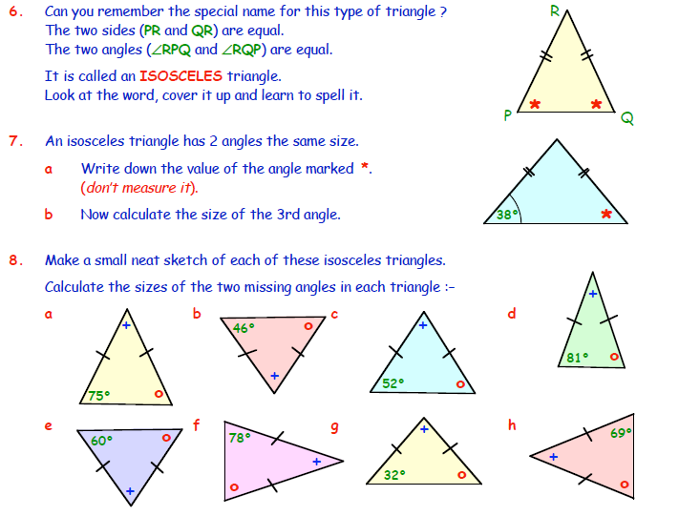

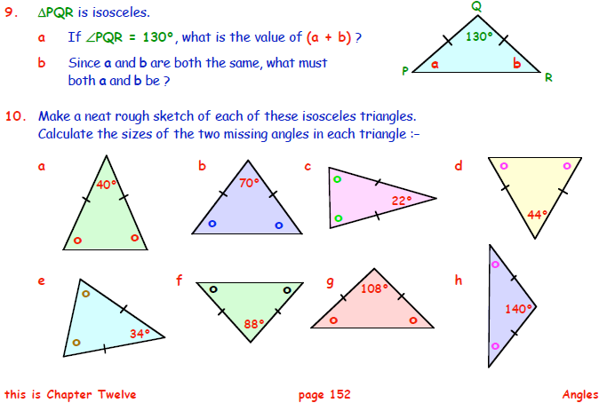

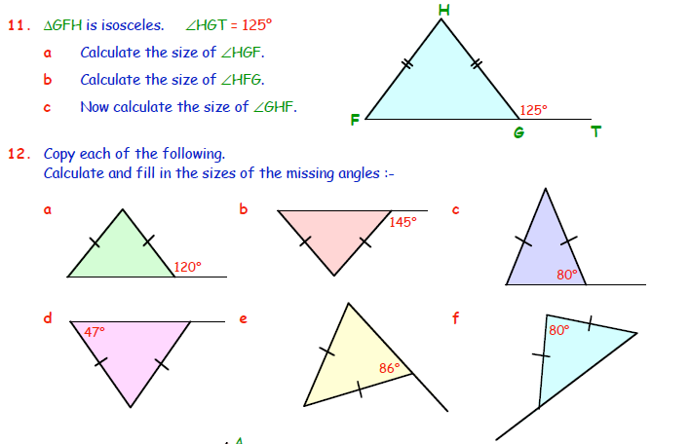

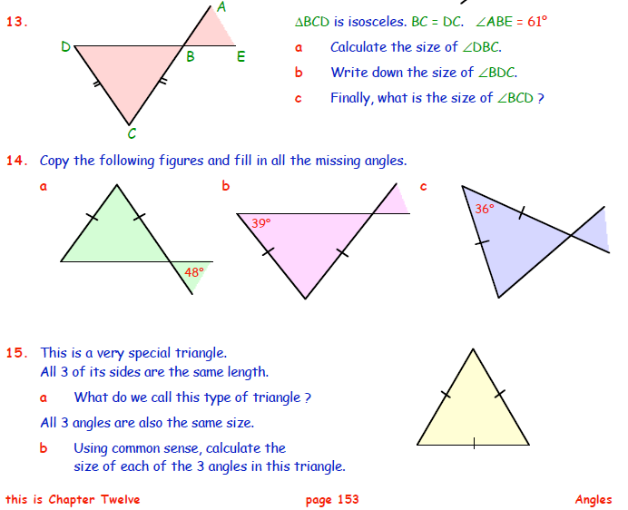

Answers:

