**S3**

**Home Pack for Miss Wilson and Mr Heaney’s Classes**

**Week Beginning : Monday 20th April**

Task 1 : Sumdog

Aim for 20 minute sessions each day. This will help in the continuous development of your numeracy skills.

Task 2 : New Topic – Quadrilaterals

Previously in your S3 course we have found the areas of squares, rectangles, triangles and composite shapes. Now we are going to find the areas of some new shapes.

**Quadrilateral – a shape with 4 sides.**

The quadrilaterals that we are going to be looking at are parallelograms, kites, rhombuses and trapeziums. I have split these into 3 lessons for this week. Each lesson will have an introduction to the shape and how to calculate the area followed by some questions for you to work through. The answers to all questions will be at the end of each exercise.

**Lesson 1 – Parallelogram**

A parallelogram is like a rectangle that has been squashed. Opposite sides have equal lengths like a rectangle but it doesn’t have right angles at the corners.

The angles at opposite corners are equal. We call the measurements in a parallelogram the base and the height. Notice the height is not the length of that side. It is the distance perpendicular from the base to the top.

**height**

**height**

**base**

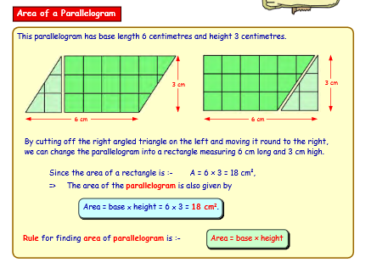

**Worked Example**

**A = b x h**

**8cm**

**A = 12 x 8**

**A = 96 ${cm}^{2}$**

**12cm**

**Now try these on your own. Remember to include units of area in your answers. Remember to show the 3 lines of working.**

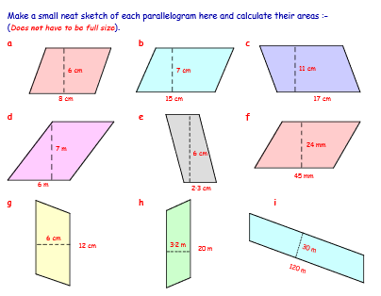

**Answers: a) 48 ${cm}^{2}$ b) $105{cm}^{2}$ c) $187{cm}^{2}$ d) $42m^{2}$ e) ${13.8cm}^{2}$ f) $1080{mm}^{2}$ g) $72{cm}^{2}$ h) $64m^{2}$ i) $3600m^{2}$**

**Lesson 2 – Kite and Rhombus**

**Kite –** a kite has a pair of equal shorter sides and a pair of equal longer sides. It also has a pair of equal angles.

**Rhombus –** a rhombus is like a square that has been squashed. All the sides are the same length but it doesn’t have right angles in the corners. Opposite angles are the same size.

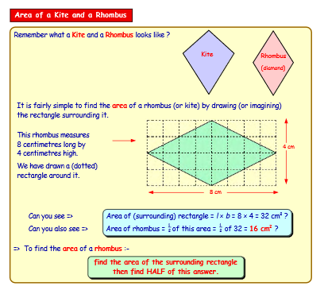

**Worked Examples**

**A = $\frac{1}{2}$ (l x b)**

**A = $\frac{1}{2}$ (15 x 8)**

**8cm**

**A = $\frac{1}{2}$ of 120**

**15cm**

**A = 60 ${cm}^{2}$**

**A = $\frac{1}{2}$ (l x b)**

**7cm**

**A = $\frac{1}{2}$ (13 x 7)**

**13cm**

**A = $\frac{1}{2}$ of 91**

**A = 45.5 ${cm}^{2}$**

**Now try these on your own. Remember to include units of area in your answer. Remember to show the 4 lines of working.**

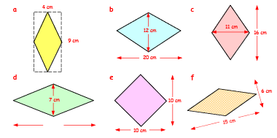

10cm

**Answers: a)18 ${cm}^{2}$ b)120 ${cm}^{2}$ c)88 ${cm}^{2}$ d)35 ${cm}^{2}$ e)50 ${cm}^{2}$ f)45 ${cm}^{2}$**

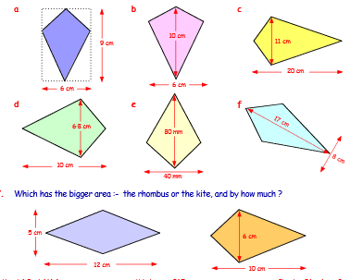

**a)27 ${cm}^{2}$ b)30 ${cm}^{2}$ c)110 ${cm}^{2}$ d)34 ${cm}^{2}$ e)1600 ${cm}^{2}$ f)68 ${cm}^{2}$**

**Rhombus = 30 ${cm}^{2}$ Kite = 30 ${cm}^{2}$ so they are both the same.**

**Lesson 3 – The Trapezium**

A trapezium is a 4 sided shape with one set of parallel sides. Shown below are some different types of trapezium.

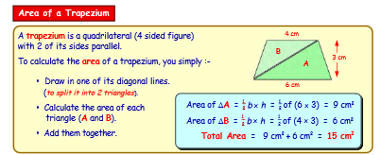

Remember how to get the area of a triangle

**height**

**base**

**Worked Example**

**Area of A A = $\frac{1}{2}$ bxh**

**A**

**B**

**9cm**

**12cm**

**4cm**

**A = $\frac{1}{2}$ 4x9**

**A = 18 ${cm}^{2}$**

**Area of B A = $\frac{1}{2}$ bxh**

**A = $\frac{1}{2}$ 12x9**

**A = 54 ${cm}^{2}$**

**Total area = 18 + 54 = 72 ${cm}^{2}$**

**Now try these on your own. Don’t forget units of area. Remember to show all the working.**

7cm

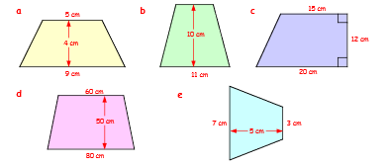

**Answers: a)28 ${cm}^{2}$ b)90 ${cm}^{2}$ c)210 ${cm}^{2}$ d)3500 ${cm}^{2}$ e)25 ${cm}^{2}$**