**Week Beg 20th April**

S2 classes

Over the next few weeks we will focus on completing the course, revising topics and improving our skills on Sumdog.

I would like you to continue spending at least 2 hours on Sumdog improving your skills, this will give us a diagnostic assessment of the topics which we need to improve and consolidate.

The next topic, Circle, has lots of new vocabulary, formulae and Mathematical Ideas.

* Introduction into Pi
* Circumference of a circle
* Area of a circle
* Extend to semi-circles and quarter circles
* Mixed questions

We will spend 2 hours on

* Introduction into Pi
* Circumference of a circle
* Introduction to Pi activity: Intro-to-pi-worksheet.docx

Textbooks

TJ level F Ch 29

TJ 4+ Ch 11

|  |
| --- |
|  |

Have fun.

Level F

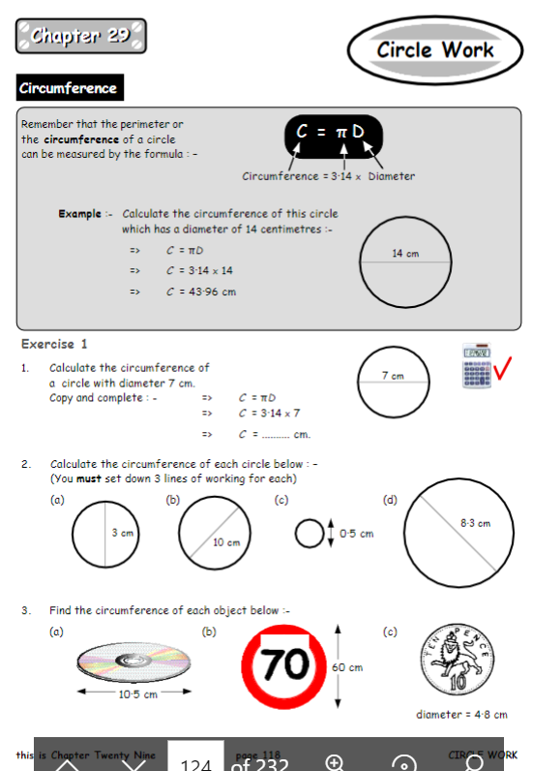

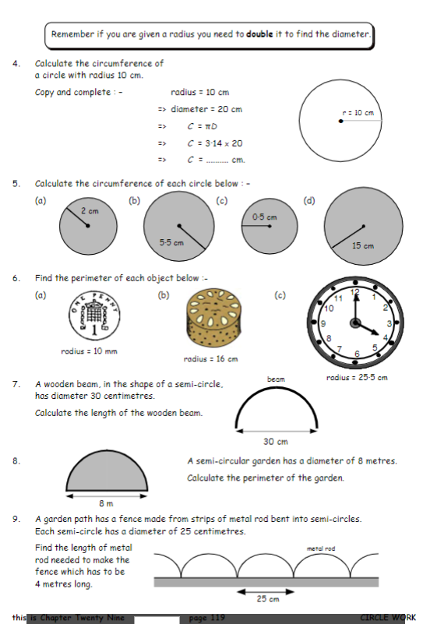

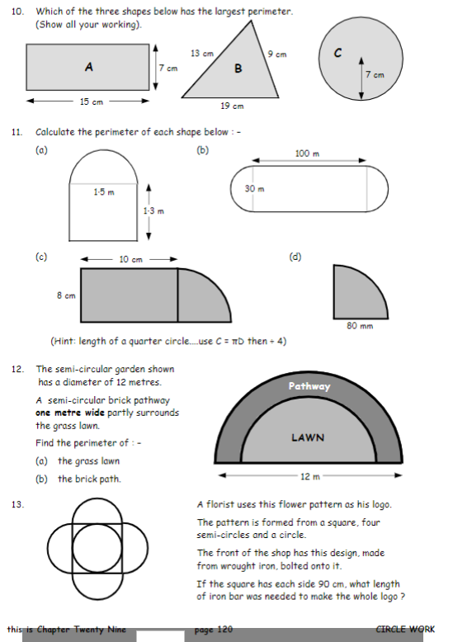

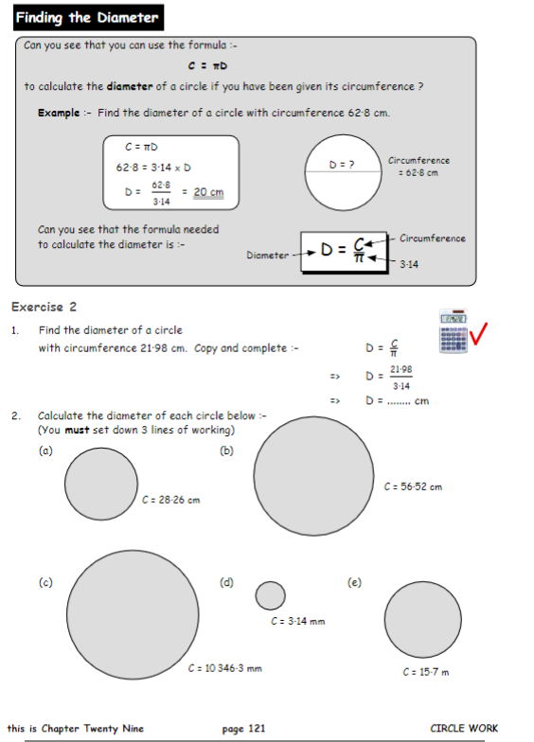

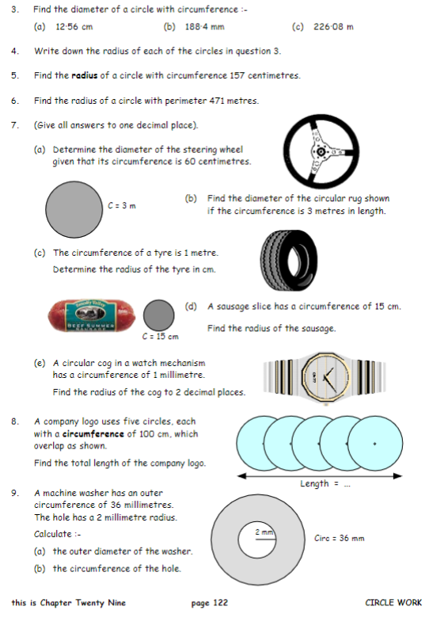

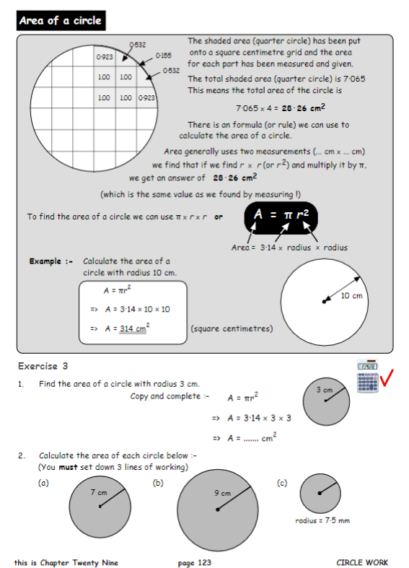

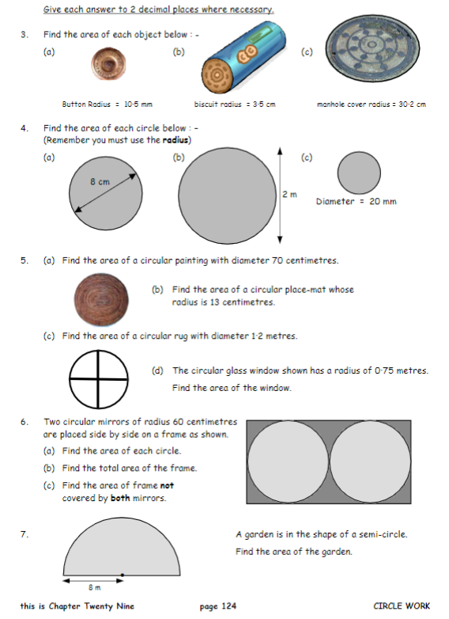

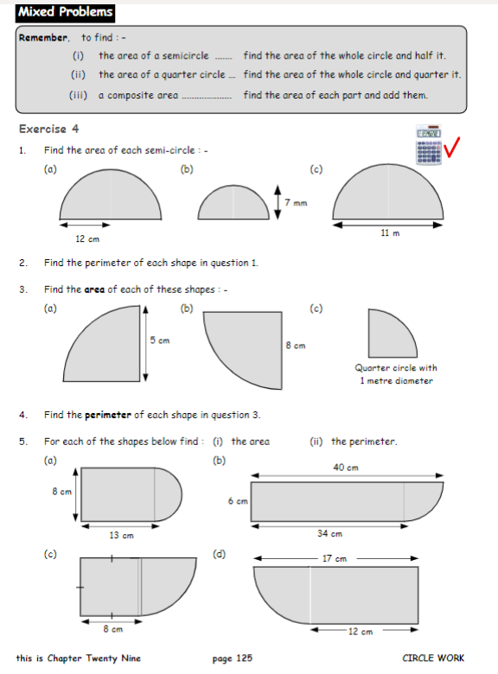

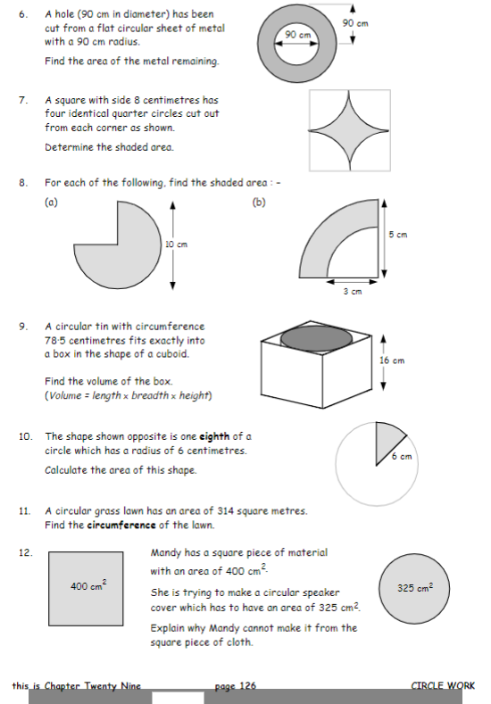

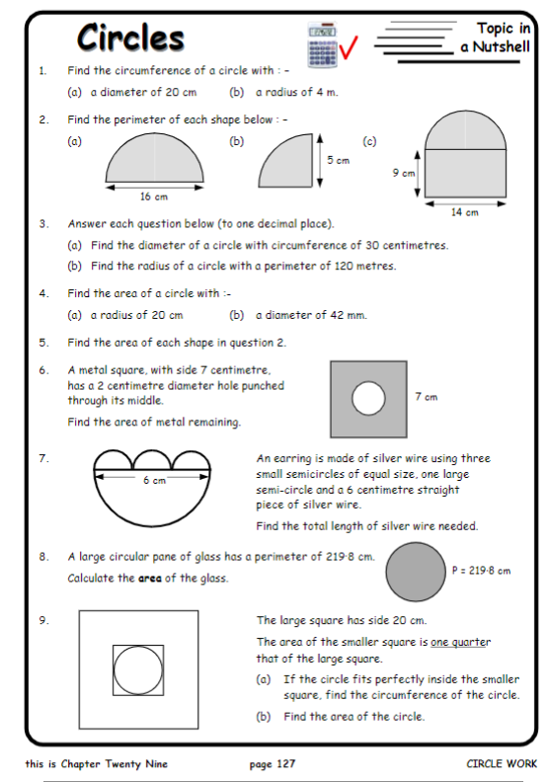

4+

