**S1**

**Home Pack for Mrs Barr and Mrs Paton’s Classes**

**Week Beginning : Monday 20 April**

Task 1 : Sumdog

You should all have your Sumdog logins and passwords.

If you don’t have these please get in touch with the school and we will give you them.

Your aim is to work on this for a total of 2 hours. You should break this up into 4 sessions of 30 minutes each or whatever timescale suits you best.

Your teachers will be able to monitor this.

Task 2 : Angles

Work through the text book pages on angles. The exercise is calculating missing angles.

What you need to know:

* Angles around a point will always add up to 360 $°$

We can use this information to find the value of missing angles.

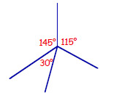e.g. If you add up the angles given you get a total of 290 $°$ (145 + 115 + 30 = 290). To find the value of the missing angle, take this away from 360 (360 – 290 = 70). So the missing angle is 70 $°$.

* Angles on a straight line always add up to 180 $°.$

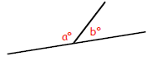e.g. Angle *a* + angle *b* = 180 $°$

We can use this information to find the value of missing angles.

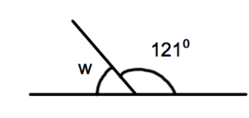Angle *w* = 180 – 121

= 59 $°$

These are called **supplementary** angles. In this example, 59 $°$ is the supplement of 121 $°$ and 121 $°$ is the supplement of 59 $°$.

Work through the textbook pages, the answers are at the bottom for you to check your work.

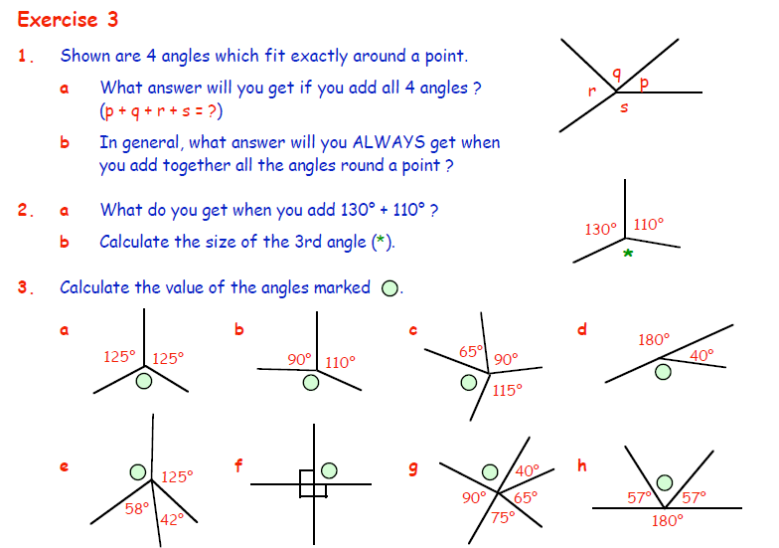

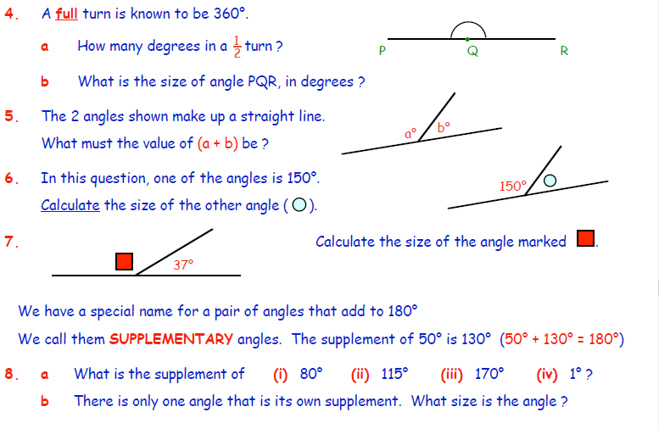

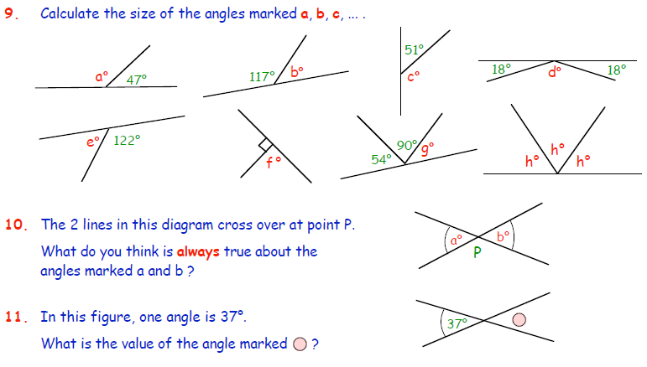

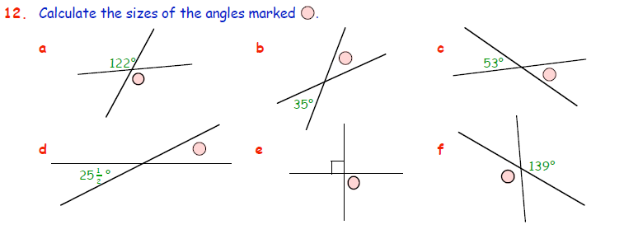

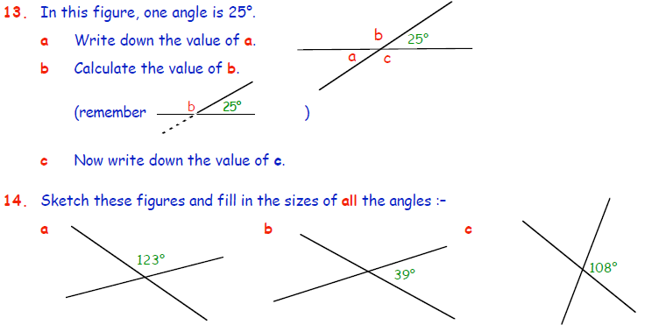

Answers:

