**S1 Home Learning Pack for Mr Heaney’s, Miss Gilluley’s, Mrs McKendricks and**

**Mr Early’s Classes**

**Week Beginning: Monday 20th April**

**Task 1: Sumdog**

You should all have your Sumdog logins and passwords. If you don’t have these please get in touch with the school and we will give you them. Your aim is to work on this for a total of 1 hour. You should break this up into 2 sessions of 30 minutes each or whatever timescale suits you best. Your teachers will be able to monitor this.

**Task 2: Area of a Composite Shape Practice**

The work we would be doing in class this coming week would be to do with the Area of Composite Shapes. To find the area of a composite shape, you first want to break the shape up into smaller shapes (ideally rectangles and triangles). I have linked below, two excellent instructional videos to help teach you this process.

[Area of a Composite Shape (L-Shapes)](https://corbettmaths.com/2013/03/26/area-of-an-l-shape/)

[Area of Compound Shapes](https://corbettmaths.com/2012/08/02/area-of-compound-shapes/)

Please take the time to copy the examples in the videos into your jotters, this will help with questions in the future. The exercises below should allow you to practice the methods from the examples in the videos. There are answers attached at the end of the booklet for you to check your work.

I have also linked below extra practice for anyone still unsure about finding the area and perimeter of basic 2D shapes from last week. Answers to this work can be found by clicking the word “Answers” at the bottom left side of the last page.

[Area of a Rectangle](https://corbettmaths.com/wp-content/uploads/2013/02/area-of-a-rectangle-pdf1.pdf)

[Area of a Triangle](https://corbettmaths.com/wp-content/uploads/2018/02/area-of-a-triangle-pdf.pdf)

[Perimeter of 2D Shapes](https://corbettmaths.com/wp-content/uploads/2013/02/perimeter-pdf2.pdf)

**Task 3: Area and Perimeter Challenge Questions**

I have also linked below some Rich Tasks for Area and Perimeter to challenge your knowledge.

[Area and Perimeter RT1](https://nrich.maths.org/content/id/9381/Perimeter%2C%20Area%20and%20Volume%20-%20stage%203%20-%202%20star%20-%20ws%201.pdf)

[Area and Perimeter RT2](https://nrich.maths.org/content/id/9381/Perimeter%2C%20Area%20and%20Volume%20-%20stage%203%20-%203%20star%20-%20ws%201.pdf)

[Area and Perimeter Matching Card Task](https://www.nuffieldfoundation.org/sites/default/files/files/FSMA%20Perimeter%20and%20area%20cards.pdf)

I have put links to the answers at the end of the booklet.

*Good Luck and Stay Safe!*

**Area of a Composite Shape**

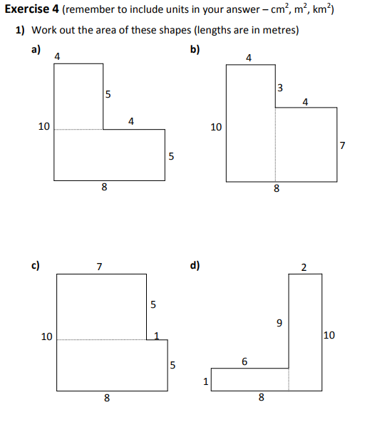

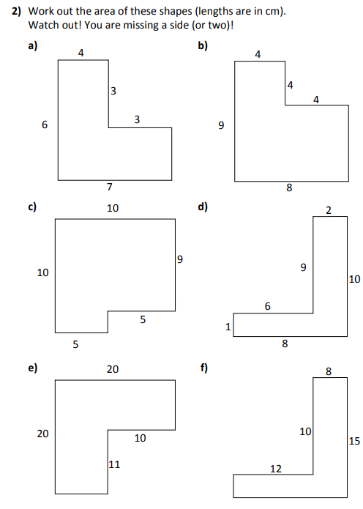

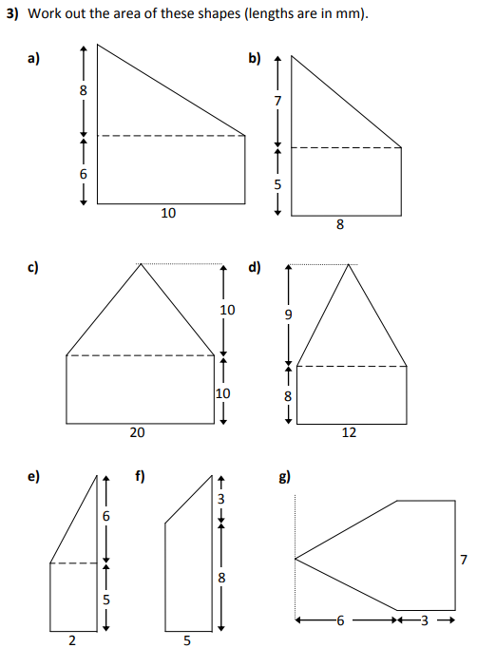

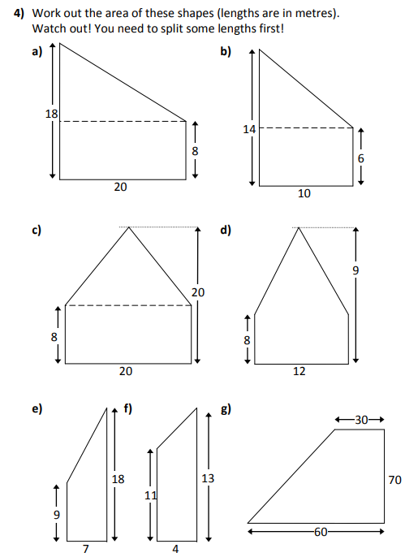

**Answers**

|  |  |  |  |
| --- | --- | --- | --- |
| **Exercise 4** | | | |
| 1a) | 60 m2 | b) | 68 m2 |
| c) | 75 m2 | d) | 26 m2 |
| 2a) | 45 cm2 | b) | 56 cm2 |
| c) | 95 cm2 | d) | 26 cm2 |
| e) | 290 cm2 | f) | 180 cm2 |
| 3a) | 100 mm2 | b) | 68 mm2 |
| c) | 300 mm2 | d) | 150 mm2 |
| e) | 16 mm2 | f) | 47.5 mm2 |
| g) | 42 mm2 |  |  |
| 4a) | 260 m2 | b) | 100 m2 |
| c) | 280 m2 | d) | 102 m2 |
| e) | 94.5 m2 | f) | 48 m2 |
| g) | 3150 m2 |  |  |

**Rich Task Answers**

[Area and Perimeter RT1 Answers](https://nrich.maths.org/content/id/9381/Perimeter%2C%20Area%20and%20Volume%20-%20stage%203%20-%202%20star%20-%20ws%201%20-%20Solutions.pdf)

[Area and Perimeter RT2 Answers](https://nrich.maths.org/content/id/9381/Perimeter%2C%20Area%20and%20Volume%20-%20stage%203%20-%203%20star%20-%20ws%201%20-%20Solutions.pdf)

Matching Task Answers are the original layout of the sheet