Week Beg 30rd March
S2 classes
Over the next few weeks we will focus on completing the course, revising topics and improving our skills on Sumdog.
I would like you to continue spending at least 2 hours on Sumdog improving your skills, this will give us a diagnostic assessment of the topics which we need to improve and consolidate.
During the remaining 2 hours we will find simple Probability of events and use these to predict results. The text books required are available on the school website and more Powerpoints and practice is available at http://www.mathsrevision.com/index_files/Level_4_.htm scroll down to Probability.
Topic & Timings | Content | Previous Knowledge | Methodologies & Resources
Probability  8 periods  MNU 3-22a  MNU 4-22a | - What is probability- extending from likely/unlikely to numerical value  - Finding simple probabilities  - Extension: Independent/dependent events |  | TJ level F- Ch 17 Pg 87-89  TJ 3b – Ch 13 Pg 140-147  Maths workout topic 9: Introduction to Probability  Probability Worksheet  Complete lessons  Dr Frost: Probability (pre-GCSE)  Dr Frost: GCSE Probability  Pixi: Probability - scales, mutual exclusivity, exhaustive events and sample space diagrams  Mistry Maths: Probability of independent events lesson  Alutwyche: Probability f to a  MAP: Analyzing Games of Chance  MAP: Evaluating Statements About Probability
FunTask
Who wants to be a Millionaire Probability
TES: Fairground Probability
Mistry Maths: Probability horse racing game

As you can see from the scheme of work we have completed the Introduction of Probability and now we will look at finding Simple Probabilities of amounts.
All the lessons and practice can be found in the scheme of work above.
Complete the Probability Worksheet and look at the first 3 lessons in Methodologies and Resources.

Have fun.

Level F
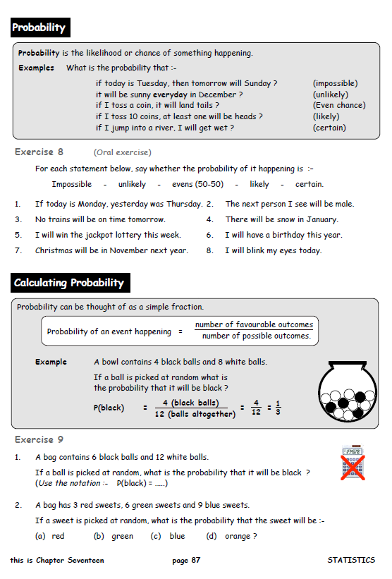

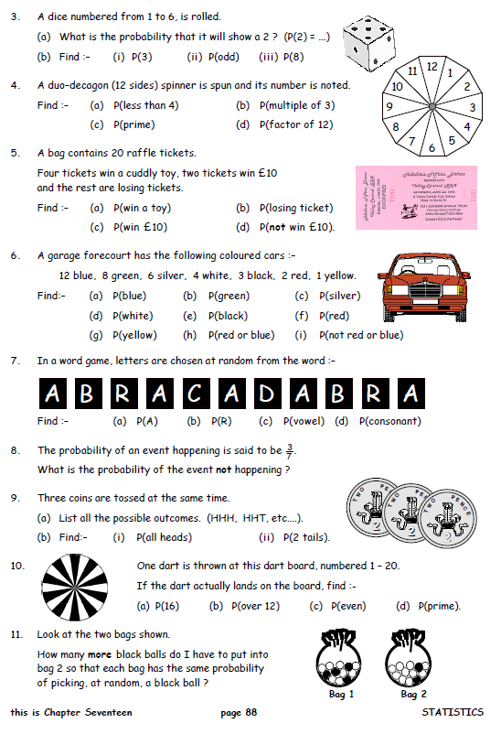
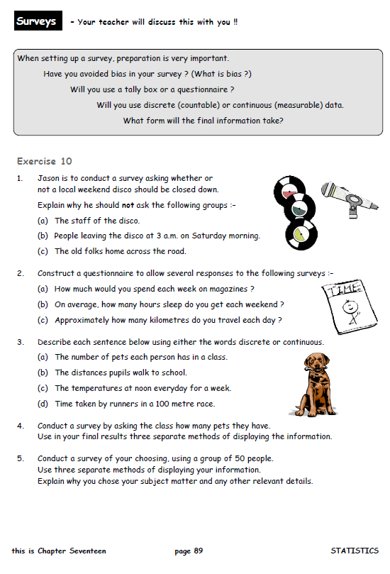

3b
