**S1**

**Home Pack for Mrs Barr and Mrs Paton’s Classes**

**Week Beginning : Monday 30th March**

Task 1 : Sumdog

You should all have your Sumdog logins and passwords.

If you don’t have these please get in touch with the school and we will give you them.

Your aim is to work on this for a total of 2 hours. You should break this up into 4 sessions of 30 minutes each or whatever timescale suits you best.

Your teachers will be able to monitor this.

Task 2 : Angles

Work through the text book pages on angles. The first exercise is recognising the different types of angles and knowing their names. Exercise 2 is naming angles correctly using letters. The answers are at the bottom for you to check your work.

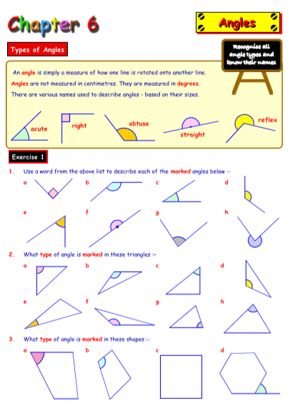

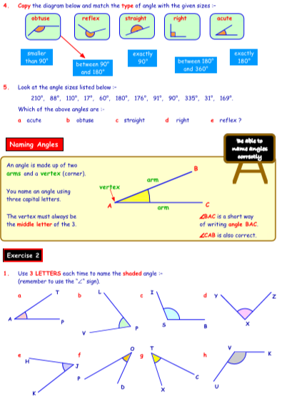

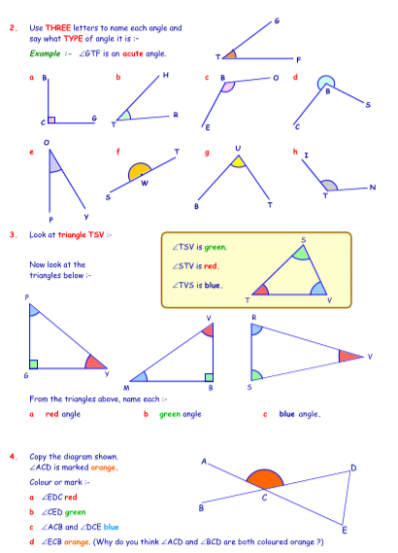

Answers:

