**S1 Home Learning Pack for Mr Heaney’s, Miss Gilluley’s, Mrs McKendricks and**

**Mr Early’s Classes**

**Week Beginning: Monday 30th March**

**Task 1: Sumdog**

You should all have your Sumdog logins and passwords. If you don’t have these please get in touch with the school and we will give you them. Your aim is to work on this for a total of 1 hour. You should break this up into 2 sessions of 30 minutes each or whatever timescale suits you best. Your teachers will be able to monitor this.

**Task 2: Area and Perimeter Practice**

The work we were doing in class was to do with the Area and Perimeter of Rectangles, Squares and Triangles. If anyone is unsure on the process for any of these shapes, please watch the instructional videos linked below.

[Area of a Rectangle/Square](https://corbettmaths.com/2013/12/20/area-of-a-rectangle-video-45/)

[Area of a Triangle](https://corbettmaths.com/2013/12/20/area-of-a-triangle-video-49/)

[Perimeter of a 2D Shape](https://corbettmaths.com/2012/08/02/perimeter/)

The exercises below should allow you to practice the methods from your notes in your jotter or from the examples in the videos. There are answers attached at the end of the booklet for you to check your work.

**Task 3: Area and Perimeter Challenge Questions**

I have also linked below some Rich Tasks for Area and Perimeter to challenge your knowledge.

[Fence It (Rich Task 1)](https://nrich.maths.org/2663)

[Changing Areas, Changing Perimeters](https://nrich.maths.org/7534)

[Perimeter and Area Mixed Rich Tasks](https://nrich.maths.org/content/id/9381/Perimeter%2C%20Area%20and%20Volume%20-%20stage%203%20-%201%20star%20-%20ws%201.pdf)

I have put links to the answers at the end of the booklet.

*Good Luck and Stay Safe!*

**Area of a Rectangle**

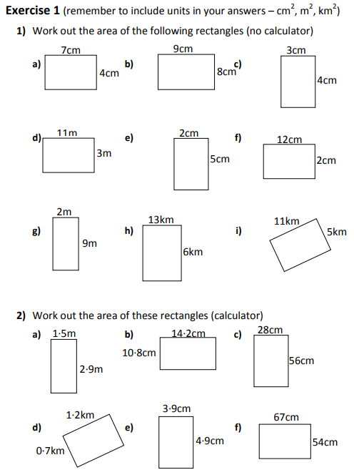

3) Work out the Perimeter of each of the shape in question 1 (Non-Calc).

4) Work out the Perimeter of each of the shape in question 2 (Non-Calc).

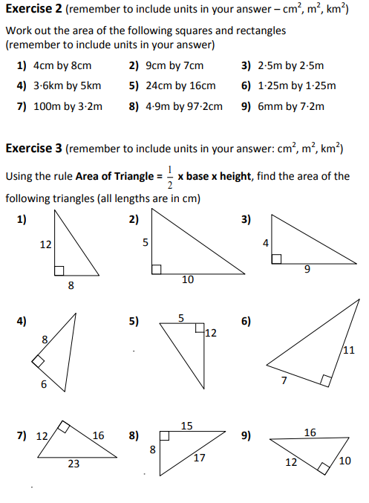

**Area of a Triangle**



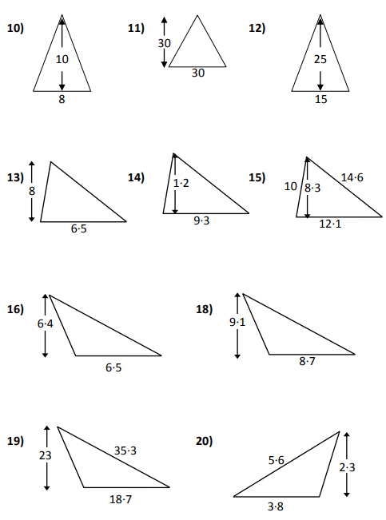

**19)**

**18)**

**17)**

**Exercise 3B** – Calculate the Perimeter of each of the triangles in questions 7, 8 and 9 (Non-Calc).

**Answers**

|  |  |  |  |  |  |
| --- | --- | --- | --- | --- | --- |
| **Exercise 1** | | | | | |
| 1a) | 28 cm2 | b) | 72 cm2 | c) | 12 cm2 |
| d) | 33 m2 | e) | 10 cm2 | f) | 24 cm2 |
| g) | 18 m2 | h) | 78 km2 | i) | 55 km2 |
| 2a) | 4.35 m2 | b) | 153.36 cm2 | c) | 1568 cm2 |
| d) | 0.84 km2 | e) | 19.11 cm2 | f) | 3618 cm2 |
| 3a) | 22cm | b) | 34cm | c) | 14cm |
| d) | 28m | e) | 14cm | f) | 28cm |
| g) | 22m | h) | 38km | i) | 32km |
| 4a) | 8.8m | b) | 50cm | c) | 168cm |
| d) | 3.8km | e) | 17.6cm | f) | 242cm |
| **Exercise 2** | | | | | |
| 1) | 32 cm2 | 2) | 63 cm2 | 3) | 6.25 m2 |
| 4) | 18 km2 | 5) | 384 cm2 | 6) | 1.5625 m2 |
| 7) | 320 m2 | 8) | 4.7628 m2 | 9) | 0.0432 m2 / 43200 mm2 |
| **Exercise 3** | | | | | |
| 1) | 48 cm2 | 2) | 25 cm2 | 3) | 18 cm2 |
| 4) | 24 cm2 | 5) | 30 cm2 | 6) | 38.5 cm2 |
| 7) | 96 cm2 | 8) | 60 cm2 | 9) | 60 cm2 |
| 10) | 40 cm2 | 11) | 450 cm2 | 12) | 187.5 cm2 |
| 13) | 26 cm2 | 14) | 5.58 cm2 | 15) | 50.215 cm2 |
| 16) | 20.8 cm2 | 17) | 39.585 cm2 | 18) | 215.05 cm2 |
| 19) | 4.37 cm2 |  |  |  |  |
|  |  |  |  |  |  |
| **Exercise 3B** | | | | | |
| 7) | 51cm | 8) | 40cm | 9) | 38cm |

**Rich Task Answers**

[Fence It Answers](https://nrich.maths.org/2663/solution)

[Changing Areas, Changing Perimeters Answers](https://nrich.maths.org/7534/solution)

[Perimeter and Area Mixed Answers](https://nrich.maths.org/content/id/9381/Perimeter%2C%20Area%20and%20Volume%20-%20stage%203%20-%201%20star%20-%20ws%201%20-%20Solutions.pdf)