Higher Drama Lexicon

Word | Section | Description
Acting style | GENERAL | This is the way you approach the portrayal of your character.
Actor- audience relationship | GENERAL | The manner in which each individual actor treats the audience establishes, sustains or varies a particular kind of actor-audience relationship between them.
Atmosphere | GENERAL | The type of feeling that the audience get from a play based on details such as setting, background and objects. This is usually felt throughout the piece in the tone or mood of a place, situation, or creative work.
Blocking | GENERAL | This is working out the details of an actor's moves, deciding where/when actors will move on stage.
Central character | GENERAL | The central person in a story, and is often referred to as the story's main character or the protagonist.
Complex character | GENERAL | A complex character, also known as a dynamic character or a round character who affects many elements of the performance.
Important character | GENERAL | This can be the protagonist, or someone who has a pivotal role in the performance
Minor character | GENERAL | This is a background character who is not focused on in the primary storyline.
Main character | GENERAL | This is a character who generates the action of a story and engages the reader's interest and empathy.
Pivotal character | GENERAL | The pivotal character is the character who sets the story in motion.
Characterisation | GENERAL | The process of fully developing a character.
Character behaviour/ motivation/ development interaction/ relationships | GENERAL | Where you consider the behaviour of the character by thinking of what motivates them. Thinking about the relationships they have with others and how they interact with each other.
Climax | GENERAL | The most intense, exciting, or important point of the drama; the culmination.
Context – dramatic/ social/ political/ cultural | GENERAL | The circumstances that form the setting for an event, statement, or idea, and in terms of which it can be fully understood.
Design concepts | GENERAL | An idea for a design aspect of the performance. This could be for any of the Production Roles; set, costume, props, hair & make-up, sound and lighting.
Dialogue | GENERAL | A conversation between two or more people.
Drama media | GENERAL | The use of projections, video footage/ sound-scapes to enhance a performance.
Drama process | GENERAL | The process gone through from the initial starting point through to the evaluation of the final performance.
Dramatic features | GENERAL | Elements added to the performance to further enhance it.
Dramatic tension/ points of tension/ moments of tension | GENERAL | The quality in a performance that causes the audience to experience anxiety or apprehension resulting from an uncertain, undecided or mysterious situation.
Dramatic irony | GENERAL | When something is understood by the audience, but not the characters.
Duologues | GENERAL | A play or part of a play with speaking roles for only two actors.
Episodic structure | GENERAL | A drama that is linked by a theme rather than a storyline.
Focus | GENERAL | The specific point of attention on stage at any moment created by the shaping of any aspect or aspects of the dramatic experience in such a way as to purposefully direct the attention of the audience.
Given circumstances | GENERAL | The term given circumstances is applied to the total set of environmental and situational conditions which influence the actions that a character in a drama undertakes.
Ground plan | GENERAL | A bid’s eye view of the set showing furniture, entrances/exits and the position of the audience.
Key scene | GENERAL | Important scene in the drama.
Key moment | GENERAL | Important point in the drama.
Language | GENERAL | The words used in the drama.
Message | GENERAL | The overall point communicated.
Mood | GENERAL | The intended feeling created by the performance within the audience.
Original production/ staging/ stage configurations | GENERAL | Consideration of the different types of staging and the advantages and disadvantages of its use.
Performance analysis | GENERAL | Analysing certain aspects of a performance.
Performance concepts | GENERAL | An idea for an acting aspect of the performance. Consideration should be given to the various aspects of the character development to ensure a rounded performance.
Pre-show | GENERAL | The time period before the show starts. This is the time when people are arriving and the cast and crew are getting ready.
Plot | GENERAL | The main events of a play, devised and presented as an interrelated sequence.
Plot twists | GENERAL | An unexpected development in the story.
Protagonist and antagonist | GENERAL | A protagonist is the central character or leading figure. They are sometimes called a “hero” by the audience. An antagonist is a person or a group of people who opposes a protagonist.
Purpose | GENERAL | The reason for which a performance is done or created, e.g. to educate, entertain…
Stage proxemics | GENERAL | The study of space and how we use it, how it makes us feel more or less comfortable, and how we arrange objects and ourselves in relation to space.
Rehearsal activities | GENERAL | Activities done within rehearsals to help the actors to develop their characters.
Set | GENERAL | The painted structures of a stage set that are intended to suggest a particular locale.
Setting | GENERAL | The place or type of surroundings where something is positioned or where an event takes place.
Site specific theatre | GENERAL | This is any type of theatrical production designed to be performed at a unique, specially adapted location other than a standard theatre.
Special effects | GENERAL | (often abbreviated as SFX, SPFX, or simply FX) are illusions or visual tricks used in the film, television, theatre industries to simulate the imagined events in a story or virtual world.
Textual evidence | GENERAL | This is evidence from a text (fiction or nonfiction) that you can use to illustrate your ideas and support your arguments.
Traditional theatre | GENERAL | These performances usually combine acting, singing, dance and music, dialogue, narration or recitation but may also include puppetry or pantomime.
Stage imagery | GENERAL | This is where the staging helps the formation of mental images, figures, or likenesses of things.
Status | GENERAL | The importance of one character in relation to another.
Stimulus | GENERAL | A starting point that generates ideas. This can be anything.
Subtext | GENERAL | This is the content underneath the dialogue.
Symbols & imagery | GENERAL | Imagery and symbols help to create the formation of mental images, figures, or likenesses of things. This can be done using various theatrical tools.
Target audience | GENERAL | A target audience is the intended audience of a performance, advertisement or other message.
Tension | GENERAL | The mental or emotional strain.
Textual analysis | GENERAL | This is the analysis of a selected text. It is a demonstration of knowledge of a text that has been studied in terms of content and the social, historical and/or theatrical context, and to show an understanding of how the text could be communicated to an audience through performance.
Theatrical background | GENERAL | This is sometimes referred to as backdrops. This is the scenes that are theatrically (and sometimes digitally) added in a performance to enhance it further.
Themes and issues | GENERAL | Theme: the subject of a talk, piece of writing, exhibition, etc.; a topic. Issue: an important topic or problem for debate or discussion. Themes that are covered will have issues in them.
Time period/ passage of time/ shifts in time | GENERAL | Time period: refers to a work set in a time period. Passage and shifts of time: these refer to performances happening at different points in time.
Positioning | GENERAL | To put or arrange (someone or something) in a particular place or way.
Use of levels | GENERAL | Using different levels during a performance.
Venue | GENERAL | The place where something happens, especially an organised event such as a concert, or performance.
MIME | MOVEMENT | Stylised form of movement which creates an illusion of reality
BODY LANGUAGE | MOVEMENT | Messages given by the position or movement of the body.
FACIAL EXPRESSIONS | MOVEMENT | Look on face which shows emotion.
GESTURES | MOVEMENT | Movement of the hand or arm which communicates a meaning or emotion.
NATURALISTIC | MOVEMENT | This aims at accuracy and objectivity and cultivates realistic and even sordid portrayals of people and their environment.
STYLISED | MOVEMENT | This is often abstract in style, using movement in a stylised and representational way.
EYE CONTACT | MOVEMENT | Where the actors use the art of making direct eye contact or avoiding eye contact to convey a feeling.
POSTURE | MOVEMENT | Position of the body - how it is held.
BALANCE | MOVEMENT | Keeping an even distribution of weight.
SPEED | MOVEMENT | Considering the pace that the performer moves at.
TIMING | MOVEMENT | Speaking, moving or pausing at exactly the right moment.
USE OF LEVELS | MOVEMENT | Using different levels during a performance.
USE OF SPACE | MOVEMENT | How you use the performance space.
POSITIONING | MOVEMENT | Considering what areas of the stage your character needs to be in at a particular moment in the performance.
MANNERISMS | MOVEMENT | A habitual gesture or way of speaking or behaving.
RHYTHM | MOVEMENT | A strong, regular repeated pattern of movement or sound.
STANCE | MOVEMENT | The attitude or position of the body.
USE OF DIRECTION | MOVEMENT | How the actor uses the direction they are moving in to enhance their performance.
PROXEMICS | MOVEMENT | The position of people in relation to each other onstage.
ACCENT | VOICE | Way of speaking used in a local area or country (“Cockney” accent, “American” accent).
PACE | VOICE | The speed of speech or movement (fast/slow pace).
VOLUME | VOICE | Loudness or quietness of the voice (loud/quiet volume).
CLARITY | VOICE | Clearness of the voice (good/poor clarity).
EMPHASIS | VOICE | The stress put on a word or phrase (emphasis put on a particular word, syllable or phrase).
PITCH | VOICE | How high or low the voice is (high/low pitch).
TONE | VOICE | Change of voice to express emotion (“angry” tone, “polite” tone).
PAUSE | VOICE | A break in speaking; period of silence (short/ long pause, pause before/ pause after).
ARTICULATION | VOICE | The clear pronunciation of words (good/poor articulation).
FLUENCY | VOICE | Natural, flowing speech (good/poor fluency).
INTONATION | VOICE | Rising and falling of voice in speech (rising at end of sentence for a question).
REGISTER | VOICE | Appropriate speech for the person being spoken to, or for the situation (boss/ employee, parent/child).
PROJECTION | VOICE | The strength of speaking or singing whereby the voice is used loudly and clearly.
RHYTHM | VOICE | This refers to the timing and pace of the actor’s voice.
FLASHBACK | CONVENTIONS | Acting out an event in the past.
FLASHFORWARD | CONVENTIONS | Acting out of a future or imagined event.
FREEZE FRAME | CONVENTIONS | The action is frozen in time.
MIME | CONVENTIONS | Stylised form of movement which creates an illusion of reality.
MONOLOGUE | CONVENTIONS | A character speaks their thoughts aloud.
MOVEMENT | CONVENTIONS | Use of the body as a means of communication.
SLOW MOTION | CONVENTIONS | Movement performed at a slowed down speed.
NARRATION | CONVENTIONS | Part(s) of the drama are told as a story by a narrator.
VOICE OVER | CONVENTIONS | Recorded speech played during a drama.
SPLIT STAGE | CONVENTIONS | The stage area is split into two or more areas.
FROZEN PICTURE | CONVENTIONS | Simpler word for tableau.
ASIDE | CONVENTIONS | A remark made by an actor to the audience only.
SOLILOQUY | CONVENTIONS | A single lengthy speech, made when no other characters are on stage.
TABLEAU | CONVENTIONS | A stage picture, held without movement.
DIALOGUE | CONVENTIONS | A written or spoken conversational exchange between two or more people.
A PLAY – SCRIPTED / IMPROVISED | FORM | Another word for a drama.
DANCE DRAMA | FORM | A drama presented through dance moves.
MIME | FORM | Stylised form of movement which creates an illusion of reality.
MONOLOGUE | FORM | A character speaks their thoughts aloud.
MOVEMENT | FORM | Use of the body as a means of communication.
MUSICAL | FORM | Drama which includes song and/or music.
PANTOMIME | FORM | Christmas theatrical entertainment usually based on a fairy tale.
FORUM THEATRE | FORM | The audience suggest changes to a drama in order to affect outcomes.
PHYSICAL THEATRE | FORM | This focuses on looking at the dramatic potential that can be unlocked from movement.
COMEDY | GENRE | A drama which is funny/comical.
TRAGEDY | GENRE | A drama about unhappy events and with a sad ending.
CRIME DRAMA | GENRE | A genre generally involve various aspects of crime and its detection.
DOCUDRAMA | GENRE | A documentary style drama, including reconstructions of events.
MELODRAMA | GENRE | A sensational dramatic piece with exaggerated characters and exciting events intended to appeal to the emotions.
COMMEDIA DELL’ ARTE | GENRE | An improvised kind of popular comedy in Italian theatres in the 16th–18th centuries, based on stock characters.
FARCE | GENRE | A comic dramatic work using buffoonery and horseplay and typically including crude characterisation and ludicrously improbable situations.
TRAGICOMEDY | GENRE | A play or novel containing elements of both comedy and tragedy.
SATIRE | GENRE | The use of humour, irony, exaggeration, or ridicule to expose and criticise people's stupidity or vices, particularly in the context of contemporary politics and other topical issues.
AGITPROP | GENRE | A political play.
BLACK COMEDY | GENRE | This finds great humour in what most people regard as inappropriate subject matter. It mocks serious topics such as death and religion.
COMEDY OF MANNERS | GENRE | Comedic play using societal references recognised by the audience.
EPIC THEATRE | GENRE | This is a theatrical movement arising in the early to mid-20th century from the theories and practice of a number of theatre practitioners who responded to the political climate of the time through the creation of a new political theatre.
HISTORICAL DRAMA | GENRE | A play set in a particular historical setting.
LINEAR | STRUCURE | The action unfolds from beginning to end.
NON-LINEAR | STRUCURE | The action unfolds through shifts in time (flashback/flash forward) and/or place, events to do happen in order.
NATURALISTIC | STYLE | Theatre that attempts to create an illusion of reality
NON-NATURALISTIC | STYLE | A broad term for all performance styles that are not dependent on the life-like representation of everyday life.
CHARACTER CARDS | CHARACTERISATION TECHNIQUES | A way to write out all the details of your character.
GIVING WITNESS | CHARACTERISATION TECHNIQUES | This gives a voice to other characters (those who have been forgotten or who are unheard in society), creating a safe forum for audiences to bear witness to real-life accounts of suffering and transformation.
HOT SEATING | CHARACTERISATION TECHNIQUES | Questioning a character in role.
IMPROVISATION | CHARACTERISATION TECHNIQUES | Is a form of live theatre in which the plot, characters and dialogue of a game, scene or story are made up.
KEY MOMENTS | CHARACTERISATION TECHNIQUES | When a scene has been created, and the group decides it's a significant moment in the drama, and they want to show this in some way. Other characterisation techniques can be used to highlight this.
MANTLE OF THE EXPERT | CHARACTERISATION TECHNIQUES | Mantle of the Expert (MoE) involves the creation of a fictional world where students assume the roles of experts in a designated field.
ROLE PLAY | CHARACTERISATION TECHNIQUES | A means of exploring attitudes and beliefs.
ROLE ON THE WALL | CHARACTERISATION TECHNIQUES | A way to write the details of your character’s appearance and their personal information.
ROLE-REVERSAL | CHARACTERISATION TECHNIQUES | Role reversal involves the changing of positions between the protagonist and his significant other, such as family members, friends, or people in school/the workplace. The protagonist is invited to show the posture, the way of speaking, the behaviour, the emotion, the attitude, and any other information of his significant other. This technique helps the protagonist explore any information of the role.
STILL IMAGE/ SPEAKING THROUGH THE IMAGE | CHARACTERISATION TECHNIQUES | This explorative strategy would be effective if you were using Brecht, TIE or Artaud as your chosen style. An example of this would be: one person acts as a sculptor and creates images by positioning individuals in the group in relation to one another to create a still image.  Speaking through the image would be where the actors are still and another person in the group verbalises their thoughts and opinions on the situation shown through the still image.
USE OF PROP | CHARACTERISATION TECHNIQUES | Using a prop can further enhance your character and give more depth. It can also raise questions within the audience/ group that then need to be considered as the development continues.
THOUGHT TRACKING | CHARACTERISATION TECHNIQUES | An aid to characterisation: the character speaks their thoughts out loud.
THOUGHT TUNNEL | CHARACTERISATION TECHNIQUES | A characterisation technique - character(s) walk past other characters who comment on their situation.
VOICES IN THE HEAD | CHARACTERISATION TECHNIQUES | When a student in a scene or frozen image voices a character’s inner thoughts or invites the group. Observing the character to voice the character’s inner thoughts.
VISUALISATION EXERCISES | CHARACTERISATION TECHNIQUES | The participants use their imagination, and draw on their own experiences, to understand what it might feel like to be in someone else’s shoes.
WRITING IN ROLE | CHARACTERISATION TECHNIQUES | Writing something as if you are your character.
LIGHTING | PRODUCTION AREAS | Lights used to help the actors to be seen.
SOUND | PRODUCTION AREAS | Songs and effects used to enhance a performance.
COSTUME | PRODUCTION AREAS | Clothes worn by actors for their character.
MAKE-UP | PRODUCTION AREAS | Worn by actors for their character.
SET | PRODUCTION AREAS | Scenery used to show where a drama takes place.
PROPS | PRODUCTION AREAS | Short for properties - items used or carried by an actor, or items on the set.
ACTING | PRODUCTION AREAS | The art or practice of representing a character on a stage or before cameras.
DIRECTING | PRODUCTION AREAS | Is an instructor in the theatre field who oversees and orchestrates the mounting of a theatre production.

STAGING
Proscenium arch | Stage within an enclosing arch | 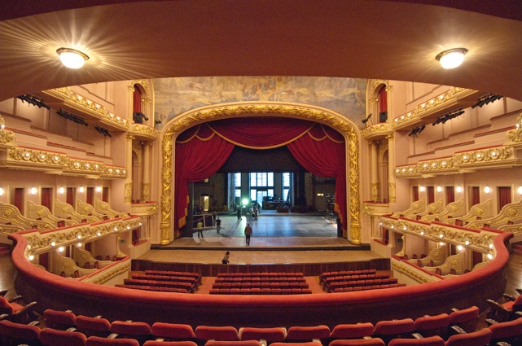
End on | Audience seated at one end – acting area at the other | Stage  Audience
Theatre in the round | Audience seated all around the acting area | 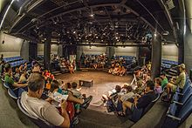
Thrust | Audience seated on three sides of the acting area | 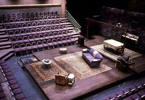
Traverse/Avenue | Audience seated on two sides of the acting area | 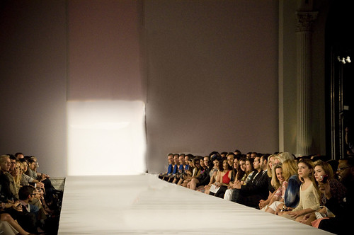
Promenade | Audience follows the action on foot, moving from one location to another | Acting area 1  Audience  Audience  Audience  Audience  Acting area 3  Audience  Audience  Acting area 2  Audience

AREAS OF THE STAGE
Areas of the stage indicate the division of the acting area into nine sections. The allocation of left and right is taken from the point of view of the actor.
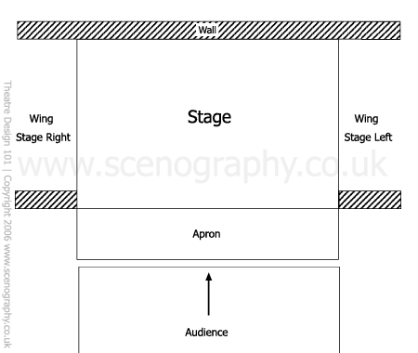
There are 9 areas of the stage. The director will refer to each area of the stage when directing actors on where they are to stand or move to.
These areas of the stage are also important for the set designer, in helping them communicate where a piece of set is to be placed on the stage.
The area farthest from the audience is up stage.

The area closest to the audience is down stage.

The apron is the part of the stage in front of the curtain.

Up Stage Right  (USR) | Up Stage Centre  (USC) | Up Stage Left  (USL)
Centre Stage Centre  (CSR) | Centre Stage  (CSC) | Centre Stage Left  (CSL)
Down Stage Right  (DSR) | Down Stage Centre  (DSC) | Down Stage Left  (DSL)
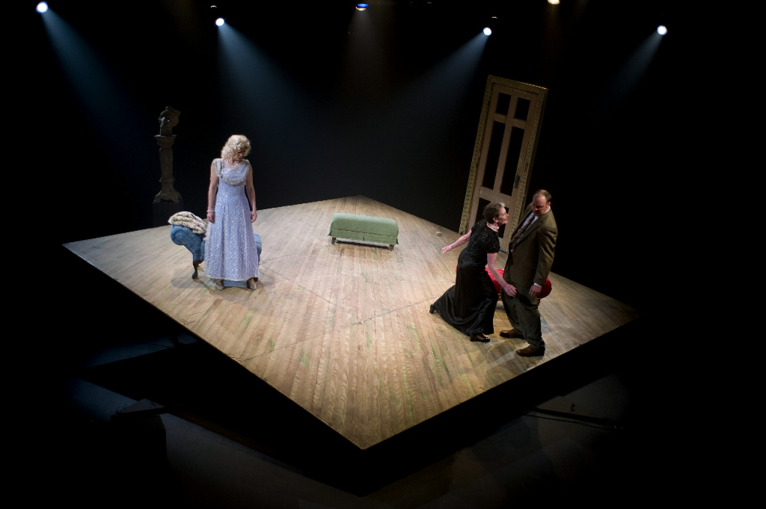
Why up stage and down stage?

Theatre stages used to be raked meaning they were built on a slope to ensure the actors could be seen. Therefore, actors had to go up the stage to up stage and walk down the stage to down stage.
This Photo by Unknown Author is licensed under CC BY-SA-NC

THE 9 AREAS

AUDIENCE

