[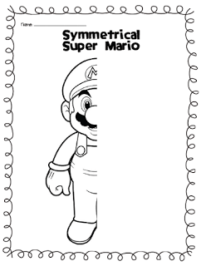](https://www.google.co.uk/url?sa=i&url=https%3A%2F%2Fwww.pinterest.com%2Fpin%2F111323422014456604%2F&psig=AOvVaw0uWZMiOJ4Qb5Qke3GKG2f-&ust=1592829150851000&source=images&cd=vfe&ved=0CAIQjRxqFwoTCND8kI_1kuoCFQAAAAAdAAAAABAE)