S3 Mathematics Homework Exercise 3 |  |  |  |  |  |  | 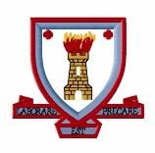
Surface Area
Issued by: |  |  |  | Return by:
Working MUST be shown in every answer.
1. | Find the total surface area of each shape below. All lengths are in centimetres.
 | a) | 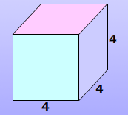 |  |  | b) |  | 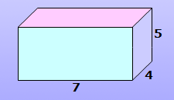
 | c) | 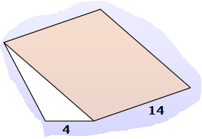  9  10  11 |  |  | d) |  | 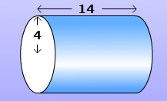
2. | A Toblerone box is a triangular prism 30 cm long, with 6cm equilateral triangles for its faces.
 | a) | Use Pythagoras’ Theorem to find the height of the triangular face.
 | b) | Use your answer to find the total surface area of the box.
3. | a) | A cylindrical soup can has a label attached to its curved surface.
 |  | Find the area of the label if the can has a height of 12cm and a diameter of 10cm.
 |  | Give your answer accurate to 3 s.f.
 | b) | The label on a different sized can of soup has an area of 346.36cm².
 |  | Find the radius of the can if its height is 9cm.
4. | A fish tank is an open cuboid with sides 1.5m, 0.9m and 0.7m as shown in the diagram. |  |  |  |  |  |  |  | 0.7m  0.9m  1.5m
 | The inside of the tank is coated with a special resin to help make it water proof.
 | Find the cost of coating the fish tank if the resin costs £16.50 per square metre.

Q. | Award 1 Mark for each ●:
1. | a) | ● 1 side = 16cm² | b) | ● 7 x 5 = 35cm²
 |  | ● 16 x 6 |  | ● 7 x 4 = 28cm²
 |  | ● 96cm² |  | ● 4 x 5 = 20cm²
 |  |  |  | ● (35 x 2) + (28 x 2) + (20 x 2)
 |  |  |  | ● 166cm²
 | c) | ● ½ x 4 x 9 | d) | ● Circle area = π x 4²
 |  | ● 18cm² |  | ● 50.2654….. cm²
 |  | ● one from 56cm², 140cm², 154cm² |  | ● Circumference = 8 x π
 |  | ● all rectangles correct |  | ● 25.1327…. cm²
 |  | ● 56 + 140 + 154 + (2 x 18) |  | ● 25.1327… x 14 = 351.8583…..
 |  | ● 386cm² |  | ● 351.8583… + (50.2654… x 2)
 |  |  |  | ● 452cm²
2. | a) | ● right angled triangle generated | b) | ● ½ x 6 x 5.19 = 15.57cm²
 |  | ● h² = 6² - 3² |  | ● 6 x 30 = 180cm²
 |  | ● 5.19cm |  | ● (15.57 x 2) x (180 x 3)
 |  |  |  | ● 571.14cm²
3. | a) | ● C = π x 10 = 31.4159… cm | b) | ● C = 346.36 ÷ 9 = 38.48444…. cm
 |  | ● 31.4159… x 12 = 376.9911184…. |  | ● D = 38.48444… ÷ π
 |  | ● 377cm² (to 3 s.f.) |  | ● D = 12.2499…
 |  |  |  | ● radius = 6.12cm
4. | ● 0.7 x 0.9 = 0.63m²
 | ● 1.5 x 0.9 = 1.35m²
 | ● 1.5 x 0.7 = 1.05m²
 | ● 1.35 + (0.63 x 2) + (1.05 x 2)
 | ● 4.71 x 16.50 = £77.72
 | Total = 40 marks

