Higher Health and Food Technology
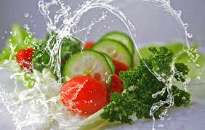

Outline of course
Health and Food Technology (HFT) course focuses on health, the influence of food and its nutritional properties, and the dietary needs of individuals. It also focuses on the application of safe, hygienic and informed practices in basic food preparation to help meet individuals’ needs. Additionally the course also covers Food Product Development, where the pupils will be given a design challenge which they must research, make and evaluate.

The course encourages learners to make informed decisions about food, nutrition and dietary needs and to experience challenge.

The Higher HFT course is made up of 3 main units:

Food for Health – Pupils will learn to describe the relationship between health, food and nutrition and make food products to meet dietary and health needs.

Contemporary Food Issues – Pupils will learn to describe consumer food choices and make food products, which address factors affecting food choices.

Food Product Development – Pupils will learn to describe how food products are developed and will develop food products to meet specific needs. Pupils will prepare dishes using a variety of functional ingredients in. Pupils will also look at the importance of hygiene procedures in relation to food production.

Suitable Candidates

Pupils do carry out some practical work to enhance their learning experiences but this is based about specific aspects of the course (for example, making a meal suitable for a toddler, or making meringues to demonstrate aeration) and is not designed to develop practical cookery skills and techniques.

Due to the requirement to analyse and evaluate information in the assessment of this course, it is advised that pupils should be studying Higher English or have already achieved an A or B in N5 English. Studying any of the sciences would also be very beneficial to pupils.

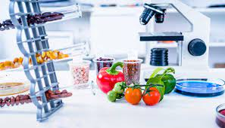
Assessment and progression
At Higher, there are two components:

Component 1: Question Paper (60 marks - worth 50% of total mark)
Component 2: Course Assignment (60 marks – worth 50% of total mark)

Higher Health and Food Technology carries equal weighting to all other Higher qualifications for University Admissions.

Extra information
This course has been extremely popular with S6 pupils ‘crashing’. Experience over the last few years has shown us that S6 pupils who have a strong grasp of English can successfully ‘crash’ this course. Any S6 wishing to do this should please speak to a HFT teacher regarding this.

Possible progression
BSc (Hons) Food Science; Food, Nutrition and Human Health; Food, Nutrition and Health; Fitness, Health and Exercise; Food and Nutrition Science; Food Manufacture and Nutrition; Health & Wellbeing and Nutrition.

Possible careers
Dietetics/Nutrition, Food scientist or technologist, Personal trainer/Sports Coaching, Teacher (for example Health and Food, Physical Education, primary teaching), environmental health officers, food auditor, Health sector (nursing, medicine, dentistry), Food product development.

With the rising popularity of the food and drink industry there is an increased demand for jobs. The food industry was responsible for employing 3.7M people in the UK in 2022

