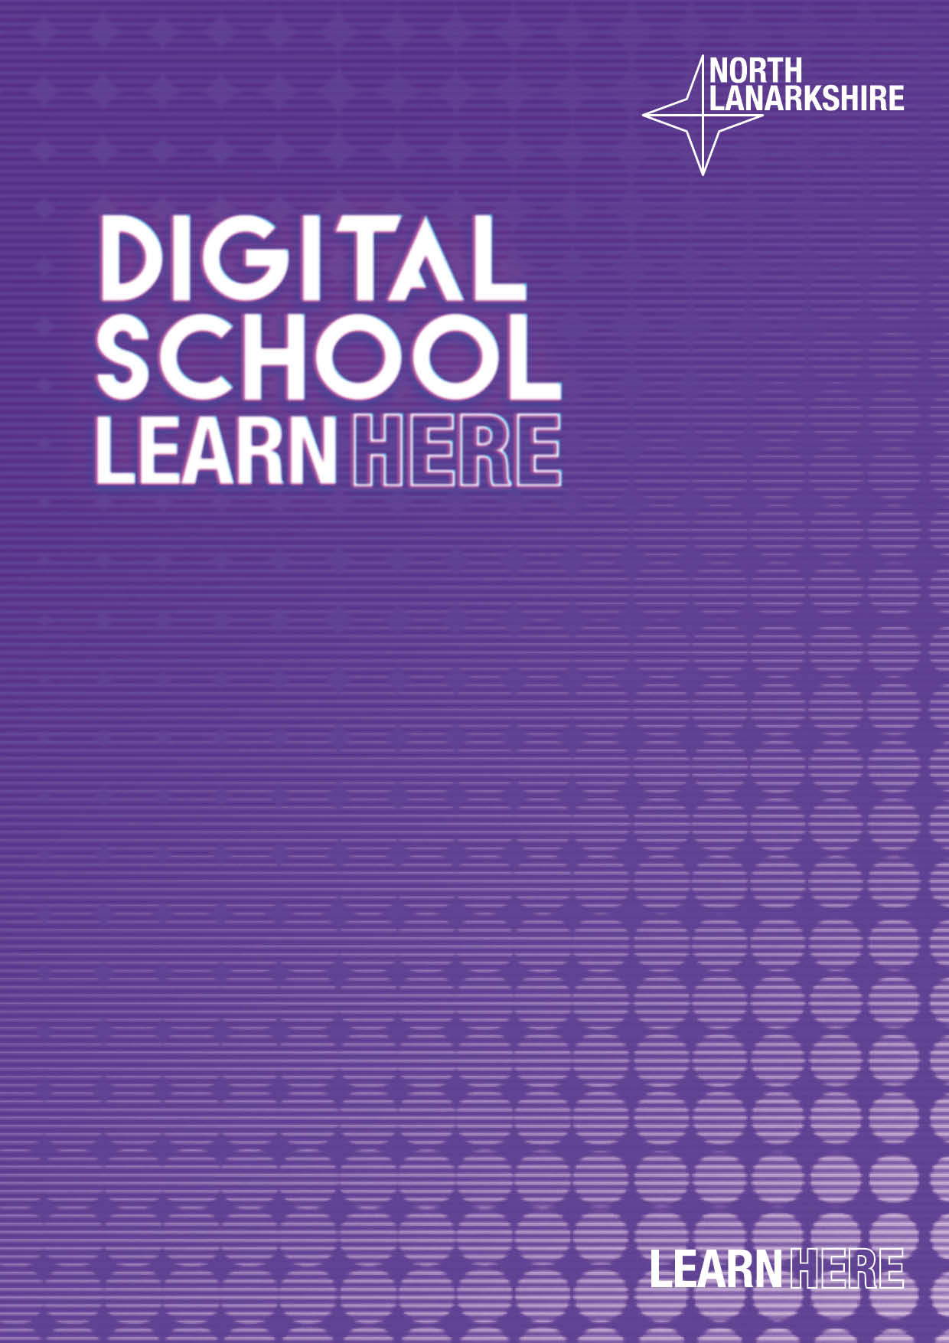

**Digital Learning Planning**

**Top 10 Tips**



**Digital Learning Planning Top 10 Tips**

1. **Keep it Simple** – feedback from parents/carers and pupils states they prefer to access as few platforms as possible. Glow is the universal offer to every pupil in North Lanarkshire. Using Teams with the support of other Office products such as OneNote, Sway and Forms will keep it simple and reduce the need for multiple logins etc. This is not to say that other platforms cannot be used but please be mindful of the expectations on families when asking to access resources from a variety of locations.
2. **Be Consistent** – it’s important that expectations, teaching approaches and quantity of work are consistent across the school/faculties.
3. **Communication** – Communication must be clear, consistent and universal with all parents/carers/staff and learners– i.e. don’t use Twitter or similar as the only platform as not everyone will have it.
4. **Provide Feedback** – High quality, relevant and regular feedback of pupil learning is as vital remotely as it is in the classroom. Using the application of MS OneNote is an effective and simple to give feedback digitally when learners are in class or remotely. This feedback is as personal as being in a jotter or marked assessment piece. Research suggests that young people prefer not to communicate this type of feedback in an open forum such a Teams Chat.
5. **Assessment** – MS Forms and particularly the Quizzes function are an easy to use and effective method of assessing learning. These can reduce teacher workload and increase learner engagement in the assessment process. Advice and video clips on creating your own quiz can be found online – [digilearn.scot](https://blogs.glowscotland.org.uk/glowblogs/digilearn/) and [Microsoft Educator](https://education.microsoft.com/en-us)
6. **Pedagogy –** Digital is a pedagogical approach to learning and teaching, at the current time this is our main approach. The principles of pedagogy and best practice apply whether learning is taking place in the classroom or remotely. Learners need to know a shared purpose for their learning and criteria for success.

1. **Resources** –. There are lots of good resources available for staff to use on the Digital School SharePoint, West OS, Scholar and Sumdog as well as more universal offers from E-Sgoil, BBC and others. Resources will also be shared within and across clusters. Sharing a worksheet onto a screen will not be engaging for learners and will give difficulty to type on without a printer. There should no expectation that parents need to purchase this as an additional resource. Remember copyright!
2. **Pupil Engagement** – There are a number of tools that can be used to track and monitor pupil engagement whilst learning digitally. Insights is an app that should be added to class Teams, allowing staff to track engagement and offer pastoral support where necessary.
3. **Time** – Be mindful of learner’s limitations, many tasks can take longer to complete online and some children and young people may not always have access to a device at all times. Research shows that recorded content has greater impact and engagement in shorter blocks, for example 10-15mins. This should be adjusted to meet the age and stage of the learner. There can be a follow up task linked to the recorded block of learning.
4. **CLPL**– There is a wide range of digital CLPL that can be accessed for staff. These include: Digital School, Glow, Education Scotland, Microsoft Educator. Also the school’s Digital Champion will be able to direct staff to additional CLPL via the Digital School and North Lanarkshire’s Digital Learning and Teaching Guidance