SNP Victory 2015- How did they do it?

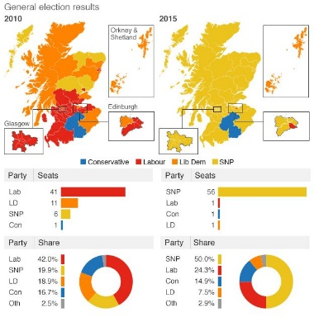
In the 2015 General election, SNP recorded a history landslide victory, winning 56 out of the 59 seats. In 2014, SNP had only 6 seats in Holyrood, and so, gained a huge 50 seats overnight. They won a 50% share of the vote in Scotland, compared to Labour who won just 24.3%.
They won all 7 seats in Glasgow with the country’s biggest swing- 39.3% from Labour- in Glasgow North East. This was a true victory that no one ever predicted.

But how did this happen?
In the 2010 General election, Labour had 42% share of the vote, compared to SNP’s 19.9%, however, in the Scottish Parliament election in 2011, Alex Salmond, the leader of the SNP at the time, gained 47 seats in Scottish Parliament, and became First Minister.
In 2016 Scottish parliament election, Nicola Sturgeon became First Minister after winning 63 seats.
In both 2010 and 2016, SNP won most seats in Scottish Parliament, however it was in the 2015 General election that they won the most to gain 50 in the UK parliament. This rise in popularity could be due to:

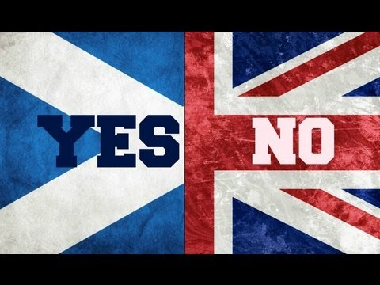
Independence Referendum
Successive opinion polls in the period since the September 2014 Independence Referendum pointed to victory for the SNP. On the back of a rising membership, a new leader in First Minister Nicola Sturgeon, and amidst Labour Party turmoil in Scotland, the way seemed clear for the SNP to emerge as the party with the largest number of seats in Scotland. Denying that the election was a re-run of the 2014 Independence Referendum, nonetheless it was impossible to escape from the shadow of the Referendum. The Referendum campaigns and outcomes had politicised Scotland in ways that had not been seen for many generations and it was evident that many of those voting YES were prepared to switch their party allegiances to the SNP.
This was a warning to Labour as many of the YES voters were previously Labour voters and supporters, and came from labour heartlands- in exception to Dundee. This could explain the huge drop of votes in the 2015 election for Labour, as many of the 45% of voted YES had changed their vote. They also lost voters to the conservative party who supported the Union in 2014, but they chose to ignore these signs and did not change their campaign.
Labour came a poor second to SNP in Scotland, with the worst result since 1931.

Brexit
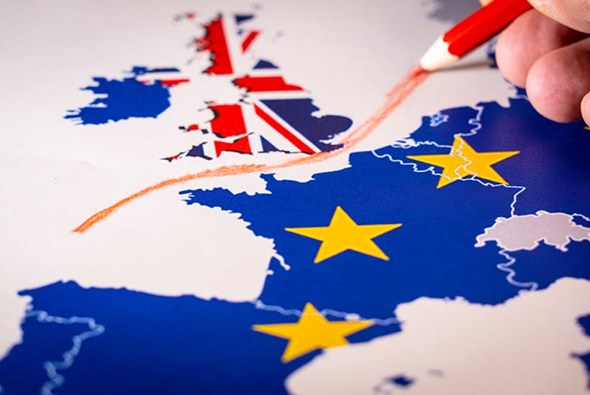
Before the European Union Referendum in 2016, SNP showed a clear opposition towards leaving, The SNP’s focus is on protecting Scotland’s interests and democratically expressed will to remain in EU – not frustrating England’s will to leave – it would be for Westminster to deal with consequences of this situation.
Nicola Sturgeon and the SNP continue to be focused on navigating through these difficult circumstances, and exploring all possible avenues to secure Scotland’s continued place in the EU. And if it becomes clear that the best or only way of doing that is by being an independent member, the First Minister has made clear that the option of an independence referendum is on the table.
This is a reason for SNP gaining popularity in 2015 as the majority of Scotland wanted to remain in the EU, and so, switched their allegiance to the SNP. This can be seen by the huge majority who voted to remain in the EU in Scotland- 62% compared to 38% who voted leave.

Media Coverage
Facebook: Our work with SNP helped them get landslide 2015 win.
The social media behemoth - which boasts over 2 billion active monthly users - said the nationalists reached 1.24 million people in Scotland by utilising the platform during their campaign which led to the party capturing 56 out of 59 Scottish seats at Westminster.
The political party (SNP) used a powerful combination of Facebook’s targeting and engagement tools to mobilise its supporters and achieve an overwhelming victory in the 2015 UK General Election.
The party saw Facebook as a key tool to connect meaningfully with its grassroots supporters and to build the profile and reputation of its leader Nicola Sturgeon.
On election day alone, the SNP reached 416,485 people via Facebook.

