Cardinal Newman High School

Higher Politics
Unit 1

Political Theory
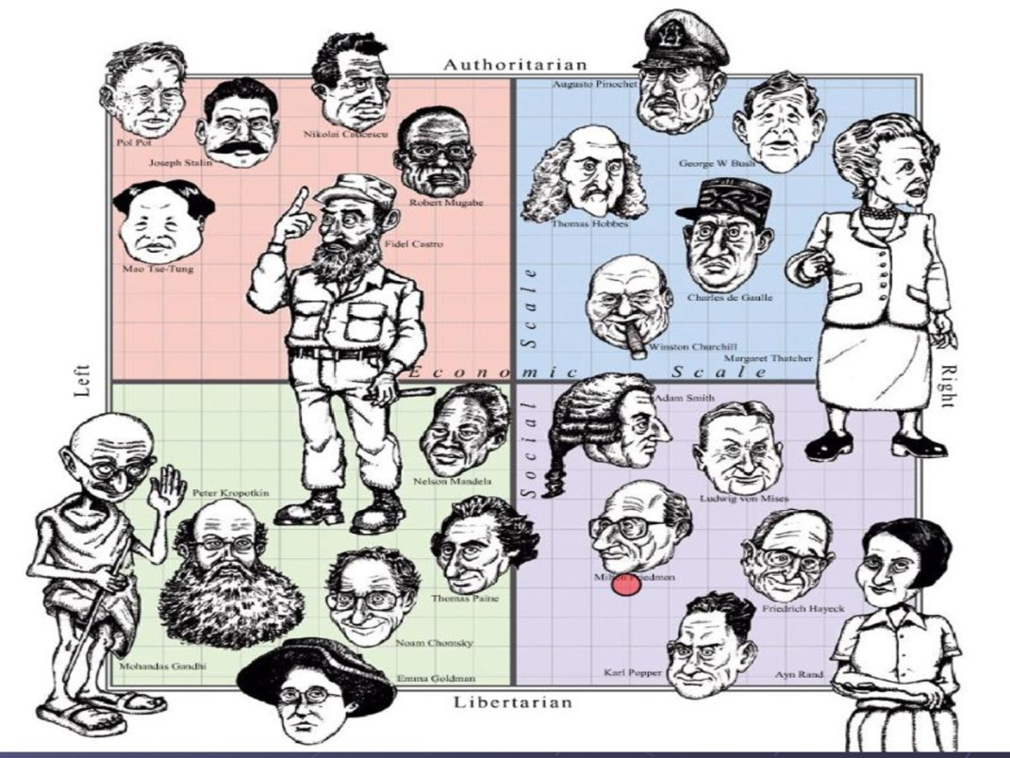

Name____________________________________________________________
In Higher Politics you will learn about the key concepts and structures that underpin modern democracies. The aim of the course is for you to develop a knowledge and understanding of political concepts and principles. The Course will promote the ability to interpret, analyse and evaluate political arguments, evidence and debate in a critical way. In Higher Politics we are going to look at three areas:

1. Political Theory
2. Political Systems
3. Political Parties and Elections

In this unit you will learn about political theory and the work of political theorists. The Unit is intended to develop knowledge and understanding of general political concepts and ideologies and to explore the work of particular political theorists in detail.
Concepts are general abstract ideas that can describe features or aspects of the world around us. Ideologies are systems of ideas and ideals. We will look at both throughout this unit.

Course Content-
- The State
- Power
- Authority
- Legitimacy
- Democracy
- Liberalism
- Conservatism
- Socialism

Choose one of the theorists from the list provided to investigate during the next couple of lessons. Your task is to introduce this theorist to the rest of your class.

You will need to come up with an inventive way of doing this (standing and reading off a ppt will not cut it!) and ensure that you cover the key ideas this person had about the state, sovereignty, pluralism, power, authority, legitimacy, toleration etc.

After these lessons have been completed, you will undertake a Theorists Hot Seating activity, to assess your learning and teaching of the various key concepts.

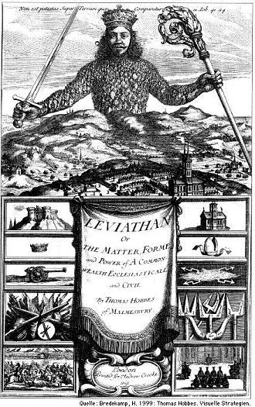
Important Theorists
- Thomas Hobbes

- John Locke

- Karl Marx

- Niccolo Machiavelli

- Max Weber

- Steven Lukes

- Jean- Jacques Rousseau

- Edmund Burke

- The State

The Origins of the State & Sovereignty

The modern State developed out of the old kingdoms of the Middle Ages. They began to appear, and be talked about from the 16th Century onwards. They were based upon the old kingdoms, but also included new ideas based upon limited monarchy, national identity and developing political institutions.

As states developed the concept of sovereignty evolved, in part due to the Reformation. The Reformation, started in 1517 by Martin Luther, was the movement which gave rise to Protestant churches and the decline of the power of Roman Catholicism. The Reformation sought to "reform" Christianity by returning it to original beliefs based solely on reference to the Bible, eliminating later additions which accumulated in tradition. Traditionally, kings had competed with the Catholic Church and the leading nobles of their kingdoms for the loyalty of the people. During the 16th and 17th centuries many kings began to believe in The Devine Right of Kings and argued that all power within a kingdom was given to them by God and, therefore, a king's power was absolute and unlimited. In Britain, this led to the English Civil War, the execution of King Charles I and occupation of Scotland by Oliver Cromwell in the 1650s.

These events established that absolute power could only be held by a state and not an individual and that it applied to all citizens. For example, the universal and uniform application of laws. Since then absolute power has been controlled by parliamentary democracy not on the dictatorial power of a monarch. This use of absolute power is now referred to as Sovereignty. Which, we can define as ‘the supreme power within territory’.

Thomas Hobbes work concerns the structure of society and legitimate government, and is regarded as one of the earliest and most influential examples of social contract theory. Leviathan argues for a social contract and rule by an absolute sovereign. Source A: The title page of Leviathan, by Thomas Hobbes published in 1651.

Task 1- Sovereignty

- To what extent does Source A tell us about Sovereignty in the early modern world?
You should:
a. Say ‘...to a large/little extent..’
b. Link the drawing to the information above [as many times as you can]
c. Say, ‘However it does not show….’
d. Identify one or two issues the source ignores.

Defining the State

There are a number of problems we face when trying to define what a state is. We often talk about nations, such as Scotland, England and Wales, but these are not the same as states. Likewise, we can talk about governments of states, but governments come and go through elections: the state is a far more permanent entity. Therefore, we need to look at a number of factors when defining what a state is:

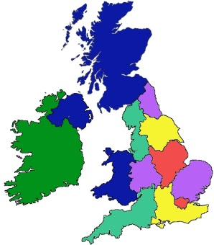
Defined Territory
States have geographical boundaries that are clearly defined a map of the world. Some countries may have boundaries and governments, although they may not be considered to be states. For example, Scotland has a defined territory and government, but is part of the United Kingdom and not an independent state in its own right. A state’s boundaries are usually permanent; however, border disputes can lead to wars and significant changes in borders between countries. The cause of these changes are often when a substantial percentage of a population no long feel loyalty to the state in which they are living. For example, in the Serbian province of Kosovo, 90% of Kosovars are Albanian. Kosovo broke away from Serbia in 1999 and In 2008, the Republic of Kosovo declared itself an independent state.

Population
States have a population, which will identify with the state and accept its authority. However, there may be significant parts of the population who do not accept the authority of the state because they do not recognise it and do not identify with being part of the state. This can lead to non-violent and also violent opposition. For example, Irish Nationalists refusal to accept British legitimacy and authority in Northern Ireland.

Central Authority

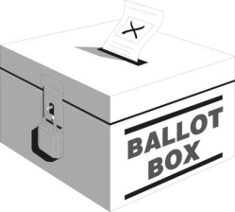
The central authority in a modern state is the government: but the state and a government are not the same thing. Government is only part of the state, and is the part of a state that is responsible for the organisation of society and are funded by the public. The government the principle agent (main body) of the state and exists to meet the state’s objectives. The state is also its citizens. For example, governments in modern democracies are elected through elections. Therefore, the state exists in modern western democracies through the democratic process, which needs the participation of individuals.

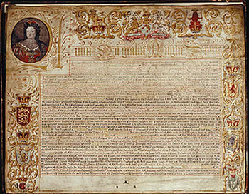
Permanence/ Longevity

States also usually have a permanence or longevity compared to other institutions. For example governments have a maximum life of five years, but the British state in its present form has lasted since the Act of Union 1707.

Legal Systems

States also have a legal system and set of laws, which gives it legal jurisdiction over its population. The rule of law is a key component of the state, and the acceptance of the rule of law by its citizens is also crucial to the continuing existence of the state. Moreover, the legal system has to apply to all of the organs of state.

Pluralist Theory of The State

The pluralist theory of the state argues that power in society is distributed amongst a number of different groups. Pluralists argue that, in a modern parliamentary democracy, power is distributed because of the democratic process; many non-governmental groups use their resources to exert influence. This is because voters have the opportunity to have a say in the running of the country through elections. These include local elections where councillors are elected, General Elections and MPs, Scottish Elections and MSPs and European Elections and MEPs. As a consequence, they argue, elected officials are accountable to the public, and can and are removed from public office if the electuary is unhappy with them. In a pluralist system other groups in society such as the media and the courts and pressure groups, all act as a check on government as the allow the government through the free expressions of differing options.

Pluralism sees the State as being politically neutral and comes from a liberal tradition where the state acts as umpire in society. No single group or elite dominates and Pluralists argue that power is fairly evenly distributed amongst different pressure groups. But, in reality, political access and power are unevenly distributed and they would recognise that some pressure groups are more powerful than others. Nevertheless, they all have, to varying degrees, access to the sources of power through legitimate methods of protest. Similarly, the permanent officials of the state such as the civil service, are politically neutral and impartial in pluralist theory. They define a state in which the masses play a role in the power structure as a ‘polyarchy’.

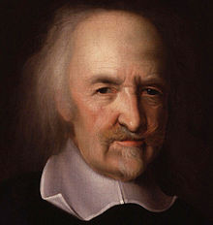
Thomas Hobbes - Leviathan (1651)

Hobbes argued that the state needed a system of absolutist government where total power was vested in the state. This, he argued, was the only alternative to anarchy, chaos and disorder as human nature was inherently violent. Hobbes claimed that man is not naturally good, but rather a selfish hedonist. As human motives were, in their natural state, guided by unenlightened self-interest, these could, if left unchecked, have highly destructive consequences. Left unrestrained, humans, propelled by their internal dynamics, would crash against each other.

Hobbes tried to envision what society would be like in a “state of nature” – before any civil state or rule of law. His conclusion was dispiriting: life would be “solitary, poor, nasty, brutish and short”, a “war of every man against every man”. Nonetheless, as all people are equal, possessing a passionate love of survival (right of nature) and some degree of rationality (law of nature), Hobbes concluded that a viable, working society would arise as an equilibrium between these competing forces. The logic is simple. Any person’s right of nature justifies violence against everybody else. Consequently, in the interests of personal survival, people will come around to agreeing that they should renounce their right to use violence. However, this yields up a tense and unstable equilibrium. The moment one party deviates from

Hobbes argued that the state needed a system of absolutist government should be able to defend your choice as well as make a case for it.
- In groups, carry out the UN task where total power was vested in the state. This, he argued, was the only alternative to anarchy, chaos and disorder as human nature was inherently violent. On the surface Hobbes commitment to absolute power would seem to run counter to a pluralist theory of the state. However, Hobbes also argued that any form of authority should be based on consent. He also argued that authority could take a number of forms other than that of an absolute monarch their promise, all will deviate and war restarts.

To keep society going with peace and confidence a Leviathan must be worked into the social contract. This Leviathan is the State – whether in the form of an absolute monarch or a democratic parliament, it does not matter. The important point is that the State will be given a monopoly on violence and absolute authority. In return, the State promises to exercise its absolute power to maintain a state of peace (by punishing deviants, etc.) Realizing that its power depends wholly on the willingness of the citizenry to surrender theirs, the State itself will have an incentive not to abuse it. Of course, there is no guarantee that it won’t. But when it does, it must brace itself for the consequences.

On the surface this commitment to absolute power would seem to run counter to a pluralist theory of the state. However, Hobbes also argued that any form of authority should be based on consent. He also argued that authority could take a number of forms other than that of an absolute monarch. There is no doctrine of separation of powers in Hobbes's discussion; the sovereign must control civil, military, judicial, and ecclesiastical powers.

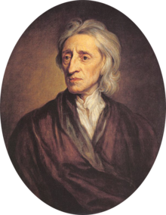
John Locke - Two Treatises of Government (1689)
Locke’s writings are the earliest example of a well-worked-out liberal political theory. In the Two Treatises he developed the social contract theory (the social contract theory was also put forward by Hobbes). This theory argued that the state was based on a voluntary agreement, a social contract, between the individuals of the state and the states itself. He argued that individuals recognised that only through the authority of the state could chaos and anarchy be avoided Locke used the social contract to emphasise the rights of the individual, which were defined as ‘life, liberty and estate’. Estate is what is now defined as property. As a consequence Locke argued that the power of the state should be limited in order to protect the rights of the individual.

"The natural state is also one of equality in which all power and jurisdiction is reciprocal and no one has more than another. It is evident that all human beings – as creatures belonging to the same species and rank and born indiscriminately with all the same natural advantages and faculties – are equal amongst themselves."

Unlike Hobbes, Locke believed that human nature was characterised by reason and tolerance. Like Hobbes, Locke believed that human nature allowed men to be selfish. Like Hobbes, Locke assumed that the sole right to defend in the state of nature was not enough, so people established a civil society to resolve conflicts in a civil way with help from government in a state of society. Locke also advocated governmental separation of powers and believed that revolution is not only a right but an obligation in some circumstances. These ideas would come to have profound influence on the Declaration of Independence and the Constitution of the United States.

Task 3- Pluralism

- Design a diagram that explains a Pluralists view of the state.
- Why can Hobbes be seen as a Pluralist?
- What did Locke mean when talking about a social contract?

Marxist Theory of The State

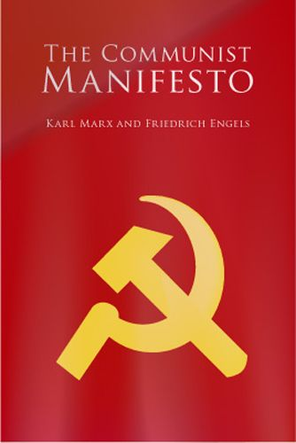
The Marxist analysis of the state is based on divisions between classes because of capitalism. Marxism is a socioeconomic theory which is the basis of communism. Marxists believe that people are entitled to enjoy the fruits of their labour, but are prevented from doing so in a capitalist economic system. In The Communist Manifesto (1848) Marx and Engels argued that the state was an instrument of oppression which allowed the ruling class to exploit the workers. For Marx there were only two classes: the bourgeoisie (business and land owners/middle class) and the proletariat (workers).

Marx argued that society was based around the economy, but the bourgeoisie used their power to build structures in the state to help them maintain power as the ruling class. These structures included the political system: for example, the Conservative Party would be seen simply as the party of big business, the courts which would implement the laws of the ruling class, religion the ‘opium of the masses’ and the media which reflects the dominant culture of the bourgeois.

As such, Marxists are highly critical of the pluralist theories of the state. They argue that power is concentrated in the hands of a ruling class, and the power of that ruling class, is based on the ownership of the means of production (i.e. money).
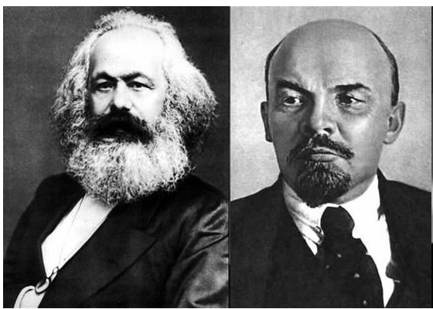
For Marx, democratic states cannot produce human emancipation (freedom from oppression), for the state always represents a particular class interest. Only when private property is replaced and classes abolished can human freedom be achieved. Indeed, in Marx’s early view the modern state was structurally bound to represent a particular interest group. Marx did not provide a coherent, detailed analysis of the state and therefore his writings have been interpreted widely by many, including Lenin.

Lenin developed the theory of ideology arguing that Marxism was the ideology of the proletariat and that a Marxist state would act in the interests of the proletariat. Thus, the state would take action in defence of their class interest. State power is about the economic base and an individual’s relationship to the means of production – proletariat/bourgeoisie; worker/capitalist. The state acts as an instrument of class rule – to protect and maintain the interests of the dominant economic/political class.
The state regulates conflict and tries to maintain order and stability and is a product of historical class struggle – thus, the state is not neutral but plays a key role in representing and operating in the interests of the dominant class. Stalin justified millions of deaths claiming they were in the interests of the proletariat. It was also the justification for oppression in the peoples’ democracies in Eastern Europe until the fall of communism in 1989 and is still the justification for the suppression of political opposition in China today.

For Marxists, the state is a dictatorship of the proletariat. However, there will be no need for a state when the lower phase of socialism moves on to the higher phase of communism.

Task 4- Marxism

- According to Marxists how is a state organised?
- Why do Marxists disagree with the Pluralists view of the state? Be as detailed as possible.
- Why, according to Lenin, would a proletariat state be a workers state?
- Write a detailed definition of the term ‘state’. Include: Origin, Sovereignty, the key factors, pluralist theories and Marxist theories. Structure your answer as a short essay.

Power

All politics is about power, who has it, what they do with it and how do you get it. The use of power and its distribution within a state is central to politics. Political power is the ability, and the right, of a state to influence, manipulate and force people en and events according to its will. Such authority requires obedience from the populace and may be established as a result of tradition, religious doctrine, charismatic leadership, military coup or democratic and legal means. However, power can be exercised in different ways.

Power is a form of domination or control that can force a person to obey another. It can also be viewed as a relationship in which one person has power over another: with this in mind we can categorise the way power is used.

Political Power

Political power refers specifically to the ability to control the institutions of the state such as the government or armed forces. When studying political events we are looking at where power lies and how it moves within a state. An election, for example, may take power to govern away from one political party and give it to different one.

Power may be taken legitimately. Many regard democratic elections as being a legitimate method of deciding who has power. However, power may be seized by way of a coup d'état: the armed seizure of power. Power is a double edged sword: if used badly by the state can cause conflict and disruption within a society ; if used well, it can enable a society to co-operate and prosper. Political power is often examined by looking at the relationships between individuals and the state or relationship between various branches of government, such as the executive (government) and the legislature (parliament).

Power Politics

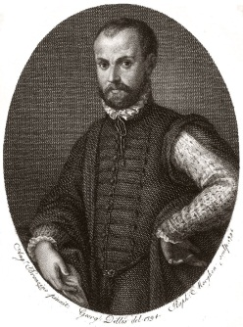
Power politics involves politicians using whatever cunning and dishonest methods they think are necessary, so long as they did not get caught, to achieve their aims. This type of political behaviour has come to be known as Machiavellian. Machiavelli, believed that in order to rule effectively, people should live in some kind of ’fear’ of what might happen if they failed to obey the will of those in power. People, Machiavelli suggests, would betray a ruler who they were not fearful of it suited their best interests, because there would be little fear of punishment. However, if the ruler exercised their power through fear the people would be too afraid to pursue their own interests at the expense of those in power. Modern Political theorists, known as ’modern realists’, see politics as the pursuit of power, and social order (i.e. an orderly society) existing entirely because of threats about what would happen if people did not follow orders.

Machiavelli examined the subject of the ‘mechanics of power’. He rejected the established medieval view that leaders were bound by a body of natural law and Christian ethics. Machiavelli argued that the advice to leaders to be merciful, liberal and loved was ideal in a world in which people were virtuous, but the problem was that the world was not like that. He argued that a leader could only survive by being mean, cruel and by keeping his word only when it was to his advantage to do so. He believed that those who govern should do whatever is required to take and hold onto power.
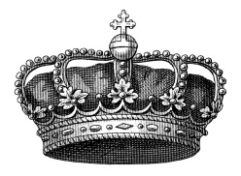

Absolute Power

Power can be judged by calculating the executive, legislative, judicial, economic and military power held by a state. Sovereignty gives the state the right and the power to act. Hobbes proposed that the state should hold full and absolute power. He believed that subjects of the King must submit in all things to the commands of the crown. It is interesting to note that he also argued that the people could revolt and overthrow the monarch, but only if their own safety was being threatened.

Power to Reward and Punish

Holding power over others inevitably means that the state will use it to reward and punish. People who have behaved bravely or served society for many years, are sometimes awarded an honour by the state, as public recognition of their good citizenship. Others are fined, imprisoned, and in some cases, executed by the state. Max Weber (1864-1920), a German Sociologist, saw the state as being defined by holding a monopoly on ‘legitimate violence’.

However, this use of ‘legitimate violence’ was the result of the corrupting nature of power that is unchecked. Montesquieu said that ‘power corrupts’. He proposed a ‘separation of powers’ in which the various branches of government operate independently of each other; this then enables them to place checks on each other. This is known as ‘checks and balances’. He argued that by dispersing power, a totalitarian regime is less likely to emerge. In this way liberal society, in which freedom and rights exist, will emerge.

Separation of Powers

Some societies, for example the United States of America, are able to confine and limit the right of the state to act, and thus, curtail their power. This is achieved by the use of a ‘written constitution’ and a ‘bill of rights’. A constitution is a set of rules and principles by which a state is governed. It sets out the powers given to the government and the legislative assembly. It describes the procedures to be used when electing their representatives and leaders. In many cases a constitution will contain the rights of citizens. A constitution can, therefore, limits the power of state within a society.

Consensus

The phrase: ’to find a political solution’ is used in situations where politicians try to solve a problem in society, without anyone having to resort to conflict. The state acts as a referee, a peacemaker: using its power for the good of the nation. All societies consist of different groups of like-minded people, each with a different set of values and opinions. Good government uses its powers to help these groups find consensus agreement where compromise on all sides can lead to a peaceful solution. This then means that the state does not have to use its powers violently in order to settle disputes.

Task 5- Types of Power

- Your teacher will give you a set of cards with different scenarios on them:
a. What type of power is being displayed in each scenario?
b. Choose two scenarios and explain how you could use either the separation of power or consensus to solve them.
- Design a task for your class that will test their knowledge and understanding of power in politics. By the end, you should all have a note of the 6 types of power (as underlined in the passage above)

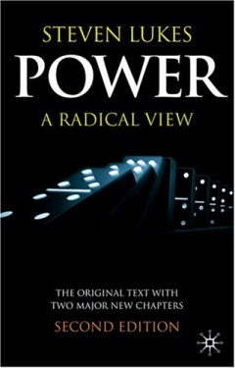
Steven Lukes on Power
Steven Lukes argued that power had three ’faces’ or ’dimensions’:

Decision Making

Lukes’ first face of power is its ‘open face’, or power that can be seen to be used. For example, when the government proposes to introduce a new law they produce a bill which will be debated in the Houses of Parliament, discussed in the media and attract the attention of pressure groups, which might, in turn lobby MPs. Eventually the bill may pass through the decision-making process and become law. Usually we can identify where the power lies, and this is exercised in accordance with the will (or the authority) of the people.

Non-Decision Making

The second face of power Lukes called its ‘secretive face’. This is power is exercised behind closed doors. He suggests that an important source of power is the power to set the political agenda, this is, being able to decide not only what will be discussed but, just as importantly, what will not be discussed. Power is therefore about preventing decisions from being made, or limiting choices, as well as making them. An example of this concerns the issue of devolution for Scotland. During the period of Conservative government from 1979-1997, the issue of devolution was never allowed on the main political agenda because the Conservatives were opposed to it. The Labour government elected in May 1997 had made devolution a prominent part of its election manifesto in Scotland and subsequently held a referendum on the issues. The Scottish National Party (SNP), whose aim was independence wanted, a question in the referendum on independence as well as devolution, but the Labour government did not allow it as it was not part of the their political agenda.

Manipulating Desires

Lukes suggests that power can go further, and its third face is one in which power is exercise through manipulation. His argument is that people in power can persuade us that the decisions being made are in our best interests and what we want. For example, some feminists would claim that women are persuaded that being a housewife and mother is in the best role for women in our society. In reality, other feminists would argue, women who occupy this role are being exploited by men for the benefit of men.

Task 6- Steven Lukes- A Radical View of Power

- Choose one of the types of power identified by Lukes:
a. Find an example of this for a case study.
b. Give your class a short overview of the case study and explain why you think it demonstrates the type of power you have chosen.

- Write a detailed definition of the term ‘power’. Include: political power, power politics, absolute power, the power to reward and punish, the separation of power, and the radical view of power. You must also refer to the all of the theorist mentioned. Structure your answer as a short essay.

3. Authority

Power and authority are often used interchangeably, but they describe things. In order for someone to have authority they must have legitimacy or rightfulness: the right to give orders, or make pronouncements or decisions.

If people have power, it means they are able to make other people do what they want them to do even if the other people do not want to do it. Power, therefore, is the ability to influence the behaviour of others by threat, sanctions or through manipulation. In political situations, those who have power are able to reward those who conform and punish those who do not.

Power cannot be exercised unless there is some way of enforcing it. This might be a direct threat or physical use of force (coercion), but it does not need to be. If people accept that power is ‘legitimate’, they are likely to be obedient and coercion will not be necessary. Although power may rest upon force (or the threat of it), it is often camouflaged by ideologies that deny its existence, or minimise its importance.

The assumption in a liberal democracy is that those in key positions of political power are able to exercise that power because they have been granted the ‘authority’ of the people (the voters) to do so. Essentially, what this means is that politicians in a liberal democracy can have the power ‘removed’ from them if they do not use their powers in a responsible and effective fashion. The power is removed through the ballot box: the voters may vote for a party other than the one in government if they think the party in government has acted irresponsibly. In this sense, then, they no longer have the authority of the people, and will not be in a position where they can exercise overall power over government policy.

Max Weber, a sociologist, developed ideas about the way in which power can become authority. He believed that there is a fixed amount of power in any society, and that power held by any individual or group is power which is not available to any other individual or group. He also argued that power is always used to further the interests of those who hold it. Weber’s three types of authority:

Traditional
Depends upon a belief in established customs and traditions. Those in authority expect obedience and loyalty on the grounds that established customs and traditions demand it. For example, the tradition of an hereditary monarchy demands that a new monarch commands as much obedience and loyalty as the previous monarch did.

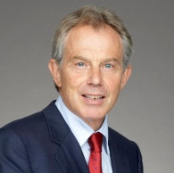
Charismatic
Depends upon the special qualities of a leader. People are drawn to follow the leader because of the qualities they believe he or she has (e.g. Hitler, Stalin, Churchill, Mandela, Thatcher, Blair). Charismatic authority may die with the leader or continue to work through a group of chosen disciples.

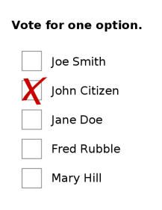
Rational-Legal
Depends upon a formal set of rules which gives those who hold authority the right to direct and command others and to take decisions on their behalf. It has a moral dimension in that people have freely handed power over to another person (or other people). So a democratic government can be said to exercise rational-legal authority because the electorate hands over power to it through the ballot box (ie. through voting).

Task 7- Authority

- Play the authority head game - what type of authority is being represented on each card?

- Having gained an understanding of power and authority from a conceptual point of view, it is important to look at an example of the exercise of political power and authority in practice.

You will be given either, a case study on the Power of the Prime Minister, or the European Union’s Democratic Deficit.

Prepare a summary of the main points of the article for the rest of the class.

- Write a detailed definition of the term ‘authority’. Include: Weber and his three types of authority, the difference power and authority, the effects of a loss of authority. Structure your answer as a short essay.

4. Legitimacy

Legitimacy is usually defined as ‘rightfulness’. Legitimacy changes power into authority by justifying the use of power, we would call this ’legitimising’ power. This means power in the form of commands or laws are obeyed out of duty and an acceptance of legitimacy, rather than out of fear.

The two terms authority and legitimacy are often used in the same context. However, as they are most commonly used people are said to have authority whereas political systems are described as legitimate.

Legitimacy is very important in understanding the role of governments within a state and it is crucial for governments to be legitimate to control in a democratic states. If governments are not legitimate then holding the state together will become difficult.

Weber defined legitimacy as being the right to rule. Therefore, as long as people were prepared to comply, a system of rule can be described as legitimate. Weber’s definition was entirely separate from any moral or rational basis for legitimacy. This is at odds with most political theorists who would argue that there are distinct differences between legitimate and illegitimate rule.

Aristotle was a Greek philosopher: he was one of Plato’s students and went on to tutor Alexander the Great. In Politics he argued that the best forms of government were those that existed for the common good (i.e. the best thing for everyone).

Rousseau argued that governments should be based on the ‘general will’. He believed that governments should be based on what was collectively good for the whole population rather than based on the selfishness of individuals as had been the case in the medieval period.

Task 8- Legitimacy

- Both Aristotle and Rousseau could be seen as arguing that legitimacy is based on democratic principles, but that is only partly true. Produce a list of the problems you can find with Aristotle and Rousseau’s arguments. Think of the times in which they were writing.

Legitimacy and Electoral Systems

For a government to be legitimate, they must have the authority to act on behalf of the people. A crucial part of our political process which produces legitimacy is the electoral system. In Britain, in particular, the legitimacy of governments has been increasingly called into question because of the way in which the electoral system works. Specifically, this has involved the increasing failure of the electoral system to produce results, and governments, which reflect the will of the people.
Firstly, under the electoral system for UK general elections, First Past the Post, a significant number of votes are wasted. For example, all the votes for the losing candidates are wasted in the sense that they are not represented in the House of Commons . Moreover, all the votes for the winning candidate over and above that which is needed to win are in fact surplus, as you only need one more vote than your nearest rival. As a consequence, nationally the percentage of votes a party gets is in no way in proportion to the percentage of seats it gets in the Commons. Moreover most MPs are elected with less than half the votes in their constituency.

Nationally this means that governments in Britain are very rarely elected with more than 50% of the vote in a General Election. In fact in the 20th century this has happened only twice, in 1900 and in 1931. The system can also produce a situation where one party can win more seats than any other, but with fewer votes than another party. This happened in February 1974 when the Conservatives polled 37.9% of the vote, with Labour second with 37.1%. However Labour had 301 MPs to the Conservatives 297, and, as such, formed the government.

The FPTP system is very unfair on smaller parties. This is because it favours parties such as Labour and Conservative in Britain whose support is concentrated in certain areas. The ‘winner takes all’ principle means that smaller parties find it very difficult if not impossible to convert support into meaningful representation, particularly if their support is spread out.

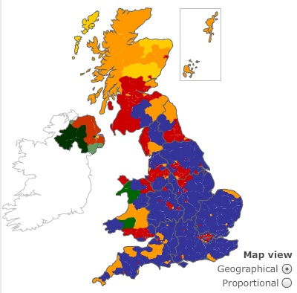
This was vividly demonstrated in May 2005 when, on average, it took 26,858 votes to elect each Labour MP, compared with 44,241 for a Tory MP and 98,484 for each Liberal Democrat MP.

The FPTP can also lead to huge regional differences from one part of the country to the next. For example in 2010 the Conservatives actually polled more votes than Labour in England, but once more did particularly badly in Wales and even more so in Scotland.

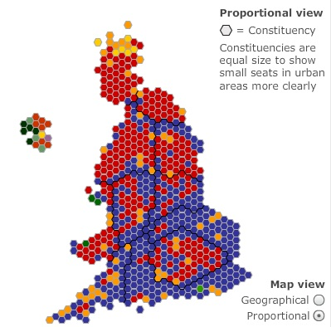
Critics of the current system also point out that in Britain, amongst the 650 constituencies, the vast majority are usually safe, and so the outcome of General Elections are dependent on what happens in a handful of marginal seats.

A final argument is that single member
constituencies are actually less representative
than in a system where there are several representatives per constituency. This is because within an area of up to 100,000 people there is going to be a huge variation in terms of social class, ethnic background, religion, etc., which cannot possibly be represented by one person. Therefore in the Commons whole groups such as ethnic communities,
women, working class people, etc., are very poorly represented.

Task 9- Legitimacy and Elections

- Why is it important for electoral systems to be legitimate in democratic countries?
- What problems exist with the British electoral system that could affect its legitimacy. Combine the information in the booklet with your own knowledge.
- Read the articles on Gordon Brown:

Gordon Brown: Still Standing http://www.ft.com/cms/s/0/d057e70a-41af-11df-865a-00144feabdc0.html#axzz1WMDLx5qU
The PM’s Problem http://www.independent.co.uk/opinion/commentators/michael-brown-the-pms-problem-is-that-he-lacks-any-legitimacy-855371.html

What are the key issues of legitimacy that affected Gordon Brown’s Premiership?

- Make a protest placard that questions the legitimacy of the current UK Government or political system.
- Write a detailed definition of the term ‘legitimacy’. Structure your answer as a short essay.

5. Democracy

The word democracy comes from the Greek words demos and kratos meaning ‘people’ and ‘government’. While ‘democratic’ is used to describe any situation in which people have a say in the way affairs are conducted democracy can also be defined in terms of accountability. Accountability can be divided into two essential types: Those who exercise power do so either as elected representatives or as appointed officials. They conduct their activities with the knowledge that they are accountable to a legislature and judiciary (e.g. the UK Parliament, UK Supreme Court, etc.) and/or the people, through the ballot box.

Powers and responsibilities are delegated by those in positions of power to the people who are charged with carrying out the will of those in power. This could, for example, a UK government minister delegating the task of drafting or implementing policy decisions to civil servants.
The idea of democratic accountability is one in which power is invested in the many and not the few: this it ‘rule by the people’. This could be associated with a specific form of government that is a characteristic of industrial society. People may mean different things by democratic accountability, i.e. whether or not they are defining democratic accountability in a capitalist or communist society. For example, the Communist Party of the Soviet Union ensured that its numerous party branches, as well as the media, industry, police, educational institutions, military, etc., were all accountable to the Communist Party. This would have been a similar experience in Nazi Germany, as well as in various military regimes throughout the world.
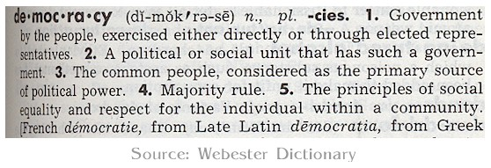

When he was president of the United States. Abraham Lincoln stated that democracy is:
‘Government by the people, of the people, for the people’ (1863).

Government by the people

This is often referred to as direct democracy: ‘a system where everyone is allowed to take part in law and decision-making’ (Cordell). Therefore, citizens make the decisions and are expected to participate fully in the political process. Examples include:

- Athens in ancient Greece about 500 BC, when all free men were entitled to attend forums to approve policies. However, women, children, slaves or those born outside Athens were excluded. Therefore, citizens were only Athens-born men, of a pure Athenian stock.
- The Cantons of Switzerland where decisions on policy were made at open-air meetings of electors.
- Referendums where governments will put a proposal to the people on the basis of a ‘yes’ or ‘no’ vote. They are generally used to settle constitutional questions, for example the Alternative Vote Referendum or the Independence Referendum. Some critics have noted that they are sometimes used as a device to gain support for government policies. Supporters argue that referendums give the electorate the opportunity to express their view and therefore increase participatory democracy.

Government of the people

This is often referred to as people’s democracy, where only one political party plays the leading role and, therefore, the elected representatives are from one party only. Examples include:

The former people’s democracies of Eastern Europe, such as the Soviet Union. The Communist Party in the Soviet Union was the vehicle for passing information from the people to the government and vice versa, and elected deputies came from this one party. The concept of democratic freedoms, in this sense, is freedom from want, hunger and exploitation. In addition, the freedoms stretched to the freedom of full employment, free education, health care, housing and other social and economic services.

Critics have argued that freedom was limited due to, for example, strict control of the media, the arts and public expression. Critics of the Soviet system or the people’s democracies argued that such a system was nothing more than totalitarian, meaning that one political party organises all social life to the exclusion of other points of view.
Dictatorships of various types are considered to be both totalitarian and anti-democratic, the most common being fascist or military rule with the state and nation-state being superior to the people’s rule. Examples include Nazi Germany, and right-wing military dictatorships in Africa and Latin America. Both Nazism and right-wing military dictatorships could not really be categorised as ‘[government] of the people’.

Government for the people

Often referred to as representative democracy. Under this system, citizens choose a smaller group of representatives to act on their behalf. Elections, which are supposed to be free, fair and regularly held, are used to choose the representatives.

Citizens’ freedoms can take the form of expression and organisation through the media, and membership of a political party. Freedom to gather together or assemble where and when people want, provided they don t break the law, is another feature of a Western liberal democracy. In the UK, popular control is exercised through an electoral system with almost everyone from the age of 18 having the right to vote. There are a number of exceptions, such as peers of the realm (Members of the Lords), the mentally insane, and ‘aliens’ (people from other countries who have not become UK citizens).

However, certain non-UK citizens can vote in UK elections, such as citizens of other EU countries who normally reside in Britain. Additionally, MPs and councillors have to submit themselves to periodic elections with political equality being achieved because every person’s vote is of equal value.

Task 10- Democracy Debate

“This house believes that direct democracy is preferable to representative democracy”

Prepare for a British Parliamentary debate on the motion above. The rules are:
- Speeches are five minutes in length.
- Points of Information should be offered during the second and fourth minutes
- Speeches should have a clear Internal Structure. It is often best to begin by
attacking the arguments of previous speakers from the other side and then to make you own points.
- Try to separate your arguments into two, three or four areas.
- Work as a team, ensuring that your arguments are consistent and complementary.
Democratic Accountability in Different Political Contexts

Liberal democracy is a feature of Britain and the other member countries of the European Union (EU), Japan, Canada, Australia, New Zealand, the United States, many of the post-communist countries of eastern and central Europe and South Africa, to name a few.

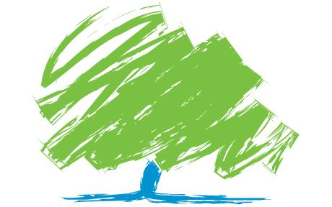
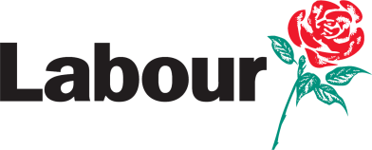
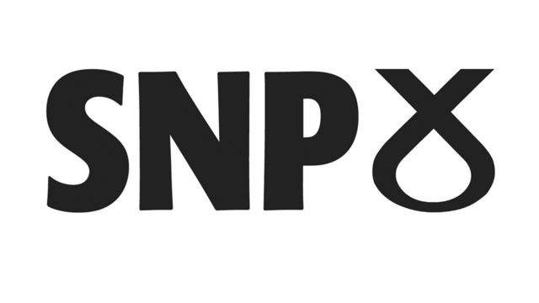
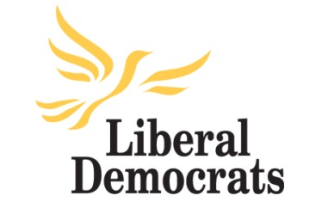
There are many distinctive features of a liberal democracy, and within each nation here exists varying levels of liberalism. However all liberal democracies should include the following:

• A representative democracy
• Free elections
• Elected representatives
• Regular elections
• Political parties
• Pressure groups

They should also have a free press, with the freedom to print/broadcast what it wishes, and not merely a propaganda machine for the government.

Political freedom, with the voters free to choose whom they want from among the candidates who are standing for election; freedom to form alternative parties; electoral safeguards, i.e. secret ballots, limitations on spending and the conduct of candidates during election campaigns.

A representative parliamentary system ensures that policies are decided upon by a majority of representatives voting for or against them.

British Liberal Democracy

In Britain, liberal democracy takes the form of a general consensus among the major political parties on how to govern the country. This consensus is supported in principle by the three main parties, as well as freedom of speech, movement and association, and they have a commitment to the means of selecting governments; elections.

However, each party’s exact policy on each of these can vary significantly. For example, the Liberal Democrats have manifesto commitments to a written constitution and a bill of rights, and a change to the electoral system, while the Labour party does not support either.

The UK’s brand of liberal democracy also supports the idea of a mixed economy, where the private sector can prosper in a market economy, and a large state sector makes provision of such public services as the NHS, Social Security, the civil service, etc., or sometimes even a combination of the two.
British Representative Democracy: elections and choice

When voters in the UK cast their votes in elections, they expect the party they vote for to be representative of their views, and accountable to them if they do not. People can control future government policy through elections. This means parties need to have different ideas and politics to gain the support of the electorate. This means there are four conditions required for elections to actually have an effect on government policy:
- The parties must offer voters a choice.
- Voters need to be aware of the choice.
- People vote on the basis of the choice.
- The party in control of the government follows the policies people voted for in the election manifest. (party accountability).

Limits of Liberal Democracy: is it really accountable?

As decisions are made by party officials in representative democracies it is unlikely that the people will have their wishes met. This is because the party officials will be making collective decisions that are likely to be compromises and not what the people actually wanted.
Representatives may become an elite group who run the state. Therefore, decisions are made by government in the shape of the politician rather than by the people. It could be suggested that political decisions rarely match what people truly want. In Britain we refer to the ‘political class’ or ‘chattering classes’ when discussing this phenomenon.

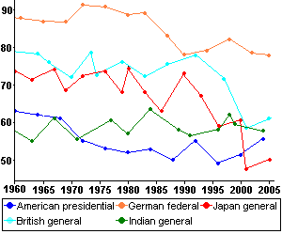
As a result of the massive bureaucracy involved in running a state, the people have minimal input into the process. Therefore, it is difficult for people to know all of the facts while institutions like the civil service or media control the information that is released.

Elections are infrequent (every 4-5 years in the UK), which means that participation for the majority of people is very limited. Low turnout in elections could undermine the legitimacy of the political system, because elections act as an important measure of democracy.
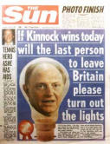
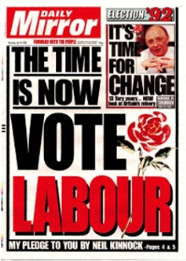
Additionally, general elections in the UK can be called any at any time in the 5 year period; generally governments only call elections early when they are riding on the crest of a wave of popularity, and are almost guaranteed victory. If, however, they are unpopular, they will wait until the last possible minute to call a general election (e.g. as the Conservative governments did in 1992 and 1997 and Labour in 2010), hoping either that their fortunes will improve, or at least that their opponents will worsen. An example of this was in 2007, when the Labour party was leading the opinion polls and a Labour victory was expected. They, however, waited until the last minute before having an election in 2010: by which time they were trailing substantially in the polls. They subsequently lost the election. Conversely in the 1992 general election when a Labour party victory was expected. The Conservatives waited until the last minute before having an election: unexpectedly they held on to power. The John Major, as prime minister, led the Conservatives to defeat in the May 1997 general election.
Civil and political rights can come under threat. In Britain there is no Bill of Rights and fewer rights in the workplace, compared to Britain’s European Union partners. For example, in 2010 courts stopped workers striking at British Airways, Johnson local newspapers group and Network Rail.

Minority parties can find themselves disadvantaged because of the voting systems used. In the UK general elections the first-past-the-post (FPTP) electoral system is one such example. The FPTP system often results in a winning candidate being elected with a minority of the vote even though the majority of people voted for somebody else. As long as he or she can win more votes than his or her nearest rival, that is enough for victory.

The fact that there are no real limits on election spending can disadvantage minority parties or poorer candidates. Communists, among others, argue that this is proof of the lack of democratic accountability in a liberal democracy.

Task 11- The Merits of and Limits to Democracy
- Create a comprehensive list of the advantages and disadvantages of democracy - consider different viewpoints.
- Write a detailed definition of the term ‘democracy’.

Ideologies
When speaking about ideologies, we tend to talk about a left to right spectrum, with parties and leaders places somewhere on a one-dimensional line on the basis of their policies being socialist, liberal or conservative.
However, on the standard left-right scale, how do you distinguish leftists like Stalin and Gandhi? It's not sufficient to say that Stalin was simply more left than Gandhi. There are fundamental political differences between them that the old categories on their own can't explain. Similarly, we generally describe social reactionaries as 'right-wingers', yet that leaves left-wing reactionaries like Robert Mugabe and Pol Pot off the hook.
Therefore, both an economic dimension and a social dimension are important factors for a proper political analysis. By adding the social dimension you can show that Stalin was an authoritarian leftist (ie the state is more important than the individual) and that Gandhi, believing in the supreme value of each individual, is a liberal leftist. While the former involves state-imposed arbitrary collectivism in the extreme top left, on the extreme bottom left is voluntary collectivism at regional level, with no state involved. Hundreds of such anarchist communities exisited in Spain during the civil war period
You can also put Pinochet, who was prepared to sanction mass killing for the sake of the free market, on the far right as well as in a hardcore authoritarian position. On the non-socialist side you can distinguish someone like Milton Friedman, who is anti-state for fiscal rather than social reasons, from Hitler, who wanted to make the state stronger, even if he wiped out half of humanity in the process.
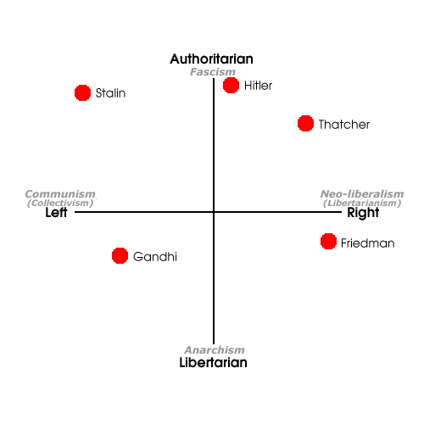
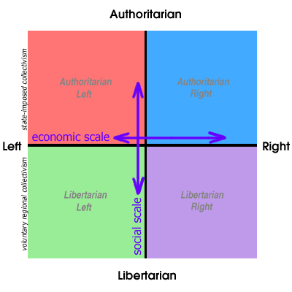
The chart also makes clear that, despite popular perceptions, the opposite of fascism is not communism but anarchism (ie liberal socialism), and that the opposite of communism ( i.e. an entirely state-planned economy) is neo-liberalism (i.e. extreme deregulated economy)
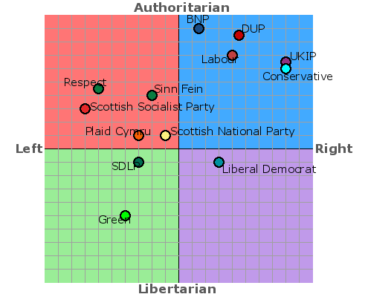
2010 General
Election Parties

Go to http://www.politicalcompass.org/test and take the test to see where you sit on the political compass/spectrum.
Take your time and think each of your answers through properly.
Mark where you are in relation to other world leaders on the chart below and create a class chart with your teacher using the following link: http://www.politicalcompass.org/crowdchart.php?showform
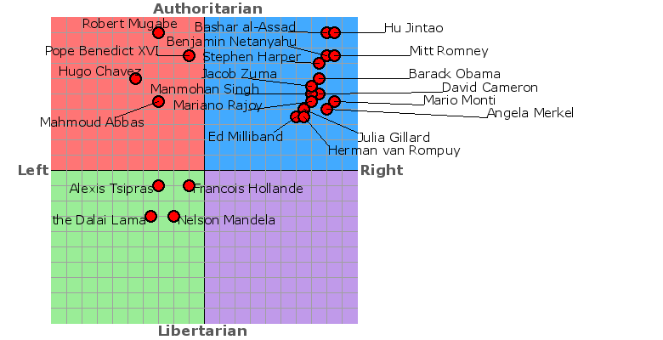

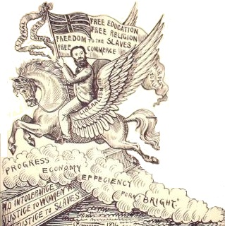
6.Liberalism

Liberalism is based on a positive view of human nature; it places a high value on individualism (a core principle of liberalism) and is based on the belief that people have the capacity to behave rationally and to shape their own lives. As people are rational, liberals believe that it is possible to create a society which maximises individual freedom and economic efficiency. As a political doctrine liberalism has two important elements:

- a society aimed at promoting individual freedom and happiness
- people, by behaving rationally, can maximise political freedom and economic well-being.

Liberalism emerged in Britain as the old feudal order, was replaced through by the industrial revolution by the new capitalist order. Fundamental to liberal theory is a belief that individuals, commercial companies and other organisations, should be able to go about their business, un-hindered by the state; the state’s only function should be to protect those people’s rights to freedom and liberty.

The Individual
Central to this political model, is the importance of the individual. Everyone is considered to be of equal, but different, worth. A good society is one, which accepts the uniqueness of every individual, and encourages him or her to pursue personal life-choices. Each person will then be able to lead a good-life, according to his or her own views on what constitutes ‘good’. The state should be morally neutral. Individualism is the belief in the supreme importance of the individual over any social group or collective body

Reason
In a liberal society human beings are considered rational, thinking creatures, that are capable of defining an pursuing their own best interests. They believe in the progress through the expansion of knowledge, particularly through scientific means and better understanding of the world. People can better improve themselves through education and the acquisition of knowledge. Nevertheless, they acknowledge that self-interest and egoism can create rivalry and conflict, however, liberals strongly believe that conflicts should be settled through debate and negation and not war. Reason is the belief that the world has rational structures and humans have the ability to reason, freeing them from superstition and ignorance.

Equality
Liberalism accepts the principle that all individuals are of equal moral worth. Everyone should be entitled to the same rights, entitlements and opportunities, especially before the law and in politics. This is not to say that they will be entitled to the same equal outcome; however, they do have equality of opportunity in the first instance to allow them to succeed. Liberalism is not, for example, about the equal distribution of wealth. It is up to the individual to create his or her own wealth (meritocracy); they should not, however, be hindered by the state, or anyone else, in their pursuit of wealth. To liberals everyone is ‘born equal’.

Toleration
Liberalism can be characterised by a willingness to accept moral, cultural and political diversity. Toleration is a willingness to allow people to think, speak and act in ways of which we disapprove. It does not, however, mean unlimited tolerations. Liberals would qualify toleration in relation to views that are in themselves intolerant. For example, Locke, who advocated toleration in 1689, was not prepared to extend the principle of toleration to Roman Catholics. While, liberals may be prepared to support laws forbidding racists opinions or undemocratic parties.

Consent
Liberalism accepts that there must be government and the rule of law, but the power given to politicians has to be consensual. Only if those in power have been democratically elected, can they expect to be obeyed. They can only rule with the consent of the people. However, they fear uncontrolled government power for example the totalitarian dictatorships of the interwar period. As a result, liberals believe in democratically elected governments limited by the principle of constitutionalism. Codified (written) constitutions and a bill of rights seek to allocate duties, power and function among the various institutions of government so that order and stability can be guaranteed.
‘Power tends to corrupt and absolute power corrupts absolutely’ Lord Acton

Task 12- Liberalism
- If liberalism was a drawing, what would it look like?
- Find a quote from a liberal theorist for each of the values of liberal described above?
- Explain Lord Acton’s quote in your own words.

Classical Liberalism
A number of political theorists have helped to develop the doctrine of liberalism. The 17th century English political philosopher, John Locke, developed the idea that political authority was based on a social contract which existed between the people and their government. Under the terms of the social contract, the people entrusted the government with power to protect their natural rights. The concept of natural rights is of fundamental importance to liberalism. Natural rights means those rights that people possessed as a gift from or God prior to the formation of governments. Natural rights belong equally to all people at birth and cannot be taken away. The idea that the individual has natural rights immediately suggests limits on the power of government.

Locke regarded people as having three important natural rights:
- the right to life
- the right to liberty
- the right to property

Locke regarded the right to property as the most important. For Locke, government was to be based on the will of the majority and its main purpose was to promote the individual’s rights to property. This provision has remained an important element in the doctrine of liberalism.

Locke took this idea further and suggested that not only do people have natural rights, but governments are required, under the terms of the social contract, to protect and promote them as a means of ensuring the general well-being of society. If the government fails to promote the general good of society, according to Locke, it can be dismissed by the people who are then free to choose another government more to their liking.

For Locke, the social contract involves two sets of obligations:
- In exchange for the benefits of living in an organised, law-abiding society, the people agree to give up some of their natural rights and obey the laws passed by government.
- In exchange for the trust put in it by the people, the government is obliged to govern well and to promote the general good of society.
As a result liberalism involves the operation of a set of mutually reinforcing rights and obligations. The government is obliged to govern well, but at the same time its power is limited by the need to respect the natural rights of the people. In exchange for the privilege of being properly governed, the people are required to obey the laws enacted by government.
Locke argued that the general good of society is determined by the will of the majority. In Locke’s version of the social contract, governments are chosen as the result of an expression of majority opinion.

Adam Smith, the 18th century Scottish economist and philosopher, developed the idea further and suggested there was a link between liberal individualism and the workings of the free market. Smith argued that under the conditions of a free market, any individual who pursued a policy of self-interest would enrich themselves as well as also create wealth for society as a whole.

The emphasis on the economic benefits of individual enterprise, pointed out by Adam Smith, lies behind liberal support for the minimal state in which the role of government is limited to maintaining peace and law and order, allowing people maximum freedom to pursue their rational self-interest.

Government has no other end, but the preservation of property' John Locke

‘The real tragedy of the poor is the poverty of their aspirations’ Adam Smith

Modern liberalism
This form of liberalism accepts that not everyone in a liberal democracy will be successful and prosperous. There may be a need for limited state intervention, to help those who may have fallen on hard times. Capitalism is a competitive economic market system that throws up both winners and losers. Rather than letting people suffer in the midst of prosperity, modern liberalism advocates the provision of a minimum welfare safety net, in order to help people in difficulty and enable them to get back on their feet again.
In his essay On Liberty (1859) Mill he argued that freedom is granted to individuals to forge their own lifestyles. As a political system, liberalism, according to Mill, is characterised a limited role for government, respect for individual rights and freedom, the rule of law and majority rule. Mill’s work was the bridge between classical and modern liberalism.
Similarly, modern liberalism developed the idea of positive freedom. Freedom is the ability of the individual to develop and attain individuality; it involves the ability of the individual to realise his or her potential, attain skills and knowledge and achieve fulfilment. However, in a capitalist system the working class, for example, can be held back by the disadvantages of poverty, sickness, unemployment and ignorance. Freedom here may only be the freedom to starve, this is negative freedom. On the other hand, positive freedom aims to empower and safeguard people from the social evils that they face. The Beveridge Report of 1942, the foundation of the welfare state, advocated positive freedoms from the ‘five giants’ of want, disease, ignorance, squalor and idleness. The central thrust of modern liberalism is to help individuals to help themselves.

Task 13- Classical and Modern Liberalism

- ‘There are no difference between classical and modern liberalism’, discuss.
- The coalition government relies on compromise. Identify liberal influence on government policies and decisions since 2010. Explain how each of the examples you use demonstrate liberal values or features of classical or modern liberalism.

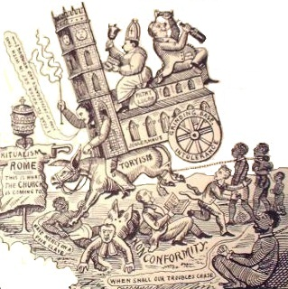
7. Conservatism

Many writers argue that conservatism has no real ideological basis. They regard it as a practical attitude about politics which avoids full-blown theories.

Conservatism in its modern form developed in Europe in the 1790s as a reaction to the French Revolution. Since then conservatives throughout Europe have been committed to defending the established order of society. Conservatism may take on various forms, depending on the country in question. Indeed, British Conservatives have often appeared to be more left-wing than their counterparts in America and Europe.

As a political doctrine, conservatism represents a set of ideas which can be traced back to the 18th century. It encompasses the following views:
- Tradition
- Human imperfection
- Authority
- Property
- Hierarchy
Tradition

Conservatives have argued against change because Institutions and practices of the past have been ‘tested by time’. Customs and institutions should therefore be preserved for the benefit of the living and for generations to come. Tradition is also important to conservatives as it gives the individuals a sense of belonging and identity. Change, on the other hand, is a journey into the unknown and can create uncertainty and insecurity.

Human Imperfection

Conservatives believe that human beings are both imperfect and unperfectible. They argue that human beings are thought to be psychologically limited and dependent creatures who fear isolation and instability. As such, they are drawn to what is familiar and seek security in knowing ‘their place’. Likewise, they believe that individuals are morally corrupt and are thought to be innately selfish and greedy. Crime, therefore, is not the product of social conditions, but it is the consequence of natural instincts. This means human beings can only be persuaded to behave in a civilised fashion if they are deterred a strong state and laws.

Authority

Authority arises naturally and can only be imposed ‘from above’. For conservatives authority is necessary and beneficial as everyone needs the guidance, support and security of knowing ‘where they stand’ and what is expected of them. This has led conservatives to place a special emphasis upon leadership and discipline. Leadership is needed to give direction and provide inspiration for others. While, discipline is a willing and healthy respect for authority, not just mindless obedience. As such, conservatives believe in a natural structure of society to be hierarchic and naturally unequally, but as everyone has a place it is a source of social cohesion.

Property

Property holds a special, almost mystical, significant for conservatives. Property ownership gives people as sense of confidence and assurance in an uncertain and unpredictable world. Likewise, those who possess and enjoy their own property are more likely to respect and the property of others. Property owners therefore have a stake in society, they have an interest in maintaining law and order. This in turn supports other the other conservative values of authority, social order and the law.

Hierarchy

Hierarchy is an important element of conservatism. They argue that as society is organic and social groups and associations are ‘contractual’ in that they are entered into voluntarily as such, gradations of social position and status are natural and inevitable. This reflects the different roles and responsibilities that people have within a society. However, this hierarchy does not necessarily give rise to conflict due a person ‘knowing one’s place’ and what is expected/required of them to do: there are mutual obligations between the different groups of a society.

Burke was deeply oppose to the French Revolutionaries belief in the abstract principles of liberty, equality and fraternity. Instead he believed in the importance of experience, tradition and fraternity. However, he believed that change was necessary in order for something to survive and grow. He had a gloomy view of government, recoding that, although it can prevent evil, it rarely promotes good.

Task 14- Conservatism

- Find a quote from a conservative theorist for each of the features of conservatism described above.
- Why could conservatism be described as a negative ideology?

Traditional Conservatism

The resourcefulness of conservatism as an ideology is reflected in its electoral success in the age of democracy. Conservatives have been highly successful in getting their ideas across to a mass audience. In doing this, conservatives have projected a view of the state which has a varied and broad role in uniting the nation. They have also emphasised individual freedom while advocating a very limited role for the state. At other times, conservatives have shown their adaptability by supporting nationalism, religion and authoritarianism at different times in pursuit of electoral success.

Authoritarian Conservatism

The authoritarian tradition dates back to Plato, who proposed that government be entrusted to a small class of philosopher-kings, the Guardians, whose authority was absolute and unquestionable because it was based upon their understanding and superior wisdom. Authoritarianism is the belief that government should be ‘from above’, which authority is exercised over a populations with or without its consent.

Authoritarian conservatives believe in the need for strong leadership, with or without the support of the population, to maintain the status quo, customs and traditional practices of the state. Examples of this form of conservatism can be found in Russia under the Tsars, Khomeini’s Islamic Republic in Iran and Péron’s regime in Argentina from 1946-55.

One Nation Conservatives

One nation conservatism grew out the ideas of Benjamin Disreali, UK Prime Minster in 1868 and 1874 to 1880. He tried to draw attention to the danger of Britain being divided in to ‘two nations: the Rich and the Poor’. In the best conservative tradition, Disraeli argument was based upon a combination of prudence and principle. The growing social inequality between the classes had led Disraeli to believe that the working class would not simply accept its misery, but would result in revolutions as had happened to other European countries in both 1830 and 1848. Therefore, reform was seen as being a sensible course of action and ultimately be in the interests of the rich. On the other hand, Disraeli also appealed to moral values by suggesting wealth and privilege brought with them social obligations and a particular responsibility (duty and obligation to) for the poor or less well-off.

One Nation Conservatives supported limited social because they believe serious deprivation could lead to social indiscipline, which could also undermine national unity. Those in the British Conservative Party who opposed Margaret Thatcher’s monetarist policies were generally supporters of the line that Conservatives should be concerned with the welfare of all social groups, and therefore disagreed with Mrs Thatcher’s policies on unemployment, for example. They were regarded as ‘Wets’ within the party. One-Nation Conservatives do, however, believe that socialism is socially disruptive and against the interests of the state.

The New Right

The ‘new right’ is a broad term and has been used to describe ideas that range from the demand for tax cuts to calls for greater censorship of the media and campaigns against immigration. Two principle themes can nevertheless be identified within it:

- Neoliberal Conservatism: Support for classical liberal economics, in particular, the free market ideas of Adam Smith.
- Neoconservatism: Strong support for the traditional conservatives values of order, authority and discipline.

Neoliberal Conservatism

In Britain, Margaret Thatcher could be seen to be an exception to the rule of gradual change, which the Conservative Party had historically adhered to. Her emergence as leader of the Conservative Party signalled an era of radical change and New Right politics, away from Keynesian economics and towards monetarism, with a free market system and individual free enterprise being at the forefront of her thinking. Keynesian economics an theory that encourages active government intervention in the marketplace and monetary policy as the best method of ensuring economic growth and stability

This approach emphasises individual initiative and suspicion about the role of the state. Neoliberal conservatives believe that state interference should be minimal, but the state should not be weak when dealing with issues such as law and order.

Certainly, Margaret Thatcher’s response to social indiscipline was demonstrated in strong state measures. For example, she ensured that the police clamped down very hard on flying pickets (strikers who went from site to site to picket the gates of factories, collieries, etc.) during the 1984-5 miners’ strike. She gave the police the authority to restrict the freedom of movement of striking miners, so that the strength and impetus would be taken out of their industrial action.

Neo-conservatism

Neo-conservatists believe in freedom, they understand freedom in economic terms only. It is a market freedom: freedom of choice in economic life supported by strict individual responsibility. Monetarism is a policy based on the belief in the efficiency of free market forces, by ensuring there is a steady supply of money to maintain stability and growth in an economy

Economic liberty must nevertheless be balanced against the need for social order. They stand for the ’family values’ and the restoration of authority. They also champion discipline, respect, duty, nationalism and, in the UK, euro-scepticism.

Task 15- Traditional Conservatism and the New Right

- Choose two conservative leaders from the last 15 years and describe where they are a traditional or a New Right conservative, give specific examples to justify your decision.

- Using the 2010 Conservative General Election manifesto identify:

a. Examples of the views/principles that form conservative ideology.
b. Examples of policies/promises that reflect traditional conservatism.
c. Examples of politics/promises that reflect New Right thinking.

8. Socialism
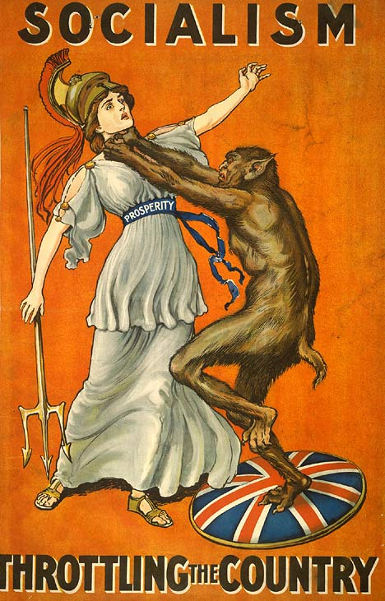
The term ‘socialist’ derives from the Latin sociare, meaning to combine or to share. Socialism arose as a reaction against the social and economic conditions in nineteenth century Europe by the growth of industrial capitalism. Socialists ideas were closely associated with the development of a new, but growing class of industrial workers, who suffered from extreme poverty and degradation.

Socialism analyses society in terms of the distribution of income or wealth and social class is significant in this. Socialism is usually associated with the interests of an oppressed and exploited class and class struggle is the agent of change, even social revolution.

Socialism can be understood in three distinctive ways. From one point of view, is an economic model, linked to collectivisation and planning. Secondly, it represents the interests of the working class and offers a programme through which the workers can acquire political or economic power. However, it is at the third and broader sense of socialism as a political ideology, characterised by a particular set of values that we will focus on. The most significant of these are:

- Community
- Cooperation
- Equality
- Needs
- Common Ownership

Community

At its heart, socialism possess a unifying vision of human beings as social creatures, capable of overcoming social and economic problems by drawing upon the power of the community rather than simply individual effort. They believe that human nature is not fixed at birth, but remains pliable and is moulded by the experiences and circumstances of social life. All human skills and attributes are learnt from society - peoples' behaviour tells us more about the society in which they live than anything else.

Cooperation

Closely linked to the socialist view of community and human nature is the belief that people are naturally inclined to cooperation rather than competition. They argue that competition pits one individual against another and only encourages selfishness and aggression. When people work in cooperation, socialists would suggest, they develop bonds of sympathy, caring, affection and also energises communities. Likewise, Socialists believe that human beings can be motivated by moral incentives and not merely by material incentives. Their belief in cooperation has stimulated the growth of cooperative enterprises that bring mutual benefits to all of the members of an enterprise together.

Equality

A commitment to equality is in many respects the defining feature of socialist ideology, equality being the political value that most closely distinguishes socialism from its rivals. Socialists believe that, human inequality very largely reflects the unequal structure of society. They do not, however, believe that all people are born identical, with the same capacities and skills, but they argue that the most significant forms of human inequality are the result of unequal treatment by society and not from nature. This is why they demand social equality as an essential guarantee that all individuals, not just the privileged, are able to develop themselves to their fullest potential. Equality, enables people to work together cooperatively and harmoniously and removes the resentment, rivalry and social division that social inequality creates. Likewise, equality applies equally to a persons' treatment before the law and in the exercise of political rights. Socialists often see equality of outcome as a positive good, and that courses such as the redistribution of wealth as well as less extreme measures such as progressive taxation are morally good if they achieve equal outcomes.
Needs

‘from each according to his ability, to each according to his need” Karl Marx

Socialists argue that material benefit should be distributed on the basis of need. Needs differ from both wants and preferences: a ‘need’ is a necessity. Needs are object and universal, belonging to all people regardless of gender, nationality, social background etc.. For socialists, ‘needs’ are not only the basic needs of food, water, shelter and so on, but also a range of higher needs, including the need for fellowship and love and the satisfaction that comes from creative labour. Since such needs are the same the world over, material resources should clearly be distributed to meet the basic needs of every person.

This does not, however, mean full redistribution of wealth, as socialists recognise that people would be paid according to their individual contribution and that this would vary according what their contribution was. Socialists would argue, material benefits is only one factor in making people work as there is an important moral incentive, which drives people continue working and help the greater good.

Common Ownership

Socialists trace the origins of competition and inequality to private property, by which they usually mean the ‘capital’ and businesses. They criticise private property for a number of reasons. Firstly, property is unjust: wealth is usually produced by the collective effort of human labour and should, therefore, be owned by the community not individuals. Secondly, private property encourages people to be materialistic. Thirdly, they believe it is divisive as it fosters conflict between owners and workers and employers and employees. Finally, socialists argue that it private property promotes social divisions and selfishness.

There are many different interpretations of how to achieve common ownership. As such, common ownership remains a controversial feature of socialism with some socialists seeing it as an end of socialism itself, others as a means of generating broader equality.

Marx believed that capitalism was system that was riddled with systemic inequality and instability. He argued that the world past through a series historical stages that would eventually led to the highest form of society: communism.

Marx argued for the abolition of private property, which would create a classless society. He believed that property should be owned collectively and used for the benefit of humanity. However, he did not say how this could be achieved.

Task 16- Socialism

- Find a quote from a socialist theorist for each of the values of socialism described above?
- What are the criticisms can be made of socialism?
- Create a socialist propaganda poster showing all that mainstream socialists believe in.

Roads to Socialism

Socialists have very different conceptions of what a socialist society should look like. They also disagree about the way they can achieve socialism. Indeed, the ‘road to socialism’ a group chooses is of crucial importance because it determines the character and form of socialism they introduce.

Revolutionary Socialism

‘Let the ruling classes tremble at a communist revolution’
Karl Marx
Many early socialists believe that socialism could only be achieved by the revolutionary overthrow of the existing political system.

Evolutionary Socialism

‘Democracy is the road to socialism’
Karl Marx
By the late nineteenth century the revolutionary character of the working class had been lost in most of West and Central Europe. The working class had instead started to develop a range of institutions (trade unions, political parties, working men’s clubs etc.) to protect their interests. The gradual advance of democracy led to the extension of the right to vote to the working class which shifted socialist’s focus to a ‘democratic’ evolutionary road to socialism.

Task 17- The Roads to Socialism

- You will be given a selection of Socialist leaders. Which path to socialism did they follow?

Task 18- Ideologies Compared

Compare each of the ideologies on the following areas:

• Freedom
• Human Nature
• Society
• Equality

Set your work out as a table like the example below
(you will need to add more about their views on freedom):

 | Freedom
Liberalism | Give priority to freedom as the supreme individualist value. Classical liberalism supports negative freedom and modern liberalism advocates positive freedom
Conservatism | Have traditionally supported a weak view of freedom. Traditional conservatives view freedom as a negative threat to society. The New Right supports negative freedom in economics, and freedom of choice in the marketplace
Socialism | Understand freedom in positive terms to refer to self-fulfilment.

Essay Questions in this Unit (From Past Papers)

- Compare and contrast the key features of Liberalism and Conservatism, using the works of Locke and Burke.

- Marxism provides an analysis of the state that conflicts with the pluralist model of the state. Discuss.

- To what extent is legitimacy crucial to the distinction between power and authority? You should refer to the works of Lukes and Weber in your answer.

- 'The key features of Conservatism and Socialism are completely different' Discuss using the work of Burke, Marx and Lenin.

- 'Max Weber’s and Steven Lukes’ classifications of types of legitimacy and power are still valid today.' Discuss.

- Compare and contrast the distinctive features of direct and representative democracy using the work of appropriate theorists.

- To what extent does Marxism offer a theory of the state that challenges the pluralist model?

- 'Power, authority and legitimacy are closely linked.' Critically examine this statement, using the work of Lukes and Weber to illustrate your answer.

- Compare and contrast the key features of John Locke’s Liberalism with those of Karl Marx’s Socialism.

- 'The defining feature of the state is sovereignty—its absolute and unrestricted power.' Discuss, using the work of Marx, Lenin and Hobbes to illustrate your answer.
- 'Max Weber’s classification of types of legitimacy is still seen as relevant today but it also has its limitations.' Discuss.

- 'The key elements of Liberalism and Conservatism are very similar.' Discuss using the work of Burke and Locke.

- 'Legitimacy is crucial to the distinction between power and authority.' Discuss, using the work of Lukes and Weber to illustrate your answer.

- Explain the key features of direct and representative democracy, using the work of appropriate theorists to illustrate your answer.

- Compare and contrast the key features of socialism and conservatism, using the work of Marx, Lenin and Burke to illustrate your answer.

- Steven Lukes’ classifications of types of legitimacy, authority and power are far more relevant for the 21st century than those of Max Weber. Discuss.

- Using the works of appropriate theorists, examine the key features of direct and representative democracy.

- Compare and contrast the key features of John Locke’s Liberalism with those of Karl Marx’s Socialism.

