# Dynamics Homework 1

# Average and Instantaneous Speed

1. Explain the difference between average and instantaneous speed.
2. State whether the following are *average speeds* or *instantaneous speeds.*
   1. The speed of train travelling between Glasgow and Paisley.
   2. The speed of a car on a speedometer.
   3. The speed of a roller coaster at bottom of a loop.
   4. The speed of a car between two lamp-posts.
   5. The speed of a golf ball as it leaves the club.

.

1. Describe a method of measuring the instantaneous speed of a trolley in the lab. Your description should include
   1. A diagram of the apparatus
   2. The measurements taken
   3. Any calculations involved.
2. A train leaving Glasgow at 9.00 am arrives in Edinburgh at 10.15 am. The distance is 84 km.
   1. Calculate the average speed in kilometres per hour.
   2. Express the speed in metres per second.
3. A jet travels from London to New York at an average speed of 223 m/s.  
   The flight time is 7 hours.

Calculate the distance travelled by the jet.

1. A student carries out an experiment to measure the instantaneous speed of a trolley using the apparatus shown below.

0.15 s

*light source*

*photocell*

*timer*

*trolley*

The length of the trolley is 30 cm.

The time recorded on the timer is 0.15 s.

Use the measurements to calculate the instantaneous speed of the trolley

# Dynamics Homework 2

# Scalars and Vectors

1. Physical quantities can be categorised as either *scalar* or *vector.*
   1. Describe what is meant by a *scalar* quantity.
   2. Describe what is meant by a *vector* quantity.
   3. Sort the following into a table with the headings *scalar quantity* and *vector quantity.*

force distance displacement velocity speed time

1. During a race, a car makes 25 complete laps of a course of 5 km.
   1. What is the total distance travelled by the car after 25 complete laps?
   2. What is the resultant displacement of the car after 25 complete laps?
2. An athlete runs 8 km due west then turns and runs 6 km due north as shown in the diagram.

000˚

090˚

180˚

270˚

*START*

*FINISH*

8 km

6 km

* 1. What is the total distance that the athlete travelled?
  2. By scale diagram or otherwise, find the resultant displacement of the athlete.
  3. The run was completed in 75 minutes.
     1. Calculate the average speed of the athlete in km/h.
     2. Calculate the average velocity of the athlete in km/h.

# Dynamics Homework 3

# Acceleration

1. State the definition of acceleration.
2. A Ford KA increases its velocity from 2 m/s to 16 m/s in 10s.  
   A Peugot 106 takes 8s to accelerate to 11 m/s from rest.

Show by calculation which car has the greater acceleration.

1. A car slows from 70 mph to 30 mph in 5 s when taking the exit from a motorway.
   1. Calculate the deceleration in mph / s.
   2. If 1 mile = 1.6 km, what is the deceleration in km/h/s?
   3. Calculate the deceleration in m/s2.

1. During a game of ten-pin bowling, a player gives bowling ball an acceleration of 3 m/s2 for 1.2 s.   
   Assuming the bowling ball was accelerated from rest, calculate the final velocity of the bowling ball.
2. A supertanker travelling at 13 m/s decelerates at a rate of 0.03 m/s2. How long does it take to come to a complete stop?
3. A rocket accelerates at 5.2 m/s2 for 10 minutes to reach a final velocity of 6200 m/s. Calculate the initial velocity of the rocket.

# Dynamics Homework 4

# Velocity-time and speed-time graphs

1. The motion of a race car is recorded as follows:

|  |  |  |  |  |  |  |  |  |  |
| --- | --- | --- | --- | --- | --- | --- | --- | --- | --- |
| Time (s) | 0 | 10 | 20 | 30 | 40 | 50 | 60 | 70 | 80 |
| Speed (m/s) | 5 | 5 | 20 | 35 | 50 | 50 | 50 | 25 | 0 |

* 1. Using the graph paper provided, draw a speed time graph of the race car’s journey.
  2. Using the graph you have drawn, describe the motion of the race car over the 80 seconds.
  3. Using the graph you have drawn, calculate
     1. The acceleration between 10 and 40 s.
     2. The total distance travelled by the race car.
     3. The average speed during the 80 seconds.

2. The velocity-time graph shown below describes the motion of a ball which has been thrown straight up into the air then allowed to fall to the ground.

* 1. At what time does the ball reach its maximum height?
  2. Calculate the maximum height that the ball reaches.
  3. Calculate the height from maximum to the ground.
  4. Use your answers to b. and c. to calculate the height above the ground that the ball was thrown from.

# Dynamics Homework 5

# Weight, mass and gravitational field strength

1. Describe how a Newton Balance can be used to measure the size of a force.
2. A student takes two identical pieces of paper. She crumples one into a ball and leaves the other one as a flat sheet.  
   The student then drops both pieces of paper.

Which piece of paper will land first? **Explain your answer.**

1. Mass and weight mean different things.
   1. Explain what is meant by mass.
   2. What are the SI units of mass?
   3. Explain what is meant by weight.
   4. What are the SI units of weight?
2. Define the term *gravitational field strength.*
3. A pupil has a mass of 48 kg.
   1. Calculate the weight of the pupil on Earth.
   2. What would the **mass** of the pupil be on Mars?
   3. Calculate the weight that the pupil would be on Mars where the gravitational field strength is 4 N/kg.
4. A scientist predicts that a person of mass 75 kg will have a weight of   
   780 N on a newly-discovered planet.

Calculate the gravitational field strength of this planet.

# Dynamics Homework 6

# Friction

1. Look at the cyclists in the picture below.

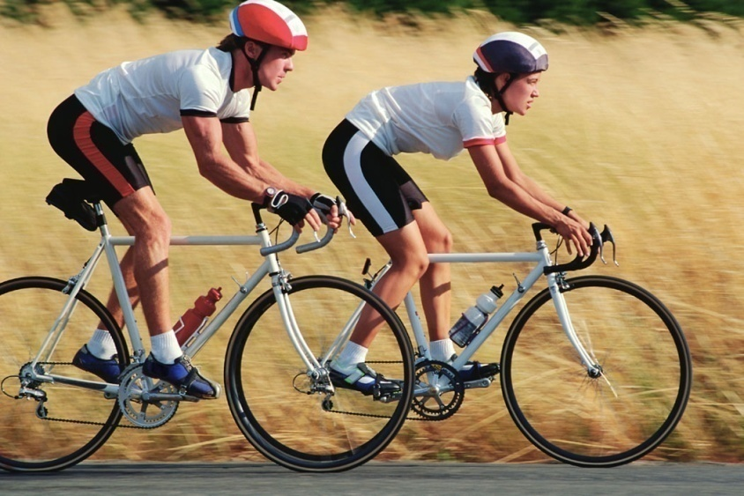

1. Identify **three** ways in which friction acting against the bicycles or cyclists has been reduced.
2. On other occasions, it is useful to **increase** the amount of friction acting.
   1. Identify **two** places on a bicycle where it friction is increased.
   2. For each place, explain why friction should be increased.
3. The cyclists find that as they start off, they can accelerate easily. After a while though, they have to pedal hard just to maintain a constant speed.

Explain why this happens.

# Dynamics Homework 7

# Newton’s First Law

1. Copy and complete the following:

An object will remain at _ _ _ _ or continue to travel at a _ _ _ _ _ _ _ _ speed in a straight line, unless an _ _ _ _ _ _ _ _ _ _ force acts.

Therefore if the forces acting on the object are _ _ _ _ _ _ _ _ then the object will either be _ _ _ _ _ _ _ _ _ _ or will be moving at a  
 _ _ _ _ _ _ _ _ speed.

1. A weightlifter holds a bar as shown.



The mass of the bar is 180 kg.

1. Calculate the weight of the bar.
2. What size of force did the weightlifter apply to raise the bar at a constant speed?
3. What is the size of force that the weightlifter applies to hold the bar stationary?

# Dynamics Homework 8

# Resultant Force and Newton’s 2nd Law

1. A fully laden oil tanker of mass 6.5x107 kg sets off from its port on a bearing of 090°.

Its engine produces a force of 4.0x106 N. A tugboat pushes against the tanker as shown with a force of 3.0x106N.

TANKER

4.0x106 N

engine force

force from tugboat

000˚

090˚

180˚

270˚

3.0x106 N

* 1. Using a scale diagram or otherwise, find the resultant force acting on the tanker.
  2. Calculate the initial acceleration of the tanker.

1. A car of mass 1500 kg accelerates at a rate of 2.3 m/s2.

The engine of the car provides a force of 4000 N.

Calculate the size of the frictional force acting on the car.

1. A firework of mass 0.2 kg provides an initial upwards thrust of 2.8 N.
   1. Calculate the weight of the firework.
   2. Draw a diagram and label the forces acting on the firework.
   3. Calculate the initial acceleration of the firework.
   4. As the firework ascends, its acceleration increases.

Explain why the acceleration increases.

1. The speed-time graph for a sky-dive is shown below:

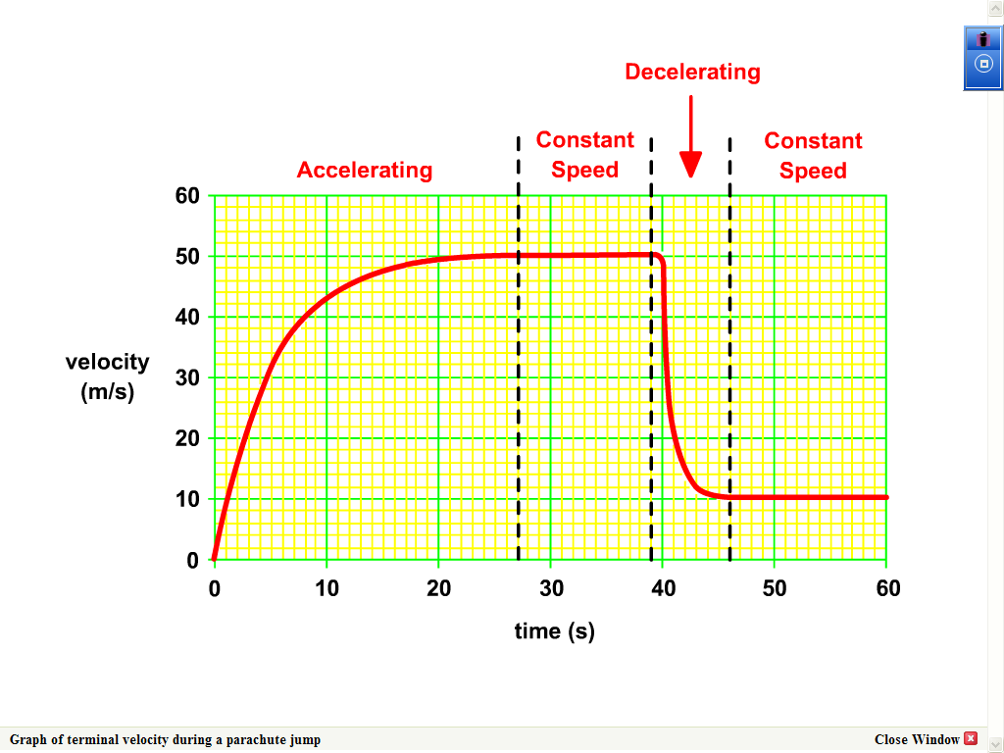

**Speed (m/s)**

1. Explain why the gradient of the graph is decreasing between 0 and 20 seconds.
2. At what time is the parachute opened?
3. What is the name given to the constant velocity reached during free-fall?

# Dynamics Homework 9

# Newton’s Third Law, free-fall and acceleration due to gravity

1. Josie and Kirsty are arguing about how a water rocket water lifts off.



Kirsty

Josie

Dave

Dave knows that what Josie says isn’t true, but Kirsty has not provided a an actual explanation either.

Dave reminds Kirsty about Newton’s Third Law and they both go back and offer an explanation to Josie.

Copy and complete what they say to Josie.

“OK Josie, this is to do with Newton’s Third Law, action and   
_ _ _ _ _ _ _ _ forces. The rocket pushes the water _ _ _ _ _ _ _ _ _, and as a reaction, the _ _ _ _ _ pushes the rocket _ _ _ _ _ _ _ with an   
_ _ _ _ _ sized force “. It has nothing to do with the _ _ _ _ _ pushing on the ground.

1. Show how gravitational field strength and acceleration due to gravity are equivalent.

***(Refer to your notes if you are unsure!)***

1. A student drops a football from above her head.

It lands on the ground 0.63 seconds after being dropped.

Calculate the velocity of the ball at the instant it strikes the ground.

Assume that air resistance is negligible.

1. An astronaut drops a hammer on the Moon where the gravitational field strength is 1.6 N/kg.

The hammer lands on the surface of the Moon 2.1 seconds after being dropped.

* 1. Show that the hammer strikes the surface of the Moon with a velocity of 3.36 m/s.
  2. Draw a velocity-time graph for the hammer as it falls.
  3. Use the graph to calculate the height that the hammer was dropped from.

# Dynamics Homework 10

# Energy, Work and Power

1. In each of the cases below, state the **main** energy change involved for the vehicle.

(a) A rollercoaster carriage rolling up a slope to a high point. (1)

(b) A skier skiing down a slope. (1)

(c) A bus driving along a level road at a constant speed. (1)



2. (a) What is work done? Your answer should

**not** be an equation!

(b) Calculate the work done by a horse when it uses a force of 800 N to pull a sled a distance of 150 m

3. Copy and complete the table below. You must show full calculations for each problem.

|  |  |  |
| --- | --- | --- |
| Power(W) | Work Done(J) | Time(s) |
|  | 400 | 4 |
|  | 1000 | 0.5 |
| 30 |  | 10 |
| 100 |  | 60 |

1. A roller coaster carriage has a mass of 300 kg when it is carrying a full load.
2. Calculate the potential energy of the carriage when it is at the top of a drop, 30 m above the ground.
3. At the bottom of the drop it is at a height of 2 m above the ground. Calculate its potential energy now.
4. Calculate how much kinetic energy the carriage will have at this point. (1)
5. A winch pulls a crate up to a height of 4 m in a time of 20 s. If the crate has a mass of 100 kg, find the power of the motor.

4 m

100 kg

1. Name two quantities that affect a vehicle’s kinetic energy.
2. Find the kinetic energy of a car of mass 800 kg travelling at 30 m/s.

# Dynamics Homework 11

# Projectile Motion

1. A javelin is launched horizontally at 5 m/s. It lands 15 metres horizontally from its launch point.

5 m/s

C:\Documents and Settings\ispencer\Local Settings\Temporary Internet Files\Content.IE5\DZOYQHH4\MC900191827[1].wmf

15 metres

* 1. Calculate the time that the javelin is in the air for.
  2. Calculate the final vertical velocity of the javelin.
  3. Using a scale diagram or otherwise, find the size of the **final resultant velocity** of the javelin **and** the angle of impact.

1. A ball rolls off a table top with a horizontal speed of 2.0 m/s.

The ball hits the ground 0.3 seconds later.

* 1. Calculate the horizontal distance that the ball lands from the table top.
  2. Calculate the final vertical speed of the ball.
  3. Sketch a velocity-time graph of the vertical motion of the ball.
  4. Use the graph to find the height of the table.

1. Explain how an artificial satellite such as the International Space Station remains in orbit around the Earth.

# Dynamics Homework 12

# Space Exploration

1. We now have evidence to support the Big Bang Theory.
   1. State **two** pieces of evidence that scientists have provided that support the Big Bang Theory.
   2. Provide a description of how each piece of evidence supports ideas in the Big Bang Theory.
2. Various Technologies that were originally developed in space exploration programmes has proved to be useful in everyday life.
   1. Write down one technology that was originally developed for a space programme that is now used in everyday life.
   2. Describe briefly how the technology benefits society.
3. During re-entry to the Earth’s atmosphere, a spacecraft will undergo a considerable increase in temperature.
   1. What causes this increase in temperature?
   2. In spacecraft design, particular attention must be paid to the features of the heat shield material used.
      1. From the list below, select **two** features of a heat shield that will help to protect the spacecraft.

***Low specific heat capacity***

***High specific heat capacity***

***Black in colour***

***White in colour***

***Thick***

***Thin***

***Large surface area***

***Small surface area***

* + 1. For each feature that you chose, explain how it protects the spacecraft.

1. A heat shield on a spacecraft has a mass of 70 kg.

The spacecraft is travelling at 900 m/s. On re-entry into the Earth’s atmosphere, the velocity of the spacecraft is reduced to 250 m/s.

1. Calculate the change in kinetic energy of the heat shield.
2. Calculate the change in temperature of the heat shield. (Assume all of the kinetic energy is changed to heat in the heat shield material).

*(Specific heat capacity of heat shield material = 980 J/kg°C)*

1. A solid heat shield is being tested that will melt on re-entry.
   1. Explain why it is a good idea for the shield to melt.
   2. The following data is provided about the heat shield material.

***Specific Heat Capacity: 880 J/kg°C***

***Melting point: 900 °C***

***Specific latent heat of fusion: 500 J/kg***

***Mass of heat shield material: 90 kg***

* + 1. Calculate the energy absorbed by the heat shield when its temperature is raised from -10 °C to the melting point on re-entry.
    2. Calculate the energy absorbed by the heat shield as it melts.
    3. Use your answers to calculate the total amount of heat energy absorbed by the heat shield.

# Dynamics Homework 13

# Cosmology

1. An astronomer views the following objects in the night sky:

Jupiter, which orbits the Sun;

Europa, which orbits Jupiter;

the Andreomeda Galaxy.

* 1. Which of the objects mentioned is a moon?
  2. Which of the objects mentioned is a planet?
  3. Which of the objects mentioned is a star?

1. Cosmologists use “light years” as a unit of distance.
   1. Calculate the number of metres in 1 light year.
   2. The Leo A Galaxy is 2.25 million light years from the Earth.

Calculate this distance in metres.

1. Scientists searching for exoplanets use the Astronomical Unit. 1 A.U. is the distance from the Sun to Earth.

The “Habitable Zone” is the range of distances from a star which could be suitable for a planet to support life.

If the planet is orbiting a star which is much twice as luminous than the Sun:

* 1. Provide an estimate of the distance that the planet would have to be from the star in Astronomical Units.
  2. Provide a reason for your answer.

1. White light is part of the electromagnetic spectrum – a family of radiation waves with different wavelengths.
   1. List all of the members of the electromagnetic spectrum, from shortest wavelength to longest wavelength.
   2. What property do all of the members have in common?
   3. White light can be split into different colours.

X

Y

Z

* + 1. What is the name of the glass block shown that splits the white light into different colours?
    2. Name another piece of equipment that can be used to split light into different colours.
    3. Which of the colours blue, green and red are seen at each position X, Y and Z?
    4. The same device can be used to analyse light from a star.

What information can be obtained from this analysis?

# Answers to Numerical Problems

## Exercise 1

4. (a) 67.2 km/h

(b) 18.67 m/s

5. 5.62x106 m

6. 2 m/s

## Exercise 2

2. (a) 125 km

(b) 0

3. (a) 14 km

(b) 10 km, 307°

(c)(i) 11.2 km/h

(ii) 8 km/h, 307°

## Exercise 3

2. KA: 1.4 m/s2

P106: 1.375 m/s2

KA has the greater acceleration

3. (a) deceleration: 8 mph/s

(b) deceleration: 3.56 m/s2

4. 3.6 m/s

5. 433 s

6. 3080 m/s

## Exercise 4

1. (c)(i) 1.5 m/s2

(ii) 1925 m

(iii) 24.1 m/s

2. (b) 5 m

(c) 7.2 m

(d) 2.2 m

## Exercise 5

5. (a) 480 N

(c) 192 N

6. 10.4 N/kg

## Exercise 7

2. (a) 1800 N

## Exercise 8

1. (a) 5x106 N (053°)

(b) 0.08 m/s2

2. 550 N

3. (a) 2 N

(c) 4 m/s2

## Exercise 9

3. 6.3 m/s

4. (a) 3.36 m/s

(c) 3.5 m

## Exercise 10

1. (a) 3.0 s

(b) 30 m/s

(c) 30.4 m/s, 80.5° below horizontal

2. (a) 0.6 m

(b) 3.0 m/s

(d) 0.45 m

## Exercise 11

4. (a) Change in Ek­ = 2.616x107 J

(b) 889.8 °C

5. (b) (i) 72,072,000 J

(ii) 45,000 J

(iii) 72,117,000 J

## Exercise 12

2. (a) 9.47x1015 m

(b) 2.13x1022 m