Actos de Bondad- S4
This week we are looking our focus as part of Mental Health Awareness week is Kindness.
Task 1: Look at the list of suggested acts of kindness. Try to translate them into English
You will see they all start with an infinitive of a verb ( the part in the dictionary which means ‘to do something’. Note this verb in your jotter with the English translation.
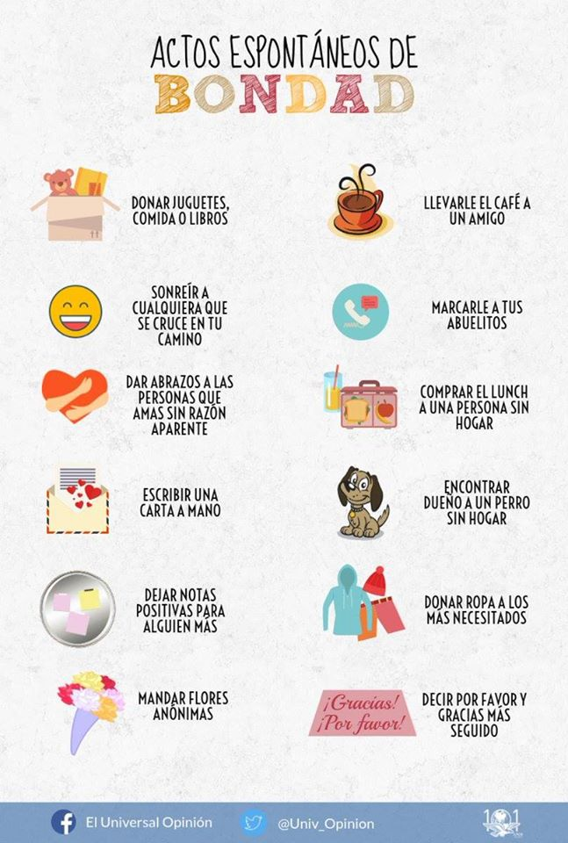
Task 2: Now look at the picture below- this time in English. Can you pick any three of these and put them into Spanish? Remember to start them with an infinitive!
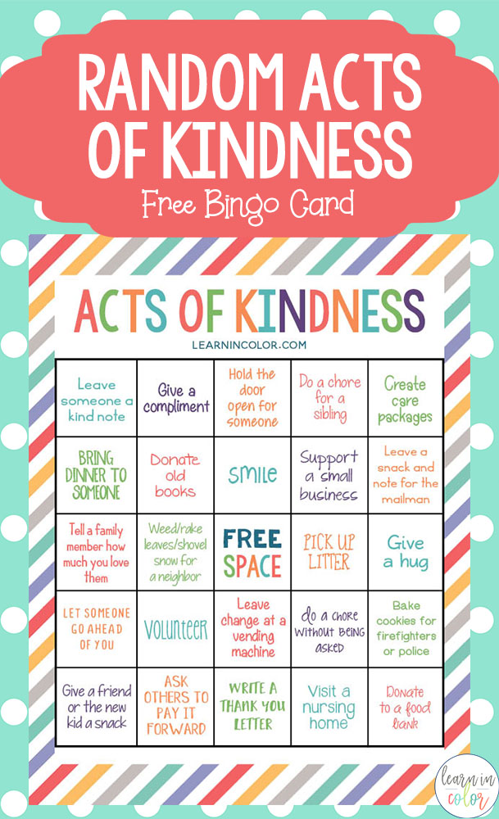

Task 3: Now make up at least one other sentence of your own. Write it in Spanish and commit do doing it this week!

