Cardinal Newman High School

Introduction to

Higher Politics

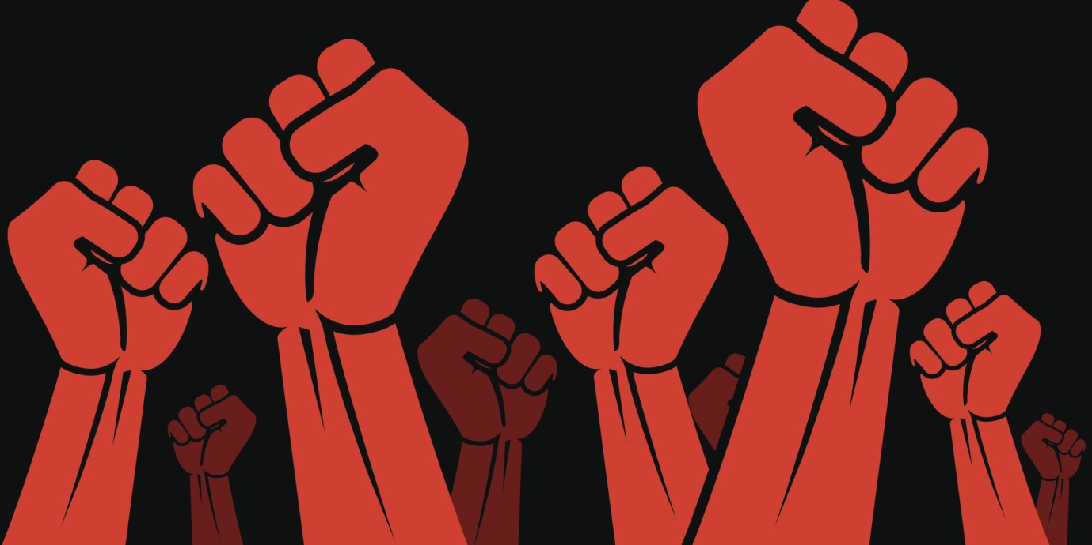

Distance Learning:

Power and Democracy

**What is Power?**

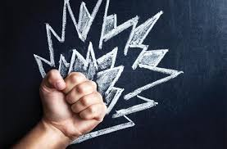

Power can be defined simply as the ability to get someone to do something that they wouldn’t otherwise do.

We are all influenced by power. When you were first born, your parents controlled everything for you. They decided what you were going to eat, when you would be put to bed, who would look after you and when. You might have wailed and bawled when you were put in your cot or dropped off at nursery but you had no choice – they were the supreme power affecting your life.

Now you are a teenager, you will have more power over your own life. You may well be in the position of rebelling against some of the powerful forces which do control what you do! That’s part of becoming an adult – feeling more independent and in control – able to make your own decisions.

However, it’s not as simple as that. You will be subject to powerful forces throughout your life, as are people all across the world. Throughout Higher Politics, we will consider what these forces are, how much influence they have and how they can be constrained or influenced by us.

**Activity**

Over the page there are images of several powerful people and organisations. Think about each one and note down:

* What power they have
* How they gained their power
* Whether their power affects your life in any way

1. Donald Trump

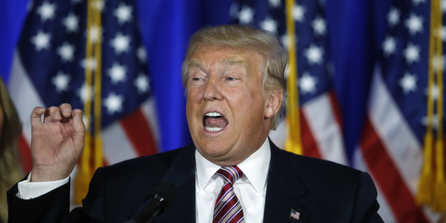

1. Nicola Sturgeon

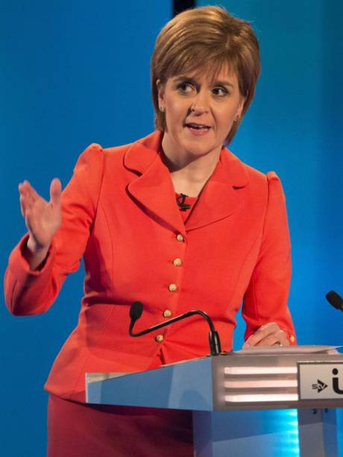

1. Simon Cowell

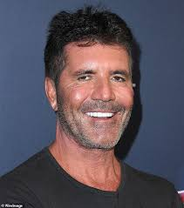

1. Mark Zuckerberg

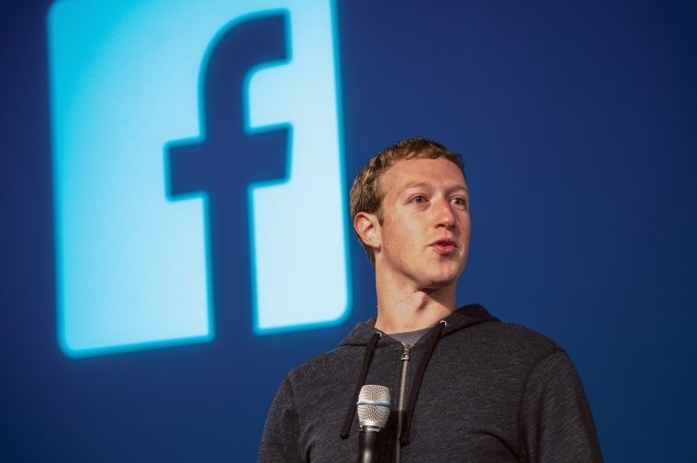

1. Kim Jong Un

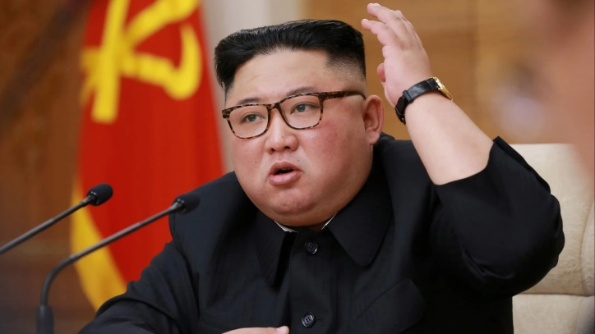

**Power, Authority and Legitimacy**

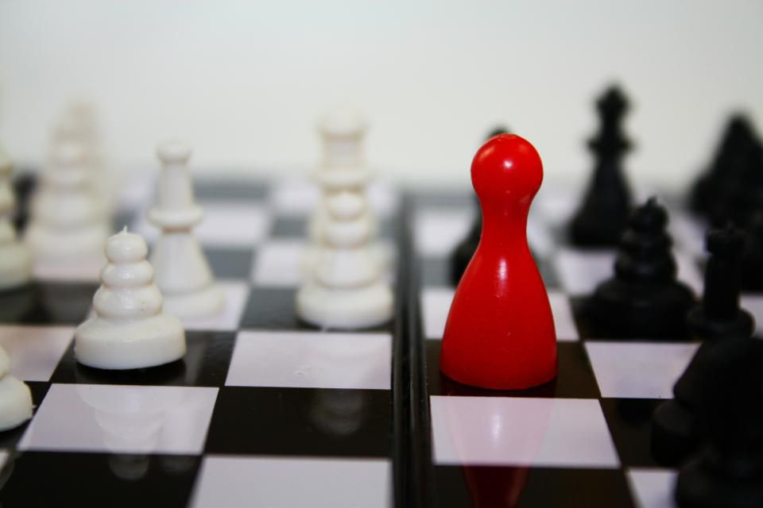

In the Higher Politics course, we will look closely at the concepts of Power, Authority and Legitimacy in order to assess how leaders get their power, why some keep it more readily than others and why challenges to this power are sometimes successful and sometimes not. Broadly, we can define these terms as follows:

**Power** – the ability to control and influence what others do

**Legitimacy** – being seen to have the ‘right’ to rule

**Authority** – having power *with* legitimacy. IE – being seen to be in control and have the right to be so.

Someone can have power without legitimacy – eg when the US invaded Iraq in 2003, they quickly took control of much of the country due to their superior military strength. However, they weren’t seen as legitimate, or rightful rulers by many of the citizens, so faced many protests and challenges to their authority.

Someone can have legitimacy without power – eg Aung San Su Kyi of Burma (Myanmar) was democratically elected leader but put under house arrest by China for many years so she was not able to run her country.

It is generally accepted that leaders must have authority – power *and* legitimacy – if they are going to be able to run their countries without significant challenge or rebellions.

However, this is still not simple as that ‘right to rule’ can be defined differently in different parts of the world.

For example, most people in Britain would be horrified if a popular leader (imagine Nigel Farage for instance) – suddenly declared themselves Prime Minister without an election. We are a democratic country and power lies with being elected through democratic means. The theorist Weber defines this as ‘**legal-rational authority’**. It is clear, open, and people can easily understand and use their rights to vote, stand for election, support parties etc.

However, approximately 40% of the world’s countries are not democracies.

In monarchies (where there is a hereditary queen/king), the rulers can still have authority if their leadership is accepted by the populace and seen as rightful. Weber calls this ‘**traditional authority.** Note that our Queen cannot be seen as an example of this as she has no real political power.

In dictatorships (where a popular leader/party rules and the public cannot remove them), rulers often establish their authority initially through their own skills and abilities – people believe in them and want to follow them. They are therefore effectively given the right to rule through the popular support of the people – expressed perhaps in big rallies rather than elections. Weber calls this ‘**charismatic authority’**. Of course, sometimes dictators who are initially popular lose the support of their people. This lessens their authority and makes them open to more challenges and rebellions – but it doesn’t necessarily mean they will be removed.

It is of course possible for a democratically elected leader who has legal-rational authority ***also*** to have charismatic authority by virtue of their personality and leadership skills. JFK would be a good example of this. However, some people argue that this is not necessarily a good thing – it can be dangerous if a leader starts to become too popular as they may have the support to challenge the democratic structures of their country and the limits placed on their power. In this way, a country can move from being a democracy to a dictatorship. Arguably Russia is in this position now with Putin.

**Activities:**

1. Summarise the differences between Power, Legitimacy and Authority
2. Explain Weber’s three types of Authority, giving examples.

**Types of Power**

We’re going to look further now at the examples of powerful people that you just considered.

As you can see from these examples, people hold power for different reasons.

**Political power - democracies**

Some people hold power because they have been elected to represent others and make decisions on their behalf. For example - politicians such as Donald Trump and Nicola Sturgeon who have been voted into positions of power by the people of their country. This is how political power works within a **democracy**. They are given **legitimacy** as leaders as they have been elected via an established process which is accepted by the electorate. This gives them **legal-rational authority**. This legitimacy only tends to be questioned when the election process used is seen to be flawed in some way. For example, when George W Bush was elected US President in 2000, there were allegations that many black voters in Florida (where his brother was Governor) had their votes disallowed due to problems with the ballot system (google ‘hanging chads’ for more info). This led to protests that he had not won the election fairly and could not be seen as a legitimate President. However, his opponent, Al Gore, conceded the election to him after the Supreme Court decided 5/4 in favour of his Presidency. This again gave him legitimacy and he was accepted as the democratically elected President by the bulk of the electorate.

**Watch – ideally the film ‘Recount’ if you can find it online without paying!**

**Alternatively – this short documentary from the New York Times:**

<https://www.youtube.com/watch?v=z3os_Vw1Eoo>

**Political power - dictatorships**

Other people hold power because they have forcibly taken it or have inherited it from their family. Those who have forcibly taken their power usually have **charismatic authority** – essentially people follow them because they are able to inspire and lead the masses. The likes of Hitler, Stalin, Mussolini could all be seen as examples of this, as well as charismatic dictators further back in history such as Napoleon. Once in place, these dictators often establish themselves as the founders of a hereditary dictatorship, essentially working like a monarchy. For example – Kim Jong Un holds power in North Korea as his grandfather won the civil war and passed his power down to him. Cuba’s dictator, Fidel Castro, has also passed power to his brother Raul. Similarly, the Communist Party in China took power in an armed revolution in 1949 under their charismatic leader Chairman Mao and have held it ever since, with their leader automatically becoming ruler of China.

In the case of all of these countries, the leaders are seen to have legitimacy not because they have been **elected** by the people, but because their authority has been **accepted** by the majority of the people. Those who do not accept it also do not have the means to challenge it in any significant way. This is how political power works in a **dictatorship.** Any challenges to the authority of the dictator/monarch will be brutally dealt with. Getting rid of them requires mass uprising as well as the ability to challenge their military power. Throughout history we can see that dictators are rarely removed in any peaceful way and it is very difficult to make the transition from a dictatorship to a democracy.

Watch these programmes on the Arab Spring 2011 and take notes – they show how difficult it is for countries experiencing dictatorship to change this – even in the present day when protests are arguably easier to organise:

**BBC (2011) – How Facebook changed the World – The Arab Spring:**

<https://www.youtube.com/watch?v=VCdIOch2970>

**Power within organisations**

Some people hold power because they have worked hard and been recognised as having valuable skills which have resulted in them being appointed into positions of power within an organisation. For example, Ms Mitchell started as a teacher at Rosshall, did a good job and was promoted to Faculty Head, then DHT and finally Headteacher. Similarly, Steven Gerrard was appointed Rangers manager due to his previous record at Liverpool. These people will have defined limits to their power – a job description that sets out what they are responsible for. Again, they are seen as being legitimate leaders due to having gained their power through a process that is legal and accepted by the public – they have **legal-rational authority**. If, for example, a person was alleged to have been appointed to a position because of favouritism or racism/sexism, there would be established legal means to challenge the appointment.

**Power of wealth and business**

Others hold power because they have set up their own business and made profits, or have inherited wealth. Wealth gives people power and influence in society as many others may depend on them – for example for jobs. For example, Mark Zuckerberg’s Facebook corporation employs over 35,000 people, has over 2.3 billion monthly users and is worth over $84 billion. He is a self-made millionaire, but not all business owners are. For example, Charlene Heineken is the 6th richest person in Britain. She inherited her share of Heineken, the world’s largest brewers, through her family and is worth £11.1 billion. The super wealthy are a relatively new, and growing, phenomenon. Many would argue that these unelected people pose a significant threat to **all** established forms of government – whether democratic or undemocratic.

**Power of influence**

Some people are able to influence us because we look up to them or respect what they have to say. For example, the singer Taylor Swift has successfully campaigned to encourage young people to use their vote in the USA. She gets media coverage as she’s famous and popular.

The media can also influence what we think about certain issues by giving us information, or disinformation. Media owners such as Rupert Murdoch, who owns Sky News, Fox News, the Times and the Sun newspapers have a huge influence on the stories and messages that go out to us. The way we are targeted through social media has also been an issue recently as there have been accusations that ‘dark ads’ and targeting of information via Facebook may have influenced the US elections and Brexit vote. Mark Zuckerberg was hauled in front of the US Congress and UK Parliament to account for Facebook’s actions in this.

**Activity:**

Using a double page of your jotter, create a mind map which describes the 5 different types of power outlined above. For each one, give at least two examples.

**Political Power in a Democracy**

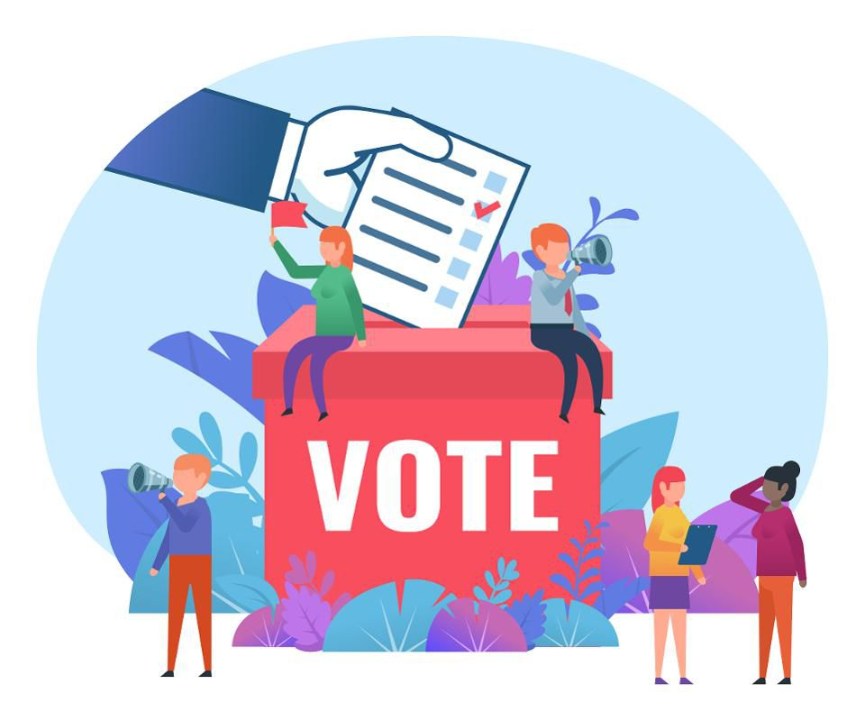

Democracy means ‘rule by the people’. The people of a country are usually known as its citizens (though technically in the UK we are not citizens but subjects of the Queen!). Countries which are democracies have the following features:

* Citizens (once they become adults) can vote in elections for people to represent them
* These representatives have defined powers and there are **limits** to these powers
* Citizens can join political parties and can stand for election themselves
* Citizens are free to join campaign or pressure groups and to protest
* Citizens are free to have their say and there are few restrictions on freedom of speech or the media

Two good examples of democracies are the USA and UK. We will consider some of the similarities and differences between them.

**Power in the USA**

In the USA there are 3 different branches of Government. It was designed this way by the Founding Fathers so that no one branch would be able to have too much power. The powers of each branch are clearly set out in the US Constitution and the rights of citizens are set out in the Bill of Rights.

The following diagram shows the different branches:

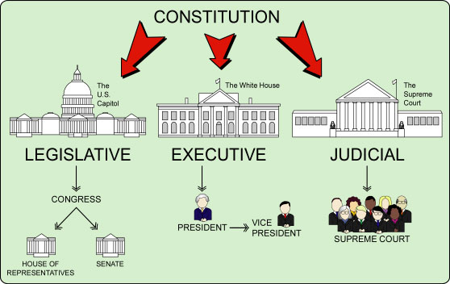

**How it works**

Congress is responsible for passing laws. There are two parts to Congress – the House of Representatives and the Senate, and representatives are voted onto these through elections. The President is elected separately through a nationwide election. When Congress pass laws, the President usually signs them and is then responsible for making sure they are acted upon. If the President doesn’t agree with a law that Congress has passed, he can veto it – which means it doesn’t go ahead. The Supreme Court make sure that any laws or actions taken by the President don’t go against the rules set out in the US Constitution – if they do, the Supreme Court can strike them down.

**What power does the President have?**

Executive power in the USA is held by the President. President Trump is a very powerful man. He is Commander in Chief of the US Armed Forces and has control of the ‘nuclear button’. He is very influential over the world. However, his power within his own country is limited by the Constitution. He cannot pass laws – he has to rely on Congress to do this and they don’t always agree with him. For example, the rival Democrat Party in the House of Representatives has blocked his attempts to get funding for his Wall.

**Power in the UK**

In the UK, there are also different branches of Government. When making laws for the whole UK, they must be voted upon and passed in both the House of Commons and the House of Lords. These institutions make up the UK Parliament, known as Westminster.

The House of Commons is made up of MPs, who are voted in every 4-5 years in a General Election. The House of Lords is made up of peers, who are unelected. Officially, laws also have to be passed by the Queen – this is known as giving ‘Royal Assent’.

The Government is usually made up by the political party which has the most MPs after a General Election. Their leader becomes the Prime Minister.

**What power does the Prime Minister have?**

Executive power in the UK is held by the Prime Minister. In some ways the Prime Minister has more power than the President. The Prime Minister is usually the leader of the largest party in the House of Commons. If that party have a majority (more than half) of the MPs, then it is easy for them to get the laws passed that they want, as long as they are able to get their own MPs to vote for them.

However, if the Prime Minister does not have a majority of MPs, or their own party disagrees with them, this makes it difficult to get laws passed. This happened with Brexit as PM Theresa May did not have a majority Government and many of her own MPs disagreed with her.

It can also be argued that the Prime Minister does not have so much power as the US President as the UK is a smaller and less wealthy country and doesn’t have the same influence over world trade or military power.

**Activities:**

1. List the five main features of a democracy
2. Describe which institutions in the USA have the power to make laws
3. What can the President do if he doesn’t agree with a law?
4. What is the Supreme Court’s role in law-making?
5. What powers does the US President have?
6. What are the limitations on the powers of the President?
7. Describe which institutions in the UK have the power to make laws.
8. How is the Government chosen in the UK?
9. Why do some people think that the UK Prime Minister is more powerful than the US President?
10. Why did PM Theresa May find it difficult getting Brexit passed?
11. Why do some people argue that the US President is more powerful than the UK Prime Minister?

‘As democracy is perfected, the office represents, more and more closely, the inner soul of the people. On some great and glorious day the plain folks of the land will reach their heart’s desire at last, and the White House will be adorned by a downright moron.’

[H. L. Mencken](https://en.wikiquote.org/wiki/H._L._Mencken), “Bayard vs. Lionheart,” *Baltimore Evening Sun* (26 July 1920)

What do you think Mencken means by this quote? Put it in your own words. Is it relevant today?

Do you agree with this statement by President FD Roosevelt? Can you think of any examples from politics today which might support it?

**The Media in a Democracy**

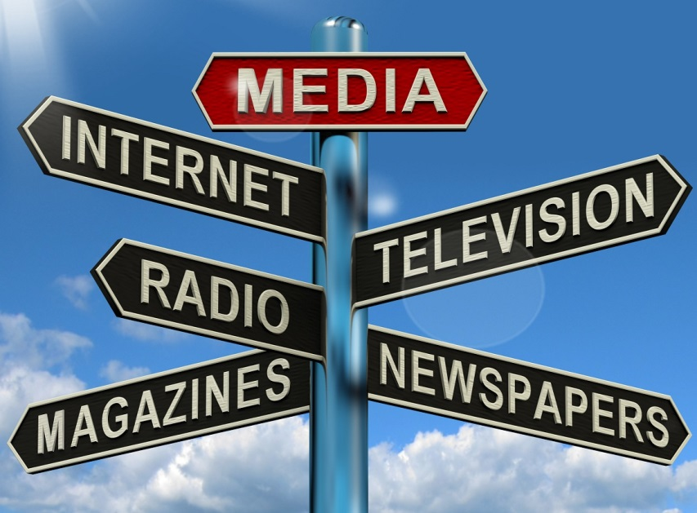

We find out most of our information about politics (and, indeed, everything!) through the media. Common media sources include TV, newspapers, radio, internet and social media.

A free and open media is a crucial part of a democracy. It should inform us about what is going on and hold our politicians and Government to account by showing us when they get it wrong. For example, the Telegraph newspaper carried out an investigation into MPs expenses in 2009 which exposed corruption and greed and led to some MPs being charged with criminal offences. This would never have happened in a country where the media was controlled by the Government.

The media is also there to inform and educate us. For example, people wanting to know which way to vote during the Brexit referendum would have read and listened to information on the pros and cons of leaving the EU before making their decision.

**Is the media good for democracy?**

Whether the media is **good for** democracy depends largely on two things:

* The quality of the information we get from media sources and whether it is accurate or gives a biased view
* Our own ability to detect whether we are being given fact or opinion

The first of these can be subject to some Government controls, though the increasing reach of unregulated or less regulated social media can make quality information more difficult to find.

The second depends on citizens developing the types of analytical skills we promote right through your social subjects’ courses. If most people in a country do not have these skills, democracy will be in danger.

**Government controls on the media**

In the UK, there are only a few restrictions on the media. They must not slander individuals (say untrue things about them) or they may face court action and have to pay expenses. They may not incite racial or religious hatred – this would be a criminal offence. However, other than this – they have free reign to say what they like. Some would argue that this is a good thing as the media are free and outwith Government control. However, as most of our media is owned by rich individuals or big businesses, the newspapers and TV stations owned by them will tend to represent their views. For example, Rupert Murdoch’s Sun and Times newspapers both show clear support for the Conservatives over the Labour Party. In the US there are even less restrictions on the media as Freedom of Speech is protected within the First Amendment of the Bill of Rights.

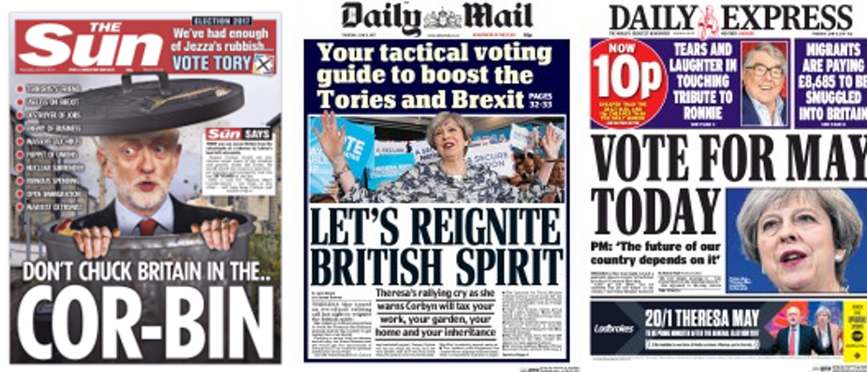

Social media has generally been thought of as good for democracy as anyone can post their views and share them – you don’t have to own or work for a newspaper to have your opinions read and shared by thousands of people. Pressure groups and campaigners have been able to use social media to organise protest – for example the #metoo movement.

However, there have been instances recently where social media has been used in a secretive way by powerful interests to influence citizens and potentially to affect elections. This has the potential to damage democracy.

**Questions**

1. Explain why a free and open media is important within a democracy
2. Give an example of when the media has been used to hold politicians to account for their actions
3. What restrictions are there upon the UK media?
4. Why are there fewer restrictions upon the US media?
5. Why might some people argue that social media is good for democracy?
6. Why might some people argue that social media can be bad for democracy?

# Control of Data – a new threat to Democracy?

# 

# Over the last ten years, people around the world have significantly increased the time they spend online. It is now common to do internet shopping, banking and to communicate with contacts via social media. Every time we access a website, we give this site some of our data. Using sites such as Facebook with a ‘user profile’ gives that site a huge amount of information on us- our likes, dislikes, photos, contact info, location, friends list etc. Those who have access to this data can then target us with adverts of all kinds. It can be argued that those who have access to our data have huge power to influence us – including influencing our political decisions. This potentially threatens democracy – which depends on informed citizens being able to make reasoned decisions.

# Activity 1:

# Who has your data? BBC Click 12th April 2018

# <https://www.youtube.com/watch?v=W3cqNHwIPjY> – first 8 minutes

# Watch the clip and answer the following questions:

# Why do we let Facebook and Amazon access our personal data?

# How do the analysts use Facebook data to find out about people’s personalities?

# How did Cambridge Analytica’s use of data influence the US Presidential election?

# How do Facebook collect data on people who don’t have Facebook accounts?

# Jean-Olivier says that current rules and regulations are not being enforced. Why does he think this is?

# Source Exercise

# A picture containing object, clock, monitor Description automatically generatedWatch: <https://www.youtube.com/watch?v=vhojV1dVrB0>

# The Guardian – 17/12/18

# Russian propagandists targeted African Americans to influence 2016 US election

[Jon Swaine](https://www.theguardian.com/profile/jon-swaine) in New York

[[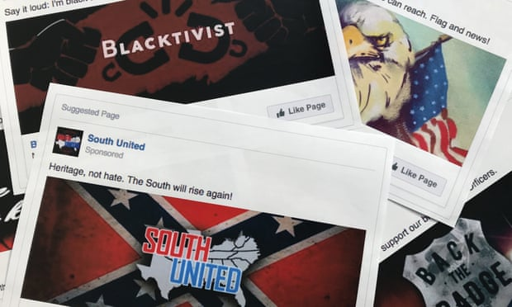](https://www.theguardian.com/us-news/2018/dec/17/russian-propagandists-targeted-african-americans-2016-election#img-1)](https://www.theguardian.com/us-news/2018/dec/17/russian-propagandists-targeted-african-americans-2016-election" \l "img-1)

Some of the Facebook ads linked to a Russian effort to disrupt the American political process during the 2016 election campaign. Photograph: Jon Elswick/AP



Russian online [propagandists](https://www.theguardian.com/technology/2017/oct/02/facebook-says-up-to-10m-people-saw-ads-bought-by-russian-agency) aggressively targeted African Americans [during](https://www.theguardian.com/technology/2017/oct/22/facebook-google-twitter-congress-hearing-trump-russia-election) the 2016 US election campaign to suppress votes for Hillary Clinton and help Donald Trump, according to new research.

Analysts found that Russian operatives used social media to “confuse, distract, and ultimately discourage” black people and other pro-Clinton blocs from voting, using bogus claims such as Clinton receiving money from the Ku Klux Klan.

Black turnout declined in 2016 for the first presidential election in 20 years, according to [the US census bureau](http://www.pewresearch.org/fact-tank/2017/05/12/black-voter-turnout-fell-in-2016-even-as-a-record-number-of-americans-cast-ballots/), falling to less than 60% from a record high of 66.6% in 2012. Exit polls indicated that black voters strongly favoured Clinton over Trump.

The new findings on the secret activities of the [Internet Research Agency](https://www.theguardian.com/technology/2017/dec/22/facebook-tool-russia-troll-army-internet-research-agency) (IRA), known as the Russian government’s “troll factory”, were revealed on Monday in a pair of reports to the US Senate’s intelligence committee. One was led by experts from Oxford University and the other by New Knowledge, an American cyber security firm.

New Knowledge said [Russia](https://www.theguardian.com/world/russia) had waged a five-year “propaganda war” against the US public. The Oxford researchers said that while the propaganda was meant to “push and pull” Americans in different directions, “what is clear is that all of the messaging clearly sought to benefit the Republican party – and specifically, Donald Trump”.

Both reports faulted the major social media companies – [Facebook](https://www.theguardian.com/technology/facebook), [Twitter](https://www.theguardian.com/technology/twitter) and [Google](https://www.theguardian.com/technology/google) – for what they said were ongoing failures to turn over exhaustive data to US authorities investigating the Russian campaign. They said some executives had “misrepresented or evaded” and “dissembled” in statements to Congress.

Mark Warner, the committee’s senior Democrat, said new laws were needed to tackle a crisis around social media. “These attacks against our country were much more comprehensive, calculating and widespread than previously revealed,” said Warner.

More than a dozen Russians have been criminally [charged](https://www.theguardian.com/us-news/2018/feb/16/robert-mueller-russians-charged-election) with hacking and other online activity by special counsel [Robert Mueller](https://www.theguardian.com/us-news/robert-mueller) and other US prosecutors [investigating](https://www.theguardian.com/us-news/trump-russia-inquiry) Moscow’s interference in the 2016 campaign.

The new reports said that while it was well known that Russian trolls flooded social media with rightwing pro-Trump material, their subtler efforts to drive black voters to boycott the election or vote for a third-party candidate were underappreciated.

One popular bogus Facebook account created by the Russians, Blacktivist, attracted 4.6 million “likes”. It told followers in the final weeks of the campaign that “no lives matter to Hillary Clinton”, that black people should vote for the Green party candidate, Jill Stein, and that “not voting is a way to exercise our rights”.

New Knowledge said the social media propaganda campaign should be seen as the third front in Russia’s interference in the 2016 election, together with the hack and theft of Democratic party emails that were passed to WikiLeaks, and the attempt to hack online voting systems across the US.

**Questions:**

1. In what ways did the Russian ‘Internet Research Agency’ discourage African Americans from voting for Hillary Clinton in 2016?
2. What happened to black American voter turnout in 2016 and why might this have affected the election result?
3. Why have Facebook, Twitter and Google been criticised over this?
4. Why does Mark Warner think new laws are necessary?
5. What was ‘Blacktivist’ and what did it do?
6. What else do New Knowledge say Russia did to influence the election?

**Extension:**

 The USA prides itself as being the foremost democracy in the world. Do you think the Presidential Election in 2016 was a successful example of democracy in action? Explain your answer.

**Political Power in a Dictatorship**

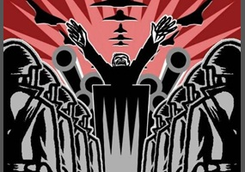

Dictatorships are countries where power is concentrated in the hands of one person or a small group of people. In dictatorships, citizens of the country do not have a say over who represents them. Dictatorships usually have the following features:

* Citizens have no real ability to change who is in power. They may have the ability to vote in elections but do not have a free choice of candidates.
* Power is often taken by the leader in an armed struggle or revolution and may be passed down from the leader to a chosen successor, without the say of the people
* Freedom of speech and protest are restricted
* The media is controlled by the Government and/or there are major restrictions on what can be published
* There are serious punishments for those who challenge the authority of the leader or Government

40% of countries around the world are dictatorships. However, there can be a fine line sometimes between democracy and dictatorship. For example, Russia see themselves as a democracy but many people would argue that the way President Putin manipulates the media and puts restrictions on his opponents means that it has more of the features of a dictatorship.

**A Dictatorship in Focus: North Korea**

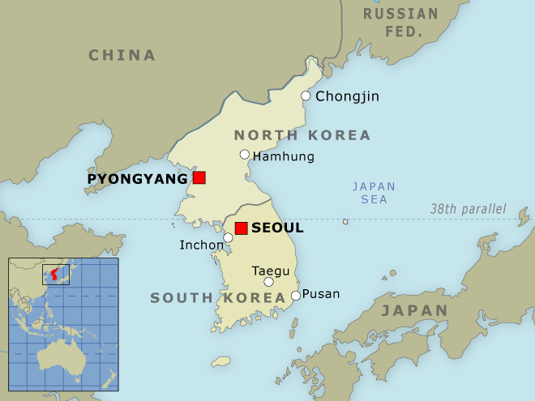

North Korea is the most secretive and authoritarian country in the world. Officially known as the Democratic People’s Republic of Korea, it split off from South Korea following the Second World War and became a Communist country.

Communism (sometimes known as collectivism) is a system of Government in which all property is owned by the community (or state) and each person contributes and receives according to their ability and needs. The term was first discussed in Karl Marx and Friedrich Engel’s Communist Manifesto, published in 1848. They believed that ordinary workers were being exploited under capitalism and there was a need for them to rise up, abolish private business and establish a fairer – ‘Communist’ system.

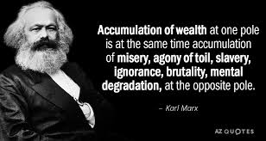

Under Communism there is no private business, everyone works in a job where the profits go to the community. They are then paid equally, housed equally and have their needs for things like healthcare, education and pensions met by the state. This is seen to be a **socialist** system – for the benefit of ordinary people rather than for private profit. Theoretically, there should be no inequality under Communism. However, no Communist state (Cuba, China, North Korea or the old Soviet Union) practices a ‘pure’ form of Communism. There is still some inequality, though arguably less than in capitalist states such as the UK and USA.

While Communism is really about shared ownership and equality, it has been associated in the minds of many with authoritarianism and dictatorships, as the countries which have adopted communism do not allow freedom of speech or challenge to the system of Government.

Since 1948, North Korea has been ruled by three men from the same family. Kim Il-sung was the country's first supreme leader, who was in charge until his death in 1994. Control passed next to his son Kim Jong-il, who held power for 17 years. It then passed to his son President Kim Jong-Un.

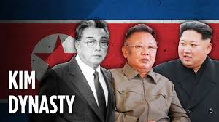

The President of North Korea is its Supreme Leader and the people have no say in who is chosen to govern them. They are expected to listen to him and follow his instructions. People are not free to leave North Korea except with the permission of the President, and it is only possible to visit North Korea as part of a state-run tour. As such, it is very difficult to get information on what happens within North Korea. Anyone caught smuggling out information would be subject to very harsh punishments.

**Activity**

Write down the title:

North Korea: Inside the World’s most secretive state – Unreported World

<https://www.youtube.com/watch?v=jI7or26HHLw>

1. What restrictions are there on people visiting North Korea?
2. Why does he feel like he’s ‘slipped back in time’?
3. Describe what Pyongyang looks like.
4. What is on the walls of the metro instead of adverts?
5. What badges do the citizens wear and why?
6. What is surprising about their mobile phones?
7. What has changed about wages in the factories in recent years?
8. What signs are there that North Korea is becoming more capitalist?
9. Where are most of the foreign businesses from and why?
10. Why are there checkpoints at the entrance to Pyongyang?
11. How many people were estimated to have died in the 1990s famine?
12. What would happen to men who grow their hair long in N Korea?
13. How many people are in the N Korean army?
14. How does the Lieutenant feel about the American soldiers?
15. What is the average income in N Korea?
16. Describe what the Mass Games are like.
17. What is the theme of the Games?



Why don’t the Kim Dynasty allow its people freedom to express their opinions? What might they be afraid of?

**How does the North Korean Government keep control of its citizens?**

**(from** [**https://www.libertyinnorthkorea.org**](https://www.libertyinnorthkorea.org)**)**

#### **No Freedom of Movement**

It is illegal for the North Korean people to leave their country without the regime’s permission, and the regime attempts to restrict the people’s movement even inside their own country. If you wish to travel to another part of the country, you are supposed to have a specific purpose and obtain permission from your work unit. If you do not live in Pyongyang, the showcase capital where most resources are concentrated, you will likely be denied access. The regime has also forcibly relocated hundreds of thousands of North Koreans to less favorable parts of the country as a form of punishment and political persecution.

#### **No Freedom of Speech**

Criticism of the regime or the leadership in North Korea, if reported, is enough to make you and your family ‘disappear’ from society and end up in a political prison camp. It goes without saying that there is no free media inside the country. The only opinion allowed to be voiced inside the country is the regime’s.

#### **No Freedom of Information**

The regime has invested massive resources in trying to maintain an information blockade and keep its monopoly as the only source of information and ideas to the North Korean people. It is illegal to own a tuneable radio in North Korea, there is no access to the Internet (except for a few hand-picked and monitored officials), and North Korean landlines and mobile phones cannot make international calls.

***Forced Leadership Adulation***

The regime forces the people to participate in the maintenance of personality cults around the Kim leaders that have ruled the country for over 60 years. Propaganda starts in nursery school and a large proportion of the curriculum for all students—even at university—is dedicated to memorizing the ‘history’ of the Kim family. State media provides a constant stream of myths about the Kims and talks about the sacrifices they supposedly make for the people. Millions of labour hours that could be used to develop the economy have to be spent idolising the leaders instead.

#### **No Religious Freedom**

Organized religion is seen as a potential threat to the regime. Thousands of Buddhists and Christians have been persecuted in North Korea. People caught practicing or spreading religion in secret are punished extremely harshly, including by public execution or being sent to political prison camps.

#### **Songbun Political Apartheid System**

The North Korean regime has invested an incredible amount of time and resources creating the songbun system, a form of political apartheid that ascribes you with a level of perceived political loyalty based on your family background. Your particular songbun level (there are 51 of them) can then restrict your life opportunities, including where you can live, educational opportunities, party membership, military service, occupation, and treatment by the criminal justice system.

#### **Political Prison Camps**

Five political prison camps hold an estimated 80,000 to 120,000 people. Some of them are the size of cities, and they have existed five times as long as the Nazi concentration camps and twice as long as the Soviet Gulags. Many people imprisoned in these camps were not guilty of any crime, but were related to someone who supposedly committed a political crime. Often they have no idea what that crime was, and even children who are born in the camps are raised as prisoners because their ‘blood is guilty’. Forced labour, brutal beatings, and death are commonplace. The regime denies the existence of these camps, but multiple survivor testimonies have been corroborated by former guards as well as satellite images.

#### **Collective Punishment**

In North Korea, if your relative is persecuted for “anti-state” or “anti-socialist” crimes, then you and three generations of your family can be punished for it. The aim is to remove from society the whole family unit to prevent any dissent from emerging in the future, and also to deter martyrs who might sacrifice themselves for a political cause but would not want to sacrifice their whole family.

#### **Public Executions**

The North Korean regime publicly executes citizens who have been accused of a variety of crimes, including petty theft. Whole communities, including children, are brought out to watch these executions, which are designed to instil fear amongst the people of doing anything that could be seen as against the regime’s wishes.

**Activity:**

Develop a mind map showing the ways in which the North Korean Government keep control of their citizens.

Your mind map should detail at least 6 methods of control.

**Democracy to Dictatorship? Hungary today.**

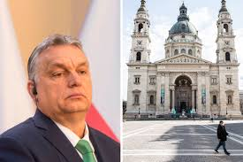 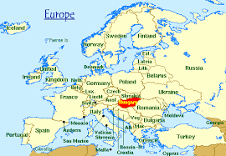

As we have discussed, it is possible for democracies to become dictatorships. This can happen due to a leader with charismatic authority seizing power, or another powerful interest within a country seizing power – eg through a military coup. It can also happen in a more gradual way through the government increasing its powers, ostensibly in order to keep the country safe. This is what happened in Germany in 1933 when Hitler, who had come to power through *mostly* democratic means, passed a series of laws to give himself absolute power. This was accepted by the majority of Germans as they felt they needed a strong leader to counter the perceived Communist threat and the financial crisis that Germany found itself in.

The former Soviet Union countries in Eastern Europe - Poland, Czech Republic, Hungary, Belarus etc - have officially been democracies since the Soviet Union broke up in 1989.

However, they, along with many other countries, have experienced a rise of populism and the far right in recent years – due both to rising immigration and economic issues following the worldwide financial crash in 2008.

The Coronavirus crisis now doesn’t just affect health, it is also having a massive impact on the world economy. The poorer countries, which were already suffering from rising inequality and unemployment – are likely to be hardest hit. This will have a significant impact on people’s attitudes towards their Government and therefore on politics as a whole.

In Hungary, a series of laws have been passed to give the Government sweeping powers to tackle the virus and its impact. Critics argue that these new powers are not temporary and that we are therefore seeing the end of Hungary as a democracy. The following case study can be seen as a clear example of how easily a fledgling democracy can be compromised and fall back into dictatorship.

**Watch and take notes – Background information**

BBC (May 2018) – Is Hungary moving towards a new form of illiberal democracy? <https://www.youtube.com/watch?v=srxbdESK1cA>

BBC (May 2019) – The Rise of the Right – populism in Hungary (the other 2 parts are well worth watching too) <https://www.youtube.com/watch?v=Yu7LvNb1atU>

Al Jazeera (March 2020) – Hungary’s PM gets sweeping new powers to tackle coronavirus <https://www.youtube.com/watch?v=xn734wtIryo>

**Source Analysis:**

*Note – look up words/terms that you are unfamiliar with and take down their meanings



**Coronavirus kills its first democracy**

By [**Ishaan Tharoor**](https://www.washingtonpost.com/people/ishaan-tharoor/)

March 31, 2020

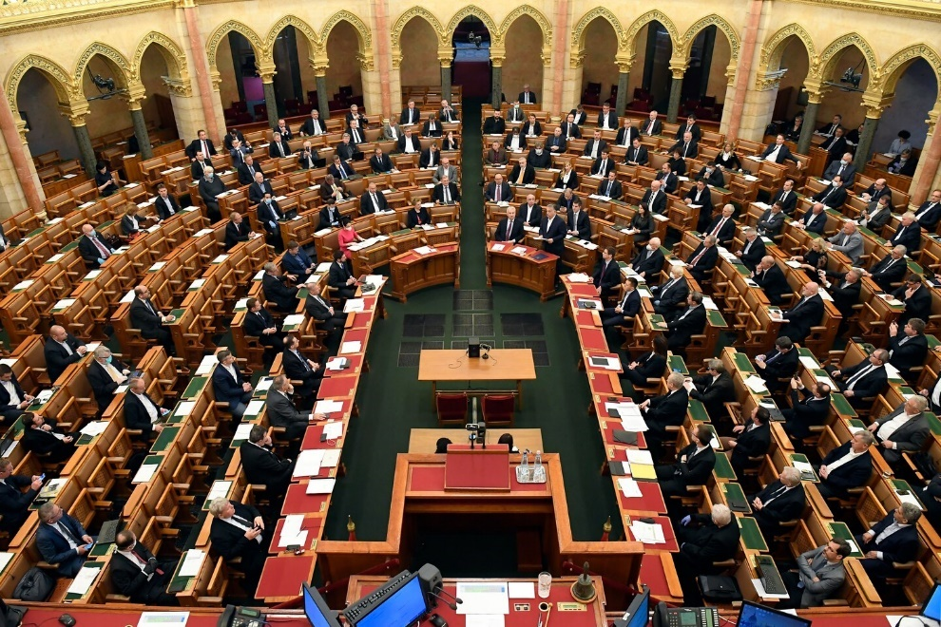

**You could say that Hungary was already “immunocompromised.”** A decade under the nation’s illiberal nationalist prime minister, Viktor Orban, has [corroded the state’s checks and balances](https://www.washingtonpost.com/opinions/2019/05/09/hungarys-prime-minister-does-not-belong-oval-office/?tid=lk_inline_manual_3&itid=lk_inline_manual_3), cowed the judiciary, enfeebled civil society and the free press, and reconfigured electoral politics to [the advantage of Orban’s ruling Fidesz party](https://www.nytimes.com/2018/04/09/world/europe/hungary-election-orban-fidesz.html). So, when the [coronavirus](https://www.washingtonpost.com/health/2020/02/28/what-you-need-know-about-coronavirus/?tid=lk_inline_manual_3&itid=lk_inline_manual_3) pandemic hit, [Budapest’s ailing democracy](https://www.washingtonpost.com/news/worldviews/wp/2018/04/06/how-victor-orban-became-the-real-threat-to-the-west/?tid=lk_inline_manual_3&itid=lk_inline_manual_3) proved all too vulnerable.

On Monday, Hungary’s parliament passed [a controversial bill that gave Orban sweeping emergency powers](https://www.washingtonpost.com/world/hungarian-parliament-hands-orban-power-to-rule-unchecked/2020/03/30/cc5135f6-7293-11ea-ad9b-254ec99993bc_story.html?tid=lk_inline_manual_4&itid=lk_inline_manual_4) for an indefinite period of time. Parliament is closed, future elections were called off, existing laws can be suspended and the prime minister is now entitled to rule by decree. Opposition lawmakers had tried to set a time limit on the legislation but failed. Orban’s commanding two-thirds parliamentary majority made his new powers a fait accompli.

The measures were invoked as part of the government’s response to the global pandemic. Hungary had reported close to 450 cases as of Monday evening, and Orban has already cast the threat of the virus in politically convenient terms, labeling it a menace carried by unwelcome foreign migrants and yet more justification for his aggressive efforts to police the country’s borders. “Changing our lives is now unavoidable,” [Orban told lawmakers last week](https://www.npr.org/sections/coronavirus-live-updates/2020/03/30/823778208/new-law-gives-sweeping-powers-to-hungarys-orban-alarming-rights-advocates) when justifying the proposed bill. “Everyone has to leave their comfort zone. This law gives the government the power and means to defend Hungary.”

The emergency law also stipulates five-year prison sentences for Hungarians found to be spreading “false” information, as well as prison terms for those defying mandated quarantines. Critics argue that vital support for [the country’s health-care system is still lacking](https://www.npr.org/sections/coronavirus-live-updates/2020/03/30/823778208/new-law-gives-sweeping-powers-to-hungarys-orban-alarming-rights-advocates), while Orban has given himself [carte blanche to exercise even more domineering control](https://www.ft.com/content/4dc85972-e917-4c8d-9db1-8e72400b9e8a?shareType=nongift).

“I don’t know of another democracy where the government has effectively asked for a free hand to do anything for however long,” Renata Uitz, director of the comparative constitutional law program at Central European University in Budapest, [said to Bloomberg News](https://www.bloomberg.com/news/articles/2020-03-30/orban-takes-sole-command-of-hungary-with-pandemic-emergency-law).

**Orban’s many detractors elsewhere in Europe see this gambit as a potential pathway to dictatorship.** Ahead of the parliamentary vote, leading figures in [Brussels and Strasbourg warned against](https://www.ft.com/content/4dc85972-e917-4c8d-9db1-8e72400b9e8a?shareType=nongift) an “indefinite and uncontrolled state of emergency” that would further undermine Hungarian democracy. On Monday, former Italian prime minister Matteo Renzi [tweeted what many liberal Europeans](https://twitter.com/matteorenzi/status/1244629436504461313) feel — that Hungary’s illiberal slide threatens the values of the European Union as a whole and could merit its expulsion from the bloc.

But there’s no clear path forward for such drastically punitive action, not least as the continent flounders in its battle against the coronavirus. And Orban has his supporters, too. He has been [lionized as a nationalist hero](https://www.washingtonpost.com/news/worldviews/wp/2018/04/06/how-victor-orban-became-the-real-threat-to-the-west/?tid=lk_inline_manual_16&itid=lk_inline_manual_16) for the West’s anti-immigrant populists and [welcomed to the White House by President Trump](https://www.washingtonpost.com/world/2019/08/16/trump-israel-global-right-wing-project/?tid=lk_inline_manual_16&itid=lk_inline_manual_16).

On Monday, far-right Italian leader Matteo Salvini [defended Orban’s new powers](https://www.ansa.it/english/news/2020/03/30/coronavirus-salvini-defends-orban-taking-new-powers-3_6dc34421-4ae2-41eb-bda3-62af5d28029b.html) as part of the “free choice” of a democratically elected parliament. For years, center-right parties in Europe have allowed Orban’s Fidesz party to shelter under their umbrella in the European Parliament, denting Europe’s ability to effectively censure Hungary. Now, you may see renewed calls for [Fidesz’s expulsion from that conservative continental alliance](https://euobserver.com/political/147351).

Orban and his allies have [rejected criticism](http://abouthungary.hu/blog/the-coronavirus-protection-law-and-the-new-depths-of-liberal-media-cynicism/) from those who have characterized the new law as anti-democratic, insisting that the measures are temporary and will end once the threat of the pandemic subsides. Others aren’t so sure.

“Everyone should think twice before giving Orban the benefit of the doubt,” [Dalibor Rohac of the American Enterprise Institute](https://www.aei.org/op-eds/hungarys-prime-minister-is-using-the-virus-to-make-an-authoritarian-power-grab/), a conservative think tank, wrote last week. “His decade-long premiership has been marked by [a continual assault](https://www.aei.org/research-products/report/authoritarianism-in-the-heart-of-europe/) on any constraints on his power — whether by courts, civil society or the media.”

**Hungary’s prime minister is not alone in exploiting this public health crisis for his political advantage.** His [kindred spirit](https://www.washingtonpost.com/news/worldviews/wp/2018/07/20/netanyahu-and-orban-meet-in-summit-of-illiberal-nationalists/?tid=lk_inline_manual_26&itid=lk_inline_manual_26), Israeli Prime Minister Benjamin Netanyahu, leveraged the threat of the pandemic into [what critics branded a parliamentary “coup,”](https://www.washingtonpost.com/world/2020/03/23/how-politicians-are-using-coronavirus-seize-control/?tid=lk_inline_manual_26&itid=lk_inline_manual_26) delaying his own trial on corruption charges while potentially securing a new political mandate to return to power.

While the threat of a pandemic requires national governments to sometimes exercise unique emergency powers, [analysts have warned throughout the recent crisis](https://www.crisisgroup.org/global/sb4-covid-19-and-conflict-seven-trends-watch) of the risk of demagogic leaders harnessing public anxiety to their benefit.

“In states of emergency, there may be a need to temporarily derogate from certain rights and procedures but any such measures need to be temporary, proportionate and absolutely necessary from a public health perspective,” Lydia Gall, an Eastern Europe researcher with Human Rights Watch, [told The Washington Post](https://www.washingtonpost.com/world/hungarian-parliament-hands-orban-power-to-rule-unchecked/2020/03/30/cc5135f6-7293-11ea-ad9b-254ec99993bc_story.html?tid=lk_inline_manual_31&itid=lk_inline_manual_31), referring to Orban’s pursuit of unchecked power. “Vaguely formulated provisions, as can be seen in the state of emergency legislation adopted, do not fulfill those criteria and certainly not when they are set for an indefinite period of time.”

Questions:

1. What powers will the new bill give Orban’s Government?
2. Why does he argue that he needs these powers?
3. What criticisms are there of the new bill?
4. Why do some people defend his actions?
5. What other countries have used the crisis to increase their powers?
6. Why does Lydia Gall think these powers go beyond what might be needed in a state of emergency?

Extension:

Research what new laws Britain has passed to tackle the impact of coronavirus. Has there been any criticism of them? Do you think they are justified?

**The Global Superpowers**

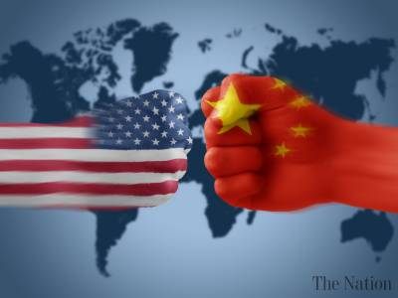

**What is a superpower?**

‘Superpowers’ are countries that are so strong that they are able to influence what other countries do. Their strength lies in a combination of economic, military, cultural and political power.

Watch this clip and write down what has changed about global superpowers over the past 60 years.

Which countries are becoming superpowers now and why?

<https://www.youtube.com/watch?v=mvt_4DqPjvc> ( 5 mins)

**China – an emerging superpower**

The global influence of the top two wealthiest countries – the USA and China – is huge. Between them, they hold around 50% of the total world’s wealth and they also have extensive military and political power.

Watch the clip and note down:

* What was life like in China under Mao?
* What is different about China now?
* Why might some people argue that Deng Xioping made China more capitalist than Communist?

<https://www.youtube.com/watch?v=hF__EF_yrFA> (3 mins 30)

China’s growth in the last 50 years has been huge and the country is increasing its economic and political influence across the world. In particular, China has now got significant interests in Africa which have led some people to accuse them of building a new ‘Colonialism’ – making other countries dependent on them in return for influence.

The New Colonialism – China and Africa

Over the past decade, China has been increasing its influence in Africa in many ways. China is benefiting economically from its relationships with African countries – as are many of these countries. However, it can be suggested that one of the main motivations for China’s interest in Africa is political. By making poorer countries in Africa dependent on them, they secure their support within the United Nations. In this way, it can be suggested that China is building a type of Empire within Africa – where officially independent countries are in fact strongly influenced by China in their actions.

Watch the documentary and answer the following questions:

<https://www.youtube.com/watch?v=zQV_DKQkT8o> (11 mins)

1. What did the UN decide about the ‘Two Chinas’ in 1971
2. Why were the USA unhappy about this decision, and who supported them?
3. What changed about African countries’ allegiances between 1971 and 2011?
4. How has China won the support of these countries?
5. What might China expect from its investments?
6. Why is China looking for a labour source (workers) from outside China?
7. How much trade did China do with African countries in 2016 and how did this compare to the USA?
8. How has China’s approach to Africa influenced world politics?

**Who controls the Superpowers?**

**The role of the UN and its limitations**

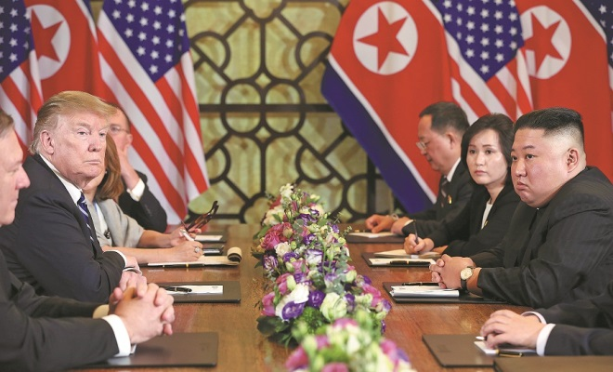

The United Nations General Assembly meets to discuss world affairs and decide what should be done about any problems. It can pass ‘resolutions’ asking a member to change its actions on an issue. Theoretically, every member country of the UN has an equal vote. However, as we have seen, some countries build alliances which give them a lot more influence.

Both China and the USA are on the UN Security Council, which in practice makes it very difficult for other countries to challenge what they do. The 15-member Security Council is by far the most powerful arm of the United Nations. It can impose sanctions, as it did [against Iran](http://www.nytimes.com/2015/07/21/world/middleeast/security-council-following-iran-nuclear-pact-votes-to-lift-sanctions.html?module=inline) over its nuclear program, and authorize military intervention, as it did [against Libya](http://www.nytimes.com/2011/03/18/world/africa/18nations.html?pagewanted=all&module=inline) in 2011.

Critics say it is also the most anachronistic part of the organization. Its five permanent members are the victors of World War II: the United States, Britain, China, France and Russia. The other 10 members are [elected for two-year terms](http://www.nytimes.com/2014/10/16/world/americas/campaigning-for-the-most-coveted-seat-at-the-un.html?module=inline), with seats set aside for different regions of the world.

Efforts to expand the permanent membership of the Council to include powers that have emerged since 1945 — such as India, Japan and Germany — have been stymied. For every country that vies for a seat, rivals seek to block it.

Any member of the permanent five — or the P5, for short — can veto any measure, and each has regularly [used this power](http://www.nytimes.com/2014/07/27/sunday-review/why-the-un-cant-solve-the-worlds-problems.html?module=inline) to protect either itself or allies. A veto is effectively a block – even if every other country is in favour of a resolution, one of these 5 countries can stop it passing by using their veto. Since 1990, the United States has [cast a veto](http://research.un.org/en/docs/sc/quick/) on Council resolutions 16 times, many concerning Israeli-Palestinian relations. Russia has done so 17 times, including eight times over Syria.

The Charter does allow the General Assembly to act if, because of a veto, international peace and security are threatened. But in reality, it is rarely done.

Questions

1. What powers does the UN Security Council have?
2. Which countries are members?
3. Why do you think efforts to expand the Security Council have failed?
4. What is a veto?
5. Why have the USA and Russia used their vetos?
6. Which is more powerful, the UN General Assembly or UN Security Council? Give reasons for your answer.

**A Threat to Democracy? The increasing power of corporations**

[Franklin D. Roosevelt](https://www.goodreads.com/author/show/219075.Franklin_D_Roosevelt) “Unhappy events abroad have re-taught us two simple truths about the liberty of a democratic people. The first truth is that t*he liberty of a democracy is not safe if the people tolerate the growth of private power to a point where it becomes stronger than the democratic state itself. That in its essence is fascism: ownership of government by an individual, by a group, or any controlling private power.* The second truth is that the liberty of a democracy is not safe if its business system does not provide employment and produce and distribute goods in such a way as to sustain an acceptable standard of living."

― **Franklin D. Roosevelt, 1938**

In a democracy, people are free to start up their own business and become successful. In the USA, this is encapsulated in the ‘American Dream’ – the idea that anyone can become a success if they work hard. This idea of working hard, establishing businesses and acquiring property and wealth is at the core of the **capitalist** ideology which dominates in the USA, UK and most other countries.

However, some people are concerned that the increasing power of some global corporations is a threat to democracy itself, as these corporations can have as much (or more) influence than some democratically elected Governments, yet ordinary people have no control over them and it is difficult for countries and their Governments to hold them to account.

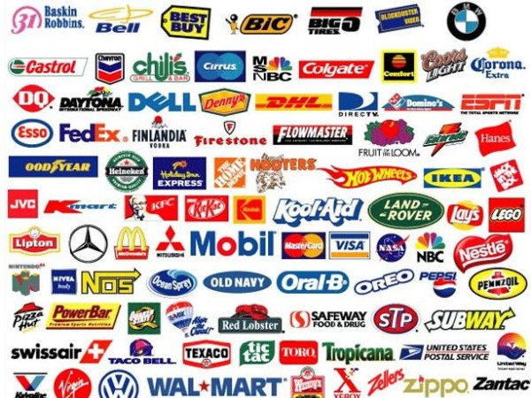

What we have seen in the past 100 years is an increasing tendency for some businesses to become so successful that they take over smaller businesses and grow to be huge corporations. These corporations have a lot of economic influence. They set the wages that their workers are paid and, because so many people work for them, this has an impact on what money people have to spend in their local communities and therefore the wages of other workers in that community.

Global corporations also have a political influence. They employ staff known as lobbyists who work to influence Government policy so it helps their business. For example, by lowering the taxes that the business pays, or making it cheaper for them to set up new stores. In the USA, businesses often donate large sums of money to political campaigns, expecting that they will then have the support of the newly elected representatives. This gives big corporations much more say than ordinary people in what laws are passed and what Government does. It can therefore be seen as anti-democratic.

<https://www.youtube.com/watch?v=gY6IPtCJCM0>

Some multinational corporations have grown so rich and powerful that they actually have more money than whole countries. The chart overleaf shows the 30 wealthiest organisations in the world. The richest corporation – Walmart – have more money than all but nine countries!

**The Richest Organisations in the World - 2018**

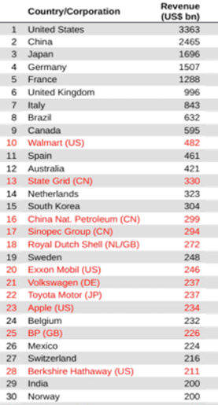

**Focus on Walmart – Inherited wealth making new money**

Walmart is the biggest company in the world. It is owned mostly by one family – the Waltons – who have seen their profits and wealth grow in recent years while the value of the wages paid to their employees has declined. 1 in 100 Americans work for Walmart and they have been criticised for not paying healthcare for many of their workers and paying such low wages that many of their employees have to claim Government welfare benefits. When Walmart sets up a store, smaller businesses in the town tend to shut down as Walmart is so much cheaper.

**Walmart Supply Chain**

[**https://www.youtube.com/watch?v=yZC4neLax5o**](https://www.youtube.com/watch?v=yZC4neLax5o)

Watch the clip and answer the following questions:

1. What evidence is there that shows the power of Walmart?
2. Describe how Walmart pays and treats its US workers
3. Explain why workers at Walmart in the US are unlikely to speak out
4. Explain where Walmart goods are produced and how the workers in the factories are treated
5. What evidence is there to show the power of Walmart in Bangladesh?
6. Why do some people argue that Walmart are putting peoples’ lives at risk in Bangladesh?
7. What does the Union plan to do to restrain the power of Walmart? Do you think they will be successful?

## Source Exercise – adapted from American Prospect

## The Big Influence of the Big Box

[Catherine Ruetschlin](https://prospect.org/authors/catherine-ruetschlin), [Sean McElwee](https://prospect.org/authors/sean-mcelwee)

December 3, 2014

The notion that all citizens have a voice in our country’s governance is at the center of the American ideal of democracy. Yet the role of corporate and private money in our political system means that the voices of the majority are often drowned out by those with the most money. Campaign and committee donations help wealthy interests determine who runs for office and who wins elections. This effect, combined with millions of dollars in lobbying, allows the biggest spenders to shape the country’s political agenda and gives them disproportionate influence over the policymaking process.

Walmart is the biggest spender by a wide margin, with $2.4 million in donations through its Political Action Committee (PAC) and individual donations and $12.5 million in lobbying expenses during the 2014 electoral cycle. This political spending is a problem for democracy, because extensive research suggests that it can significantly affect public policy, and that the priorities of the affluent often diverge from majority opinion.On issues like taxation, economic regulation, Social Security, and the minimum wage, the differences can be stark.

**The Walton Family Goes to Washington**

The majority of Walmart’s public shares are owned by the Walton family heirs. Since the beginning of the Great Recession in 2007, the Walton family wealth has grown by 96 percent while the typical American household’s net worth fell by 40 percent. The spectacular growth of the Walton family’s affluence can be linked, in part, to decades of political influence. According to Bloomberg News, the Waltons started lobbying for a repeal of the estate tax in the 1990s, and continue to exploit obscure tax loopholes that protect the assets of the country’s richest heirs.  In a prime example of the revolving door between the private interests of the affluent and policymakers, one Arkansas Congresswoman who supported the repeal of the estate tax and received $83,650 in campaign donations from Walmart works as a lobbyist for the company today.

Demos examined Walton family political contributions over the period between 2000 and 2014 and found that the Waltons made a total of $7.3 million in campaign contributions over the period, with greater total contributions in presidential election years The Waltons achieve broad access by contributing to both parties, but their spending heavily favors Republican candidates and PACs.

This is unsurprising—Republicans are often seen as the party of big business. Over the last two years, House Republicans have unanimously voted against raising the minimum wage. At the same time, they fought to extend the Bush Tax Cuts and made 50 attempts to repeal the Affordable Care Act (which makes health care cheaper for ordinary Americans).The Senate has taken similar stands on behalf of corporate interests: all Republicans but one voted against the Buffet rule that would ensure that the wealthiest one percent pay a 30-percent income tax rate.

Research suggests that campaign contributions like those examined here can significantly affect policy. Polls consistently show that a majority of American voters favor raising the minimum wage. But while 78 percent of the general public favors a minimum that would bring full time workers and their families above the poverty line, only 40 percent of wealthy Americans agree.Organizations representing the minority opinion, like the Chamber of Commerce, have spent tens of millions of dollars to advance their position in legislatures.And policymakers have allowed the real value of the federal minimum wage to erode for the past five years.

**Questions:**

1. How do wealthy people make sure they can influence politics?
2. How much do Walmart spend on political donations?
3. Why does the writer think that political donations are a problem for democracy?
4. Since the recession in 2007 started, what has happened to the wealth of the Waltons compared to the average American?
5. Why does the writer think the Waltons have done so well?
6. Which political party do the Waltons donate to most and why?
7. Why do you think US politicians have done little about the minimum wage in recent years, despite public support for an increase?

**Reflections**

Hopefully you’ve enjoyed looking at some aspects of Power, Authority and Legitimacy and considering the many ways in which power is wielded in our world today.

**Try now to write a response to the following quotes. For each of them, you should note down:**

: Who wrote/said the quote and why are they famous?

: Explain what you think the quote means. Is it relevant today?

: State whether you agree with the quote or not.

: Back up your answer with evidence and, ideally, take account of any counter arguments.

[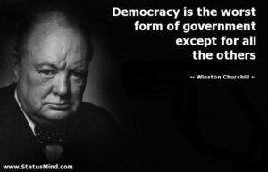](https://www.google.co.uk/url?sa=i&url=https%3A%2F%2Fwww.pinterest.com%2Fpin%2F608056387160592199%2F&psig=AOvVaw3jtkbdJRlnhJCePlg83joR&ust=1586444454538000&source=images&cd=vfe&ved=0CAIQjRxqFwoTCPCOuKeM2egCFQAAAAAdAAAAABAD)

1. [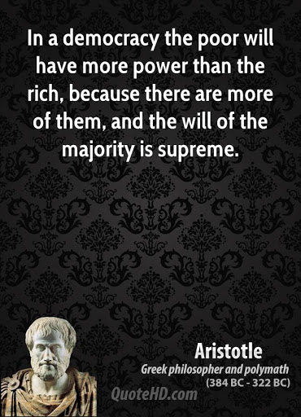](https://www.google.co.uk/url?sa=i&url=http%3A%2F%2F34quotesz.blogspot.com%2F2018%2F06%2Faristotle-quotes-on-democracy-quotesgram_15.html&psig=AOvVaw3jtkbdJRlnhJCePlg83joR&ust=1586444454538000&source=images&cd=vfe&ved=0CAIQjRxqFwoTCPCOuKeM2egCFQAAAAAdAAAAABAI)
2. [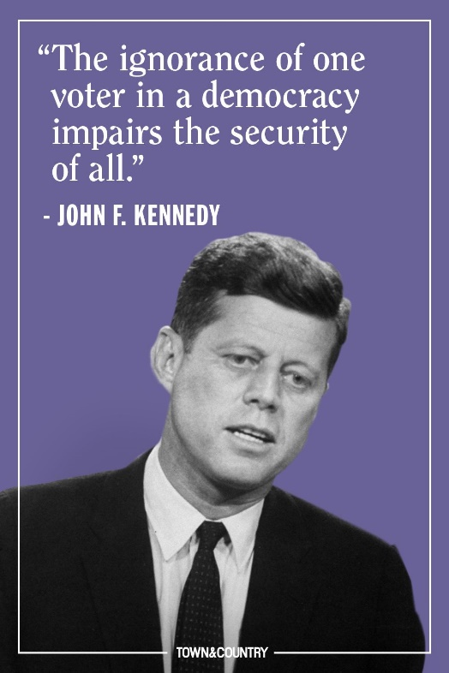](https://www.google.co.uk/url?sa=i&url=https%3A%2F%2Fwww.townandcountrymag.com%2Fleisure%2Farts-and-culture%2Fnews%2Fg1324%2Fthe-best-jfk-quotes-of-all-time%2F&psig=AOvVaw3jtkbdJRlnhJCePlg83joR&ust=1586444454538000&source=images&cd=vfe&ved=0CAIQjRxqFwoTCPCOuKeM2egCFQAAAAAdAAAAABAO)

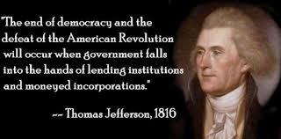

1. [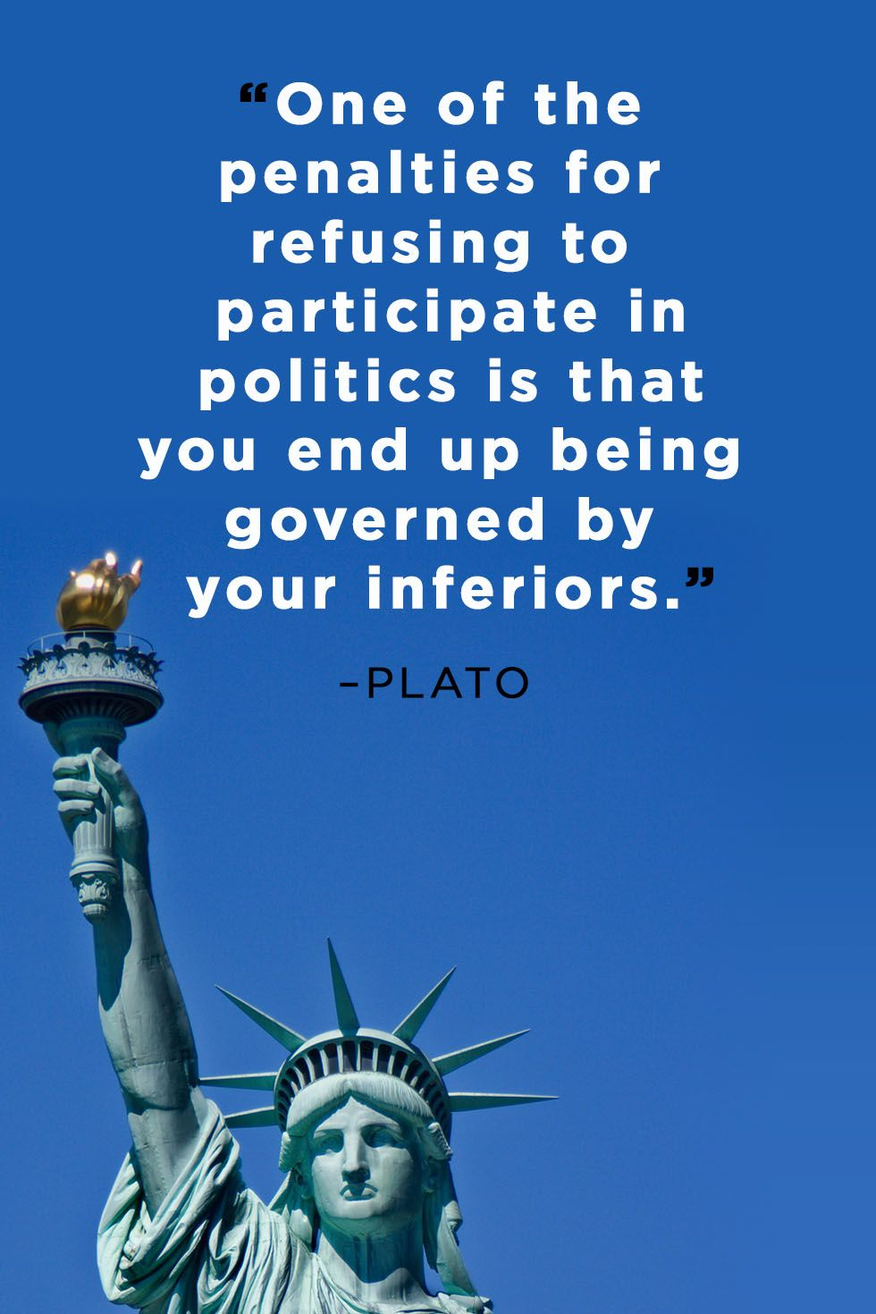](https://www.google.co.uk/url?sa=i&url=https%3A%2F%2Fwww.countryliving.com%2Flife%2Fg24446791%2Fvoting-quotes%2F&psig=AOvVaw3U94olE3Omv7rSAzhfc97j&ust=1586445901469000&source=images&cd=vfe&ved=0CAIQjRxqFwoTCJiR__eR2egCFQAAAAAdAAAAABAE)