Homelessness

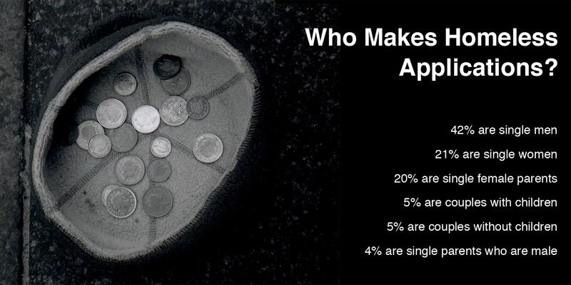
One of the most important needs people have in our society today is the need to have adequate shelter. This generally means having a secure house big enough to accommodate all the members of a family. Unfortunately last year in Scotland over 55,000 homeless applications were made to local authorities.

In addition to this many people will not appear in these statistics. These may be people who do not believe they are eligible for help or may not want any help from the local authority. This is often referred to as ‘hidden homelessness’ e.g. people sleeping on a friend’s couch or having to stay with other members of their families.

Activities
- Make a title page for your new topic.
- On a new page take a heading 'The Homeless'
- Look at the sentences below. Decide with a partner which are True and False. Now copy out those which are false and explain why.
a) There are over 55,000 homeless people in Scotland
b) Most homeless applications are made by single women
c) 5% of applications are made by couples with children
d) All homeless people make applications for housing to their local council
4. What is meant by the term 'hidden homelessness'?
Reasons for homelessness

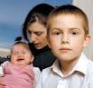
Relationship breakdown -- e.g. between young people and their parents/step-parents, or between married couples/partners are major causes of homelessness. Many people leave home because of arguments, relationship breakdown or being told to leave.

Poverty — Many people who experience long spells of poverty or unemployment can get into problem debt, which makes it harder for them to pay for their rent or mortgage and so they end up homeless.
Crime — Becoming involved in criminal activity from an early age can also result in difficulty in finding a place to live after release from prison.
Health issues —There are many homeless people who suffer from e.g. mental health problems.
Substance abuse — Drug and alcohol abuse are also major causes of homelessness.
Disaster -- Such as flood or fire can result in the destruction of the family home.

The table below shows the results of a Shelter survey (Shelter is a charity which helps homeless people) which asked people the reasons why they had become homeless.

Reasons for homelessness | %
Asked to leave family home | 28
Relationship breakdown | 41
Drug problems | 31
Alcohol problems | 28
Mental health problems | 19
Leaving prison | 25
** Most people asked gave two or three reasons for being homeless.

Activities
1.Take the heading Reasons for people becoming homeless and write a short paragraph using the information on the page and the table to explain why some people may become homeless.
2.With your teacher you may now tackle the Who's Homeless quiz

What it means to be homeless

You know what it's like at the end of the school day. You are desperate to go home, get changed into comfy clothes, go up to your room and relax, enjoy your evening meal, maybe go round to your friend’s house, go to football training, returning to a nice warm house and a comfy bed. Imagine instead that you are in a homeless hostel, bed and breakfast accommodation, some form of temporary home or worse still sleeping rough. Think of all the things that you take for granted which may not now be possible for you.

Activities

Watch the video clips from Shelter Scotland and Newsround with your teacher. Take careful notes of what the people are saying about homelessness.

In groups of 4 or 5 discuss the main issues you feel homeless people would face.


Make a spider diagram.
In the middle of the diagram write -- ISSUES FACING HOMELESS PEOPLE.
You have three minutes to write down as many things as you can. Each person in the group must make a contribution to the diagram.


Now, when your teacher tells you, move to another group and see if you can add anything to what has been written.
You will have one minute to do this.
When you are asked to by your teacher move on to another group. When you have been round three groups apart from your own you can go back and see what your classmates have added to your diagram.


In your group make up a short play showing the reasons why some people become homeless and the problems they may face.

What rights do homeless people have?

Local authorities have a legal duty to provide help to people who are homeless or threatened with homelessness.

Local social work services also have a responsibility for some homeless people. They have a duty to provide accommodation for children and young people over 16 who are leaving care or who are in need for other reasons.

People will be considered to be in 'priority need' for housing if they are homeless and :
- expecting a child
- have children under 16
- because of an emergency such as a flood or fire
- are aged 16 or 17
- are experiencing domestic abuse (which includes any behaviour that makes someone afraid or distressed – it does not need to include actual violence)
- are experiencing abuse because of their colour, race, religion, ethnic origin or sexual preference.

Temporary accommodation

While on the waiting list for a house, however, homeless people face living in some form of temporary accommodation.
The council may offer people temporary accommodation in a: flat, house, bedsit, hostel, bed and breakfast hotel (although this should only be a last resort).
The accommodation may be run by: the council, a private landlord, a housing association or a voluntary organisation.
If there is a shortage of accommodation in your area, the council may have to house people in a bed and breakfast hotel outside its own area.

What is temporary accommodation like?

The accommodation should meet certain standards, and should:
- not be overcrowded
- not be a danger to anyone's health (for example, it should have adequate fire safety provisions and should not be damp or in need of major repair work)
- meet any special needs the homeless person or their family may have.

In addition, the council has to take a number of other factors into account when it decides whether the accommodation is suitable

- how much rent people can afford to pay
- the condition/size of the accommodation
- where the accommodation is
- any health needs the person may have

Homeless people may have to share facilities such as a bathroom or kitchen with other people. In some bed and breakfast hotels there are no kitchen facilities available for residents to cook their own meals. Those people who are placed in a hostel may also have to share a bedroom.

Activity


You are a housing officer for North Lanarkshire Council. You have to prepare an information leaflet for homeless people within North Lanarkshire.

Your leaflet should have :
- A title page
- A summary of the rights of homeless people
- Information for homeless people telling them what type of accommodation they can expect to be offered
- Some research information from Shelter Scotland or North Lanarkshire Council's website giving facts about the numbers of homeless people/homeless hostels in North Lanarkshire

Rough sleeping

Rough sleeping is the most extreme form of homelessness, but not all people who are homeless will need to sleep rough. 13% of applicants to local councils had a household member who had slept rough at some time in the previous three months. However many people who sleep rough will not seek assistance from their local authority, therefore the numbers who experience it is expected to be much higher.

What health problems can result from rough sleeping?

Rough sleeping can also cause serious health problems, or worsen existing health issues. Illnesses that are closely associated with rough sleeping and poverty include tuberculosis, malnutrition, and severe dental problems. Other health problems in society such as alcoholism, mental illness and physical disabilities are even worse for people who sleep rough, since they may have no shelter or money to manage the problem.

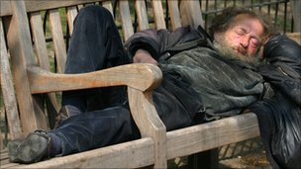
People without shelter can easily get frostbite, get infections, or be victims of violence, even in public shelters. Finding appropriate health care can be a difficult challenge for someone who is sleeping rough.

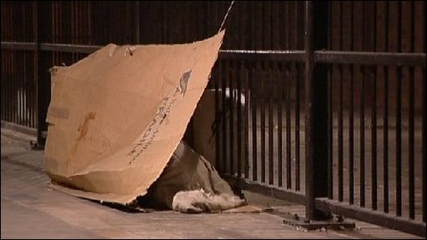
Activities

Explain as fully as you can why rough sleeping is said to be the worst form of homelessness.
Take care not to miss anything out as one of your classmates will be marking your work.

The Big Issue


Happy 20th birthday

The Big Issue has just celebrated it's 20th birthday. It exists to offer homeless people the opportunity to earn a legitimate income by selling a magazine to the general public. "We believe in offering ‘a hand up, not a hand out’ and in enabling individuals to take control of their lives."
In order to become a Big Issue vendor an individual must prove that they are homeless, undergo some training and sign up to the code of conduct.

Once they have done so they are allocated a fixed pitch and are issued with 5 free copies of the magazine (or 10 in London). Once they have sold these magazines they can purchase further copies, which they buy for £1 and sell for £2, thereby making £1 per copy.

Vendors are not employed by The Big Issue, and they do not receive any money back for magazines which they fail to sell. Each seller must therefore manage their sales and money carefully. Earning an income is seen as the first step on the journey away from homelessness. The Big Issue Foundation, a registered charity, exists to link vendors with the vital support and services which will help them deal with their problems and make positive life changes. They work exclusively with vendors, offering advice and referrals in four key areas; housing, health, financial independence and future hopes.

Vendors sign a Code of Conduct and agree not to
- Use threatening, or aggressive behaviour.
- Use offensive language
- Sell in any way which could be associated with begging
- Sell while under the influence of alcohol or drugs

They must also agree to
- Only sell on an authorised Big Issue pitch
- Give the correct change at all times
- Sell for the correct price
- Clearly display Big Issue identification at all times while selling

