Urban Change in Mumbai

Background:
Mumbai (formally Bombay) is the largest city in India. The original site of Mumbai was an island off the west coast of India. It initially developed as a fishing and trading port before becoming an industrial centre. It is now one of the most crowded cities in the world - population is now over 20 million people.
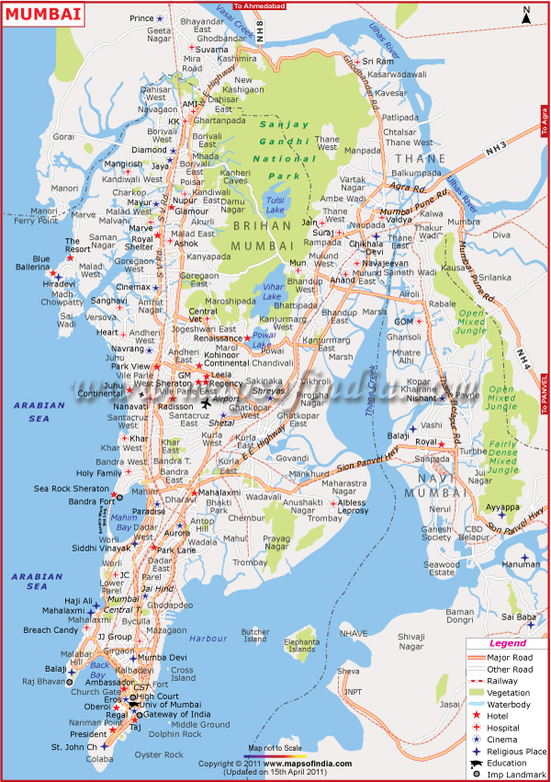
Many of the problems in Mumbai are linked to the geography of the area.

Mumbai consists of several islands with reclaimed wetlands in between to form BOMBAY ISLAND.

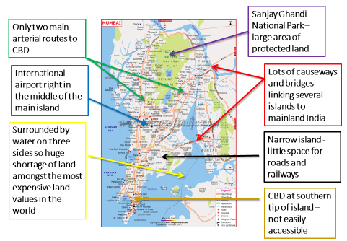
Housing Problems in Mumbai
Shanty Towns:
A Shanty Town (also called slums, favelas or squatter settlements) is a collection of shacks and poor-quality housing which can lack a water or electricity supply and sewage disposal. Known as favela in Brazil. India has one of the largest slums in the world which is found in Dharavi, Mumbai.
Below are some pictures of slum areas in India.
Task: In your jotter, create a table showing what the housing conditions look like. Categorise the table into two problems: social – economic and environmental.

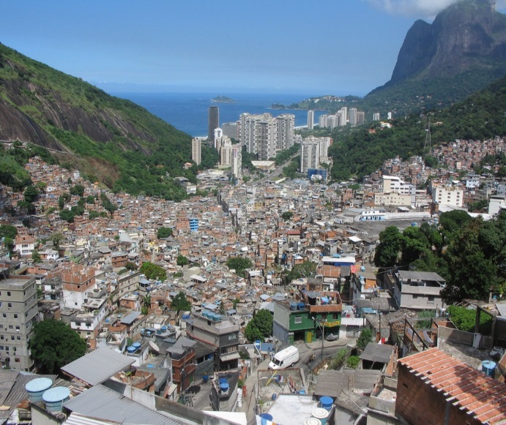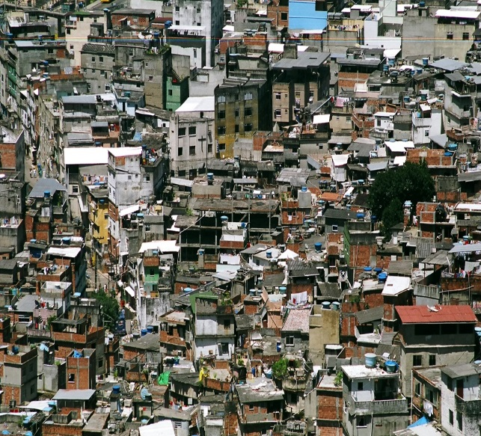
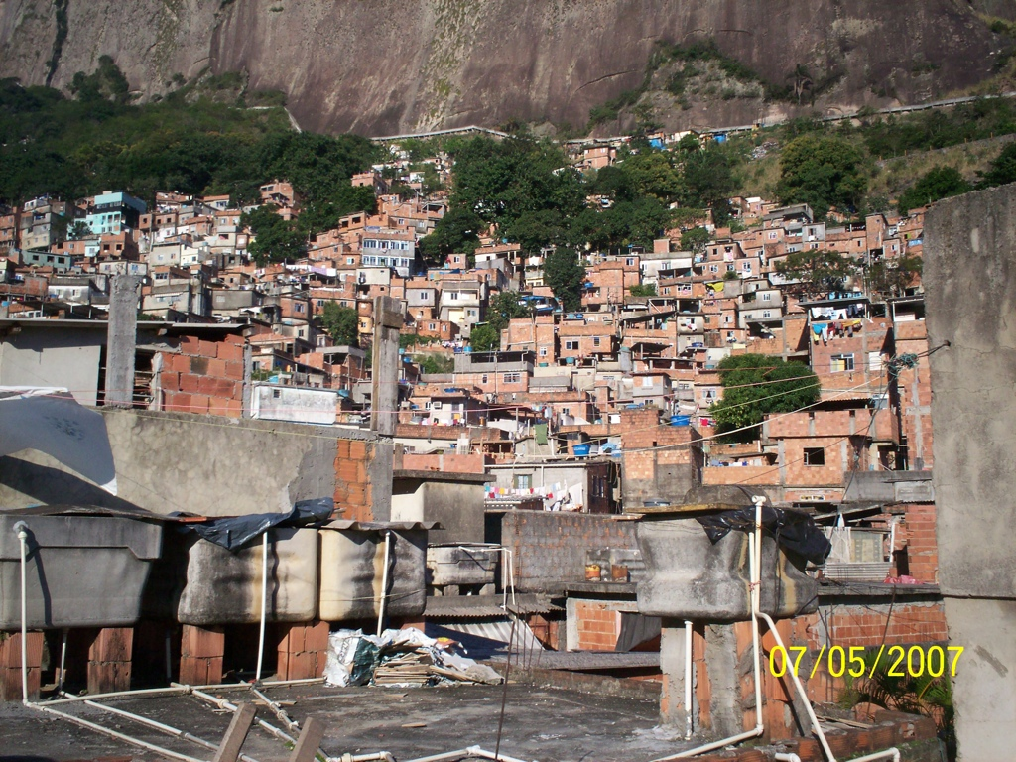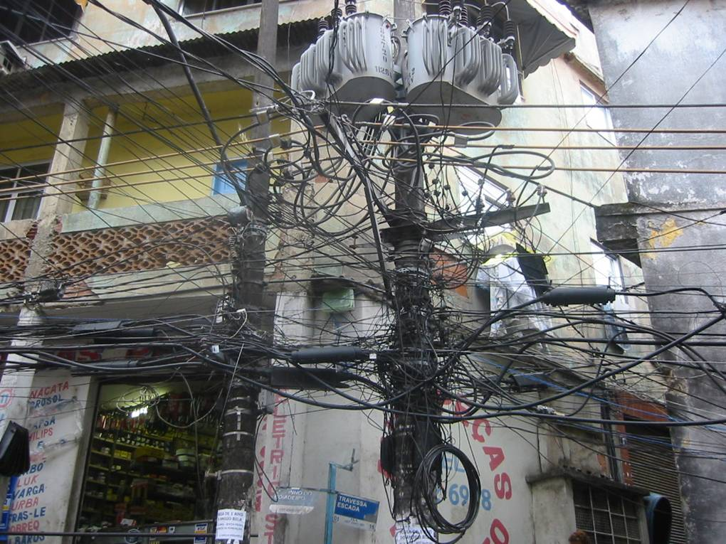

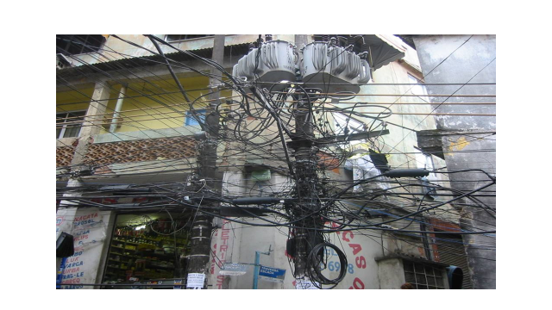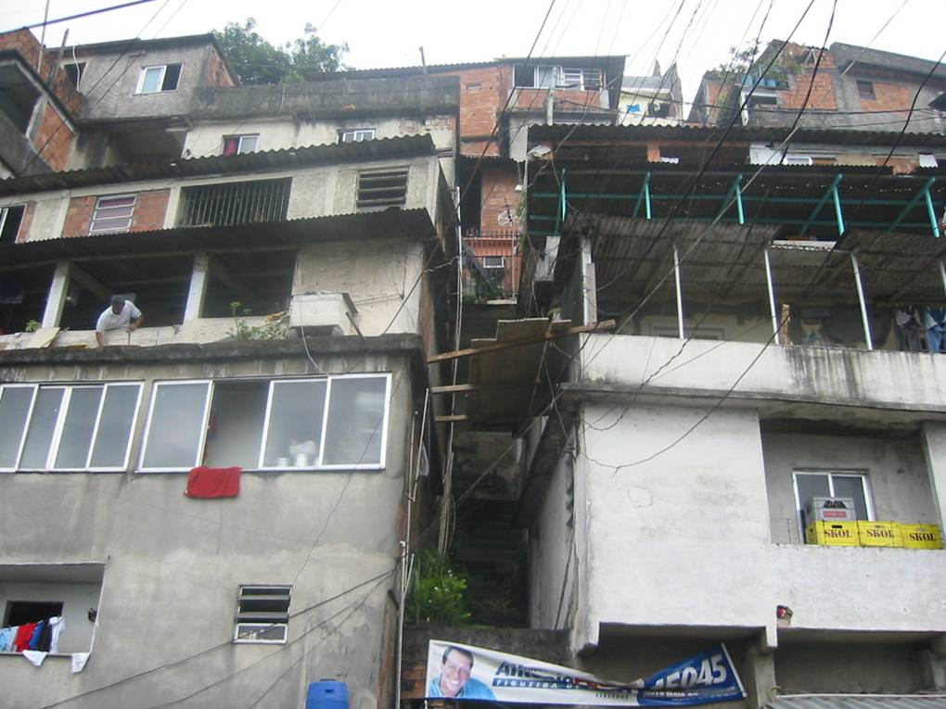
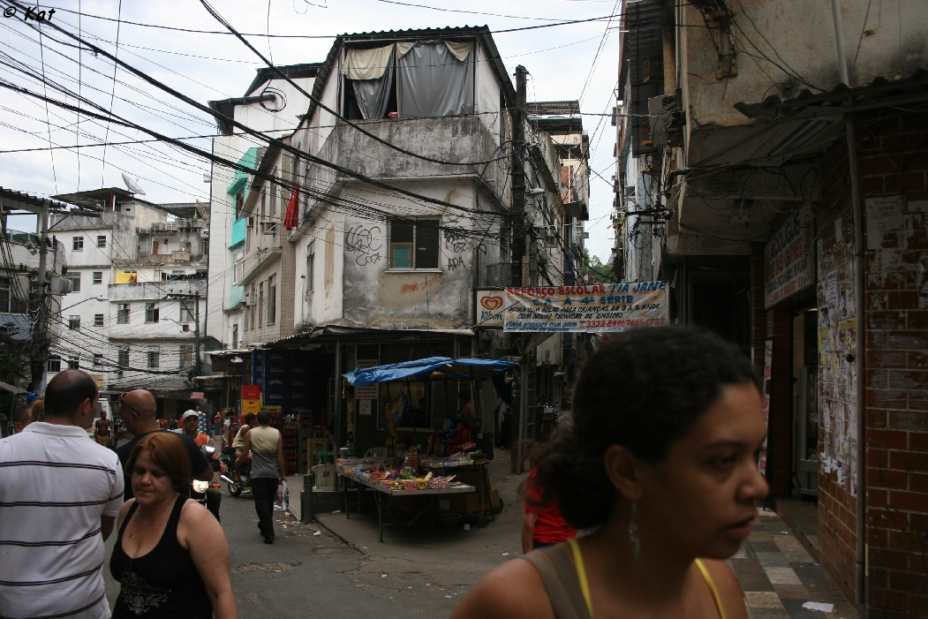

Task: Watch the opening few scenes of ‘Slumdog Millionaire’ and add more notes to your table on the social-economic and environmental issues that you see.

Class discussion will follow.
Problems in Shanty Towns
Many shanty towns lack basic facilities such as schools and water. They also lack public utilities such as sewage disposal or electricity. There are high rates of disease e.g. cholera from dirty water which means that people cannot go to work leading to high unemployment rates. People therefore cannot afford to feed their families or sent their children to school.
Many buildings are unsightly buildings made out of scrap materials such as wood, cardboard and brick. Some areas are located on areas prone to flooding or landslides. Many are often illegal but due to the volume of them, police don’t tend to move people on due to crime and violence within the shanty towns. They are run by gangs which is dangerous for the families living there and for anyone who enters from outside. Finally, shanty towns are overcrowded which leads to lack of privacy.
Task: Complete the following exam style question based on the notes from the table you have written.
Referring to a world city you have studied:
Discuss the socio-economic and environmental problems associated with housing in shanty towns.
6 Marks

Remember to mention the specific housing issues and not the overall issues of the area.
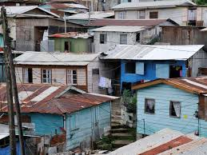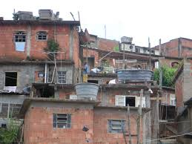
Management Strategies to Improve Dharavi, Mumbai
Six main strategies have been put in place to solve the housing issues in Mumbai.
- Dharavi Redevelopment Project where local people will be moved to high-rise apartment blocks these aim to replicate the streets and build-in working and open spaces. 2 billion pound redevelopment is underway to improve the whole area of Dharavi

- Slum rehabilitation has planned and managed improvements such as upgrading mains sewerage to help reduce diseases such as cholera.

- Self-help schemes support the efforts of local people to improve their housing for example by adding an additional floor to buildings thus reducing overcrowding. For example, the NGO SPARC supports this.

- Residents have been given legal rights to land.

- Residents have been supplied with building materials to strengthen/make safe the housing.

- Building new health centres and schools to try and tackle health problems in area and provide education for children.

Task: Complete the following exam style question based on the management strategies above.

Referring to a developing world city you have studied, explain the strategies used to manage these problems.

8 Marks

How effective have the housing strategies been?

- Large Scale Redevelopment:
- The Dharavi Redevelopment Project only helps those who are have been resident in Dharavi since 2000 so not everyone is eligible to be helped.
- Other residents will be moved to other parts of the city which will break up communities and may result in people being far away from work.
- New flats will also be too small for those who have workshops above their homes.

- Slum Rehabilitation:
- Has planned and managed improvements such as upgrading mains sewerage to help reduce diseases such as cholera however, within twelve years, only 15% of Dharavi was redeveloped.

- Local projects:
- Self-help schemes support the efforts of local people to improve their housing for example by adding an additional floor to buildings thus reducing overcrowding.
- Toilets have been added and are shared by two or three families who help to keep them clean, which has reduced the incidence of water related diseases.

Task: Complete the following exam style question based on the effectiveness of management strategies above.

Evaluate the effectiveness of strategies used to improve the housing in Kibera or any other developing world city you have studied.

5 Marks

Transport in Mumbai

Task: Look at the picture below of a common train station scene in Mumbai. What problems do you notice? List at least 5 into your jotter.

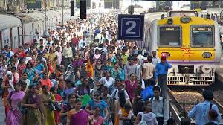

Below are some of the common problems with traffic in Mumbai.
Task: Pick 6 of the problems listed below in the picture and create a 6 box storyboard in your jotter to highlight the traffic issues. The storyboard must include writing, images and colour.

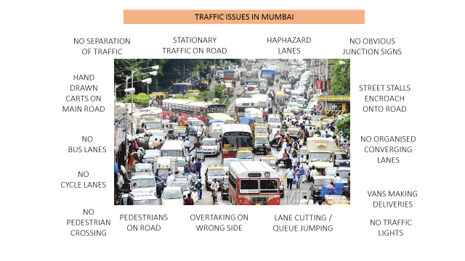
Transport Problems in Mumbai

This is mainly due to Mumbai’s location. It was originally over several islands so many bridges need to be built across the water. Bombay Island is very narrow so little space for roads and railways. The CBD (central business district) of the island is only accessed from the North therefore, few roads and railways reach the city centre. With the rising population, the transport system is in crisis.

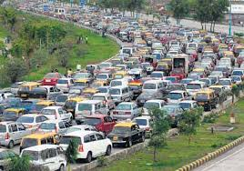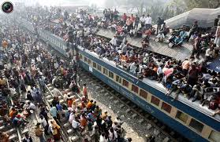

Task: Watch the following video clips and take notes in your jotter about the transport issues in Mumbai and what can be done to solve them.
https://www.youtube.com/watch?v=dpcHa3c5XG4
https://www.youtube.com/watch?v=KnPiP9PkLAs
https://www.youtube.com/watch?v=ig7DZ7W-6GQ (4 mins 30 secs onwards)
https://www.youtube.com/watch?v=y5XDxP3lIIg

Solving Mumbai’s Transport Problems and their effectiveness

- Urban Transport Project 2002 used 4 methods to solve traffic congestion:
- Railways were improved e.g. more stations built
- New road links were made between motorways, some widened with up to 6 lanes
- 500 eco-buses which is good for the environment
- Flyovers instead of intersections and subways instead of pedestrian crossings
- All of this helped to reduce air pollution levels so has been successful.

- In 1979, a new town called New Bombay was built:
- Navi Mumbai (New Bombay) was a completely new planned new town on the mainland opposite Mumbai.
- It was built to help alleviate the problems of Mumbai as its aim was to reduce the number of people commuting into the CBD of Mumbai.

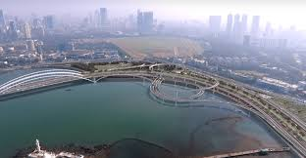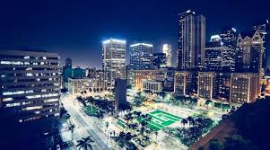
- By 2000, over 1 million people were living in 20 separate but connected settlements and it was intended that New Bombay would have enough jobs and services for everyone living there.
- However, it is very stretched and has become overcrowded itself so many commuters still travel into Mumbai every day so congestion is even worse.

- India plans to build 1,864 miles of walls along its railways (2018)
- This is an attempt to cut the tens of thousands of deaths that occur from people being hit by trains each year.
- Build a 2.7 metre high reinforced concrete barrier along residential sections of the sprawling network.
- The railways department had already begun building more than 1,000 miles of concrete barriers, but said work had been slowed by locals who objected to the construction.
- Material from the walls, such as bricks or iron, was also a target for thieves.

- With support from the World Bank, the city recently invested in a new traffic management system.
- It allows police officers to monitor traffic flows at key junctions via a network of cameras and sensors and adjust signals when necessary to help prevent issues.
- Pushing a button in the control centre can make a traffic light at a distant junction turn from red to green or vice versa.
- It is a relatively simple system and has proved quite effective in easing the pain of Mumbai's ever-present jams, but it certainly hasn't eradicated them.

- Driverless Cars 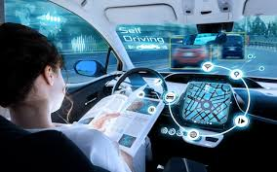

- Automated cars could also be made to work as driverless taxis, picking people up at their doors and dropping them off at their destinations meaning fewer cars on the road.
- However, could they cope with the busy traffic?
- Cost to implement technology to this scale and to maintain it would be millions – many parts of India are poor.

Task: Watch the following clips and more detail to your notes on transport solutions in Mumbai.

https://www.youtube.com/watch?v=YH-STykTgC4
https://www.youtube.com/watch?v=OIwctENuO38 (first 5 minutes)

Have they worked?

Task: Read through the online articles and evaluate whether these traffic management strategies have worked?

Does Mumbai still have a major problem with traffic congestion?

Once you have read through the information from the articles, create an A3 poster showing the pros and cons of each strategy. This will be good as a revision tool for the exam. You can include information from the 5 strategies above too and any extra you find online.

http://indiatoday.intoday.in/story/sanjay-nirupam-letter-maharashtra-cm-mtro-construction-vehicle-traffic/1/1119438.html

http://auto.ndtv.com/news/mumbai-traffic-authorities-consider-adopting-delhis-odd-even-rule-1253412

http://www.bbc.co.uk/news/business-21804350?print=true

http://www.abc.net.au/news/2014-02-02/an-mumbai-opens-first-monorail-system-to-ease-traffic-congestion/5232906

Task: Complete the following exam style question into your jotter.

For a named city in the developing world:
a) Describe the management strategies put in place to solve the traffic
problems.
b) Evaluate how useful they have been?
10 marks

