Human Environments
Paper I



Introduction

Population is the statistical study of populations, where the size, structure and spatial distribution of populations are analysed and changes in population trends are examined.
Issues relating to population are of vital importance to governments of every country around the world. Population size, structure, growth and decline can have huge implications for the economy, planning and DEVELOPMENT of a country. Therefore governments must monitor population and be ready to introduce or change government policy on population if development is threatened by demographic change (growth or decline). One of the most pressing issues facing the survival of the human race today is overpopulation. Many population scientists believe that planet earth has a carrying capacity – a limit of how many people the environment can support – and if we exceed that carrying capacity; OUR species will begin to die out! Again, it is up to governments to control population growth if such a catastrophe is to be avoided.
This topic will examine population size, structure, growth, decline and change in the populations of case study countries around the world. We will learn 2 migration case studies. We will also study the implications of overpopulation and overcrowding, as well as the opposite problem of population decline in some countries. In both cases we will look at the impact that government policy and decisions can have on such population issues in countries such as China and the UK.

Topic Checklist

- Gathering Population Data

- Difficulty in Gathering Population Data in ELDC’s

- Population Pyramids

- Population Structure : Comparing ELDCs/EMDCs and their consequences

- Population Change : The Demographic Transition Model

- Migration: Forced vs Voluntary

Gathering Population Data
For a long time it has been considered very important for governments to gather information about the people in their country. Information on the number, structure and characteristics of the population is required if proper provision is to be made for the various needs of the population in the realms of housing, transport, education, health and food supply, all of which need to be assessed and planned for in advance. This information can be obtained from a number of sources:
- CENSUS - In the UK these are taken every 10 years and have been taken since 1801. A census is basically a survey which is sent to every house in the UK and is required to be filled in by law. Questions include: The number of people in the household, the race, ethnicity, language, ages, qualifications, occupations and incomes of the people in the household. Census’ in EMDC’s cost a lot of money – approximately £4 per person who is enumerated. The last census in 2001 cost the UK £254 million! But census’ are vital. It allows the government to plan for the future if we know such details about the population. For example, if we know the occupations of the population, we can identify occupations which may have a shortage of workers in the future. For example in the UK, a shortage of tradesman has been predicted. This allows the government to channel more people into apprenticeships to prevent shortage. If we know how many people live in an area, the balance of young and old and what their needs are in terms of housing, schools and health services, it allows tax payers money to be spent where it is needed most. It also allows us to compare previous census’ to note changes and trends. In the UK, comparison shows us that average life expectancy is rising. This can have implications for the government as they will have to provide more pensions, so they will have to put more money aside for this.

- Sample Surveys –These are surveys sampling just 10% of the population and are used to update the full census every few years, as a lot can change in 10 years. These are more popular with poorer countries as an alternative to a full census as costs are cheaper.

- Vital Registrations of Births, Deaths and Marriages. When ever there is such an event, it is required by law to be recorded and certificated. This keeps a record of the Birth Rate, Death Rate and Population Growth Rate.

Task: Answer the following Past Paper Questions...
- 2007: Describe the ways in which countries can obtain accurate population data
(6 marks)

- 1998: Despite the cost of a census, explain why it is very important to conduct this survey
(6 marks)

Difficulty in Gathering Population Data in ELDC’s

Although the results of the UK census are very accurate, Economically Less Developed Countries (ELDC’s) struggle to take an accurate census. As we have seen, census’ are very expensive to conduct (£254m in the UK) so clearly ELDC’s have more important priorities to be spending such large sums of money on, such as education, housing and food supply. As a result, some ELDC’s fail to take a regular census. Quite often they simply take a sample of 10% of their population, and base all statistics on this. However, this will be inherently inaccurate as 10% is not a large enough sample to be representative of the whole population. There are many other complex reasons to explain why ELDC’s census data is often inaccurate...

Mind Map – showing reasons for inaccurate census data in ELDC’s
War
& Conflict

Cost
Size

Suspicion
Reasons for inaccurate census data in ELDC’s
Language Barriers
Remoteness

Low literacy levels
Poor / difficult communications
Migration, nomads & homelessness

Task:
Copy the above diagram into your jotter. Underneath the diagram, take each point and explain in detail how these difficulties prevent accurate census completion.
Include the statistics below to illustrate your answer with case study information.
Ethiopian Literacy Rate – just 52% No. of languages spoken in Ethiopia – 84
Illegal migration – Zimbabwe to South Africa Indian population - 1 billion
Tribal differences and suspicion in Kenya Afghan urban population – just 24%
Amazon Rainforest population – 20 million China – 1 million villages Sahara Desert nomads

World Population Growth

The population of the world today is approximately 6.6 billion people. This colossal number is growing at an annual rate of 1.17%, adding approximately 80 million people per year to our world. As the map below shows, this spectacular rate of growth is not even across the world. There is a real geographical difference in population growth. The scale of the map shows countries with the highest rates of population growth (between 2-3%) are the ELDCs, mostly concentrated in Africa. Countries with the slowest rates of population growth (between -0-1%) are EMDC’s. What factors explain this stark difference?

World Population Growth Rates (%)

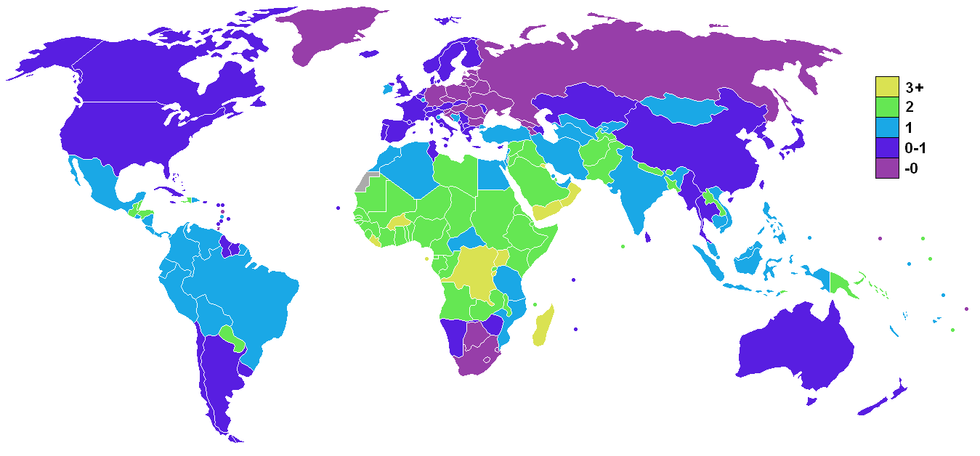

Uneven Population Growth: Comparing ELDCs/EMDCs

As the graph below shows, world population growth has exploded since 1950, from almost 3 billion people to 6.6 billion people in 2008. The graph also shows that the vast majority of population growth has been in the ‘Developing’ nations of the world – the ELDC’s.
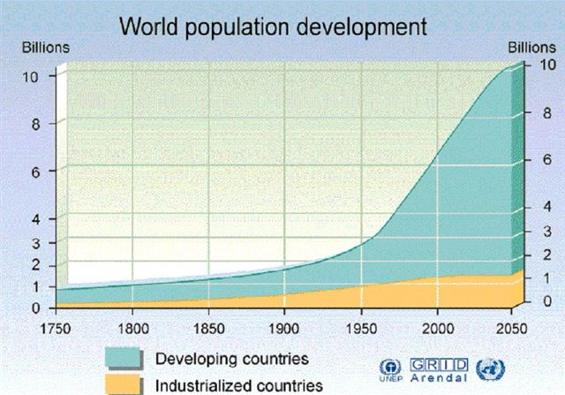

80% of the world’s population growth has taken place in ELDC’s and it is estimated that 95% of population growth in the next 25 years will happen here too. EMDC’s such as those in Europe and the USA are experiencing much slower rates of population growth. In fact some countries such as Russia, Germany and Poland are suffering from population decline. To understand these trends we firstly have to remind ourselves how populations can change. Birth Rates and Immigration increase the population, whilst Deaths and Emigration cause decline.
In the poorest ELDC’s such as Sierra Leone, Afghanistan and Zimbabwe, both Birth Rates and Death Rates are very high. This means that total population growth is low. In other ELDC’s such as Kenya, where economic and social progress is starting to take place, Death Rates are declining but Birth Rates remain high. This is when population growth rates increase rapidly.

Conversely, both Birth and Death Rates have been declining in EMDC’s such as Germany and Scotland since the 19th Century. Here, population growth is low and stable. In some countries, such as Russia the total population is actually declining!

Population Pyramids

In Geography, we often use different methods to process or display information – various tables, graphs, charts, maps and models. It is important to develop these numerical skills in Higher Geography, ensuring we are able to read, interpret, analyse and draw these.

Population information about the age/sex structure of a country is often given as a specialised bar graph called a population pyramid. Such pyramids show the number or percentage of the population in each 5-year age group as a series of horizontal bars with males on the left and females on the right.
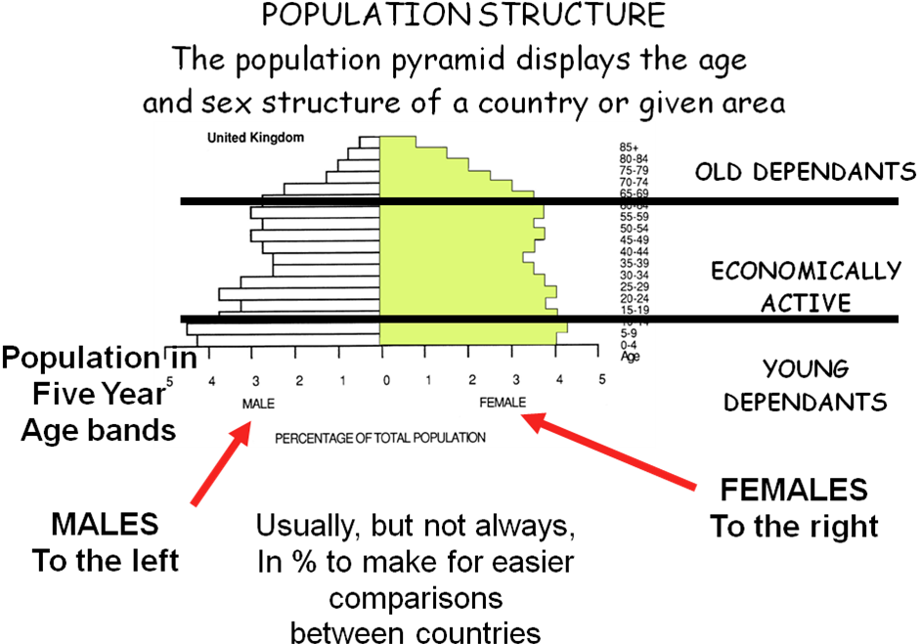

Population pyramids can provide information about the 3 main age categories in a population –

- Under 15 – Young Dependants (too young to work)
- 15-64 – Economically Active (of working age)
- Over 65 – Old Dependants (too old to work)

Population Pyramids make it much easier for demographers and government organisations to read and interpret population information at a glance, in order to spot characteristics, trends and changes in populations quickly, and plan accordingly by estimating future needs for education, housing, medical services, labour markets, etc. The shape of the pyramid can also provide information about how wars, epidemics, economic recessions or migrations have affected population structure. Often there are big ‘chunks’ out of one or both (male and/or female) sides of the graph, and/or at different age categories. This can be attributed to one or more of these events.

Population Pyramids – EMDC’s and ELDC’s

Below are two population pyramids. These are the typical population pyramid shapes for an ELDC (Kenya) and an EMDC (Scotland). The general shape of the pyramids tells a lot.

Scotland’s Population Pyramid Kenya’s Population Pyramid

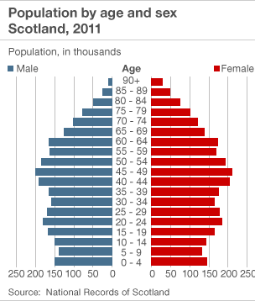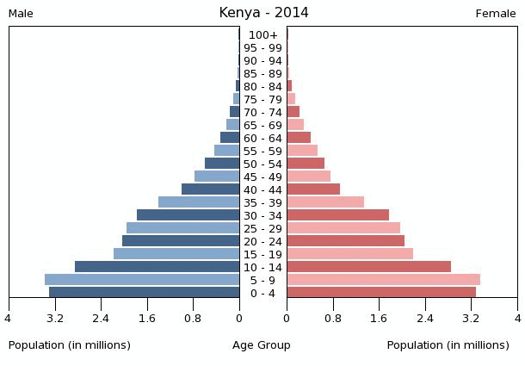
Kenya’s population pyramid is a typical pyramid shape. It has a very wide base, indicating a high birth rate (BR). Just fewer than 6 million people are between 0-4 years old. Afghanistan has high juvenility, as shown by the high number of young dependants - people in the under 15 age category (approx. 15 million are under 15). The pyramid tapers quickly towards the top, indicating a high Death Rate (DR). The pyramid has a very narrow apex, indicating a very low life expectancy, with very few people over 65. This type of population pyramid is described as a progressive population.

Scotland population, on the other hand, is ‘bullet’ or ‘coffin’ shaped. It has a narrow base, indicating a lower Birth Rate and that the BR is decreasing. The graph bulges and increases in the middle, showing that there is a large economically active age category. This also shows that the Death Rate is low. There is a large proportion in the over 65 age category, indicating high life expectancy. This means Japan has an ageing population, with a large number of old age dependants. This type of population pyramid is described as a regressive population.

Explaining population structure
ELDC’s and EMDC’s have very different population structures, as clearly shown by comparing the 2 pyramids above. We now have to explain each component of the pyramids – the Birth Rate, the Death Rate, Infant Mortality Rate and Life Expectancy.
Why are Birth Rates so high in ELDC’s?
Although Birth Rates in most countries around the world are declining, they are much higher in ELDC’s than they are in EMDC’s.
Country | Afghanistan | Malawi | India | China | USA | UK | Japan | Germany
BR / 1000 | 48.2 | 40.7 | 23.0 | 14.0 | 13.1 | 12.0 | 8.3 | 8.2
There are many wide ranging reasons for this trend.
Firstly, we have to look at the lifestyles of people in ELDC’s. Most people in live in rural areas. For example, in Ethiopia the urban population is only 16%. This means that the vast majority are working from the land. If it takes one person all day to plough or weed the fields, or fetch the firewood, or find grazing for the goats, or carry the water and pound the grain, then you need a big family. People who live in urban areas often rely on the income that their children earn by running errands, shining shoes, washing cars and in some countries, working in sweat shop factories, in the city. So there is a desire for a large family in order to contribute to the household economy in both rural and urban areas. Here, children are seen as economic assets.
Most ELDC’s lack the social security that is offered to old age pensioners in richer countries like the UK. Old people don’t receive pensions, residential care or free healthcare from the government. They are on their own. So in ELDC’s, children are the social security. Children can help to look after their parents in old age by providing them food, shelter and payment for medical care. This is another reason why people have large families in ELDCs.
When we consider the Infant Mortality Rates (IMRs) in ELDC’s, this sheds further light on such high BR’s. Infant Mortality in Afghanistan is 154/1000 compared with just 2/1000 in Japan. So if many of your children die before they reach adulthood, you need to have lots to ensure that some survive.
In poorer countries, such as Niger, contraceptives are not widely available and/or are too expensive for people to buy. Quite often, there is widespread ignorance towards contraception due to limited education. Religion is often more fundamental and more strictly followed in ELDC’s. Some religions preach against the use of contraception, especially Catholicism and Islam. In countries such as Afghanistan, 99% of the population is Muslim, whilst the majority of Filipinos are strict Catholics. In such religious nations, contraception is a taboo subject and is openly condemned by both the church and the government. Abortion is also illegal in many of the more religious countries of the world, for example in the Philippines. Both of these factors increase Birth Rates.
Fertility is also higher in countries where women have less status in society, for example in Pakistan, where females do not have equal access to education and jobs. Here, women marry early (the average age is 17) and the main role of a woman is in the home, bearing and raising children.
In other cultures, e.g. Mexico, having many children is a regarded as a sign of virility – masculine fertility – and helps to boost social status.
Another cultural trend is the preference of baby boys. In countries such as China, giving birth to a baby boy is more desirable than a baby girl. This is because boys can carry on the family name and boys would provide more help and security to the family. Therefore couples keep trying for a boy, and so end up with a larger family.

Why are Birth Rates so low in EMDC’s?
In EMDC’s, many of the social, cultural, economic and political factors keeping BR’s high do not apply. Birth Rates are dramatically lower in EMDC’s. Many countries in the West, including Scotland, Germany and Russia, are suffering from population decline brought around by falling Birth Rates.
Birth Rates are low in EMDC’s due to a number of factors.
As a country industrialises, women tend to gain more equal status in society with much better access to education and they begin to become more career focused. Increasingly women are postponing marriage until much later. For example in Japan, half of all women have not married by the age of 30. Later marriages result in fewer children or none at all.
With increasing economic development, consumerism increases also. People become more materialistic and sacrifice having children in order to have a more extravagant lifestyle.
In advanced economies, bringing up children can be very expensive. The cost of food, clothing, presents, education and more adds up very quickly. According to a recent study, the cost of raising a child until the age of 21 (after university) is £140, 000 in the UK. Therefore children become economic burdens and many people can only afford to have one or two. To ensure that the children have a comfortable upbringing – nice home, family car, holidays every year, presents - couples are also choosing to have fewer children.
In EMDC’s contraceptives are much more readily available, and because orthodox religion doesn’t have the prominence in society that it does in ELDC’s, contraception is much more widely accepted and is considered the norm. People in EMDC’s can easily afford contraceptives, and in many countries, such as the UK, contraceptives are available free from the NHS. Sex education in schools also helps to reduce birth rates by cutting down unwanted teenage pregnancies. Abortion is legal in most EMDC’s, and sterilisation procedures are widely available and practiced.
Since EMDC’s have a high standard of living and quality healthcare, the Infant Mortality Rates are much lower. This means people do not have to have more children to ensure the survival of a few as is the case in ELDC’s.

Demographic Transition Model

We have already looked at the difference in Birth Rates, Death Rates and Population Growth Rates between ELDC’s and EMDC’s. From the study of birth and death rates for the industrialised countries of Europe and North America, a model called the Demographic Transition Model has been produced. This model implies that as the countries of the less developed world start to develop, they will move through the 4 (now 5) distinct stages of Demographic Transition, as shown in the model below...

Corresponding Pyramids
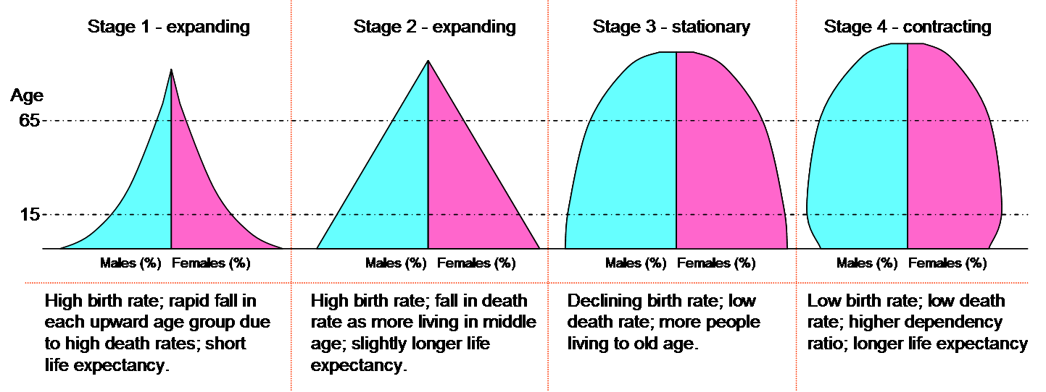

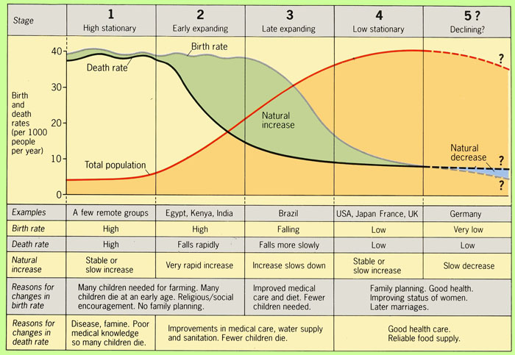

Describing the Demographic Transition Model

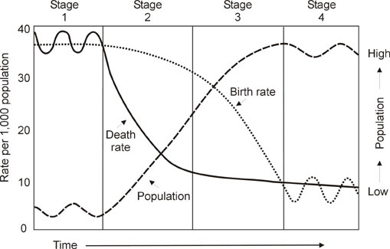

Stage 1 - The least developed countries in the world are in stage 1, where Birth and Death Rates are both high (around 38/1000) and fluctuating according to natural events such as drought and disease. Therefore total population growth is low. The UK was in stage 1 over 250 years ago (pre industrial times <1750). Countries that are in Stage 1 today include rainforest tribes in areas such as the Amazon and the Congo Basin.

Stage 2 – The Birth Rate remains high whilst the Death Rate declines dramatically to around 15/1000. Therefore total population growth is high. The UK was in stage 2 from 1750-1880. Countries in Stage 2 today include Peru, India and Kenya.

Stage 3 – Birth Rate declines dramatically to around 20/1000 whilst the Death Rate continues to decline, but more slowly, to around 10/1000. Therefore total population growth is slow. The UK was in Stage 3 from 1880-1940. Countries in Stage 3 today include China, Cuba and Brazil.

Stage 4 – Birth and Death Rates are both low and fluctuating. Therefore total population growth is low. The UK is in Stage 4 at present. Other countries in Stage 4 are the USA and Japan.

Stage 5 – The Death Rate rises (due to ageing population) and Birth Rates fluctuate and decline further. Therefore, for the first time, the population will decline. Germany has now entered Stage 5, where the BR is 8.2 whilst the DR is 10.7 – meaning natural population DECLINE is taking place in Germany. Many other EMDC’s will enter Stage 5 fairly soon as BR’s continue to decline and DR’s increase due to the ageing population.

Impacts of Demographic Transition (DTM)

Demographic Transition literally means population change. As we have learned, different countries around the world are in very different stages of the Demographic Transition Model, some experiencing very high population increase whilst others are experiencing much lower levels of growth. Some countries are now even experiencing population decline. There are many socio-economic problems associated with being in Stage 2 (very high population growth) and Stage 5 (population decline).

Stage 2 – Problems: High population growth, high juvenility, overpopulation, regressive economic development
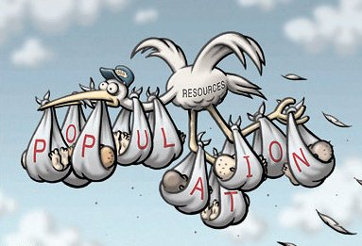

Countries such as Kenya, who are in Stage 2 of DTM, have been experiencing very rapid population growth. This is due to Kenya having a very high Birth Rate (39/1000) and a much lower Death Rate (10/1000). There are many problems associated with this trend. Firstly, due to the high juvenility of the population, there will be a high DEPENDENCY RATIO. This means that there will be too many young dependants relying on the smaller proportion in the economically active age category due to the low life expectancy (56 years old) and high age specific death rate amongst the young. Therefore there will not be enough money to fund essential provisions for young people such as maternity units, midwives, vaccination programmes, medicines, food, water, schools and teachers. Without the money, social development in health and education suffers. If health and education are poor, foreign industry (factories) will not locate in the country and so the country will be unable to develop economically and will remain stuck in the cycle of poverty.
This trend will also result in population momentum – where the high number of babies being born will in turn grow up and have many children each, and so the population grows very quickly. Overpopulation becomes a problem. This trend means that with too many people to provide food and water to, malnutrition, famine and water borne disease (such as Cholera) occur and many people die (e.g. Sudan/Ethiopia). With more pressure on farm land, environmental degradation can result, permanently eroding soil making it infertile and useless. Social provisions such as education and healthcare will suffer as simply there will not be enough to go around. Housing shortages become apparent and so many people are forced into homelessness or to live in shanty towns. Shanty towns (e.g. Rochina in Rio de Janeiro) have their own set of problems, being overcrowded, dangerous, and vulnerable to hazards like fire or natural disaster, unhygienic, ridden with crime and are a social and environmental blight on the city. Cities become very congested and air pollution becomes a major problem e.g. China. Living conditions deteriorate due to problems of sewage pollution and solid waste disposal. Crime rates also increase in areas of overpopulation, with drug cartels and people thieving resources in order to survive. Conflicts over scarce resources (e.g. Oil in Georgia/Russia or water of the Nile), can also result.

Governmental Population Policies - How do we solve the problems of overpopulation?
If these problems are to be avoided, governments must act by introducing anti-natal population policies (i.e. a policy which discourages high BR’s). Government campaigns, advertising and propaganda help to spread the message that less children = better standard of living for all. In Madras, the year 1985 was declared a ‘No Child Year’ by the Indian government in the hope to reduce Birth Rates and improve living standards. A government helicopter hovered over the city and dropped leaflets reading ‘Why bear unnecessary children?’ Increasing the availability, acceptability and affordability of contraception and educating people on the matter through family planning centres also helps to reduce family size. Sterilisation treatments can be encouraged. For example, in India in the 1950’s, men who volunteered to be sterilised were given a transistor radio – a rare luxury in those days. In Bangladesh they took a more drastic approach – where it was reported that women who refused to be sterilised were denied food! Many governments of ELDCs have also risen the age of consent and minimum age of marriage to encourage fewer births. If equal rights legislation is passed allowing women to work then this will have a real impact on family size.
The most extreme case of government intervention is China’s One Child Policy (now two child policy) which was introduced in 1979 by leader Deng Xioping. This was a controversial policy which restricted Chinese couples to just one child per family, enforced strictly by heavy fines and the removal of benefits such as extra holidays, free healthcare, education and pensions. The policy was dogged by reports of terrible human rights abuse such as forced abortion and sterilisations and non compliance would result in people’s homes being destroyed and women being locked up in cells. Due to the preference of baby boys over girls for cultural reasons such as carrying on the family name, many baby girls were aborted, adopted out, neglected or even killed so couples could try again for a boy. This culture has created a skewed population ratio of 114 boys to every 100 girls. This causes many social problems for the population later on, where many young men remain unmarried. This leads to increased depression, alcohol abuse and suicide amongst men. The one child policy has also been criticised as a mass population which grows up without brothers and sisters to share and compromise with, breeds a culture of selfishness termed ‘little emperor syndrome’ and a population which finds it difficult to empathise with other people.

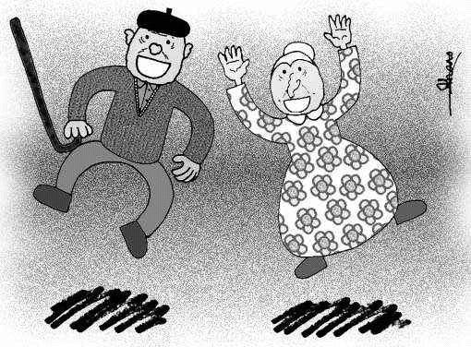
Stage 5 – Problems: Low Birth Rate, declining population, ageing population

In countries such as Germany, which is in Stage 5 of Demographic Transition, natural population decline is a problem. This is happening because the Birth Rate (8.2/1000) is lower than the Death Rate (10.7/1000). This is problematic for many reasons.
Firstly, with such a low Birth Rate, many industries associated with young people will have less demand. This will mean redundancies in many key areas such as midwifery; teaching and any manufacturing connected with children e.g. prams. This will increase unemployment in these areas, and people will require redundancy payouts and/or retraining schemes, costing the government millions.
With such a low Birth Rate, in the future there will be a very small economically active population. This means that there could well be skills shortages in some key professions – e.g. tradesmen. This will lead to a requirement for migrant labourers, which in itself can cause problems for the country – ethnic tensions, driving wages down, the cost of translators/language classes, repatriation of wages to the foreign county.
The squeezed economically active age category will feel added pressure in the future due to the fact that the population is ageing since life expectancy is high and increasing (80 years old in Germany). This will mean that countries like Germany will struggle to provide for the increasing number of OAP’s. The elderly will require pensions (£90/week/person in the UK), services such as free bus passes, meals on wheels and home helps. Many will require operations, regular hospital health care and/or residential care in nursing homes. All of these services cost the tax payer billions of pounds every year and the quality of the NHS could buckle under the pressure. But with a dwindling number of tax payers, who will pay for it all?

Governmental Population Policies - How do we solve the problems of an ageing population?
The repercussions of this predicament will be felt in countries like Scotland and Germany in the coming years. In fact, some changes have already been set in motion in the UK. The government will raise the age of retirement of women to the age of 65 (in line with men) instead of 60 from 2010. It has also been hinted that in the future, the age of male retirement will be 70, in response to rising life expectancy. It has also been suggested that the government in the UK will scrap the state pension and instead encourage people to take out private pensions. Income tax will also have to be increased to raise the revenue to support the ageing population of the future. These decisions are likely to be very unpopular with the public, and could lead to political turmoil and protest as well as economic downturn.
Population policies are designed to solve problems associated with population trends and change. In the UK it is important to try to encourage a higher Birth Rate. Many methods have been employed here. Firstly, it is important to ease the financial and social burden of having children. Financially - couples can be given more child allowance with the more children they have, creating financial incentive. Child Tax Credits were introduced in the UK in April 2003. Free childcare and childcare allowances are given to encourage mothers who wish to work to have children too.
Another way to tackle this problem is to introduce policies to encourage immigration. Governments can do this by providing incentives for migrants – such as housing, benefits such as free education and healthcare and by making the process of moving easier for the migrant by reducing ‘red tape’. Migrant labour will fill skills shortages in the key areas and is beneficial to the host country as immigrants often take up the unskilled, dirty jobs and work for low wages. Immigrants generally tend to come from less well off areas, and with this comes a tradition of high BR’s and large families. This means that population momentum and natural population growth will take place in the host country, again helping to alleviate to financial burden pressure on the economically active in the future.
However, with immigration comes a host of social problems. Ethnic and racial tension issues can become apparent which can lead to conflict. For example, in the UK in 2002 there were race riots in Leeds and Bradford and recently there has been much race related conflict in the city of London. During economic recession, where many people lose their jobs, there is often a sense of resentment towards the migrant workers who retain their jobs. This also adds to the ethnic tension. Immigration also results in pressure on national services such as health care and education, as more people use the services. Language barriers can also be a problem and the government has to spend money on providing language classes to fully integrate people into society.

Migration
Migration is simply the movement of people from one area to another. Migration can be classified as either:
Permanent Temporary Voluntary Forced International Internal
Temporary migration can include a daily commute from Glasgow to Edinburgh or it can be seasonal, for example herders in the Sinai Desert, Egypt. It can also include contract labour, for example working for a British bank in Switzerland for a fixed period. Other types of temporary migration can include a student taking a year out to do voluntary work in Bolivia, or a guest worker in a country intending to return home at some stage. Sometimes the word ‘circulation’ is used since the intention is that the person will return to the original point. When there is no such plan then migration will be permanent.
Permanent migrant can include retired people moving away to warmer climates e.g. Florida for a better quality of lifestyle, or rural villagers in India moving to live in a city.
Voluntary migration is where people have chosen to move to another area in search of a better quality of life or job opportunities, for example British couples moving to Australia.
Economic migrants are those who move to earn more money for themselves and their family and so improve their standard of living. For example, Scots moving to the USA or Canada.
Forced migration is when people feel that they have no choice but to move, as they are in fear of persecution. Unfortunately, quite often these migrations involve high levels of suffering and a lower quality of life.
International migration involves crossing international boundaries, from one country into another whilst internal migration occurs within a country, or even a city. For example urban to urban – moving house within a city; urban to rural – moving out of the city for a quieter life in the countryside; or rural – urban – from the countryside to the city, in search of health, job, education opportunities (in ELDCs).
An asylum seeker is a person who feels threatened on the basis of their race, ethnicity, nationality, skin colour, political beliefs or social identity.
Migrants can also be labelled according to the reason for their move. For example, as asylum seekers, economic migrants or refugees.
There are many complex reasons why people choose to migrate. We have to be able to recognise the basic factors that break down into push factors, those negative features of the old location (origin) which encourages people to leave the area, and pull factors, those positive features or attractions of the new location (destination).
Task:
- Drawing from your own experience, what push and pull factors might explain the migration patterns from Scotland to countries like Australia or Canada?

Forced Case Study (Syria to Neighbouring countries)

For this case study you should be able to:
- Explain the reasons for the forced migration
- Describe and explain the consequences of the emigration for Syria
- Describe and explain the consequences of the immigration for neighbouring countries

What is causing the forced migration?
The Syrian crisis is an ongoing armed conflict in Syria between forces of the government and those opposing them.
In March 2011 a civil war in Syria began between President Bashar al-Assad’s Government and rebel forces who want him out. Since this war was declared, civilians have been displaced within Syria or have fled the country to seek refuge in neighbouring countries. There have been claims of chemical weapons being used in this civil war. In 2013 there was a chemical attack in Damascus which killed over 1,300 civilians.
Therefore people have been forced to leave their homes and migrate to other parts of Syria (displaced) or move to another country.
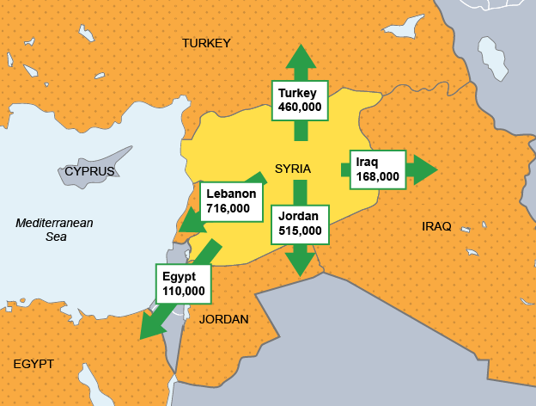

Background Statistics
9 million Syrians have fled their homes since the outbreak of civil war in Match 2011.
2.5 million Refugees have fled Syria to many neighbouring countries such as Lebanon, Jordan, Iraq and Turkey.
6.5 million Syrian children have been affected by the brutal conflict.
1 million children are living as refugees in neighbouring countries.

Impact on Syria
6 million people have moved from their homes within Syria to escape escalating violence (internally displaced). They have lost their home, possessions, and their jobs. In many areas they have been separated from family members.
As a result of this, there is now widespread poverty in Syria.
Aid agencies are struggling to cope. In some areas of Syria they cannot support basic refugee needs. They cannot reach many people as they have been made homeless. The ongoing conflict has also meant that aid agencies cannot reach areas as it is unsafe.

Impact on Neighbouring Countries
Camps have been established in neighbouring countries from the beginning of the Syrian Civil War in 2011. Although many camps provide shelter for refugees, some camps are struggling to cope with the large numbers fleeing Syria every day. Sanitation is low and overcrowding is common. Refugees have been separated from family members in Syria and many children have become orphaned due to the conflict.
Many Syrian refugees in Jordan are not living in camps and have fled into the urban areas. They cannot receive aid from the United Nations or other donors. This is putting a huge strain on public resources in Jordan. Food is expensive, rents have tripled in some cases and competition for jobs has driven wages down. This has created tensions within the native communities.
Lebanon has the highest number of Syrian refugees. This has created an overwhelming burden on infrastructure, society and the economy.
Task:
- Listen to the podcast of Amira’s Story and take notes as you listen to her journey as a Syrian refugee.

Voluntary Case Study (Poland to Scotland)

For this case study you should be able to:
- Explain the reasons for the voluntary migration (push and pull factors)
- Describe and explain the consequences of the emigration for Poland
- Describe and explain the consequences of the immigration for Scotland


Why are people leaving Poland?
- Higher Unemployment
- Lower monthly minimum wage
- Housing shortages and poor housing in some areas

What attracts Polish people to Scotland?
- Fresh Talent Initiative’ 2004/05 and Polish Guide 2006 (attracting Polish to Scotland)
- Job fairs and employment agencies
- Wide range of careers with better pay
- Join other relatives who already live here

Benefits and Problems for Poland

Benefits:
- Fewer working people left so unemployment levels drop
- Less Pressure on existing resources including; accommodation, schools and services
- Surplus money can be sent home to families in Poland helping to boost the economy
- If migrants move back to Poland, new skills can be brought back, e.g. in construction, business and commerce and health helping to develop the country
- Closer links established between Poland and Scotland: Industrial, business, cultural and political

Problems:
- Poland’s population structure could change with fewer younger people, and fewer children being born resulting in …
- fewer workers to help develop the economy
- fewer goods and services bought, resulting in less industrial production
- less taxes from goods and workers the Government has less money to spend
- a large percentage of people leaving are young, skilled graduates
- people in Poland being worries that their traditional customs and values may be negatively affected


Benefits and Problems for Scotland

Benefits:
- “Most Poles are extremely hard-working, law abiding, and make a tremendous contribution to this country” Daniel Kawczynski, Conservative MP
- Initially Polish migrants worked mainly in the construction and food industries, and in poorer paid jobs that few British workers would apply for
- Migrants spend money, boosting the economy, with the Government also gaining added tax and VAT revenues
- Cultural benefits to Scotland e.g. Edinburgh Polish Cultural Festival, March 2009
- Church attendances have increased, e.g. St Mary’s Cathedral, Edinburgh, has two Polish services every Sunday
- Cheap flights between Scotland and Poland

Problems:
- Racial tension and fears can arise about an economic downturn and unemployment
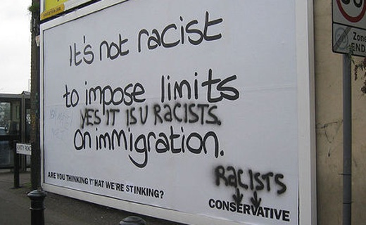

Glossary
active population | the number of people of working age (approximately 15 -64 years)
ageing population | a population with a low birth rate and a low death rate so that the average age of the population is increasing.
census | a count of the number of people in a country.
counterurbanisation | Modern trend of migration, usually in EMDC’s, from cities and towns to the relative peace of the countryside.
crude birth rate per 1000 | the number of live births per 1000 people in a year.
crude death rate per 1000 | the number of deaths per 1000 people in a year.
demographic transition model (DTM) | a model which shows how changes in birth rates and death rates are related to population growth over a long period of time.
dependent population | the number of people of non-working age (approximately under 15 and over 64).
EMDCs (economically more developed countries) | rich countries, such as the USA and Japan, with developed economies.
ELDCs (economically less developed countries) | poor countries, such as Kenya and Ethiopia, with economies which are still developing, often referred to as Third World countries.
economic factors | or problems that are related to money, including employment.
emigration | the movement of people out of a country.
forced migration | the compulsory movement of people away from an area.
immigration | the movement of people into a country.
infant mortality rate per 1000 | the number of deaths of infants under the age of 1 year per 1000 live births
international migration | the movement of people from one country to another country, for example from India to Scotland.
life expectancy at birth | the average number of years a new-born baby can expect to live.
migration | the movement of people away from their homes.
mortality rate | the number of deaths per 1000 people.
natural increase | the birth rate minus the death rate
nomadic group | people with no fixed home.
overpopulation | a population which is bigger than which services (such as housing, schools, and medical care) can support.
population density | the number of people relative to the space or area in which they live (the number of people per square kilometre of land, for example).
population distribution | The spread of population within a country or continent.
population pyramid | a horizontal bar graph which shows the age and male / female structure of a population. Each bar represents 5 years.
pull factors | factors, such as jobs, better housing and social facilities, which attract people to migrate to the area.
push factors | factors, such as, natural disasters, unemployment and housing shortages, which force people to leave (or migrate from) an area.
refugees | people who are forced to leave their home areas because of, for example, a war or natural disaster such as famine.
rural-urban migration | the movement of people from the countryside to towns and cities, most commonly found in ELDCs.
urban-rural migration | the movement of people from towns and cities to the countryside, most commonly found in EMDCs. This is often referred to as counter-urbanization.
seasonal migration | a short term movement of people, for example, the movement of labourers to farming areas during the busy harvest period.
shanty town | area of temporary accommodation inhabited by squatters. Found in ELDCs and lacking in basic services such as clean water supply and electricity
social factors | problems are related to standard of living and include medical care, education and housing.

