C
S
I
Climate
Struggle
Investigation

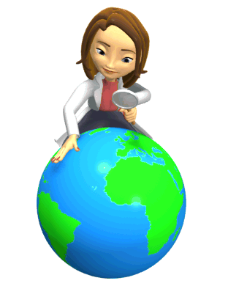

Case Study 1: Amazon Rainforest, South America
Case Study 2: Sahel Region, Africa



By the end of this unit;-
- you will have an awareness of the threats that face the Amazon and Sahel Regions of the World

You will know you have achieved this overall aim when you;-

- can locate the Amazon and Sahel Regions on the world map using an Atlas

- can describe the climate and vegetation of both regions

- have identified what life is like for the people of the Amazon and the Sahel

- understand the reasons why deforestation is taking place in the Amazon

- can explain why the Sahel is in danger of turning into a desert

- can provide solutions to overcoming the problems which affect both these regions

Climates around the world

Climate is the average weather of a place. It is a summary of what the weather is usually like, based on measurements taken over a long time, usually 30 years.

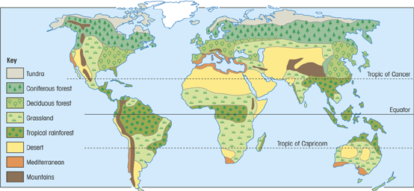
Climate varies around the world but we can divide the world up into climate zones. These are areas of the world that have a similar climate.

Why do places have different climates?
Latitude is the main factor in global climate. The further you go from the equator, the cooler it gets. Places on the equator receive the most direct and concentrated energy from the sun and the north and south poles receive the least amount of energy.

Climate and Ecosystems
What is an ecosystem?
An ecosystem is a community made of two parts:-
- Living things (plants, animals, bacteria)
- And their non-living environment (air, water, soil, climate, rocks)
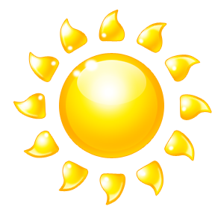
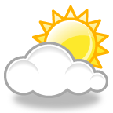
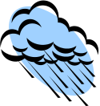
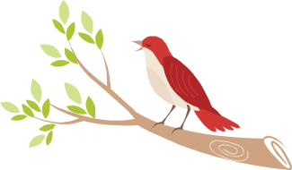
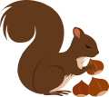
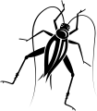
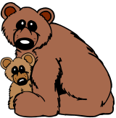
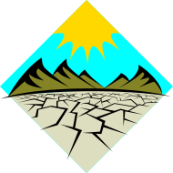
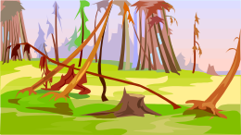
Energy from the sun
Climate
Living creatures
Rocks and soils
Vegetation
A simple ecosystem

Ecosystems come in a variety of sizes – from small ponds to whole rainforests. The largest ecosystems are called biomes.

How we humans fit in
Unlike most animals we’ve spread all over the world.
- We’ve moved into every ecosystem (although some climates do not suit us too well)
- Our numbers have grown quickly – there are over 6.4 billion of us
- We consume a lot. Over 40% of the plants now growing on Earth will be consumed by us and our livestock (cows, sheep etc)
- We use a lot of land. Not just to live on, but to grow food and provide water and fuels and dump waste and so on. Experts say we each ‘use’ 2 hectares of land (about 1.5 football pitches) in our lifetime. This is called our ecological footprint.

There are problems with this:
- The more land we use up, the less there is for the Earth’s other 6 million species
- As we’ve spread through ecosystems, we’ve tended to take over them – and drive many other species to extinction
- In places, we’ve treated the soil so badly that we have ruined it
- We burn a lot of fossil fuels and now we think this is causing global warming. That will affect every ecosystem on Earth.

We are going to look at two ecosystems of the world in detail:

- Amazon Rainforest in South America
- Sahel Semi -desert in Africa

For each area you will learn what the climate is like and how humans have used, damaged and are starting to repair these damaged areas.

My Global Footprint

http://footprint.wwf.org.uk/

Case study 1: The Amazon Rainforest, Brazil

Brazil lies on the eastern side of South America. It is bordered by the Atlantic Ocean on the east and the Andes Mountains in the west. Brazil lies on either side of the equator with most of the country in the Southern Hemisphere. Brazil is located 6,500 kilometres from the UK.

The largest rainforest in the world is called the Amazon Rainforest. Most of this rainforest is located within Brazil. This biome is often referred to as an Equatorial Rainforest.
What is the Amazon like?
L.O. - understand the impact modern life is having on the Amazon
I know I am there when;
  - I can describe what traditional life in the Amazon is like
  - I have identified ways I use the rainforest
  - I can explain how developments are harming the rainforest



The Amazon biome has an equatorial climate. All equatorial areas are found within the tropics (5º either side of the equator) and have a hot and wet climate all year round.


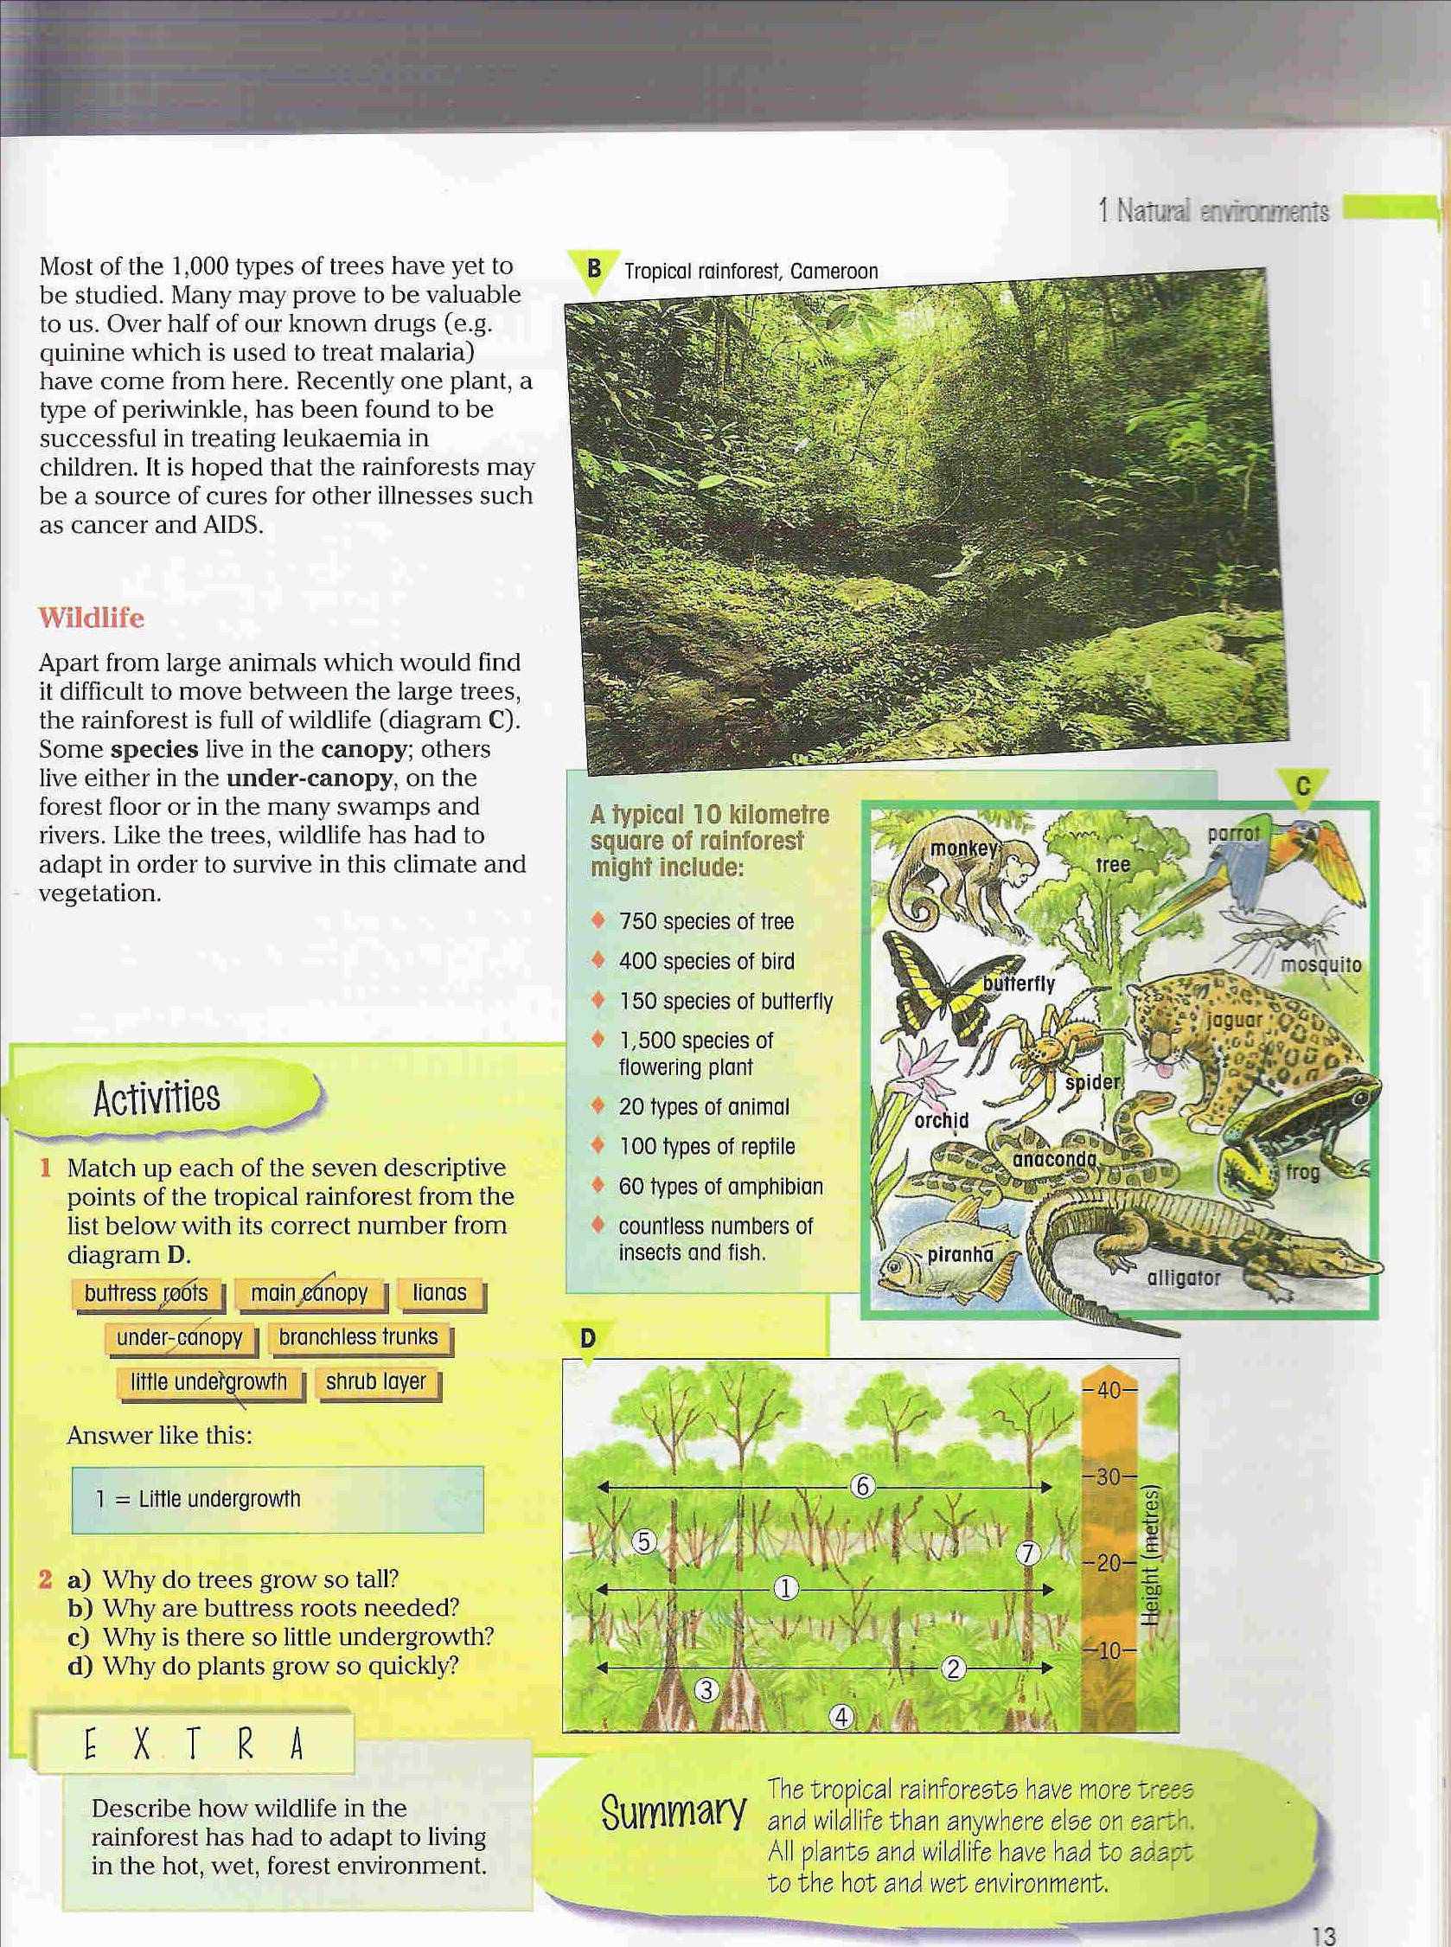
Take your copy of the rainforest structure and match up the seven features of a rainforest from the list below with its correct number from your diagram.
main canopy
little undergrowth

under-canopy

lianas

branchless trunks

buttress roots
shrub layer



*Check Point 1 – Rainforest in my home*
Some of the work has to be completed at home


Your teacher will give you a handout that explains the homework part of this task.

You will be assessed on your presentation of the material
you find at home – this can be completed in class


*Check Point 2 – BBC News Amazon Special*
This activity will allow you to work with others.

Group Task – Based on the information you
have gathered from the Amazon DVD your group
will be responsible for reporting live from the
Amazon on the reasons why the rainforest is
being cut down!

Case study 2: The Sahel Region, Africa

The Sahel is a semi-dry area in Africa. It forms a transitional (in between) zone between the dry Sahara desert to the north and the belt of humid tropical grasslands to the south. The Sahel stretches from the Atlantic Ocean eastward through northern Senegal, southern Mauritania, Mali, Burkina Faso, southern Niger, north-eastern Nigeria, south-central Chad, and into Sudan.
What is the Sahel Region like?
L.O. - understand the problem of desertification in the Sahel Region
I know I am there when;
  - I can describe what life is like in the Sahel Region
  - I have identified the human and physical causes of desertification
  - I know the ways to help overcome the effects of desertification

BBC Learning Zone
1500 – Expansion of the Sahara Desert

In the Sahel Region at least eight months of the year are dry, and rain only falls during a short wet season in June, July and August. On average the region only receives 100-200mm of rainfall per year. Sometimes the rains come in several downpours that just run off the surface of the soil while in other years there may be no rain at all!

What vegetation grows here?
Some areas of the Sahel region have semi-dry grasslands where there is low-lying grass, tall bushes, thorny shrubs and acacia and baobab tress. The area is very open to wind which means that it is difficult for tall trees to grow. It is also very difficult to grow crops because the soil can be very dry and crumbly, especially during the dry winter and spring seasons. When the soil is dry it can be blown away easily.
BBC Learning Zone
BBC 1501 – Desertification and Climate Change

What is life like in the Sahel Region?
The Sahel people are farmers. They are either Nomadic Farmers or Livestock Farmers.

Nomadic Farmers
Nomads wander from place to place with their herds of cattle, goats, camels and sheep in search of fresh grass and water. They measure how rich they are in terms of the number of cattle they have – they would rather have lots of skinny cattle than a few well-fed ones. This is not a good idea if the rains fail to arrive as there are too many cattle wandering over the Sahel lands.

Take the Heading “Life in the Sahel Region” and answer the following questions in full sentences.

1. Describe the way of life for a nomad
2. How do nomads measure their wealth?
3. Why is this bad for the Sahel Lands?

Livestock Farmers
These people live in villages and look after their herds of cattle, camels, sheep and goats. They also grow crops such as maize on the land using farming methods that have been passed down through the generations.

Rainwater is stored in wells and tanks during the wet season and is used to water (irrigate) the crops during the dry season.

If the rains fail to arrive then the farmers have to take their animals to distant waterholes. Sometimes there are too many animals around the one waterhole and it dries up. The animals also eat the grass around the waterhole leaving bare soil behind.

Goats can climb trees and if there is no grass they will go up a tree and eat the leaves. This can cause the tree to die and the lack of leaves means the sun can shine through the bare branches and dry out the soil below, which can then be blown away.

4. What effect do too many animals around one waterhole have for the Sahel lands?
5. What is irrigation?
6. Why is irrigation important in the Sahel?

What is happening in the Sahel Region?
We already know that in recent years the Sahara Desert has spread to take in some of the Sahel Region. This means that the semi-dry land of the Sahel has changed into a desert – this is called desertification and is happening all over the world.

The Sahara Desert is spreading because the Sahel soils are fragile, there is not a lot of plants growing and the climate is difficult to live in.

BBC Learning Zone
4322 – Burkina Faso
- What was the region like?
- What happens to the rivers during the dry season?

Causes of desertification
There are 2 main causes of desertification

Human causes
This is mainly about population growth. The population in most Sahel countries has risen rapidly mainly due to high birth rates (lots of babies being born) and people moving into these countries away from civil war in their own country. This has lead to overpopulation where there are too many people farming an area of land. There are too many animals grazing on the land and the people are forced to farm in areas which are not really suitable to grow crops as the soil is too poor or the land is too dry. This has meant that the soil has become exhausted and prone to desertification.

Physical causes
The rains have always been unreliable in the Sahel. From the 1940s to the 1960s there were wet years and dry years. For the 20 years after 1960 rainfall totals were well below average. More recently it has been suggested that the increased temperature due to global warming has meant that air can hold more water vapour and therefore there will be even less rainfall.

There are many reasons for the spread of deserts. In some areas the cause is physical (to do with nature) in others it is human (to do with people). In the Sahel it is a mix of both reasons

The Impact of Desertification

BBC Learning Zone
4323 – Local impact of desertification
- What happens to the land when villages grow?
- What is the land under pressure from?

Take the Heading “The Impact of Desertification”

Look at the physical factors on the flowchart on page 12 and answer the following questions

1. Why did the crop harvest fail?
2. What happened to the people when the crop harvest failed?
3. What were the trees used for?
4. What happened when the trees and grass were removed?

Look at the flowchart again and write a paragraph explaining how human factors cause desertification.

Human factors Physical factors
Population Increase
Plenty of food meant lots of babies were born and old people lived longer.
Less rain
The crop harvest failed and people started to go hungry.
Animals increase
People needed more of them for meat, milk and wool or leather.
Vegetation dies
The crops died and the animals ate all the remaining dry grass. The trees were bare of leaves and died too. The trees were cut for shelter and fuel.
Overgrazing
The animals ate all the grass and goats climbed the trees to eat the leaves.
Bare soil
The grass and trees were removed so the sun beat down on the soil and dried it up. The soil either got blown away or rain washed it away.
Desertification

Climate change
In the Sahel there were a number of wet years and lots of food could be grown.
Climate change
In the Sahel there were a number of wet years followed by a number of very dry years.

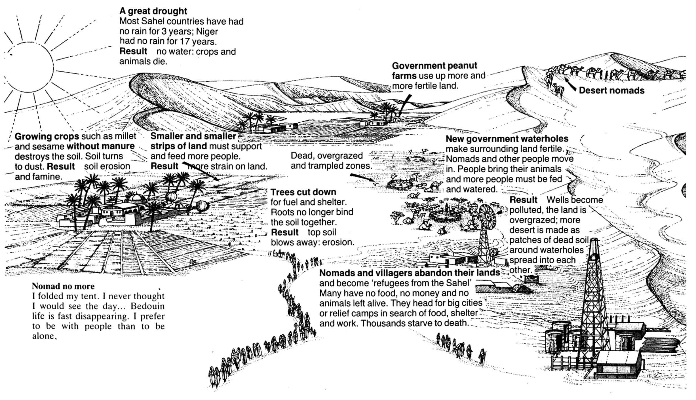
.

Collect your own copy of the above diagram from your teacher and complete it by colouring it in the show an area affected by desertification.

What can be done to help?

Humans can slow down or stop desertification. If they do this then they can again grow crops and keep animals in order to increase their food supply.

- Planting trees, especially as shelter belts, will stop the wind blowing the dry soil away. The tree roots bind the soil together and the leaves provide shade for the soil. Trees that have not been cut down should be protected from being cut down in the future.

- Planting grasses that grow well in dry soil and sand can help keep the soil from being blown away by the wind or washed away when it rains.

- Farming experts teach the people to use crop rotation, animal fertiliser and water from wells for irrigation so that they will grow more crops.

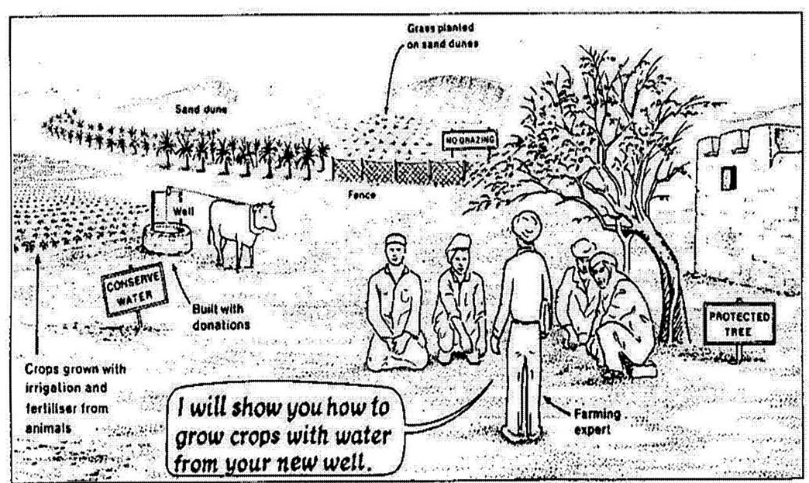
- It is important that young trees are fenced off to prevent grazing by animals and animals are fenced into other areas to prevent them grazing over large areas.


*Check Point 3 – Report to the United Nations*
This is an individual task to be completed in class and at home.

You should write a report to the UN based on recent work you have completed in the Sahel Region of North Africa.
Your report should have 4 main parts:-

- The main problem facing the region
- The main causes of desertification
- The impact of desertification
- Your solutions to dealing with the problem – including a diagram showing these solutions

The information on the next few pages will help you with your report. The diagram you should include in your report is below along with labels you can use to illustrate your solutions to desertification.
Plant trees for shade and roots bind the soil.
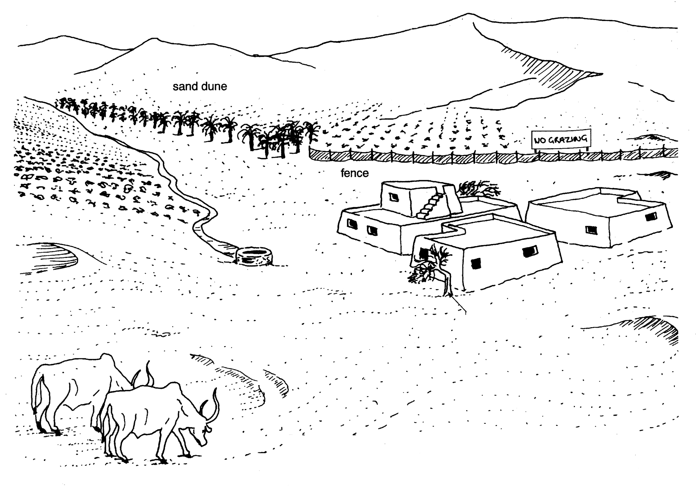
Protect trees as they provide shade.

Grow crops with irrigation water from wells. Water keeps the soil sticky and stops it from blowing away.
Build fences to stop grazing animals eating all the grass.
Plant grass on the sand dunes. Its roots bind the soil together.

Drought and Desertification
The United Nations estimates that by 2050 two thirds of the world’s population, mainly living in Africa, Asia and Latin America are likely to be short of reliable clean water. Few Economically Less Developed Countries (ELDCs) like those in the Sahel have the money or the technology to build dams to store the water that falls in the rainy season. Where dams have been built it has been with aid from foreign countries like Britain. Improvements to water supplies and farming systems have been mainly due to charity organisations such as Oxfam and Actionaid, which have helped local communities in the following ways:

- digging wells to reach permanent underground water supplies;

- lining the sides of the wells with concrete to stop the water draining away;

- using modern pumps to pump up the water from the deep wells; and

- introducing the people to new farming ideas that they would be able to manage.

*Check Point 4 – Climate Struggle Investigation Assessment*

This assessment will be completed in class

