Chryston
Primary School Handbook 2023/2024
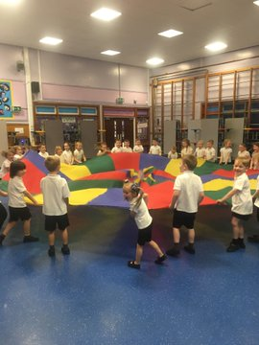
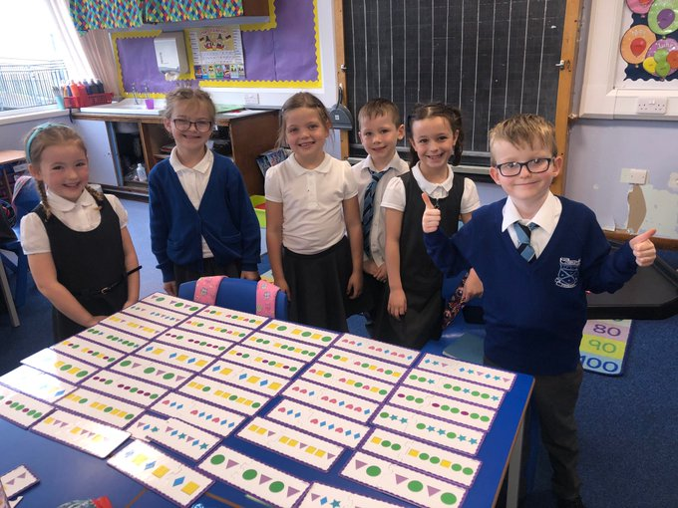

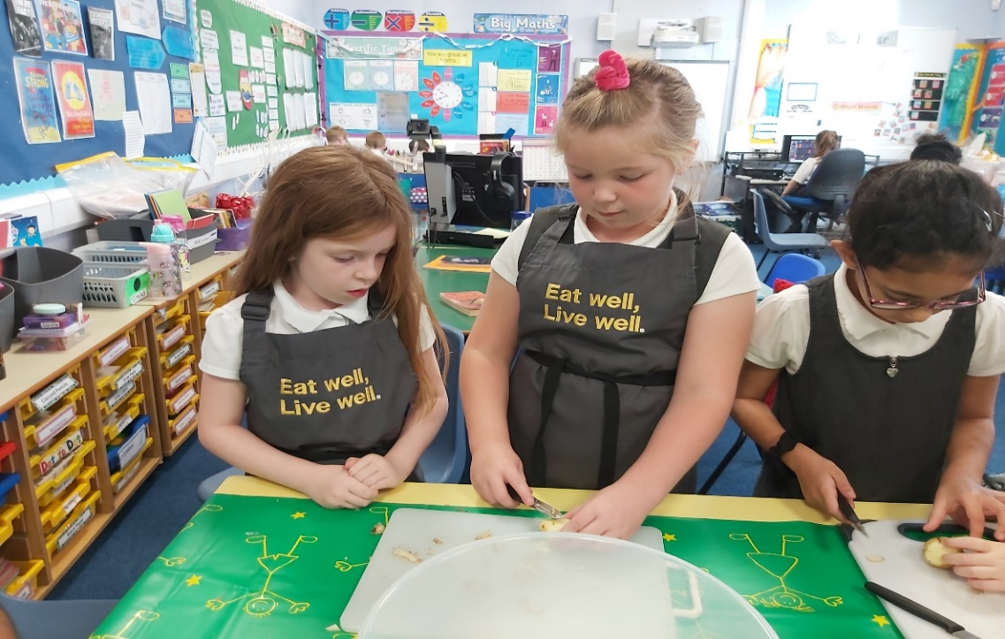

Contents
Page Number
- Introduction – Letter to Parents
- School Aims
- School Information
- Composite Classes, Management Team Remits, Staff
9. School Hours, Supervision in Non-Class Times, Out of School Care
- Enrolment, Placing Requests, Transfer from Primary to Secondary
- School Improvement
- HMIe, What is Curriculum for Excellence?
14. Capacities of Curriculum for Excellence
- Raising Achievement for all, Learning and Teaching, Transition Projects
- Curriculum for Excellence
- Literacy
- Numeracy and Mathematics
- Health and Wellbeing
- Social Studies
- Sciences, Technologies
- Expressive Arts
- Spiritual, Social, Moral and Cultural Values
- Homework
- School Community Links, Home, and School Links
- Out of School Hours Learning, School Discipline
- Anti-Bullying, Pupil Committees
- Additional Support Needs
32. Equal opportunities and Social Inclusion, Attendance at School
- Attendance and Absence Data
- Clothing and Uniform
37. Meals
38. Information in Emergencies, Transport
- Medical and Health Care
- Child Protection, Parents
- The Parent Forum,
- The Parent Council
44. Data Protection Act 1998
49. Photographs/Video Footage
50. Important Addresses
52. Glossary of Specialist Terms

Appendix
54. School Year 2023–2024

Introduction

Welcome
On behalf of our whole school community, I would like to welcome you and your child to Chryston Primary School. At Chryston, we aim to create a happy, safe, and stimulating learning environment for our young people. We are committed to ensuring that every child is effectively supported in their learning and their wellbeing which will enable them to develop skills for life, learning and work.
We have so much to be proud of in Chryston Primary School and this is evident in the positive ethos throughout the school. Relationships are at the heart of everything that we do and we strongly value the partnerships that we have in our school community.
This handbook contains a range of information that you might find useful and gives you a glimpse of life at Chryston Primary School. You will also be able to find out further information by following us on Twitter or accessing the school website. Please do not hesitate to contact us if you have any further questions.
We look forward to working with you and your child and hope that this will be the start of a strong partnership.

Jilly Moffat
Headteacher

Chryston Primary Vision/Values and Aims

Vision

Chryston Primary is a welcoming place of friendship and safety where all learners work to achieve their full potential in order that they make their best contribution to society.

Values
Work hard, be kind, and show respect.

Aims
- To create a positive environment for learning to take place
- To encourage positive behaviour
- To remove all barriers to learning
- To support all pupils to become independent learners
- To provide learners with the opportunity to plan for and reflect upon their own learning.
- To give all pupils a voice in the school
- To provide the opportunity to experience a variety of technology
- To become a central part of the Chryston community
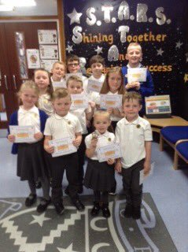
- To work in partnership with parents and the community to enhance learning

School Information  School name | Chryston Primary
Address | Lindsaybeg Road
 | Chryston
GLASGOW
G69 9DW
Phone number Email address | 01236 632136  enquiries-at-chryston-pri@northlan.gov.uk
Website  Twitter | www.chryston-pri.n-lanark.sch.uk  @ChrystonPrimary
Associated Secondary | Chryston High School
 | Lindsaybeg Road
Chryston
GLASGOW
 | G69 9DW
 | 01236 794890 or 01236 794898
Stages covered | Primary 1 - 7
Present Roll | 368
Present Class Structure | Primary 1a 21 Primary 1b | 23
 | Primary 2a 25 Primary 2b | 27
 | Primary 2/3 23 Primary 3 | 26
 | Primary 4a 27 Primary 4b  Primary 5a 25 Primary 5b  Primary 6a 29 Primary 6b  Primary 7a 29 Primary 7b | 29  26  28  30
Planning Capacity | Permanent – 217 Temporary - 434

Denominational Status Non-Denominational
Co-educational Status This school is co-educational

Letting procedures Application for lets of school premises should be made
Community Facilities Section
Coatbridge Community Centre
9 Old Monklands Road Coatbridge
ML5 5EA
Telephone: 01236 632778
Email : school&facilitybookings@culturenl.co.uk

Composite Classes
Composite classes are made up of children from more than one stage, e.g. P.6/7 class will consist of children from both P.6 and P.7. From time to time it may be necessary to form composite classes as described in the definition above.
Previously the school consulted with the School Board and parents to agree school policy for the criteria to be used when forming composite classes and it was agreed that ‘working groups’, based on language / math would be the determining factor. When forming a composite P.1/2, the age of the P.1 children may be the determining factor. For further information please request a copy of our Composite Class Parent’s Guide and www.northlanarkshire.gov.uk

Staff
Part of the National Agreement, “Teaching Profession for 21st Century”, stated that the maximum class contact time for teaching staff be reduced to 22.5 hours allowing 2.5 hours non-contact time from August 2006. Release from class will be timetabled on a weekly basis.

Management Team

Head Teacher: Mrs Jilly Moffat
Remit Overall responsibility for the management of the school
Formulation and monitoring of school policies
Structure and balance of the curriculum
Raising Achievement and attainment for all
Learning and Teaching
Self-Evaluation
Child Protection coordinator and GIRFEC Named person
Planning for and assessment of learning
Improvement Planning: School Improvement Plan, School Improvement Report
Promoting Inclusion
Whole school discipline and ethos
Staffing: Appointment and deployment of all staff
Professional review and Development of staff
Development of staff roles.
Coordinator for student teachers
Coordinator for Probationers
Tracking & Monitoring: Forward plans, learning and Teaching, class work, pupil progress and through self- evaluation
Management of resources: DSM Budget, School Building, School fund
Health and safety, School security
Adviser: Parent Council, Parent Association, Pupil Groups
Liaison: Associated Pre 5, Primary and Secondary establishments
Psychological service, Social Services and Partnership Agencies
Communication: Newsletters, School Handbook
All other management issues.

Acting Depute Head Teacher: Lorraine Fleck
Remit Pastoral Support Primary 1-7
Additional Support Needs Coordinator
Depute Child Protection Co-ordinator
Community links co-ordinator
Tracking and monitoring PEF
Deliver school-based in-service linked to curriculum and school improvement
Lead curricular change as identified in the School Improvement Plan
Develop teamwork within the school by co-operating with colleagues and leading by example.
Curricular Responsibilities: Health & Wellbeing, Literacy
Probationer Support
Active School coordinator link and Extra Curricular timetable
Literacy Champion
Supporting Head Teacher with Nursery/Primary transition

Principal Teacher: Linda McIntyre
Remit Teaching Commitment, where timetabled
Pastoral Support Primary 1-7
Deliver school-based in-service linked to curriculum and school improvement
Lead curricular change as identified in the School Improvement Plan
Develop teamwork within the school by co-operating with colleagues and leading by example.
Curricular Responsibilities: Health & Wellbeing, Literacy
Resources
Probationer Support
Active School coordinator link
Literacy Champion
Supporting Head Teacher with Nursery/Primary transition

Both Depute and Principal Teachers are responsible to the Head Teacher

Teaching staff (Session 2022 – 23)

(Total Number of Teaching Staff – 17.44 FTE)

P1a Mrs Kirsty Oliphant
P1b Miss Katie McLure
P2a Miss Taylor Wengenroth/Mrs Gemma Noble
P2b Mrs Erin Ross
P2/3 Miss Ashleigh Lamont
P3 Miss Emily Heneghan
P4a Mrs Suzi Cornwell/Mrs Liz Mutch
P4b Mrs Jasmine Campbell
P5a Mrs Kathryn Kinloch
P5b Miss Debbie MacGregor
P6a Mrs Deborah Duncan/Mrs Kirsty Whyte
P6b Mr John Furlong
P7a Miss Mikaela Anderson
P7b Mrs Fiona White

Non-Class Contact Cover and Support

Mrs Carolann Coventry

Mrs Linsey McTier

Mrs Karen Murray

Mrs Gemma Noble

Miss Caitlin Paton

Non-Teaching Staff

Classroom Assistants | ASNA | Office Staff | Catering/Cleaning | Janitor
Mrs. Anne McLoone | Mrs. Geraldine Hansen  Mrs. Margaret Ross  Mrs. Francesca Moyes-Feeney  Mrs. Claire Webster | Mrs. Margaret McLaren  Mrs. Jennifer Troup | Mrs. Agnes Brady  Miss. Angela Carmichael  Mrs. Tricia Kidd  Mrs. Josie Gracie  Ms. Jacqueline Ward  Mrs. Fay McAllister | Mr. Barry Grant

SCHOOL HOURS

The school opens each day at 8.50 and closes at 3.00pm. Our Primary 1 children will attend full time from first day of the session. On the first day you will be advised of the Start/End times for that day only.
- Open 8:50am
- Break 10:20am – 10:35am
- Lunch 12:05pm – 1:00pm
- Close 3:00pm

Breakfast Club
Breakfast Club is open to all pupils every school day starting at 8:15am until 8:45am. Pupils should arrive no later than 8:35am to allow them time to eat their breakfast. Primary 1-5 pupils are included in the free school meals and for Primary 6 & 7 the cost is £1/child, £1.50/2xchildren, and £1.80/3xchildren. Options are toast with/without butter, cereal with/without milk, milk or water to drink.

Supervision in Non-class Times
During non-class times children are supervised by Classroom Assistants, Janitor, office staff and overall, by members of the Management Team.
In line with the ethos of Curriculum for Excellence, our Primary 7 pupils are involved in mentoring younger pupils and are therefore available during non-class times to give support.
An adult presence is provided in playgrounds from 8:45a.m and at break times in terms of the schools (Safety and Supervision of Pupils) (Scotland) Regulations 1990. In Chryston, our SMT, Janitor, Classroom Assistants and Additional Support Needs Assistants provide supervision of the playground at various times throughout the day.

Out of School Care
After school care facilities linked to the school are called POMP which stands for "Peace of Mind for Parents" and FAST out of school care.
Children will be collected from the school at 3.00pm. POMP is in CHS and FAST is in St Barbara’s
For further information on After School Care please contact: POMP 01236 721382
FAST 07824884601
KIDZ OUT 07588210366

Enrolment
Children who are starting school for the first time are normally enrolled or registered in January. Advance notice of the actual dates will be placed in the local press and information will be available from local nurseries and playgroups. Notice is also given through school newsletters, website, and twitter.
Parents wishing to see round the school should contact the Head Teacher, to arrange a suitable appointment time.
Parents who need a place for a child at any other time of the school year should contact the Head Teacher to discuss availability and to make arrangements to visit the school.

Transition from Nursery

We work closely with our partner nurseries to ensure a smooth and purposeful transition for all children and parents. Staff in Nursery and Primary share learning experiences and children’s work.
We have a broad transition programme in place at Chryston Primary, arranging for three visits to the school in the summer term. At these we aim for children to meet their teacher and become familiar with the school environment. Children and parents are also asked to come and try school lunch. There is also an opportunity for parents to hear more information about the school, our uniform and what the first days and weeks will be like.

Placing Requests

You have the right to make a placing request for your child to be educated in a school other than the local school. In December each year, the authority will advertise its arrangements for placing requests. There are sound educational reasons for trying to ensure that the transfer or admission of children to a school takes place at the start of a school session.
Other than those who are moving home, to a new area, parents are advised to time any placing requests so that they take effect from the beginning of the new school session. Every effort will be made to try to meet the parental wishes, but you should note that it is not always possible to grant every placing request to a particular school.

Placing requests to a primary school does not necessarily ensure that your child will have a direct entry into the associated secondary. Advice on this must be sought from the primary school Head Teacher. All placing requests details and procedures are available from the school or the council’s website.

Parents and Young People have a right under the Additional Support for Learning Act 2009 as amended by the Education (Additional Support for Learning)(Scotland) Act 2009 to make a placing request for their child or young person to attend nursery (including partnership nursery),special school or special class managed by the home authority. In the event of a successful placing request the authority is not required to provide transport.
The Act also enables parents and young people to make a placing request to attend a school/establishment belonging to another authority.

Transfer from Primary to Secondary
Pupils normally transfer between the ages of 11 ½ and 12 ½, so that they will have the opportunity to complete at least 4 years of secondary education. Parents will be informed of the arrangements no later than December of the year preceding the date of transfer at the start of the new session.
Pupils from Chryston Primary normally transfer to: -
Chryston High School
Lindsaybeg Road
Chryston
GLASGOW
G69 9DL
Tel: 01236 794890 or 01236 794898
Chryston Primary has very good relations with Chryston High and its staff and pupils. Links are strong in curricular continuity and transition procedures, and these are reviewed annually to ensure the highest quality of service and smooth transition for pupils and parents.

School Improvement
All schools in Scotland are required to devise an improvement plan as a means of managing change and planning for major development initiatives. Following audit, including consultation with parents, pupils, and staff, and taking into consideration national and authority targets, priorities are identified. Below are the school’s current priorities, some of which will continue into session 2021-2022.
 | Current Improvement plan Priorities
Priority 1 | Raising Attainment and Achievement – specific improvement in writing by increasing pupil engagement and relevance
Priority 2 | Improvement in children and young people’s health and wellbeing with a focus on mental health and wellbeing.
Priority 3 | Establish a digital pedagogy across all stages of the curriculum, which engages learners and delivers a high quality learning experience for all children and young people.
Priority 4 | School leadership resulting in improved learning, teaching, assessment, and inclusion.
Our school audits and self-evaluation will be completed throughout the school session. These will identify our priorities for the next session.
Annually we produce a school improvement report, which details the improvements and developments the school has made. This report also has an impact on our future priorities. We issue a summary of this report to parents annually and copies are available from the school office on request. Further information on national developments can be found at www.educationscotland.gov.uk

H.M.I.e.
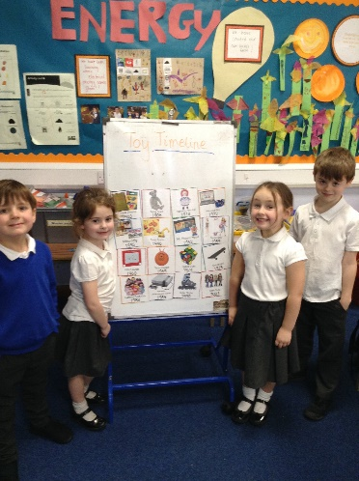
H.M.I.e. completed an inspection of Chryston Primary in December 2008. The inspection report was published in March 2009 and identified several major strengths within the school.
The follow up report to this inspection was completed in 2012, detailing the schools’ continued progress. This was completed by the Head Teacher.

What is Curriculum for Excellence?
Curriculum for Excellence is Scotland’s national curriculum. It provides a coherent and inclusive curriculum from 3-18 years wherever learning is taking place, including early learning childhood centres, schools, colleges, and community learning. It places children and young people at the heart of Scottish Education.

he purpose of Curriculum for Excellence is encapsulated in the four capacities – to enable each child or young person to be:
- a successful learner
- a confident individual
- a responsible citizen and
- an effective contributor

These four capacities govern the entire curriculum from age 3 to 18 and aim to raise the standards of achievement for all learners.
Curriculum for Excellence is underpinned by the values inscribed on the mace of the Scottish Parliament – wisdom, justice, compassion, and integrity.

Throughout Curriculum for Excellence there is a strong focus on Literacy, Numeracy and Health and Wellbeing across all aspects of learning and every teacher will support learners with the development of these, including digital literacy skills.

Curriculum for Excellence is defined as:
The totality of all that is planned for children and young people throughout their education’.
The opportunities for learning and teaching are governed by the Four Contexts for Learning, which ensure that the education your child receives is informative, interesting, relevant and fun.

These contexts are:
- Ethos and life of the school as a community
- Curriculum areas and subjects
- Interdisciplinary learning
- Opportunities for personal achievement.

What is the Curriculum for Excellence levels?
There are five levels, and these are flexible depending on pupils’ needs and abilities (some children and young people may achieve these levels earlier or later dependent on ability):
- Early level pre-school to P1
- First level to the end of P4
- Second level to the end of P7
- Third and fourth levels S1 to S3
- Senior phase S4 to S6 and other forms of study

What is the Broad General Education?
The Broad General Education (BGE) is the first phase of two closely connected phases of education. The BGE phase stretches from age 3 until the end of S3 after which learners move into the Senior Phase which starts in S4.

Curriculum Areas and subjects
The BGE is delivered via 8 curricular areas which, in secondary school cover years S1 to S3, and may be subdivided further into individual subjects.
The 8 curricular areas are:
- Expressive Arts
- Languages and Literacy
- Health and Well Being
- Mathematics and Numeracy
- Religious and Moral Education
- Sciences
- Social Studies
- Technologies.

The Senior Phase
The senior phase curriculum, from S4 to S6, follows a young person's broad general education, building firmly on the experiences and outcomes they will have experienced and achieved by the end of S3. It enables them to extend and deepen their learning and continue to develop skills for learning, life and work, through qualifications and also through a range of opportunities for personal development such as awards and wider achievements. It is designed to support young people in moving on to positive sustained destinations, whether that is college, university, training or employment. In the Senior Phase, schools and their partners ( such as colleges, employers or community learning and development providers) now have flexibility to offer a range of pathways that meet the needs and raise the attainment levels of all learners – including pupils who might previously have become disengaged from education.
Schools are taking a range of approaches to the senior phase and are able to offer greater personalisation and choice for young people in a variety of ways, for example by:
- designing the senior phase as a three-year experience rather than planning each year separately
- delivering qualifications over different timescales in response to young people's needs and prior achievements
- developing pathways for able learners, which bypass qualifications at lower levels to allow more time to be spent on more challenging learning at higher levels
- providing specific and appropriate programmes that maximise achievement and attainment for young people planning to leave after S4.

Personal Support/Career Planning
From 3-18 years, learners are supported to achieve their full potential and, as they progress through broad general education into senior phase, to plan and prepare for further learning, training, or employment. All schools and nurseries in North Lanarkshire are working hard to raise standards so that children and young people will develop all the skills necessary to continue to be successful when leaving school and entering the world of higher education, training, or work. As part of developing skills for learning, life and work, young people will be offered careers information advice and guidance to ensure they leave school and enter a positive post-school destination of higher education, further education, pre-employment training, employment (including modern apprenticeships), activity agreement or volunteering.

Assessment and Reporting
Assessment is an important part of the Curriculum for Excellence and, at all levels, pupils’ progress is closely monitored by teachers and staff.
In turn, teachers and staff work with pupils to reflect on their results, looking at their strengths and learning needs, agreeing next steps and action based on these. As they progress, pupils become more involved in this process, as they develop the skills to make effective judgments on their own learning, developing personal expertise that will be important to them throughout life. Assessment also helps teachers plan learning experiences which are motivating and challenging. Children who may have additional support needs will be assessed using methods best suited to their individual requirements.

In Chryston Primary School assessment is an integral and ongoing part of teaching and learning, and pupils are continuously assessed in an informal way as part of the daily class routine. Teachers and children use a range of formative assessment strategies to assess progress and plan next steps.

At other times, standardised assessments may be used to help teachers assess pupil progress, to identify any strengths and diagnose any barriers to learning. Pupils in P1, P4 and P7 complete a Scottish National Standardised Assessment each year. Other summative assessment are used with individual children over the course of the year to determine benchmarks and help map a way forward. All parents will receive a written school report each year in June. This will indicate pupil’s progress in all areas of the curriculum. There will also be two parent progress meetings one in October and the other March.

Raising Achievement for All

Raising Achievement for All forms the overarching strategy for the service. Subtitled ‘Experiences to Last a Lifetime’, this strategy aims to harness the combined forces of Learning and Leisure Services to provide a rich set of learning opportunities and experiences for young people and adults which begin in the classroom, nursery or learning centre and extend out into the community and the wider world beyond. In seeking to offer ‘Experiences to Last a Lifetime’, we will also look to draw upon ‘a lifetime of experiences’ already there in the communities which make up North Lanarkshire.”

Learning and Teaching
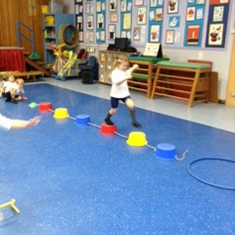
At Chryston Primary the curriculum is planned to provide a well-balanced curricular programme which will give equal status to Mathematics, Languages, Sciences, Social Studies, Technologies and Expressive Arts. Religious and Moral Education and Health and Well Being are very important aspects of the 3-18 curriculum where multi-cultural emphasis is introduced into classroom teaching.
The curriculum is taught in a cross curricular or interdisciplinary manner to allow pupils to understand the links to life
skills and use their knowledge and skills across their learning. We do however teach aspects of the curriculum in a discrete manner when a focus on specific skills is required.

Active, engaging learning is central to the teaching approach at Chryston Primary, we therefore ensure this is an integral part of all subjects. All our staff are committed to Co-operative Learning strategies which are implemented from Primary 1 to Primary 7.

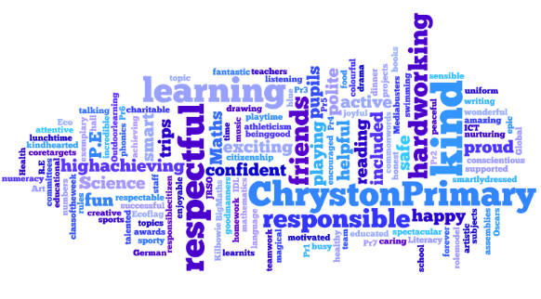
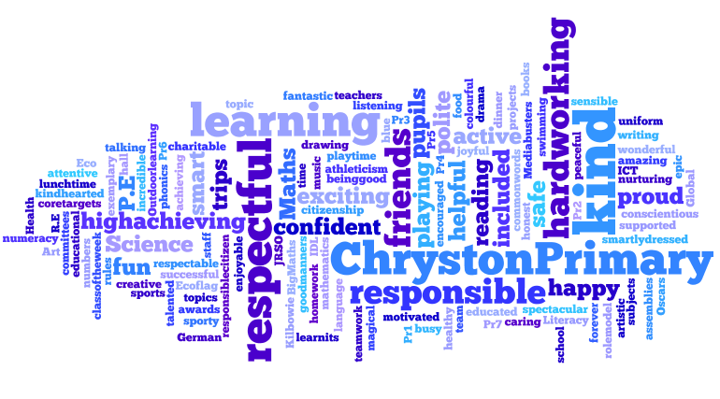The Curriculum for Excellence

Importantly Literacy, Numeracy and Health and Wellbeing are given added importance because these skills are so vital in everyday life. All teachers will have responsibility to teach Literacy, Numeracy and Health and Wellbeing.

Our curricular areas consist of the following: HEALTH and WELLBEING
Mental & Emotional Wellbeing Social Wellbeing
Physical Wellbeing Movement& Skills Nutrition
Safety & Hygiene

LITERACY and ENGLISH
Listening
Talking Reading Writing
Literacy across the curriculum

Modern Languages (German)

NUMERACY and MATHEMATICS
Number, Money and Measure Shape, Position and Movement Information Handling
Numeracy and Mathematics across the curriculum

SCIENCE
Planet Earth
Forces, Electricity & Waves Biological Systems Materials
Topical Science

SOCIAL STUDIES
People, past events & societies People, place & environment
People, society, economy & business

TECHNOLOGIES
Technological developments in society ICT to enhance learning
Business Computing science Food & textiles
Craft, design, engineering & graphics

EXPRESSIVE ARTS
Art and Design Drama
Music Dance

RELIGIOUS and MORAL EDUCATION
Beliefs
Values and Issues Practices and Traditions

Literacy and English

Active Literacy
At Chryston Primary School we have implemented North Lanarkshire's Active Literacy Programme to raise attainment and develop literacy skills. Children are taught using Phonics, Spelling, Daily Writing and Guided Reading.

As the children develop their reading skills, they progress using reading books split into different levels. Each child’s progress will be at their own level using a range of texts. As children develop, reading will include more challenging text such as novels and chapter books. Each child will work on a variety of books/novels, class books, non-fiction, media, and poetry each session.

We encourage children to make use of the class libraries and the Chryston Cultural Centre, based in the Chryston High School Building. Pupils will gain experience of using a variety of skills in reading different types of text. We value the help from parents in encouraging children to read regularly and supporting the reading homework, hearing your child read and ensuring they have their book with them every day.

Writing
Pupils are involved in both daily writing and weekly taught writing lessons using different genre skills. These are then used across different curricular areas and writing for a real-life purpose. All writing is part of our Active Literacy approach.

Children need to express themselves in different written formats and for different purposes. They are given the opportunity to express their own ideas and opinions or for a more practical purpose, to learn the skills for letter writing, completing forms, etc. This is done within a context as this gives relevance to the tasks and children are motivated because they are interested and involved.

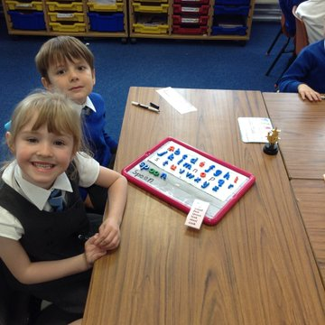
A number of methods are used to improve sentence structure, spelling, punctuation, and use of vocabulary. These are not taught in isolation but are part of an integrated approach to ensure accurate and fluent expression.

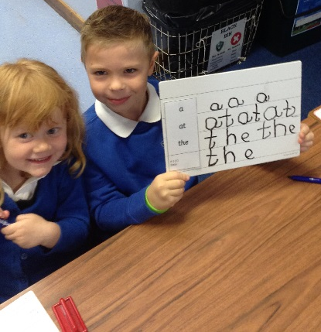
Spelling
Rules and strategies for spelling are developed
through the teaching of initial sounds
and then their blends, known as phonics. From
Primary 1 children are taught using magnetic boards to Make, Break, Blend, Say and Write their words.
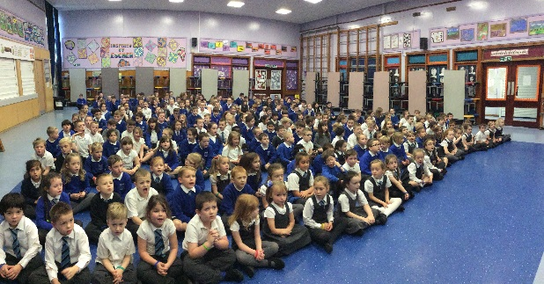
As the children progress through their learning, they will consolidate this learning by introducing new blends and understanding similarities and differences in groups of sounds.

The spelling of common words is also taught. In the early stages, these will be words that will support the children’s writing and reading of text. Words will increase in difficulty as the learning progresses. However, there will be consolidation and personalization of spelling built in, as children assess their own writing and identify words they may need to revisit. Primaries 3-7 will be assessed using the Single Word Spelling Test each year. Progression and support will be further developed in these stages.

Listening and Talking
In the classroom children are taught to be active listeners. Listening skills are developed through every aspect of the curriculum.

It is through discussion and talking together that children make sense of their learning. Many opportunities are planned for children to talk in pairs, groups, with the teacher and other adults.

Modern Languages
German is the modern language taught at Chryston Primary School. We work in partnership with Chryston High to teach German to Primary Seven on a weekly basis.
This ensures a smooth transition to their Modern Languages department. Children cover a range of topics in Primary 7 which will extend their vocabulary.

In order to implement the principles of the Scottish Government focus 1+2.
German is also now taught across all other stages of the school. We also employ a soft start approach to introducing French as a second foreign language through songs and video clips at assembly.

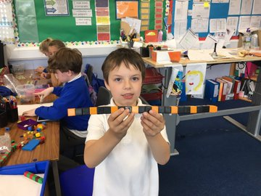
Numeracy and Mathematics

Chryston Primary School is committed to delivering dynamic and purposeful learning opportunities, which demand active involvement and develop independence and pupils’ responsibility for their learning within mathematics and numeracy.

As part of the ongoing work at Chryston Primary School, your child will experience the three main outcomes in Numeracy and Mathematics to ensure they become successful learners, effective contributors, confident individuals, and responsible citizens.

The three main outcomes, which form the areas for learning and teaching in our Mathematics curriculum are:
- Number, Money, and Measure
- Shape, position, and movement
- Information Handling

Each of the three main outcomes each contain a number of subdivisions
Number, money, and measure is made up of:
- Estimating and rounding
- Number and number processes
- Multiples, factors, and primes
- Powers and roots
- Fractions, decimal fractions, and percentages
- Money
- Time
- Measurement
- Mathematics – its impact on the world past, present and future
- Patterns and relationships
- Expressions and Equations
Shape, Position and Movement includes:
- Properties of 2D and 3D objects
- Angle, symmetry, and transformation.
Information handling consists of:
- Data and analysis
- Ideas of chance and uncertainty

The experiences and outcomes encourage learning and teaching approaches that challenge and stimulate pupils and promote their enjoyment of Mathematics. To achieve this, teachers will use a skillful mix of approaches and resources such as Number talks, Big Math’s and Heinemann Active Math’s. ICT is widely used to enhance pupil learning.

Health and Wellbeing

Learning in Health and Wellbeing ensures that children and young people develop the knowledge and understanding, skills, capabilities, and attributes which they need for mental, emotional, social, and physical wellbeing now and in the future. Learning through Health and Wellbeing enables children and young people to:

- make informed decisions to improve their mental, emotional, social and physical wellbeing
- experience challenge and enjoyment
- experience positive aspects of healthy living and activity for themselves
- apply their mental, emotional, social, and physical skills to pursue a healthy lifestyle
- make a successful move to the next stage of education or work
- establish a pattern of health and wellbeing which will be sustained into adult life, and which will help to promote the health and wellbeing of the next generation of Scottish children

It also enables some to perform at high levels in sport or prepare for careers within health and leisure industries.

As part of the Health and Wellbeing programme staff and pupils will also explore subjects such as Personal Safety, Relationships, Sexual Health and Parenthood Education, Drug and Alcohol Abuse, Road Safety, anti-bullying, Keeping Healthy, etc. We run a parental workshop annually to support the teaching of Relationships, Sexual Health, and Parenthood Education. Letters will be issued to all parents giving prior information before children develop in this learning. All materials used are available for parents to see.
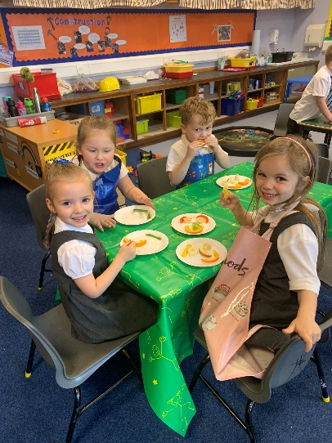
We have already gained North Lanarkshire’s Gold Health Promotion award for the work which we do in school, and we are committed to continuing this good practice. As part of this health promotion work our pupils receive high quality health education and take part in a range of activities throughout the year including sport taster sessions, visits from our dental hygienist, a variety of after school clubs and opportunities to prepare healthy food.

Physical Education
All pupils have two hours of P.E. each week. This provides them with opportunities to develop physical skills, encourage confidence and
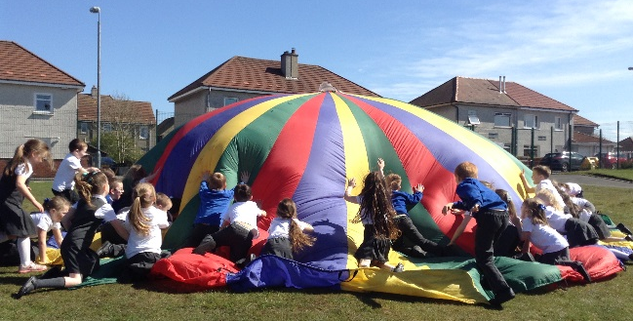
co-operation with others and to foster a positive attitude to health and fitness.

Social Studies
In Social Studies children learn about the world around them, both now and in the past (locally and globally) and develop the understanding, skills, and attitudes necessary to interpret it. Children are encouraged to make informed decisions about their own behaviour. Positive and caring attitudes are fostered using problem solving, decision making and practical action.

Children are encouraged to learn in a variety of ways, through explanation, enquiry, activity and discussion. They also learn in a variety of settings within and beyond the classroom. Social Studies also provide a context for and brings relevance to learning across the curriculum. Children are taught how to develop enquiry skills in researching, recording, planning, and evaluating.

Our programmes of study are devised to ensure balance and progression throughout the school and Experiences and Outcomes of learning and to ensure an appropriate balance of knowledge and understanding and enquiry skills.

Educational visits are arranged, where appropriate, to support and enhance the learning and teaching in Social Studies. Likewise, members of the community and visiting specialists add practical and personal contributions to our many programmes of study.

Sciences

Science is an important part of our heritage which we use every day in our lives at work, in the home and when we have leisure time. Through learning the Sciences, children develop an interest and an understanding of the living, material, and physical world.

We place a strong emphasis on the development of children’s understanding
and their ability to be able to evaluate critically. We feel that how children learn is as important as what they learn. Children are being encouraged to learn by being involved. The key words are activity, enquiry, and critical evaluation.

Science learning is approached through an integrated topic which makes natural links with other areas of the curriculum, like our development of Environmental issues through plants and animals. There are however times that Science must be a subject on its own e.g.: the teaching of Practical Investigations. As with all curricular areas we teach using Active / Co-operative Learning strategies to ensure pupils are involved in their own learning.

We use North Lanark’s Science programme at Chryston Primary, ensuring we use active and co-operative teaching learning techniques that take account of the Curriculum for Excellence experiences and outcomes.

Technologies
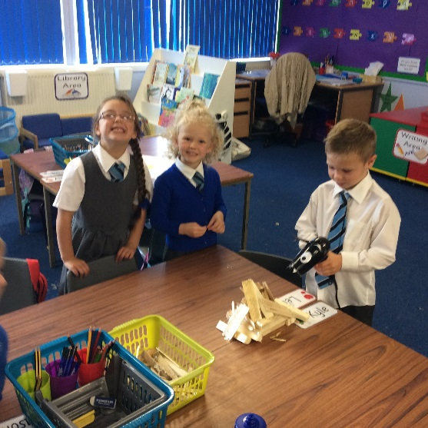
Children are taught Technology to ensure they develop the knowledge and skills to extend their capabilities.
Technology has a profound effect on society and children need to have a strong foundation of technology which they can build on in the future. Learning in technologies enables children to be informed, skilled, thoughtful, adaptable, and enterprising citizens.

At Chryston Primary, Technologies has six areas which are:
  - Technological developments in society
  - ICT to enhance learning
  - Business
  - Computing Science
  - Food and Textiles
  - Crafts, design, engineering, and graphics

ICT to Enhance Learning

Chryston Primary School has a fully balanced programme of I.C.T. implemented throughout the school which includes use of the Internet and the Scottish Intranet site, Glow. Children can access Glow both in school and at home.

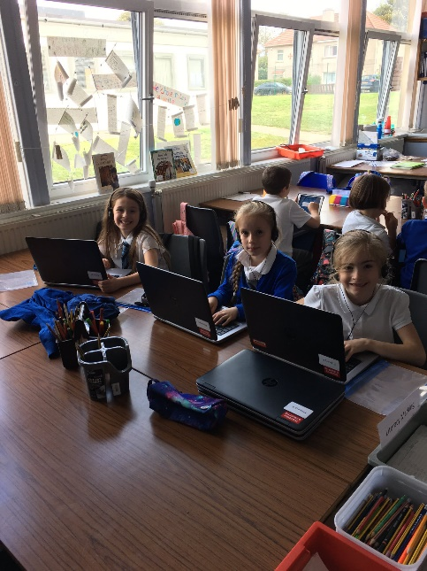
At Chryston Primary School, we are committed to promoting quality in learning and teaching for all through the effective use of I.C.T. across the curriculum. P7 pupils complete a profile which is shared with the receiving high school.

As well as providing our young people with the skills they will need in later life, we provide all members of staff opportunities for personal development in ICT to enrich and enhance the learning process. To develop broad skills, we make use of a broad range of ICT hardware; laptops, iPads, Interactive Smart Boards and Promethean Boards.

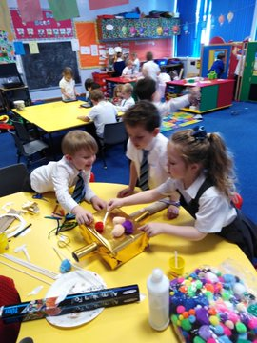
Expressive Arts

Art and Design
Through Art and Design, children are encouraged to express themselves visually and to appreciate and enjoy their own and the work of other artists. Their imaginations are stimulated through various mediums,
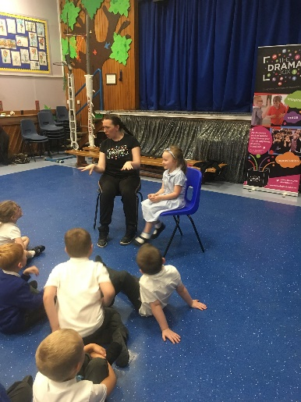
  - music, poetry, the work of famous artists, etc. All children are encouraged to develop their creative talents through participating in activities, which include the use of different materials, e.g., paint, and collage work, plasticine, and clay. By displaying children’s work, we develop a sense of pride and achievement

Drama
Children from their earliest years use imaginative play to explore, order and make sense of themselves and the world about them. Drama extends and builds on this
natural process and helps to build confidence and self-esteem. To help develop a range of dramatic techniques and skills, children have the opportunity to role play, improvise, and use movement and mime, use sound to express their own and others’ ideas. The opportunity to develop these skills often arises through other curricular areas and in Chryston these can be linked to topic and language work.

Music
Our aim in music is to foster a lasting interest in and enjoyment of musical skills. In Chryston all children have the chance to realise their full potential, whatever their musical talents and abilities. Activities to encourage this may include listening and responding to music, making, and inventing their own music by using instruments which are available in the school, and singing modern and traditional songs.

Dance
Through dance, learners have rich opportunities to be creative and to experience inspiration and enjoyment. Creating and performing will be the core activities for all learners and taking part in dance contributes to their physical education and physical activity. Learners develop their technical skills and the quality of their movement and use their imagination and skills to create and choreograph dance sequences. They further develop their knowledge and understanding and their capacity to enjoy dance through evaluating performances and commenting on their work of others.
In all areas of Expressive Arts, we make purposeful use of ICT to enhance the children’s experiences

Spiritual, Social, Moral and Cultural Values
Religious Education makes a distinctive contribution to the curriculum in helping pupils towards a consistent set of beliefs, attitudes, and practices within our own community and beyond. Religious and Moral Education is taught in Chryston with these broad aims in mind and reflects council and national policies as set out by the Education (Scotland) Act 1980.
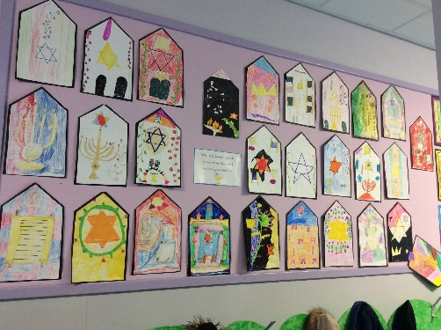
We have a structured programme, which is taught by class teachers and includes input from the school chaplain.
Included in our R.E. programme is the study of Christianity and other world religions. This encourages harmony, appreciation, and consideration for the beliefs of others.
While studying R.E. classes may make visits to local churches and other sacred buildings.
It is recognised that the Education (Scotland) Act 1980 allows parents to withdraw their children from any religious instruction and observance, and parents wishing to do so should contact the Head Teacher, in writing, to allow any arrangements to be made.
Parents/Carers from ethnic minority religious communities may request that their children be permitted to be absent from school to celebrate recognised religious events. Only written requests will be considered. Appropriate requests will be granted on not more than three occasions in any one school session and the pupil noted as an authorised absentee in the register.
Through our curriculum children are given opportunities to become responsible citizens who have respect for others and a commitment to participate responsibly in political, economic, social, and cultural life within their community. They can develop knowledge and understanding of the world and Scotland’s place in it, understand different beliefs and cultures and make informed choices and decisions.

Homework
Due to current restrictions, homework continues to be delivered digitally through Glow Teams. It provides an opportunity for the children to reinforce prior learning while at the same time improving and enhancing their digital skills. Homework or shared learning aims to inspire children’s learning at home and be the learning link with parents. Our homework experiences will develop curricular and social skills. Our homework has been designed to give importance to the quality and nature of children’s learning and provide opportunities for personalisation and choice.

Our specific aims of homework for Primary One to Three are:
- Practice reading aloud with parents/carers each night.
- Practice their common words and sounds.
- Share current learning
- Complete work to the same standard as in class.

Our specific aims of homework for Primary Four to Seven are:
- Use their curricular skills in their homework building on current learning being taught in class.
- Through the use of novels, develop their personal reading skills.
- Complete work to the same standard as in class.

It is our wish that parents and carers will:
- Hear their child reading nightly, particularly at P1-3.
- Supporting their child and the school to ensure homework is completed at home to reinforce and consolidate prior learning.
- Contact school if they have any concerns regarding homework.
- Evidence tasks by including a photograph, a drawing or writing a short description.
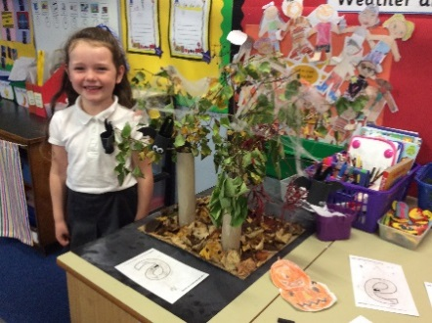
- Assess their child’s learning once a term, with their child through Snapshot jotters *

School Community Links
The school is an important feature of the local community and as such we work hard to foster good relationships amongst the members of our community. Children, as part of their work, will be involved in exploring their environment and we are always keen for people in the community to offer their expertise to enrich this work. Members of the community, whether parents or not, are welcome to visit the school to view the work that is going on.
The children are encouraged to get involved in the community by taking part in projects involving the community e.g.: concerts, visiting and entertaining senior citizens.
The school has business links with the local Co-operative Store as part of our Enterprise initiatives and we are keen to develop further links. To support learning, we also arrange at least one visit for each class further afield. These are arranged at different times of the year to meet learning needs.

Home and School Links
In Chryston Primary we take pride in the level of parental involvement throughout the school and are constantly looking for ways in which many parents can become involved in school life. We have parents, grandparents, and carers who, from time to time, help with a range of events and activities throughout the school year e.g., assisting on educational visits, and special events. Any parents/carers wishing to become helpers, should contact the Head Teacher.
Regular newsletters are emailed home to inform parents of coming events, to report on activities that have taken place and to celebrate the achievements of our pupils.
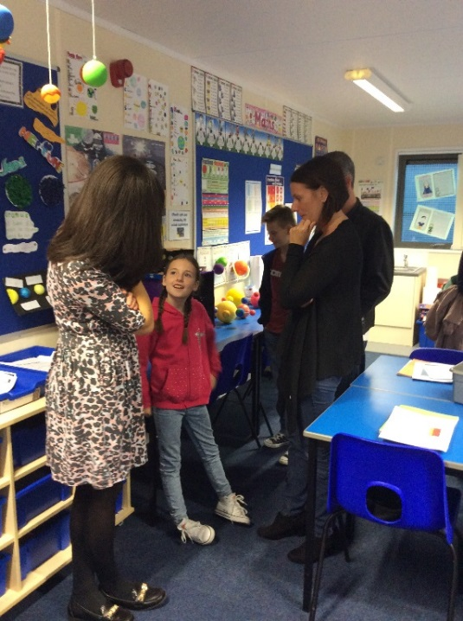
Newsletters and updated school information is on our website www.chryston-pri.n-lanark.sch.uk and Twitter @ChrystonPrimary. Open days are organised to allow parents to see round our school and to meet with staff in an informal setting. Pupil achievements are displayed around the school and in the local press. An Open Evening and Shared Learning events are organised for parents as well as parent/teacher meetings, which take place in twice each session.

Out of School Hours Learning

Pupils have the opportunity to participate in various festivals run by the Active Schools Coordinator.

The school has had a wide and varied Out of Hours Learning Programme over the years. These have included:

Dancing Environmental / Garden | ICT | Choir
Rugby Tots Cycle Proficiency  Quest (Scripture Union) Healthy Families | Judo  Jewellery | Fundamentals  Badminton
Cross Country Running K’Nex | Tennis | Football

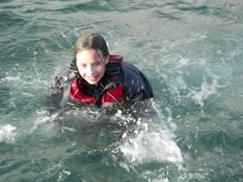
The assistance of parents in extra-curricular activities is always welcome and any parent who can use his or her talents or interests in this way will receive the full support of the school.

An outdoor learning week at Strathclyde Park is organised by NLC for Primary 7 children. Trips normally run from Monday to Friday and include a range of outdoor activities and water sports.

School Relationships

At Chryston Primary our values are: work hard, be kind and show respect.

The relationship between pupils and teacher is similar to that between a child and his or her parents/carers and is built on trust and mutual consideration, understanding and tolerance on both sides. Chryston Primary promotes positive behaviour and relationships. However, rules are necessary to ensure the safety and well-being of all.

Parents/Carers are partners in supporting children’s behaviour and we work in partnership with parents and carers to support our children and resolve any issues that may arise.

Chryston Primary School is committed to the belief that every child has the right to grow up free from bullying. We want children to live, learn, socialise and work in an inclusive environment, where differences between people are valued, people support each other, treat each other with respect and understanding.

Our Golden Rules are:
We are gentle, we don’t hurt others,
We are kind and helpful, we don’t hurt people’s feelings.
We are honest, we don’t cover up the truth.
We work hard, we don’t waste our own or others time.
We look after property, we don’t waste or damage things.
We listen, we don’t interrupt.

Anti-bullying

All those who play a daily role in the lives of our learners should be enabled to prevent bullying and respond effectively to incidents of bullying behaviour when they occur.
The school recognises that the impact of bullying behaviours will differ for each child. It is often the signs of bullying behaviour and the impact on the child that will give rise to concern, intervention, and support.

In many instances this behaviour will be seen at home before in school, therefore parents/carers should contact the school as soon as possible. These concerns will be treated in a confidential and sensitive manner.

Bullying incidents are very rare in the school and we believe that is due to our proactive approach. Parents, children and the school will be kept informed, and the children supported to accept appropriate behaviour. If you would like further information on our anti-bullying measures at Chryston Primary, please do not hesitate to contact the head teacher.

Pupil Committees

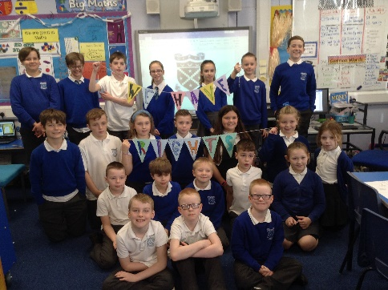
Five years ago, we launched our Chryston Committees and all children are in a range of committees annually; Media Busters, Eco , Junior Road Safety, Health and Rights Respecting Schools, to name a few. These groups change year on year and work towards different activities and events which will have an impact on the whole school. Each child will have the opportunity to be part of one of these groups and have an impact in the whole school. Groups have learners from each stage of the primary.

*Due to Covid this has not taken place over the last two sessions. We hope to continue this next session.

Additional Support Needs

Chryston Primary complies with the Additional Support for Learning (Scotland) Act 2004 as amended by the Additional Support for Learning (Scotland) Act 2009 and the Additional Support for Learning: Statutory Guidance 2017.

By means of careful monitoring, record keeping, and assessment, difficulties are quickly identified, and prompt action is taken by the teacher to assist the children with learning difficulties. Most children have barriers to learning at some time during their school career and this is supported by the class teacher, parents and specific learning targets. Some children may require further educational input within a small group. This is provided by the school's support for learning mechanism. In cases of long term or serious challenges, outside agencies (e.g.: Psychological Service) are always available to assist. Parents are always involved in the decision-making process before, and during use being made of the service.

Bilingual pupils in the school are regularly monitored to assess whether they need the support of English as a Second Language teacher.

We aim to assist all pupils to reach their full potential, both academically and socially at Chryston Primary School.

Through a process of staged intervention and, where appropriate, in conjunction with other appropriate agencies, the school will work to support any pupil and their families within the framework of the new legislation and in line with the Code of Practice.

Care experienced children i.e., children who are cared for directly or whose care is supervised by the local authority are deemed to have Additional Support Needs unless assessment determines otherwise. We have procedures in place which ensure that all care experienced are closely monitored and supported.

Parents and pupils are an essential part of the assessment, planning and review processes and your views will be actively sought. Parents and young people can request of the authority to establish whether a child has additional support needs. They can also request an assessment at any time.

Getting it Right for Me plans (GIRFMe) enable staff to plan effectively for children and young people when interventions are requires supporting their learning a improve outcomes. Parents/carers and pupils are an essential part of the assessment; planning and review processes and their views will be actively sought.
Some children and young people may require significant support from education and at least one other agency, such as health, social work and/or voluntary agency to help them meet their learning targets. Where this support requires a high level or co-ordination the opening of a Co-ordinated Support Plan (CSP) may be considered. A CSP may be initiated by the school or another agency.
Parents/carers and young people can, if they wish, request that a CSP be considered and would be involved in the process.
Parents/carers will receive letters from the Education Authority throughout the CSP process.
Parents/carers and young people will be invited to take part in multiagency meetings and their views will be recorded in the plan.
Where more intensive support for a child or young person needs to be planned for, usually when several agencies are involved in supporting their wellbeing then a Child’s Plan may be developed. The plan will tell you what actions need to be taken and who will help with each action. It will usually be someone called a ‘Lead Professional’ who will have the job of making sure that the actions outlined in the plan take place and things get better for the child or young person.

Dispute Resolution
North Lanarkshire Council is committed to resolving any differences of views through discussion, dialogue and building and common ground. If the matter cannot be resolved with the Education Authority, you have the right to request mediation. An independent mediation service is available to parents and young people through Resolve (see contact details at the back of this handbook). Mediation is free and independent of the Education Authority.

If a disagreement cannot be resolved through mediation, then an application for Independent Adjudication (see contact details at the back of this handbook) can be made by parents free of charge. The Independent Adjudicator will make recommendations to the Education Authority about how the dispute should be resolved.
The Additional Supports Needs Tribunal has been set up to hear appeals made by parents or young people on the decisions made by the Education Authority relating to Co-ordinated Support Plans and placing requests and post school transition. If you disagree with any decision relating to your child’s Co-ordinated Support Plan, either the creation of a CSP or the content of it you may be able entitled to refer to the Tribunal.

Equal Opportunities

At Chryston Primary we aim to provide children with an educational and social environment which will enable all children to reach their full potential. We promote equality of opportunity and have procedures in place to eliminate unlawful discrimination.

The school is committed to ensuring its policies and practices do not impact adversely on any particular group (s) of people and opportunities to promote equality are actively pursued.

The Equality and Human Rights Commission’s Technical Guidance for Schools in Scotland is the essential guide for the school community to promote equality. This information can be accessed at: http://www.equalityhumanrights.com/news/2013/june/commission-publishes-equality-guidance-for-schools/

Freedom of Information

Freedom of Information (Scotland) Act 2002 came into force in 2005. The Act allows anyone to ask for information held by the Council and imposes a time-scale of 20 working days for the Council to respond. To deal with Freedom of Information requests, the Council has appointed a Corporate Freedom of Information Officer with the support of an officer in each Service. The Freedom of Information Coordinator can be contacted by telephone on 01698 302484

Attendance at School

Section 30 of the 1980 Education Act places a duty on every parent/carer of a child of ‘school age’ to ensure that their child attends school regularly.
Attendance must be recorded twice a day, morning, and Afternoon.
Regulation 7 of The Education (School and Placing Information) (Scotland) Amendment, Etc., Regulations 1993 requires each child’s absence from school to be recorded in the school register as authorised or unauthorised: As defined by the Scottish Government.
At the start of each school session, parents/carers will be asked to provide contact details including at least one emergency contact number. Parents/carers are required to inform the school if these contact details change during the school year.
Parents and carers are asked to inform the school if a pupil is unable to attend from the start of the school day on the first day of absence. Failure to do so will result in school staff accessing all contact numbers provided for the school. In the interests of child safety, the police will be contacted if all attempts to locate the child have been exhausted.
Parents/carers should be asked to inform the school by letter or telephone if their child is likely to be absent for some time, and to give the child a note on his or her return to school, confirming the reason for absence.

- Family Holidays During Term Time
Every effort should be made to avoid family holidays during term time as this both disrupts the child’s education and reduces learning time. Parents/carers should inform the school by letter of the dates before going on holiday.
Absences will be classified as authorised only in exceptional circumstances. Such circumstances may include:
A family holiday judged to be important to the wellbeing and cohesion of the family, following serious or terminal illness, bereavement, or other traumatic events.
A family holiday classified under the ‘authorised absence’ category will not include such reasons as:
- The availability of cheap holidays
- The availability of desired accommodation
- Poor weather experience during school holidays
- Holidays which overlap the beginning or end of term
- Parental difficulty obtaining leave (except in cases where evidence is provided by the employer that it cannot accommodate leave during school holidays without serious consequences)
Family holidays with the above similar characteristics will be classified as unauthorised absence. Where the head teacher’s prior agreement has not been sought the absence will automatically be classed as unauthorised.

- Extended leave with parental consent
Where most family holidays will be recorded as unauthorised absence (see above) extended leave with parental consent will not be considered the same as a family holiday.
Leave in such circumstances will be authorised under circumstances such as:
- Extended overseas educational trips not organised by the school
- Short-term parental placement abroad
- Family returning to its country of origin (to care for a relative, or for cultural reasons
- Leave in relation to the children of travelling families

- Exceptional Domestic Circumstances
Parents/carers may request permission for such leave in writing and the school may authorise such requests under the following
- The period immediately after an accident or illness
- A period of serious or critical illness of a close relative
- A domestic crisis which causes serious disruption to the family home, causing temporary relocation.

It should be emphasised that the school investigates unexplained absence, and that the authority has the power to write to, interview or prosecute parents/carers, or to refer pupils to the Reporter of the Children’s Panel, if necessary. A statement of the school’s policy including procedures for the enforcement of attendance.

Attendance Monitoring
The school will be monitoring attendance monthly and any holidays taken in term time, even those approved will impact to attendance figures.
If attendance falls below 95% then the Head Teacher will begin a series of formal letters reminding you of attendance procedures and asking you to work with the school to increase your child’s attendance.

Clothing and Uniform

All North Lanarkshire schools must have a dress code which encourages pupils to dress in a way which is appropriate to attendance at school. This dress code must not lead to direct or indirect discrimination on the grounds of race, religion, gender, or disability. Prior to drawing up the dress code, the parents, pupils and staff were fully consulted. It is the expectation of the Education Authority that parents and staff will be keen to support the dress code and written agreement may be sought.

Clothing which is unacceptable in school under any circumstances would include items which:

    - could potentially, encourage factions (such as football colours)
    - could cause offence (such as anti-religious symbolism or political slogans)
    - could cause health and safety difficulties (such as loose-fitting clothing, dangling or hoop earrings or other potentially dangerous jewellery)
    - are made from flammable material which may be a danger in certain classes (eg: shell suits)
    - could cause damage to flooring
    - carry advertising for alcohol or tobacco and
    - could be used to inflict damage on other pupils or be used by others to do so

Parents/Carers in receipt of a clothing grant from the council will be encouraged to purchase items which are in accordance with the school dress code. Approval of any requests for such grants in other circumstances are at the discretion of the Executive Director of Leisure and Learning Services. Information and application forms may be obtained from the Council website www.northlan.gov.uk

Parents/Carers are entitled to receive a clothing grant if they are in receipt of any of the following benefits - Income Support, Job Seeker's allowance (income based), Employment & Support Allowance (income related), Universal Credit (with an income below £660/month), housing benefit (housing element of Universal Credit is not housing benefit), council tax reduction. Deadline for school clothing grants is 31st March 2024.
Whilst in general terms it would not normally be the policy of the authority to exclude a pupil from school solely based on his/her dress, persistent refusal to respond to a reasonable dress code might be deemed to be a serious challenge of the Head Teacher's authority and be detrimental to the well-being of the whole school community. In such circumstances a Head Teacher could justify the use of the school discipline procedure.

The Council wishes to minimise claims from the loss of pupils' clothing and/or personal belongings. Parents are asked to assist in this area by ensuring that valuable items and unnecessarily expensive items of clothing or jewellery etc. are not brought into school. Parents should note that any claims submitted to cover the loss of such items are likely to be met only where the authority can be shown to have been negligent.
Please make sure that all articles brought to school are clearly marked with your child's name.

School Uniform
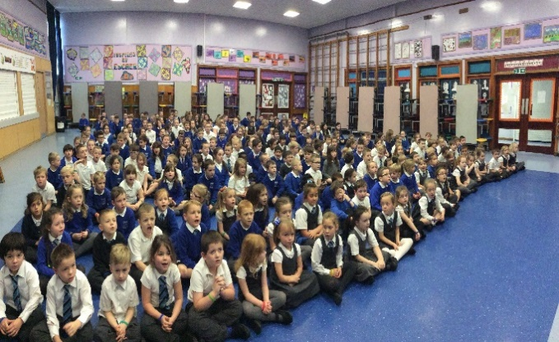
The school colours are grey and royal blue. Sweatshirts, cardigans and jumpers are royal blue in colour. Skirts and trousers are grey and shirts /polo shirts are white. Sweatshirts and Poloshirts are available with the embroidered school badge. Pupils require to wear suitable clothing for P.E. Shorts and T-shirts are comfortable, with soft shoes with non-mark soles for indoor activities. All children should have black plimsoles to wear
inside school. These will be kept in school for everyday use. PE shorts may also be kept in school for the week, if they are kept in a suitable bag, which can be hung on the child’s coat peg. It should be noted that a pupil's white polo shirt is acceptable as P.E. clothing.

Parents are entitled to receive a clothing grant if they are in receipt of any of the following benefits: Income Support, Job Seekers Allowance (income based). Employment & Support Allowance (income related), universal credit, housing benefit, council tax rebate.

Meals
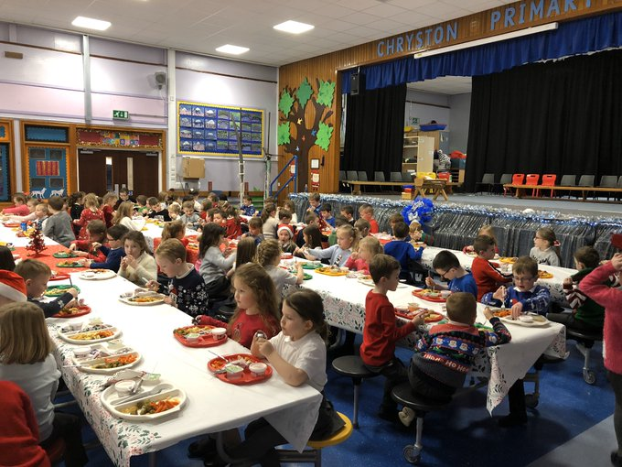
Lunch meals are provided daily in the school dining hall with a cost of £3.10 for pupils in Primary 6 & Primary 7, payment should be made in advance through online payments. All children in P1 – P5 receive a free school meal. Meals are cooked off site and brought into school. Children pre-order lunch between 9 and 9.30am. There is a choice of main meal and a snack, including cakes, fruit, and soup. Children are given a coloured band which they give to catering staff at lunch, indicating their meal choice. A vegetarian meal option is offered daily.

Special Diet Procedures
- By arrangement, children on special diets can be accommodated. A medically prescribed diet form must be completed and signed by the child’s GP or registered dietician. Procedures and forms can be accessed online through North Lanarkshire Council’s website.

If your child is going to be late into school and requires a meal, please call the school to order a lunch no later than 10am. Children who are entitled to a free school meal can choose lunch to the value of a two-course meal.

Children of parents receiving income support, universal credit, or job seekers allowance (income based), Employment & Support Allowance (income related) are entitled to a meal without charge. Information and application forms for free school meals may be obtained North Lanarkshire council website – www.northlan.gov.uk

Only those children who receive a free school meal are entitled to free milk. Milk may however be available for purchase in the school dining hall during the lunch period. Water is available to all pupils throughout the lunch break.

Children requiring leaving school premises to purchase their "lunch" will be deemed not to be under the responsibility or supervision of the school authority during the lunch period. Children having school lunch, or a packed lunch must remain in the school during the entire lunch break.

Some parents do prefer to provide their children with a packed lunch and children will eat this in the dining hall alongside children eating their school meal.

Please be aware that we are a ‘nut free school’ and the policy can be accessed on our website.

Information in Emergencies

We make every effort to maintain a full educational service, but on some occasion’s circumstances arise which lead to disruption. For example, schools may be affected by severe weather, temporary interruption of transport, power failures or difficulties with fuel supply. In such cases we shall do all we can to let you know about the details of closure or re-opening. We shall keep in touch by using letters, notices in local shops and community centres, announcements in local churches and announcements in the press and on local radio, on NLC website and Twitter.

Transport

The Council has a policy of providing free transport to primary pupils who live more than one mile from their catchment school by the shortest suitable walking route. This policy is more generous than the law requires. This provision may be reviewed at any time.
Parents/carers who consider they are eligible should obtain an application form from the school or from Education and Families. These forms should be completed and returned before the end of February for those pupils beginning school in August to enable the appropriate arrangements to be made.
Applications may be submitted at any time throughout the year but may be subject to delay whilst arrangements are made.
There is discretion in certain circumstances to grant privilege transport for pupils to travel in transport provided by the authority, where spare places are available, and no additional costs are incurred.

Pick-up points
Where free transport is provided it may be necessary for pupils to walk a certain distance to the vehicle pick-up point.
Walking distance in total, including the distance from home to the pick-up point and from the drop-off point to the school in any one direction, will not exceed the authority’s limits (see above paragraph).
It is the parent’s/carers responsibility to ensure their child arrives at the pick-up point in time. It is also the parent’s/carers responsibility to ensure the child behaves in a safe and acceptable manner while boarding, travelling in, and alighting from the vehicle. Misbehaviour could result in a loss of the right to free transport.

Placing Requests
The council does not provide transport for those pupils in receipt of a placing request other than in exceptional circumstances.
In the case of early entry requests if a child is offered a place in the catchment area school, transport will be provided in accordance with the Council’s policy as stated above.

Medical and Health Care

Children are examined medically during their school life, normally in the first year of primary schooling and then at 10 – 11 years and 13 – 14 years, by staff of Lanarkshire Health Board. Parents are notified in advance and will be informed if any issues arise from the medical. Occasionally, the school nurse may visit to examine whole classes for general fitness and hygiene. Dental inspections are carried out on a routine basis in primary schools and parents are offered any necessary treatment for their children although they may choose instead to attend the family dentist. Children who are thought to have sight, speech or hearing problems may be referred to the appropriate service by the Head Teacher, where any necessary tests may be carried out by qualified staff – naturally, parents are informed before any referral.
Parents should always inform the school of any medical problems, which may affect their child’s schooling or if their child needs regular medical treatment. If a child requires medication a consent form must be completed. this can be accessed on our website or obtained from the school office.
Please be advised that we have children with severe allergies, and we are a nut free school. Please see the policy on the school website.
On occasions it may be necessary for a child to be taken home due to ill health, etc. In all cases the school makes every effort to contact a parent in the first instance. If a parent is not available, the school will contact the child’s emergency contact for the necessary arrangements to be made. It is essential, therefore, for the school to have an emergency contact that can be reached by telephone should any child have to be taken home unexpectedly. Under no circumstances will a child be sent home/allowed to leave the school unaccompanied.

If a young person is unable to attend a suitable educational establishment as a result of prolonged ill-health, North Lanarkshire Council must make special arrangements for the pupil to receive education elsewhere, other than at an educational establishment.
In North Lanarkshire, children and young people are treated in the paediatric in- patient unit within Wishaw General Hospital. It is not common for children and young people to have extended stays in Wishaw General, and therefore North Lanarkshire Council does not require a dedicated hospital education service. Children and young people resident in North Lanarkshire and in hospital in Glasgow, can access education through the Hospital Education Service (H.E.S.). The service is provided by Glasgow City Council Education Department and Social Services. For further information, please contact your child’s school.

Child Protection

Every adult in Scotland has a role in ensuring all our children and young people are safe and always protected from harm and in all situations. The Headteacher is responsible for the school’s action in response to Child Protection concerns.

If there are any Child Protection concerns, the Headteacher or the Child Protection Co-ordinator will follow North Lanarkshire Child Protection Procedures and Guidelines.

Adult Protection

The Council has responsibility under the Adult Support and Protection (Scotland) Act 2007 for the protection and support of adults at risk of harm within North Lanarkshire. Its employees therefore have the responsibility to ensure the welfare of all adults at risk of harm with whom they come into contact, as well as providing the highest possible standard of care for some of the most vulnerable members of our society. If there are any Adult Protection concerns the Head Teacher or the Adult Protection Co-ordinator will follow North Lanarkshire Adult Protection Procedures and Guidelines
The current Child/Adult Protection Co-ordinator is:
Jilly Moffat Headteacher Phone number: 01236 632136

Parents

The school encourages close liaison with parents and would welcome approaches from parents with ideas in this direction. We see Home and School as being in partnership to provide the best education possible for our children. The Head Teacher will be happy to speak to you if you seek advice or wish to discuss a matter which concerns you. It is obviously easier to organise if you arrange an appointment but if there is an emergency please ring or call at the school. Parents are respectfully asked not to go directly to their child's teacher as he/she will be busy with a class of children.

The Parent Forum

As a parent of a child at this school you are automatically a member of the Parent Forum.

The Parent Forum is composed of all the parents and carers of children at the school.

As a member of the Parent Forum, you can expect to:

    - get information about what your child is learning
    - get information about events and activities at the school
    - get advice / help on how you can support your child's learning
    - be told about opportunities to be involved in the school
    - have a say in selecting a Parent Council to work on behalf of all parents at the school
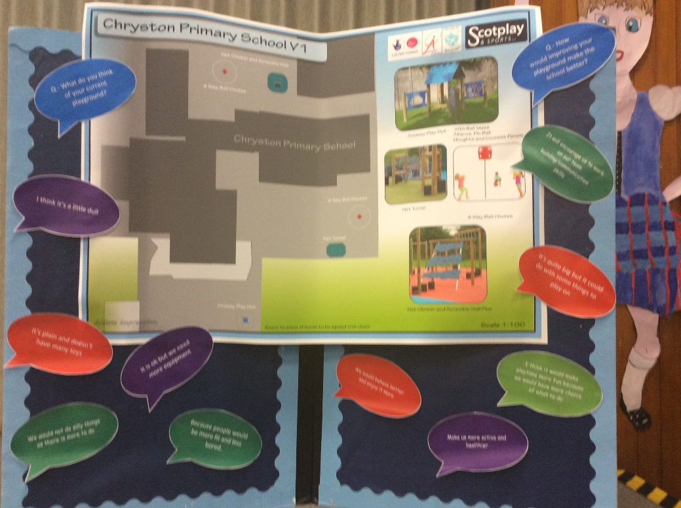
- be invited to identify issues for the Parent Council to work on with the school

The Parent Council

Parent Councils came into force on 1st August 2007. The composition of the Parent Council is decided by the Parent Forum. The Headteacher, who has a right and a duty to attend meetings, is the professional adviser to the Parent Council.
The Parent Council’s rights and duties include:
    - supporting the work of the school
    - representing the views of parents
    - consulting with parents and reporting back to the Parent Forum on matters of interest
    - promoting contact between the school, parents, pupils, providers of nursery education and the wider community
    - fundraising
    - taking part in the selection of senior promoted staff
    - receiving reports from the Headteacher and Education Authority
    - receiving an annual budget for administration, training and other expenses
    - Improving home school partnership and facilitating parental involvement.
Members of Parent Councils, on a voluntary basis, may also have an advisory role in decisions on placing requests by parents in respect of those situations where the number of placing requests for a particular school or for a particular stage exceeds the number of places available.

The following parents are valued members of Chryston Primary’s Parent Council:
Leigh Moore - Chair
Jayne Clinton - Vice Chair
Lynsey Graham - Treasurer
Debs Fraser - Secretary
Joanne Elliott
Jennifer Troup
Arlene Butcher
Jennifer Rodden
Rachel Crozier
Lee McKellan
Samantha McLaughlan
Colin McIntyre
Graeme Walker
Levi White
Mark Graham
Agnieszka Ibek- co-opted
Kara Denholm - co-opted

The Head Teacher has a right and duty to attend all meetings of the Parent Council. Meetings of the Parent Council are open to members of the public.
The Parent Council hold their A.G.M. annually in May. All parents/carers are invited to attend. Office bearers will be reselected on a biannual basis at the A.G.M. The parental membership of the Parent Council will be a minimum of four parents/carers of children attending the school. The maximum number of parents/carers is fifteen.
Any parents/carers of a child at the school can volunteer to be a member of the Parent Council, the preferred make up being at least one parental representative from each year group. If the number of volunteers exceeds the number of places set out in the constitution, members will be selected by formal election. Anyone not selected to be a member of the Parent Council may be offered the opportunity to be part of any subgroups set up by the council.

The Parent Council also organise social and fundraising events throughout the session. The school has benefited from many of their fundraising activities.

Facebook Group: Chryston Primary Parent Council
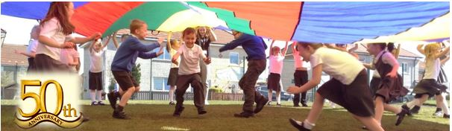
Email Address: chrystonpcfunding@gmail.com

General Data Protection Regulations (GDPR) Statement for Education

What is this statement?
This statement explains when and why we collect personal information about you, your child or young person and how this information is used, the conditions under which it may be disclosed to others and how it is kept secure.
Who are we?
North Lanarkshire Council is a Local Authority established under the Local Government etc. (Scotland) Act 1994. Education, and Families is in Civic Centre, Motherwell ML1 1AB
Why do we need your personal information and that of your child or young person?
The Council has a legal obligation to deliver an effective education service to all children and young people in North Lanarkshire. In order to do this, we need to collect personal information about children, young people and their families so that we can help them to learn and keep them safe.
Legal basis for using your information
We provide this service as part of our statutory function as your Local Authority. Processing your personal information is necessary for the performance of a task carried out in the public interest by the Council. If the information we have asked for is not provided, then we will not be able to provide this service to your child or young person.

Your personal information
Education uses the national IT system, SEEMiS, to store personal information electronically. We ask parents/carers during registration and enrolment to provide us with their child’s name, date of birth, gender, address, family contact details (phone/email). We will also ask you to update this information annually.
We may also ask you for information about medical conditions, additional support needs, religion, and ethnicity. We may also record information you might wish to provide about your family circumstances.
We require this information to ensure children and young people are educated appropriately, supported, and that we take account of their health and wellbeing.
During a child’s journey through education a pupil’s record is kept, this core record is mainly paper based and is stored securely in the child or young person’s establishment. If the establishment has requested assistance from educational staff outwith the nursery or school, key staff from these services may also store information securely about your child or young person.
How will we use this information?
Your personal information will be used:
• to enrol your child or young person in nursery or school
• to provide your child or young person with an appropriate education
• for teaching, assessment, and planning purposes and to monitor educational progress of children and young people
• to support pupil learning, improve outcomes and identify where additional support is needed to help children and young people
• to provide appropriate pastoral care to support health and wellbeing of children and young people
• to keep children and young people safe
• to maintain records e.g., of attendance, absence, attainment and behaviour of children and young people (including exclusions)
• to support children and young people during transitions when moving on each year from nursery to primary, primary to secondary and when they move or leave school
• to enable schools and establishments to process personal data in support of SQA and Further Education
• to monitor and report on pupil attainment and achievement in relation to the national improvement framework issued by the Scottish Government
• to assure the quality of our education services in line with national expectations from Education Scotland
• when we require to contact you by post, email, telephone, or text.

Who do we share information with?
To support your child or young person’s access to appropriate education and meet our legal obligations, personal information may be shared internally between Services of the Council. From time to time, education staff may also need to share information about you, your child or young person with another person from another agency or service, e.g., Social Work, Health.
We also share information with Scottish Government and bodies such as Education Scotland, Scottish Qualifications Authority, Skills Development Scotland, and other organisations that support children and young people’s learning.
When a child or young person moves or transfers to another school the Council has an obligation to pass on information with regards to pupil records to the new school.
Only identified staff and those who require having the information to enable them to carry out their job, will have access to you, your child or young person’s information. We care about the information we hold in respect to the education of children and young people. We will keep this information safe and secure.
How long do we keep your information for?
We only keep personal information for the minimum period necessary. Sometimes this is set out in law, but in most cases, it is based on what we need to fulfil our function. We maintain a ‘records retention and disposal schedule’ which sets out how long we hold different types of information for. You can view this on our website at
http://www.northlanarkshire.gov.uk/index.aspx?articleid=15003
Your rights under GDPR
You can:
• Request access to your information – you have the right to request a copy of the personal information that we hold about you, your child or young person. You can ask us to confirm what personal information is being used and with whom it has been shared with.
• Request a correction to your information – we want to make sure that all personal information is accurate, complete, and up to date. Therefore, you may ask us to correct any personal information that you believe does not meet these standards.
• Request the restriction of processing – this enables you to ask us to suspend the processing of personal information about you, your child or young person, for example if you want us to establish its accuracy or clarify the reason for processing it.
• Request the transfer – you can request the transfer of your information to another party.
• Deletion of your information – you have the right to ask us to delete personal information about you, your child or young person where:
• you think that we no longer need to hold the information for the purposes for which it was originally obtained
• you have a genuine objection to our use of personal information
• or use of personal information is contrary to law or our legal obligations.

If you wish to update any personal information, retrieve it, or have it removed from records please contact your child or young person’s head teacher or head of establishment in the first instance.

The Council’s Data Protection Officer
If you have any questions or are unhappy about the way that we use the personal information of your child, young person, or yourself you can contact the Data Protection Officer.

Data Protection Officer (DPO)
Civic Centre,
Windmillhill Street,
Motherwell ML1 1AB
or by email to AITeam@northlan.gov.uk
The Information Commissioner
You also have the right to complain to the Information Commissioner about the way the Council has handled your rights, to enquire about any exercise of these rights or to complain about the way the Council has dealt with your rights (or any other aspect of data protection law).

Information Commissioner's Office,
45 Melville Street,
Edinburgh, EH3 7HL
or by e-mail to
casework@ico.org.uk

Transferring Educational Data about Pupils
Education authorities and the Scottish Government
Education Portfolio (SGEP) exchange data about pupils either on paper or electronically through the ScotXed programme.
The data collected and transferred covers areas such as date of birth, postcode, registration for free-school meals, whether a pupil is looked after by his/her local authority, additional support needs including disability, attendance, absence, and exclusions from school. Pupil names and addresses are collected by the school and the council, but they are not passed to SGEP. The postcode is the only part of the address that is transferred. Data is held securely and no information on individual pupils can be published by SGEP
Providing national identity and ethnic background data is entirely voluntary. You can choose the ‘not disclosed’ option if you do not want to provide this data. However, we hope that the explanations contained in this message and on our website will help you understand the importance of providing the data.
Why do we need your data?
To make the best decisions about how to improve our education service, SGEP and education authorities need accurate, up-to-date data about our pupils. We are keen to help all our pupils do well in all aspects of school life and achieve better educational outcomes. Accurate and up-to-date data allows SGEP, education authorities and schools to:
- plan and deliver better policies for the benefit of all pupils,
- plan and deliver better policies for the benefit of specific groups of pupils,
- better understand some of the factors that influence pupil attainment and achievement,
- target resources better.
Your GDPR rights
The collection, transfer, processing and sharing of ScotXed data is done in accordance with the GDPR. We also comply with the National Statistics Code of Practice requirements and other legislation related to safeguarding the confidentiality of data. GDPR gives you the right to know how we will use your data. This message can give only a brief description of how we use data. Fuller details of the uses of pupil data can be found on the ScotXed website (www.scotxed.net).
SGEP works with a range of partners including Education Scotland and the Scottish Qualifications Authority. On occasion, we will make individual data available to partners and academic institutions to carry out research and statistical analysis. In addition, we will provide our partners with information they need to fulfil their official responsibilities. Any sharing of data will be done under the strict
control and prior agreement of the Data Access Panel in SGEP, which will ensure that no subject specific data will be made public because of the data sharing and that such data will not be used to take any actions in respect of an individual.

Further details are available on:
https://www2.gov.scot/Topics/Statistics/ScotXed/PrivacyInformation
Any Concerns
If you have any concerns about the ScotXed data collections, you can email school.stats@scotland.gsi.gov.uk or write to:
The ScotXed Support Office, SEGP, Area 1B, Victoria Quay, Leith, EH6 6QQ.
Alternative versions of this page are available, on request from the ScotXed Support Office, in other languages, audio tape, braille and large print.
Want more information?
Further details about ScotXed data exchanges are available on the ScotXed website, http://www.scotxed.net.

Photographs/Video Footage
On occasion events in school may receive coverage from the local or national press resulting in photographs/video footage of children appearing in newspapers, leaflets and/or school/authority documents. Parents/Carers who would not wish their child to be included should write to the Head Teacher to make this known.

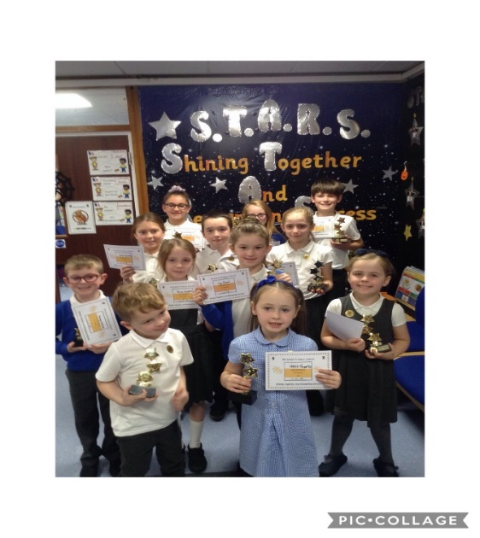

Important Addresses

Education & Families Education Managers
Municipal Buildings Michelle O’Halleron
Kildonan Street Margaret Hunter
COATBRIDGE
ML5 3BT
Tel. – 01698 403140

Councillors for the School
Councillor John McLaren Councillor Stephen Goldsack Councillor Lynne Anderson
Member Services
Civic Centre Windmill Hill Street MOTHERWELL
ML1 1AB
Tel. - 01698 302500

Area Office Community Learning and Development
Gary Stark
Council Offices Locality Manager North
Bron Way Baird Memorial Primary School
CUMBERNAULD G67 1DZ Brown Road
Seafar
01236 632740 CUMBERNAULD G67 4RA
01236 638383

Contacts in relation to Support for Learning
Help and advice on any matter relating to Support for Learning can be obtained from:

Lesley Grant
(Cluster Improvement and Integration Lead)
GrantL@northlan.gov.uk

You can also get more help and advice from:

Enquire
The Scottish advice service for additional support for learning. Operated by Children in Scotland, Enquire offers independent confidential advice and information on additional support for learning, Enquire also provide a range of factsheets.
Tel. – 0345 1232303
Email - info@enquire.irg.uk
Website for parents and practitioners - www.enquire.org.uk Website for children and young people - www.enquire.org.uk/yp

Resolve (Independent Mediation)
Tel. - 0131 2222456
Email -resolve@childreninscotland.org.uk

Scottish Independent Advocacy Alliance Reference to Additional

Support Needs Tribunal
Mansfield Traquair Centre Health & Education Chamber
15 Mansfield Place First Tier Tribunal for Scotland
EDINBURGH Glasgow Tribunals Centre
EH3 6BB 20 York Street
Tel. 0131 524 1975 Glasgow
Email - enquiry@siaa.org.uk G2 8GT
Website - www.siaa.org.uk Tel. – 0141 302 5860
Website – www.asntscotland.gov.uk

NHS Lanarkshire Social Work
Kildrum Health Centre Bron Way
Tel. – 01236 721354 Town Centre Cumbernauld
G67 1DZ
Tel. - 01236 638700

North CLD Locality Office
Pivot Community Centre
Glenmanor Ave
Moodiesburn
G69 0DL
Tel. - 01236 638393
Email - CLD-North@northlan.gov.uk

Glossary of Specialist Terms
Circle Time A weekly time in class for staff and pupils to talk
uninterrupted about matters brought up by the children or by the teacher; a time / forum used for the development of personal and social skills.

Curriculum The range of subjects taught in every class and school, e.g.
Numeracy, Literacy, Social Studies, etc.

Curriculum Continuity This term relates to the need for schools to make sure that the courses children follow show progression and do not overlap unnecessarily.

Emergency Contact The person(s) nominated by a child’s parents/guardians to
be the first to be contacted if a parent/guardian is not available.

Ethos This term relates to the specific characteristics of the school, the spirit, or principles of the school.

Out of School Hours Subjects which are not taught in the formal curriculum, e.g., Learning after school clubs.

Group Teaching Children are normally taught and work in groups with other
children – for Literacy and Numeracy these groups are normally ability groups where children of a similar ability progress at a similar rate; for most other curricular areas children are taught in mixed ability and social groups.

Transition This term usually relates to the movement of children from
nursery to primary, or primary to secondary.

Although this information is correct at the time of printing, there could be changes affecting any of the matters dealt with in the document –

- before the commencement or during the school year in question

- in relation to subsequent school years

By law Authorities are required to issue a copy of the school handbook to certain parents in December each year. It details the current policies and practices of both the council and the school.

Although this information is accurate at the time of printing, there could be changes affecting any of the matters dealt within the document.

Before the commencement or during the school year in question.

In relation to subsequent school years.

Education Authorities are required by law to issue a copy of the school handbook to certain parents/carers in December each year.

In details the current policies and practices of both the council and the school.

The School Year
The following is a list of the main school holiday dates for session 2023 - 2024.
August 2023
In-Service day: Monday 14th August 2023
In-Service day: Tuesday 15th August 2023
Pupils return: Wednesday 16th August 2023
September 2023
September weekend: Friday 22nd September to Monday 25th September 2023 (inclusive)
October 2023
October week: Monday 16th to Friday 20th October 2023 (inclusive)
November 2023
In-service day: Monday 13th November 2023
December 2023 – January 2024
Schools close: Friday 22 December 2023 at 2.30pm
Christmas and New Year holidays: Monday 25th December 2023 to Friday 5th January 2024 (inclusive)
Schools return: Monday 8th January 2024
February 2024
Mid-term break: Monday 12th February 2024 and Tuesday 13th February 2024
In-service day: Wednesday 14th February 2024
April 2024
Schools close: Thursday 28th March 2024 at 2.30pm
Spring holiday (Easter): Friday 29th March to Friday 12th April 2024 (inclusive)
- Good Friday: 29th March 2024
- Easter Monday: 1st April 2024
Schools return: Monday 15th April 2024
May 2024
In-service day: Thursday 2nd May 2024 (to coincide with UK Parliamentary elections, but may be subject to change)
May holiday: Monday 6th May 2024
May weekend: Friday 24th May 2024 to Monday 27th May 2024 (inclusive)
June 2024
Schools close: Wednesday 26th June 2024 at 1pm
