Parent Council Meeting and AGM
Tuesday 17 May 2022, Chryston Parish Church

Welcome
Chair welcomed attendees to the meeting and notified of apologies given.

Attendees
Leigh Moore | Colin McIntyre | Mrs Rooney
Joanne Elliott | Rachel Crozier | Lynne Bradshaw
Tracy Slaven | Samantha McLaughlin | Lorraine fleck
Jayne Clinton | Lee McKellan | Linda McIntyre
Debs Fraser | Arlene Butcher | Mr Rutherford
Roy Boyd |  | William Collum
Levi White |  | Carole Henderson (NCCF)
Louise Donegan |  | Councillor Claire Williams
Mark Graham
Jennifer Troup

Apologies: Jennifer Rodden, Caroline Kirkwood, Councillor Cairns

Minutes of Last Meeting
Available on school website and on request

Post
Nothing New to Report

Head Teacher Update
Mrs Rooney provided an update in which she acknowledged her gratitude to a strong team in Chryston Primary School, particularly the senior management team.
An update on the upcoming events has been emailed out to all parents by the school listing dates and times for sports day, P7 leavers events, Ice cream van visit, Church service and School trip.
Uniform - Uniform company will be in the high school prior to the disco for parents to view and order.
PEF. - A hand out was provided by Mrs Rooney - Attached for your information.
Carry forward due to NLC picking up the cost of staff last term. Lots of schools had carryforward due to COVID. Delay in Ipads due to Covid. The Admin fee is a fee paid by all schools.

Left Over £9716.00

This is being used with
Seasons for growth
Literacy Program
Inclusion and Nurture
Nurture Base - area at back of stage being developed for this

£3000 of this will be used for Buses for the whole school trip
The rest will carry over.

£61250 will be used for 1 teacher - NLC will pay for 1 more additional, as unable to release staff to work with small groups.

The school has bid for 2 probationers and an extra 2 from PEF money.
Staffing should be finalised for June - School will not have information from NLC until June.
Probationers are still awaiting posts from L.A.

Barnardos have been brought in to help support children

Reports - will be with SLT by next friday and then out to parents before end of term.

Mr Rutherford and Mrs Fleck have been allocated to establish the nurture are and interventions for those children who require them.

Roy - Queried ongoing problem with ASN support - Mrs Rooney will discuss with Roy at a later time.

William Collum, Improvement & Equity Lead (PEF/SAC), North Lanarkshire Council

William Collum attended this meeting to provide some information regarding PEF.
PEF funding should provide targeted support aimed at closing Attainment gap. The funds provided to seach school is determined by its individual demographic. There must be a clear rationale for any spending.
Underspend - Due to national shortage of staff and shortage of outside companies providing services due to COVID Restrictions and their own staff shortages.
Of 125 schools, 41 had 50-91% underspend and 50 had a 10-50% underspend.

PEF for Chryston has been Guaranteed at £62,000 for next 4 years with Scot Gov agreeing underspend can be carried forward.
Not all schools will allocate money before June - some will keep that to see where it will be needed in the new school year.

William also informed those attending of changes made to the NLC finance system which has meant that info contained in the FOI requested by some parents was not up to date due to some costs having not yet been processed through the new system.

William confirms that unfortunately if Chryston Primary’s demographic was to change with an increase in poverty it is unlikely, with the current financial situation, that any additional money would be available. Therefore the funding allocated will need to stretch further. There are additional pressures including the proposed changes to increase teacher non-contact time and the impact on teacher numbers required to allow for this. It was also noted that PEF teachers are also more expensive than substantive Teachers.

Parent Council Business:
- Financial Report of Accounts

Balance 16/03/22 £2309.69

Since then
Post Office (My Childs Art) £15.05
Chq 37 (Hoodies P7) £695.00
Balance @14/4/22 £1599.64

Still to go through:
Chq 38 (P7 Hoodies) £53.50
Chq 39 (P7 Event) £170.00
Dress Down - Easter £203.00
Raisins £26.35
Stickers for Raisins £11.99
P7 Ties £307.50
P1 Gifts £50.00
Stickers for P1 gifts £7.49
P7 Gifts £51.25
P7 gift bags £13.24

Total Left £1111.32

Costs
Ice Cream Van £200
Disco entertainer £150
Disco Tuck £150
£500 - leaves - £611.32

?Ice Lollies for Sports day £50 - Ainsley offered to pay

Events
25/5/22 - Raisin boxes to be returned
26/5/22 - Crazy Hair Day

Fundraising Matters:
- Easyfundraising - No Update
- Shorts & Shades Disco
  - Tickets - Roy has designed tickets
  - Tracy has a list of volunteers.

Points of Discussion
- Sports Day
  - Ice Lollies - Mrs Fleck will confirm freezer space
- School Trips
  - Volunteers to be arranged closer to event
- Class Teachers for new term
  - AS before - cannot be confirmed until NLC confirm staff to school in June
- Report Cards
  - As before - going to SLT next week before sending out to parents before end of term

Selection of Parent Council Members

Continuing in Parent Council
Leigh Moore
Joanne Elliott
Lee Mckellan
Jennifer Rodden
Jennifer Troup
Debs Fraser
Jayne Clinton
Rachel Crozier
Arlene Butcher
Louise Donegan

Joining
Samantha McLaughlin
Colin McIntyre

Further Vacancies will be advertised in the new term.

Selection of Office Bearers

Chair - Leigh Moore (Proposed by Joanne and Seconded by Rachel)
Secretary - Vacant
Treasurer - Vacant

Despite discussion there were no further proposals/ volunteering to fill the remaining vacant posts and it was therefore agreed to take it forward to the first meeting of the new term.

MELM Subcommittee
- Update was provided by Colin (see attached)

Any other business

Tracy will attend P1 induction on 8th of June to highlight Parent Council to new parent forum members

P7 Hoodies for 2023
- Due to this years P7 week being in the first term of next year, hoodies will need to be ordered in August/ early sept to ensure delivery in time for activity week
  - Joanne has agreed to co-ordinate this in the new school term.

Date of next meeting: TBC

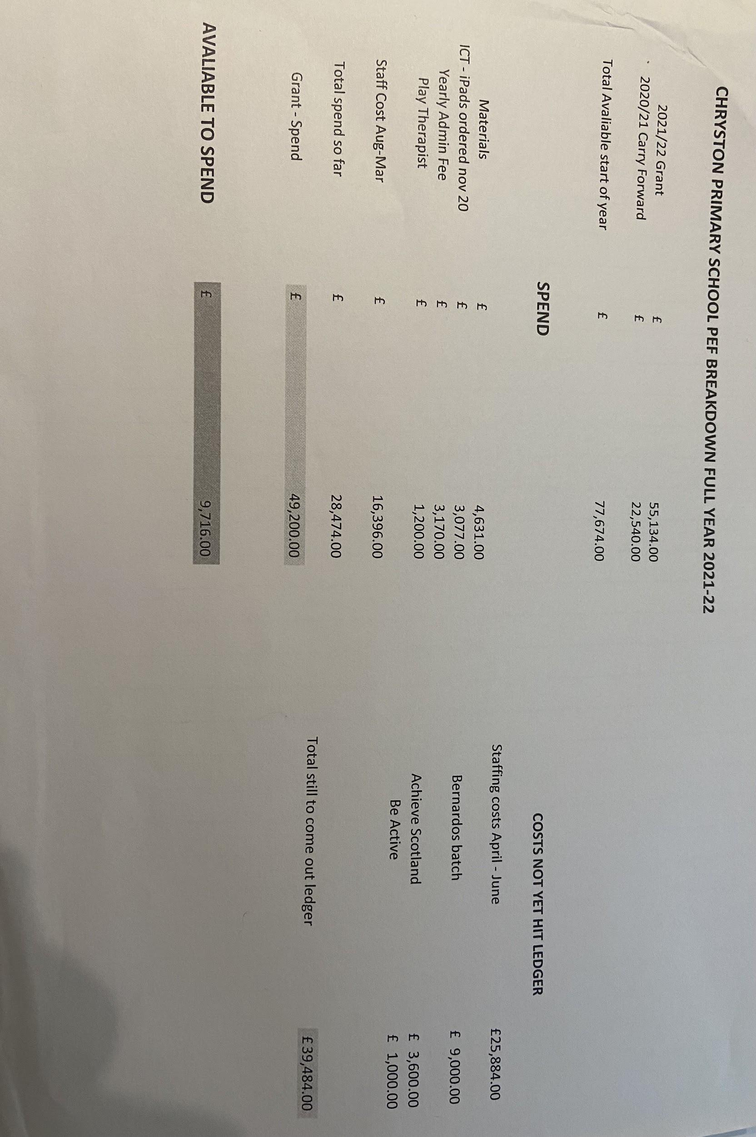

MELM Update
Provided by Colin McIntyre
Parent Council Meeting 16 May 2022
- After the last update we gave on 26 April, MELM group have been really busy working on a number of things

- MELM Group growing- setup Subcommittee (9) and general group of 24 people

- Facebook group (532) –Petition site 1574

- Argyll & Bute going through same scenarios working with us – Not Unique to NLC Schools – (Proposed3-18 Campuses NLC)

- Leigh engaging with other Parent Council Groups across the Cluster – Holy Cross, Stepps, Westfield, Glenmanor, Gartcosh, Auchinloch and Holycross

- Parent Council meeting 26/4/22 – MELM group attended – focus on £50k of PEF Money not spent – Chryston High had underspend £150k – Meghan Gallagher MSP - raised an FOI on all NLC Schools

- Adverts for HT’s Posts Mossend Primary and Tannochside Primary are within the local area of the Convener of Education and Families, Councillor\Convenor Frank McNally. Is appointing head teachers in his local community any different to mine? Again (12th May) we have seen 3 further Advertisements for Clarkston Primary Airdrie, Langloan Primary Coatbridge & Ravenswood Primary Cumbernauld. A further 2 High Schools advertised - St Margaret’s secondary & Greenfaulds High – Are the Chryston the number one guinea pig for the MELM Proposals

- Assistance from Fulton MacGregor MSP SNP, Meghan Gallacher MSP Conservative & Gillian McKay MSP Greens – Fulton MacGregor Holyrood update on Thursday
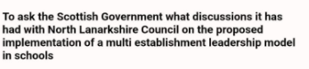

- A number of the Subcommittee Group attended the online EIS Hustings 28th April – Oliver Mundell (Strongly against it Dumfries & Galloway not working), Jon Molyneux (will not support it in Glasgow), Michael Marra (Completely opposed to this – Dundee issues – Crazy ideas/Cost), Will Rennie (against in Fife), Shirley Somerville (This is not in best interests of our children and costs shouldn’t come into it).

- The group attended the Northern Corridor Meeting 11th May, they have our full support. They are prepared to help us in any shape form – Newly elected councillors present – Claire Williams, Josh Cairns and Gregg Lennon all with us..

- NLC seem so adamant to keep pushing this through for Chryston, and again - This is not in best interests of our children and costs shouldn’t come into it. We are not keyboard warriors and want the best for the children, the teachers and of course a Head teacher.

- Now the Council Elections are completed, it’s going to be extremely interesting with the Full Council meeting on Thursday 19th May on who will have overall control of NLC Administration. This is a massive problem and needs resolved asap..

- Next steps…

- No results for the consultation 28th - Plan to email reach out to Mr McLaughlin (and Mr Brown if he's still McLaughlin's senior) to request a meeting and formally introducing us as the PCs- MELM subcommittee

- "phase two" of the campaign and trying to dismantle the legitimacy of NLCs consultation, due process and pack of lies.

- Standards Commissions..

