Digital Parents Evenings – Parent/Carer Instructions
Logging in:
VIA PARENTS BOOKING SYSTEM: To gain access to the parents evening you log in to the Parent Booking website using this address:
https://www.parents-booking.co.uk/ChrystonPrimary

If you have a mygovscot account you can log in using your username and password. Alternatively, you can enter you and your child’s details to log in (please note, these details must be entered exactly the same as the school records).
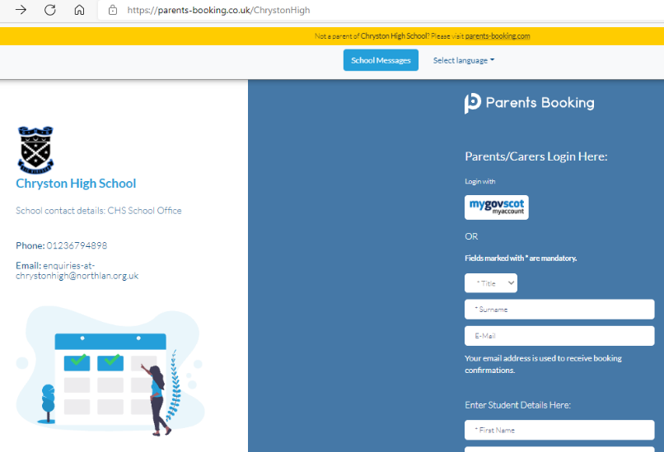

NOTE: You can also log in via Parents Portal. If you are using Parent Portal, please log in to Parent Portal and click the Parents Evening Booking tile which will take you to the school’s parents evening site. (Please see Parent Portal video guide for help if required).

Once you have logged in you will be able to see the parents’ evenings available to you.
Please click on the appropriate parents evening, e.g. Autumn Term

You can then click to make/edit your own bookings.
Making appointments:
You should see your child’s name at the top of the page and their teacher’s name for you to make your appointment.
Child’s Name
Primary Curriculum
Teacher Name

You will then be able to pick which 7 minute slot you would like from the list of available appointments. Once you have decided on a time, simply click the blue ‘Book’ button.

Once you have made all your appointments you can then print or email your schedule.

If you need to cancel an appointment, you can click on that specific appointment and click cancel.
Please ensure you cancel all bookings if you can no longer attend the parents evening.
Virtually attending the evening:
You are required to login to Parents Booking again on the day/night of the parents’ evenings and click the red ‘Join Video Call’ button next to the parents’ evening.
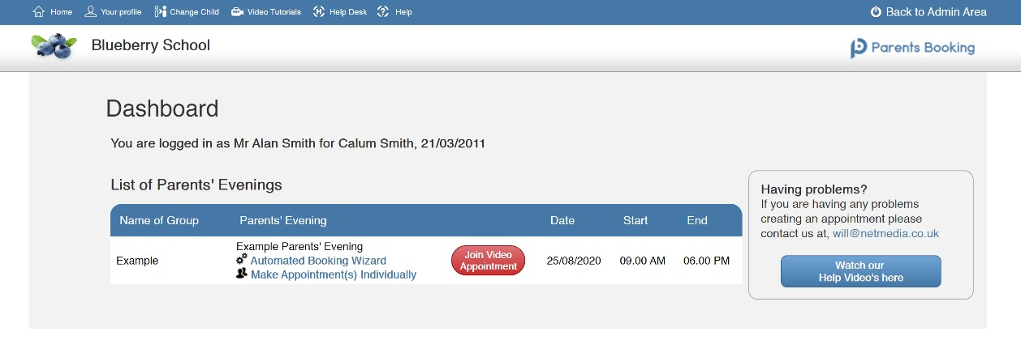

Joining the video call will take you to a video call page, where you will be able to see the teacher once the appointment has started.

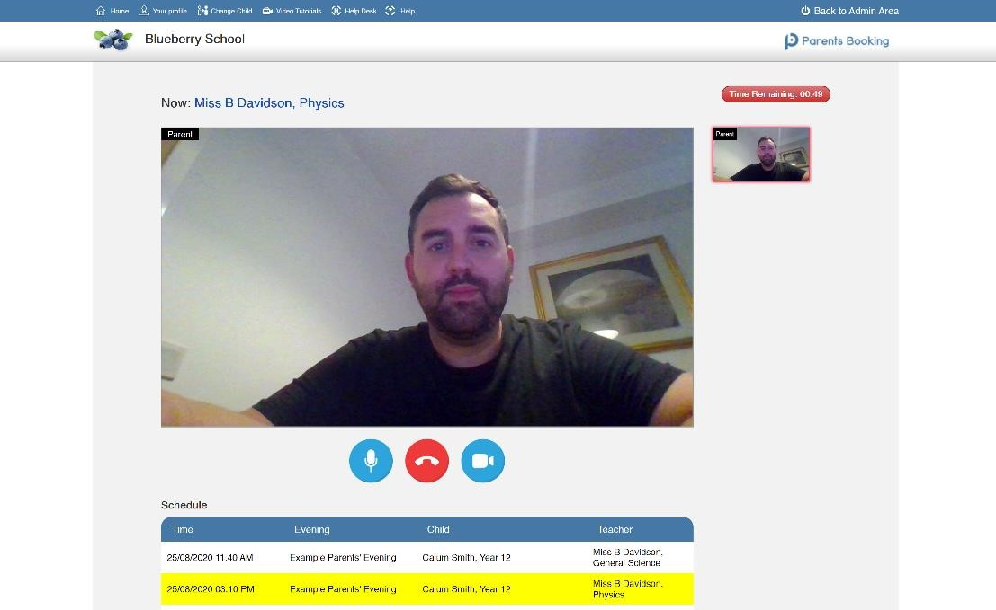
To ensure this works, you must give your internet browser permission to use your microphone and camera when requested.

The meeting will automatically close after the 7 minute appointment time runs out and you can see how much time is remaining in the countdown timer at the top right hand side of the screen. There will be a 1 minute buffer between appointments.

