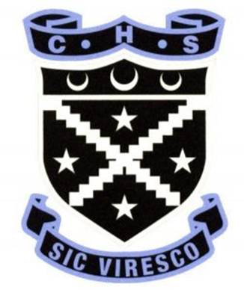
CHRYSTON HIGH SCHOOL PARENT COUNCIL
chrystonhighparentcouncil@gmail.com
@ChrystonHS_PC / @ChrystonHSS

WHAT DOES A PARENT COUNCIL DO?
- Aims to create a welcoming and inclusive school for all.
- Represents all the parents / carers of Chryston High pupils (the Parent Forum).
- Supports school activities through the fundraising group, Chryston High School Supporters.
- Works in partnership with the School, the pupils and parents to deliver a supportive learning environment.
- Explores how everyone can best support the education and welfare of pupils.
- We want a range of views, skills and experience to be involved with the Parent Council to deliver meaningful outcomes for the pupils.
- Recently the PC has supported refurbishment of the senior flexible learning space; set up the Chryston High 500 club which raises money for the school; fed into the school improvement plan and anti-bullying policy; assists with the pre-prom event and meets with the School Captains and hears from various pupils groups as to their current projects and views on school life.

WANT TO GET INVOLVED?
- Come along and listen to what is discussed, there is no commitment required.
- For volunteering for fundraising events / activities come along and share your ideas.
- Follow @ChrystonHSS for specific fundraising initiatives you could get involved in.
- We currently meet every second month, on a Wednesday from 1830 –2000.
- Meetings are held online at the moment and will return to face-to-face when allowed with the ambition of still making the meetings accessible online for those who can’t join in person.
NEXT MEETING IS ON WEDNESDAY 11TH JANUARY,
- Email chrystonhighparentcouncil@gmail.com if you would like to come along.
We’d love to see you there!

