Name | Address | Amount | Paid
Thank you!

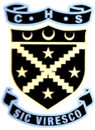
A sponsored climb to raise money for

and
Ben Nevis Challenge 2016
Sponsor Form
Name | Address | Amount | Paid
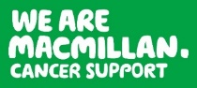
Name: Class:
Saturday 18th June, 2016
Everyone, including both pupils and staff, have been given a fundraising target of £60. To allow you to start raising this money you have been issued with a sponsor form. Climbing to the top of Ben Nevis is an exciting yet tough challenge, so please ask as many people as possible to sponsor you.

All sponsor forms and money should be handed in to Miss Renicks by Monday 13th June, 2016. This deadline has been put in place to give everyone an opportunity to collect and return sponsorship money before the summer holidays.

