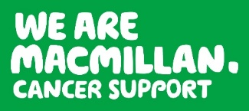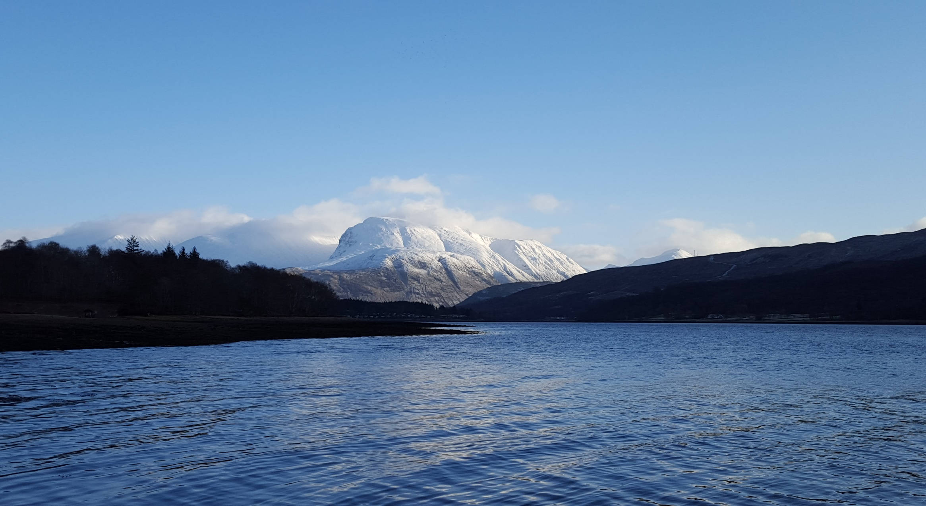Kjlkjlkjlkjlkjlklkjlkjlkjlkjlkjlkjlkjlkjlkjlkjlkjlkjlkjlkjlkjlkjlkjlkjlkjlkjlkjlkjlkjlkjlkjlkjlkjlkjlklkjlkjlkjlkjlkjlkjlkjlkjlkjlkjlkjlkjlkjlkjlkjlkjlkj

Information Booklet

A sponsored climb to raise money for

and

Saturday 18th June, 2016

Ben Nevis Challenge

2016

Thank you for choosing to take part in Chryston High School’s first ever Ben Nevis Challenge to help raise funds for Macmillan Cancer Support and our World Challenge expedition.

Ben Nevis is the highest mountain in Britain, standing at 1345 metres (4411ft) high. It is situated in Glen Nevis near Fort William in the Scottish Highlands and from the summit, on a clear day, you can see views all the way to Loch Lomond and Northern Ireland.

This booklet will provide you with important information about the details of the trip as well as important health and safety information. **Please read it very carefully!**

Chryston High School

Lindsaybeg Road, Chryston, Glasgow, G69 9DL

01236 794890

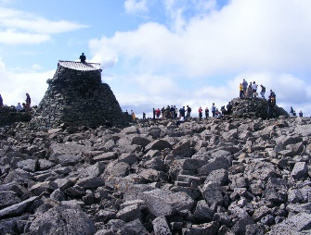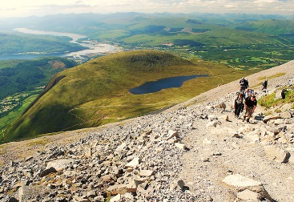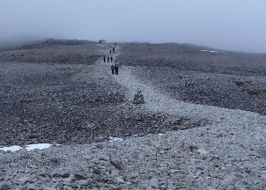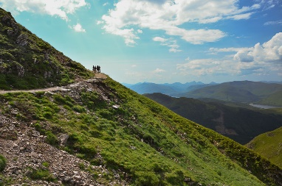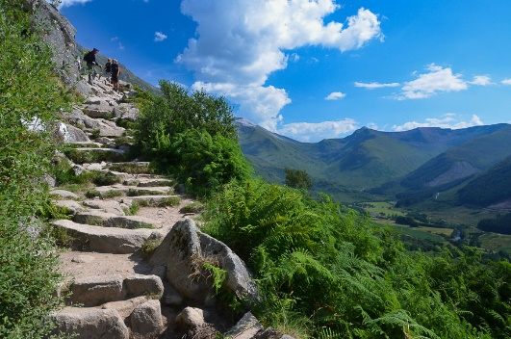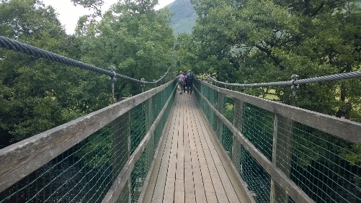

The climb consists of:

* A mixture of terrain. The Mountain Track is rocky and step like, as well as a mixture of scree, gravel and loose rocks.
* Walking 10.75 miles in total.
* Climbing to a height of 1345 metres.

Key Information

fatal fall down into the North Face or into the Five Finger Gully. Upon reaching the summit, it is possible that there will be some snow, and it will be very cold. There are the remains of the old Ben Nevis Observatory and the summit is marked clearly by a cairn.

The descent back down the mountain will follow the same route down the Mountain Track. The descent can be just as, if not more challenging as the ascent due to the differing terrain.

The Mountain Track will lead us up to the Halfway Lochan and then up to the Red Burn which marks the halfway point of the ascent up the mountain. After reaching the Red Burn the terrain changes from being rocky and step like to a well worn path which zig zags up to the summit. The ascent to reach the summit needs to be approached with a lot of care as veering off the path can result in a

The climb will start at the bottom of Ben Nevis at the Glen Nevis Visitor Centre. We will then proceed to cross a small suspension bridge to the base of the Mountain Track (Tourist Path) on Ben Nevis where the climb will properly begin. The Mountain Track, whilst it is a good, clear path which is regularly maintained, can be very rocky, arduous and challenging.

Ben Nevis is the highest mountain in Britain and taking on the challenge to climb it, is a decision not to be taken lightly.

What Will the Climb Involve?

It is recommended that you have the following clothing and equipment for climbing Ben Nevis.

* A pair of walking boots. These are **essential** as trainers or other footwear are inappropriate. You will **not** be allowed to climb the Ben without walking boots.
* A pair of waterproof trousers.
* A waterproof jacket.
* A pair of warm thick socks. It is advised to bring multiple pairs of socks.
* A warm hat.
* A warm pair of gloves.
* A pair of warm, comfortable trousers – NO JEANS!
* A warm mid layer top.
* A warm fleece or jumper (no cotton jumpers – these get very cold when wet)
* A small rucksack. It is a good idea to line your rucksack with a bin bag to keep the contents dry if there is bad weather.
* Blister plasters and travel sickness tablets (for the coach journey if required.)
* A **fully charged** mobile phone.
* Sun cream.
* Snacks – see food and nutrition section

**Change of Clothing**

If the weather is wet on the mountain, you will need something dry and comfortable to change into after the climb. You **must** bring a FULL change of clothing, including footwear with you. Your change of clothing can be left on the coach during the climb and be collected after the climb.

**Layers**

The temperature at the bottom of Ben Nevis can be extremely different from the temperature at the summit of Ben Nevis. The temperature as you climb will drop and therefore it is very important that you have multiple layers of clothing with you that you can put on as it gets colder.

Recommended Kit List

Food and Nutrition List

You will need to bring a packed lunch, water and snacks with you to give you energy for and during the climb. You will need to bring food to last you throughout the duration of the day.

**Breakfast and Lunch**

Taking part in this climb means that you will be using up lots of energy. It is important to eat carbohydrates both before and during the climb. You might want to consider the following foods to eat before and during the climb as part of your breakfast and lunch:

* Bread – sandwiches, toast etc.
* Pasta
* Rice
* Potatoes
* Cereal

**Snacks**

You will be using up a lot of energy very quickly throughout the climb. It is important that you have snacks with you to provide you with the bursts of energy that you’ll need to get you to the summit and back down to the bottom of the mountain again. You might want to consider the following snacks to have in your rucksack for the climb: **Please note: No nut products are allowed due to a sever allergy.**

* Bananas
* Sandwiches
* Jelly Babies
* Mars Bars
* Flapjacks

**Water**

It is extremely important that you remember to stay hydrated throughout the climb. Regardless of the temperature or the weather during the climb, you will still be sweating and your body needs to stay hydrated to ensure that it stays healthy and that you enjoy the climb.

Please bring **at least 1 litre** of water with you. When packing your ruck sack please place your water **outside** of the bin bag in case it leaks. This will keep the contents inside of the bin bag dry.

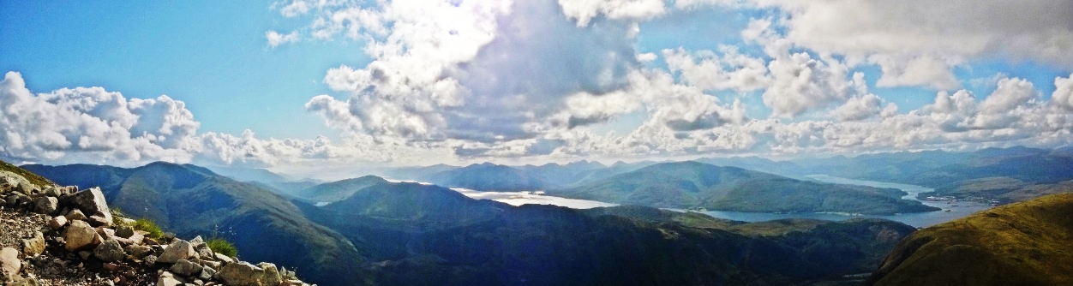

We will be accompanied on our climb by four very experienced mountain leaders. The will be guiding us on our climb up the Mountain Track and looking out for our safety at all times.

Pupils will be split into groups of 10 and will be paired up with a mountain leader. Staff will also be assigned to a group and a mountain leader. It is vitally important that you stay will your assigned group at all times and **do not** change groups to allow everyone to stay safe at all times.

Before the climb everyone will be given a safety briefing by our mountain leaders. It is very important that you listen to this briefing carefully and that you listen to the mountain leaders **at all times**.

Mountain Leaders

The weather on Ben Nevis can change very quickly and very dramatically. The weather at the bottom of Ben Nevis can be very different from the weather at the summit.

You may feel comfortable starting the climb wearing a t-shirt, however, it will get increasingly colder as you start climbing. The temperature drops roughly 1°C per 100 metres climbed, so while it might be a warm sunny June day at the bottom of Ben Nevis, it will feel like a winter’s day at the summit. As a result it is very important that you have many layers of warm clothing with you to be prepared for such weather.

In addition to the temperature changing, the Scottish weather can be very changeable. It is important that you have a waterproof jacket and a pair of waterproof trousers to keep you dry from wet and windy weather. There is a high probability that there will be snow at the summit, and that you may be walking through clouds so keeping yourself dry is essential.

If the weather is particularly bad, or if the weather changes during the climb, our mountain leaders will assess the situation to determine whether the groups will be permitted to climb to the summit. Safety on the mountain is number one priority and everyone **must** follow the instructions of the leaders.

Weather Safety

The following safety guidelines must be **strictly** adhered to by pupils and staff.

1. When filling out your registration and emergency contact form, please make sure you fill out all of your details accurately and carefully. These will need to be used in an emergency situation.
2. All medical conditions should be recorded on your form.
3. You must carry all of your own medication in your ruck sack. It is your responsibility to make sure that it is in date and that you have an adequate supply of it to last you on the climb.
4. You **must** listen to the Mountain Leaders and follow their instructions at all times.
5. Walking boots **must** be worn. **Strictly no trainers, converse, or equivalent are to be worn**. Anyone not wearing walking boots will not be allowed to climb Ben Nevis.
6. Waterproof clothing **must** be worn or carried in your rucksack.
7. If you stop to rest during the climb, please alert the rest of your group that you are stopping, and rest on the uphill side of the path. This will stop you from getting lost, and will allow other climbers to pass you.
8. Don’t push yourself beyond your own limitations. Everyone has their own personal summit, and every step that you take is an achievement.
9. Stick to your groups of 10, and wait on and support each other. Do regular head counts. There is safety in numbers.
10. **If you or someone in your group feels unwell you must notify your Mountain Leader and a member of staff immediately.**

Safety Information

Problems, Incidents and Emergencies

If any issues arise on the day of the climb you should notify a teacher or one of the mountain leaders immediately.

In an **emergency** **ONLY**, telephone **999** and ask for the **POLICE** and then **MOUNTAIN RESCUE**.

Emergency Contact Details: **Miss Renicks – 07904976038**

**(For emergency purposes only! – Please enter this into your mobile)**

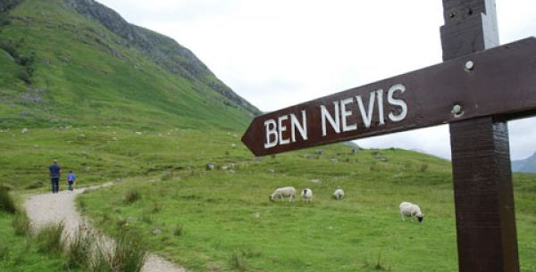

1. Water is essential. Please carry smaller bottles and not big bottles. You will need at least 1 litre of water.
2. **If you or someone in your group becomes injured, you must let your Mountain Leader know immediately in order for them to assess the seriousness of the situation and the best course of action to take.**
3. You must not go wandering off on your own, or race ahead in front.
4. **Keep to the main path at all times. At the summit there are very steep edges. At the summit there will be snow, and this could be compacted together creating ledges that could be overhanging and disguising these edges. A fall down one of these ledges will most probably result in death. Follow your Mountain Leader at all times!**
5. Sections of the Mountain Track can be very steep and rocks may be loose underfoot. It is vitally important that you are careful at all times and are cautious of the changing terrain on the mountain.
6. Your behaviour on the climb must be very good. Any bad or reckless behaviour can very quickly result in a serious accident. Don’t put yourself in that situation as a result of your behaviour.
7. Strictly no alcohol will be permitted on the climb or the bus journey to and from Fort William.
8. You must **not** eat any wild berries, or leaves that you find on the Mountain Track.
9. You must **not** approach any animals (sheep, deer or dogs) that you come across on the Mountain Track.
10. You **must not** drink water from any of the streams or the Halfway Lochan. There are no toilets on Ben Nevis so many people, as well as the local wildlife, find a sheltered spot to do the toilet. As a result the water near the Mountain Track is not clean and could give you a very upset stomach.
11. You will be given a coloured laminated card with your emergency contact details on it. This must be attached to the **outside** of your rucksack.

The time schedule on the mountain MUST be strictly adhered to for health and safety reasons.

9.15am Pupils and staff will be asked to go into their groups where they will receive a safety briefing from all of/their own Mountain Leader. Laminated emergency contact details will also be given out and these will be attached to ruck sacks at this point.

9.30am The groups will start the ascent up Ben Nevis.

12.00pm Groups should have reached the halfway point, just beyond the Halfway Lochan.

2.00pm Groups should have made it to the summit of Ben Nevis by this time.

2.30pm Groups should have left the summit by this time to ensure that the descent will be finished during daylight hours.

6.00pm Groups should have completed the descent, and be back at the base of Ben Nevis. At this point you may access your personal belongings and your change of clothes on the bus and get changed in the visitor centre. The coach will then depart Glen Nevis and head into Fort William for dinner.

7.00pm The coach will depart Fort William for the Green Welly Stop.

8.20pm Arrival at the Green Welly for a very brief toilet stop.

(approx.)

10.30pm The coach will arrive back at Chryston High School.

(approx.)

5.15am Pupils and staff are to arrive at Chryston High School no later than this time to ensure all consent forms, equipment, and pupils are present.

5.30am The coach will depart Chryston High School for Fort William.

9.00am The coach will arrive at the Glen Nevis Visitor Centre where we will be met by the Mountain Leaders.

Itinerary

Emergency Contact 1 Details

Emergency Contact Name:

Telephone No. (Home):

Telephone No. (Mobile):

Relationship to You:

Emergency Contact 2 Details

Emergency Contact Name:

Telephone No. (Home):

Telephone No. (Mobile):

Relationship to You:

Group Details

Mountain Leader:

Group Members (Pupils):

Group Members (Teachers):

Group Colour:

Please fill in the following section **accurately and in detail** for your group. Members of the group should take it in turns to carry out head counts as the climb progresses. Please make sure that you support everyone in your group at all times.

Please fill in the following section **accurately and in detail** for your emergency contacts.

Groups and Contact Info

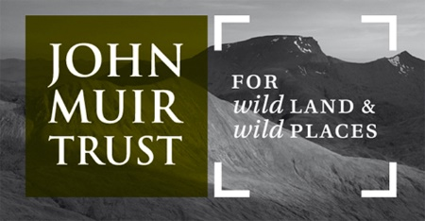

John Muir was a naturalist who was born in Dunbar near Edinburgh. He was an early advocate for conservation in America, and Scotland. He was the founder of the world’s first national parks and today the John Muir Trust look after, preserve, care for and enhance wild places in Scotland. Every year thousands of people climb Ben Nevis and this has a huge impact on the mountain. You can help support the aims of the John Muir Trust and minimise the impact by:

* Sticking to the main path to reduce erosion.
* Taking **all** of your litter and food scraps with you off of the mountain.
* If you need to do the toilet, please avoid doing it near water and streams.
* Do **not** move rocks etc and do not leave any belongings on the mountain.

John Muir Trust

All sponsor forms and money should be handed in to Miss Renicks by Monday 13th June, 2016. This deadline has been put in place to give everyone an opportunity to collect and return sponsorship money before the summer holidays.

Macmillan Cancer Care

Pupils and staff who are not going on the World Challenge expedition in 2017 will be raising money from their climb up Ben Nevis to support Macmillan Cancer Care.

World Challenge Expedition

Pupils who are going on the World Challenge expedition to Southern Tanzania in 2017 can use Ben Nevis as part of their fitness training. Challengers can also use this as an opportunity to fundraise for their expedition, putting any money that they raise towards their final total for Southern Tanzania.

Everyone, including both pupils and staff, have been given a fundraising target of £60. To allow you to start raising this money you have been issued with a sponsor form. Climbing to the top of Ben Nevis is an exciting yet tough challenge, so please ask as many people as possible to sponsor you.

Sponsorship

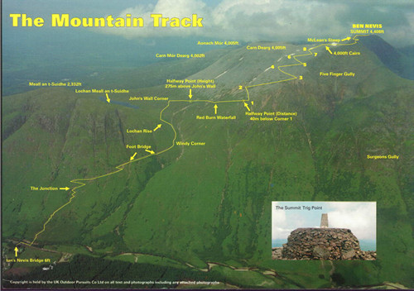

Things to Consider…

Training

Climbing Ben Nevis is physically demanding and takes the average person between 6 and 8 hours to climb and descend. To make the challenge easier and more enjoyable, it is advisable to train and prepare your body for the climb. You should put on your walking boots and get out walking as often as possible. Try walking to and from school, use stairs instead of lifts, go for a walk at lunchtime, evenings and weekends. Walking can be a great way to have a break and de-stress from exam preparation.

Expectations and Timings

If you intend to reach the summit, your timing of the climb in line with the itinerary is crucial. If timings are not met, the Mountain Leaders might make the decision on health and safety grounds to stop the climb to the summit, and start the descent. You **must** respect the decisions made by the Mountain Leaders as they have your safety in their best interests.

Climbing Ben Nevis is not a race, so do not push yourself beyond your limits. Every step climbed is an amazing achievement and whatever point you reach on the day will be your summit and you should be very proud.

\\h024filesrv01\staff$\Work\15499renicksshon\Desktop\scollins.png

A massive thank you to all of our sponsors in the local community who have helped make this trip possible.

Sponshorships