P6/5 Brazil Homework
As part of our interdisciplinary theme your child is being asked to complete 4 of the following tasks. Your child can choose what 4 tasks they want to do and what order to do them in. One task must be ready to report back to class on the following dates. Friday 9th Sep, Fri 30th Sep, Friday 14th Oct and Friday 4th Nov.
- Create a 3D artefact related to Brazil. This could be :  *A famous landmark  * Football Stadium  *linked to the rainforest  * map of Brazil/city | 2. Make a fact book about Brazil or a city within Brazil. You can compare to Scotland. | 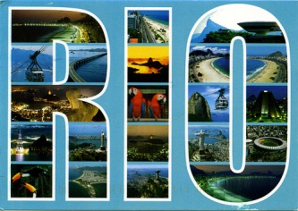  3. Pretend you have been on a holiday to Brazil. Design and write a postcard to your family about your time there. | 4. Interview somebody who has been to Brazil and find out about their time there.
5. Research football teams and stadiums in Brazil. Design your own Stadium, team and football strips based on your findings. | 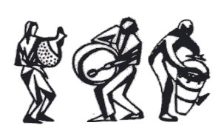  6. Find out about the style of music in Brazil. Design an instrument and compose your own Brazilian piece of music to share with the class. | 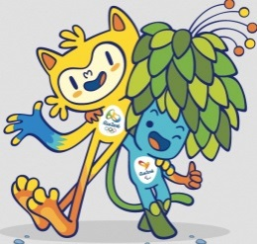  7. The Olympics was held in Brazil this year. Find out about the 2 Mascots and why they were chosen. | 8. Design a new piece of clothing/headdress to wear during the carnival.

