P4 IDL Homework for French Topic
These tasks are for Thursday night’s homework. Choose four tasks you would like to do. Hand one in every 2 weeks. The first one is due on the 6.5.16.
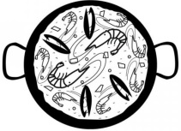  Can you find a French recipe? Write it out or type it up with pictures and instructions for a class recipe book. | 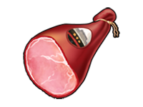  When you are at the supermarket look for food from France. Cheese, ham, olives, oil. Write down names of them and where in France they are from. | Can you find out some French words?  For example numbers, colours, days of the week, food, hello, goodbye, please, thank you.  Choose one and create a colourful poster to teach other children.
- Pretend you are  - on holiday in  - France. Create  - and write a  - postcard to your  - friend or family  - of what you have  - done and things you  have seen. | - Do you know anybody who has been to France? Interview them about their time there and find out some information and report back to the class.  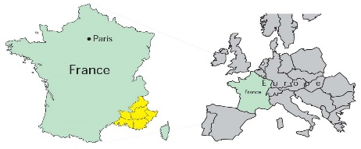 | 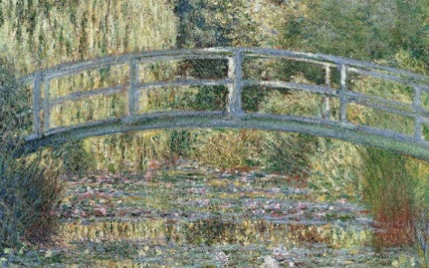  Claude Monet is a famous French artist. Research his artwork and create your own piece.

