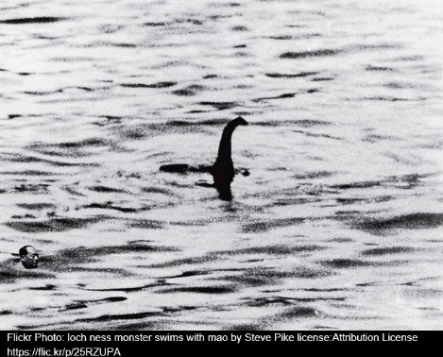
Narrative Task – Blue Group

The Loch Ness Monster is a large creature that many believe lives in the Scottish waters of Loch Ness. People come from all over the world to see this creature but with no success. Imagine you see this creature when you are out walking somewhere or you look out your window and it is in your garden. What do you do? Do you go near it or just watch from a distance? Who do you tell or do you keep it a secret? What does the Loch Ness Monster look like? How do you feel?
Writing Guide
- Please write and underline the date at the top of your jotter.
- Write a title for your story and underline it.
- Remember to tell about when your story takes place, where it takes place and who is in it.
- Remember to tell about what happened in your story.
- Remember to tell about how your characters felt.
- Remember to use the core targets to check your work as you go.
Core Targets
- I have spelled most common and tricky words correctly.

- I have used capital letters and full stops when writing sentences.
- I have joined sentences using a variety of conjunctions/connectives e.g. and, but, because.
- I have presented all work legibly and include features to make it attractive. (headings, labelled diagrams/charts)

