Bonjour Primary 3/4! We have an exciting new online French resource to explore called Linguascope! This week, our French task is to get logged in and play some French games about the weather. Follow the instructions below:
- Go to the website www.linguascope.com and click on ‘Login’.
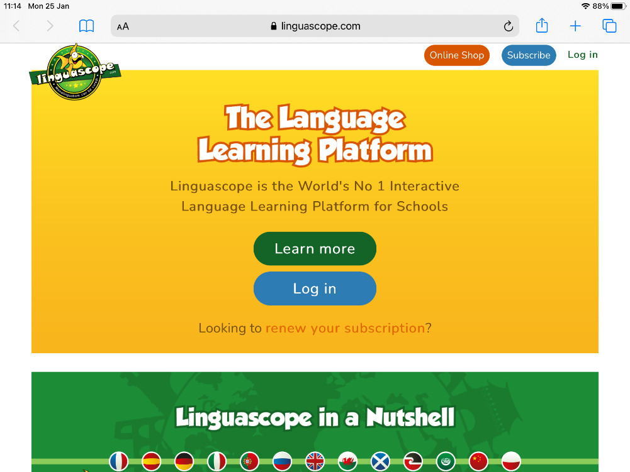

- Login using the following details:
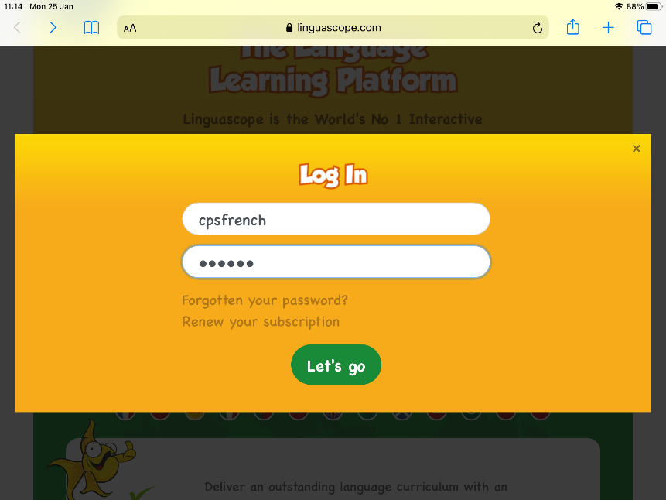
Username:cpsfrench
Password: cps123

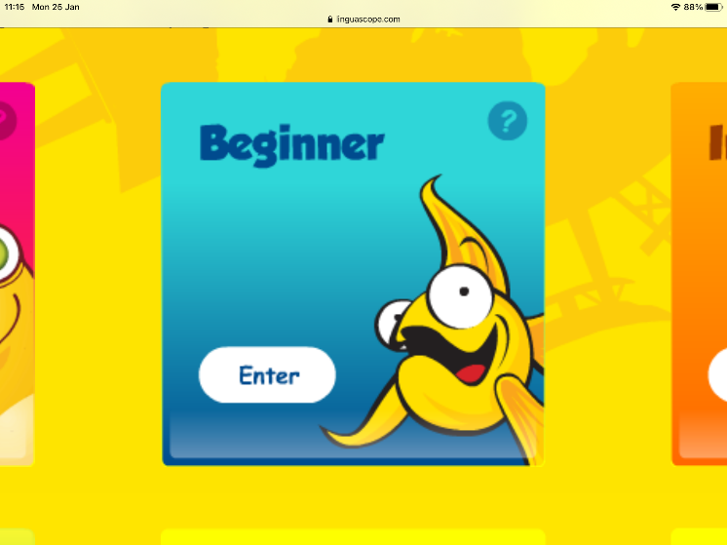
- Click on the blue ‘Beginner’ box.

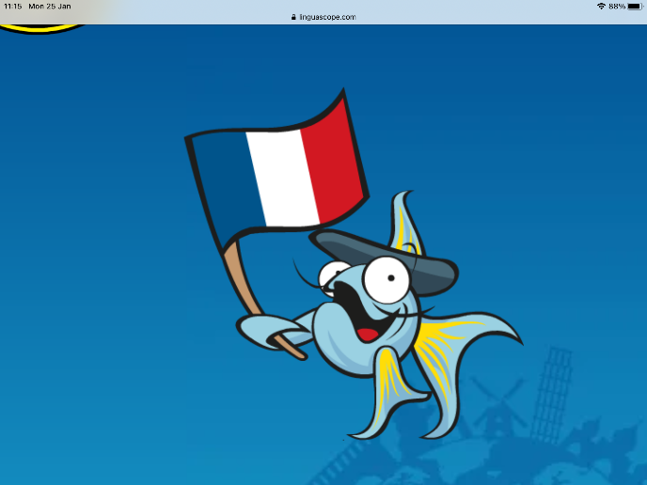
- Click on the French flag.
Things may look slightly different depending on the device you are using. If you’re using a desktop or laptop, you may have to click on a French flag in the beginner box. Don’t worry about this, it will still take you to the same page.

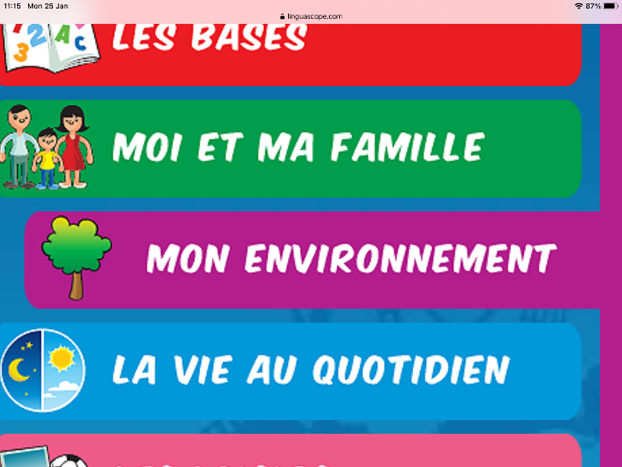
- Click on the purple tab ‘mon environnement’.

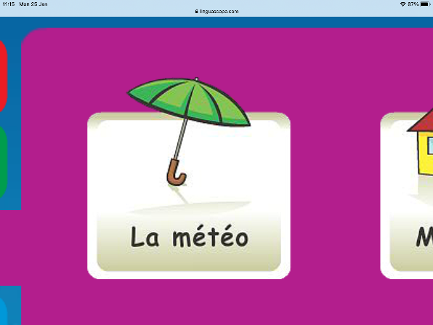
- Click on the umbrella ‘La météo’.

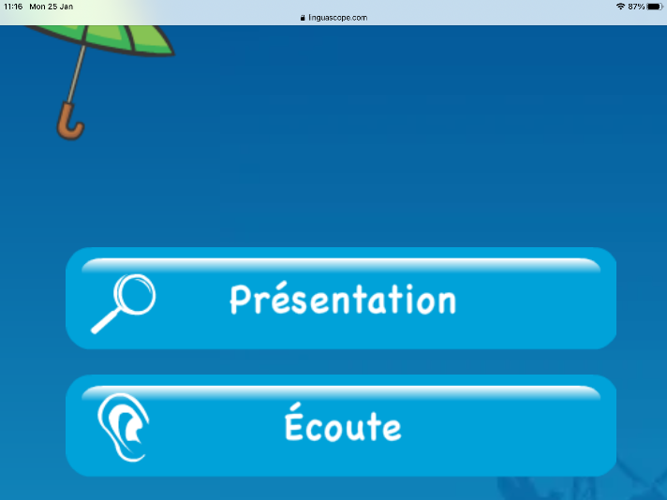
- Click on ‘Présentation’ to learn more vocabulary about the weather.

When you are finished watching the presentation, go back to the la météo page. All the other tabs are games you can play to practise your French weather vocabulary. Play as many as you like!

On the Primary 3/4 French channel, leave a comment to tell me which games you chose and if you enjoyed using our new French resource. I’m looking forward to hearing from you all!

Mademoiselle Meechan

