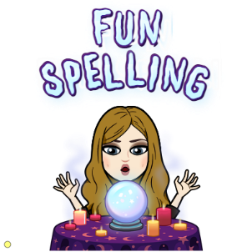**Fun Spelling examples**

When you have time to do a fun spelling task, here are some of the things you can do.

* Rainbow spelling

Use different colours to write your spelling words, this could be a different colour for each word or even different coloured letters in each word.

* Backwards spelling

Write your spelling word backwards!

* Number spelling

In this task, each letter in the alphabet is worth a number. Add your letters together to see their value.

|  |  |  |  |  |  |  |  |  |  |  |  |  |  |  |  |  |  |  |  |  |  |  |  |  |  |
| --- | --- | --- | --- | --- | --- | --- | --- | --- | --- | --- | --- | --- | --- | --- | --- | --- | --- | --- | --- | --- | --- | --- | --- | --- | --- |
| a | b | c | d | e | f | g | h | i | j | k | l | m | n | o | p | q | r | s | t | u | v | w | x | y | z |
| 1 | 2 | 3 | 4 | 5 | 6 | 7 | 8 | 9 | 10 | 11 | 12 | 13 | 14 | 15 | 16 | 17 | 18 | 19 | 20 | 21 | 22 | 23 | 24 | 25 | 26 |

car= 3+1+18 = 22

* Hidden words

Draw a picture and hide your spelling words throughout the picture.

* Silly sentences

Use your spelling words to create a silly sentence. Remember to underline your spelling words.

My dog drove the car to school last week.

* Spell-er-size

Pretend you are a cheerleader and call out your words. Stretch your hands above your head for the letters that touch the top writing line, put your hands on your waist for letters in the middle, and ouch your toes for letter that go on the bottom line.

bag

**b** (above) **a** (waist) **g** (toes)