Castles around Scotland
Task
Cut out the castles along the bottom of this sheet. Read the name of each castle and search online to see where it is in Scotland. Stick a castle on the map where the castles are. Some may be close together, that is ok, just place these castles near to the location.
If you can’t print the sheet you can use the mark-up tool to draw a small castle or draw an X where there should be a castle.
- Cawdor Castle in Cawdor
- Stirling Castle
- Glamis Castle in Angus
- Edinburgh Castle
- Braemar Castle
- Blair Castle Pitlochry
- Inverness Castle
- Inverary Castle
- Dunnottar Castle in Stonehaven
- Eileen Donan Castle in Dornie

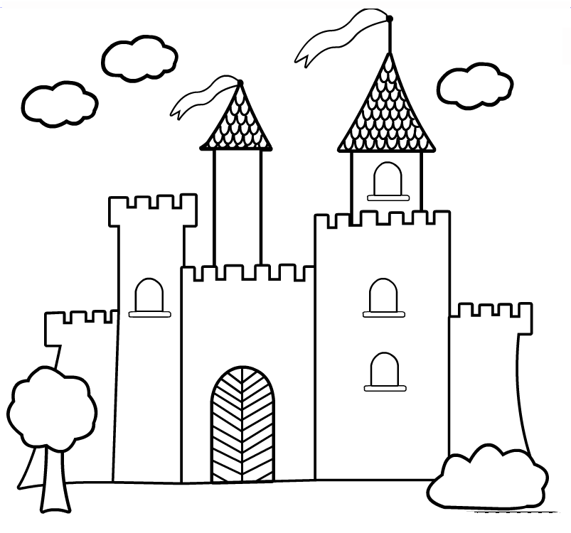

Extra Task
When you are finished you could look up these castles on the internet to see what they look like.

