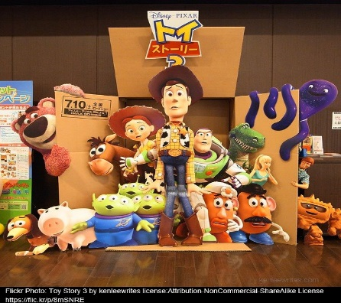
Narrative Task – Blue Group

In the film ‘Toy Story’ Andy’s toys come to life and get up to all sorts of adventures. All the toys have different personalities and skills.
This week I would like you to write a story about a time when one or two of your toys come to life. What toys came alive? What adventure did they go on? How did you help them or they help you?
Writing Guide
- Please write and underline the date at the top of your jotter.
- Write a title for your story and underline it.
- Remember to tell about when your story takes place, where it takes place and who is in it.
- Remember to tell about what happened in your story.
- Remember to tell about how your characters felt.
- Remember to use the core targets to check your work as you go.
Core Targets
- I have spelled most common and tricky words correctly.

- I have used capital letters and full stops when writing sentences.
- I have joined sentences using a variety of conjunctions/connectives e.g. and, but, because.
- I have presented all work legibly and include features to make it attractive. (headings, labelled diagrams/charts)

