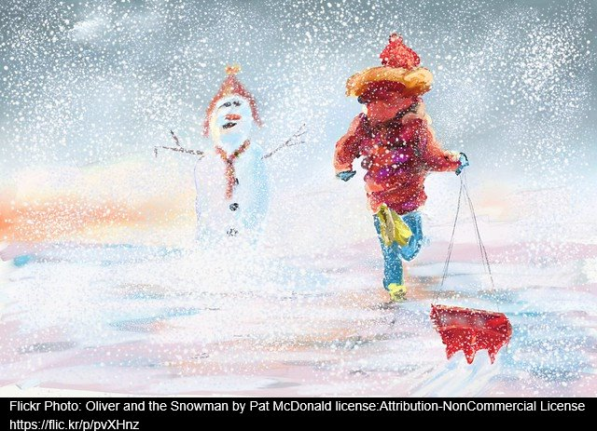
Narrative Task – Green Group

In the story of The Snowman James builds a snowman in the garden, then wakes up in the night to find that it has come to life. He shows the Snowman his home, and in return, the Snowman whisks him away on a very special journey.
This week I would like you to write a story about when your snowman came to life. Did you go on an adventure? What did your snowman look like? Was your snowman friendly? Did you tell anyone else or keep it a secret? What happened to your snowman in the end?
Writing Guide
Please write and underline the date at the top of your jotter.
Write a title for your story and underline it.
Remember to tell about when your story takes place, where it takes place and who is in it.
Remember to tell about what happened first, then, next and finally.
Remember to tell about how your characters felt.
Remember to use the core targets to check your work as you go.

Core Targets
- I have spelled most common and tricky words correctly.
- I have used capital letters and full stops when writing sentences.
- I have joined sentences using a variety of conjunctions/connectives e.g. and, but, because.
- I have varied the sentence lengths and sentence beginnings.
- I have presented all work legibly and include features to make it attractive. (headings, labelled diagrams/charts)

