PE – Athletics – Running

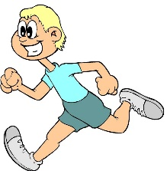

Arms
- Straight arms. Keep your arms straight the whole time you run.
- Arms above your head. Put your arms straight above your head the whole time you are running.
- Bent Arms. Bend your arms by your side and move them back and forward as you run.

Legs
- Straight legs. Keep your legs really straight the whole time.
- Bent legs. Bend and straighten your legs as you run.
- Knees up. Bring your knees up as high as you can while you run.

Head
- Look straight ahead. Keep your head looking right to the place you are running towards.
- Look upwards. Look up toward the sky as your run.
- Look to the side. Look to one side as you run.

Body
- Side ways. Run with your whole body facing the side of the running track.
- Backwards. Run backwards (carefully)
- Forwards. Run facing forwards facing the way you are going.

Now you have worked out the best ways to run. Have a race with someone or time yourself three times and see how fast you can go.

