Page Duties Checklist
Pretend you are a page living in the castle. You must complete all these activities for the day. Tick off each job as you complete it.
Wake up and get dressed in your tunic and tights.
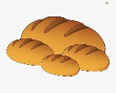 Eat bread and beer for breakfast.
Learn the three h’s:
Hawking – Train your Hawk to capture other small animals
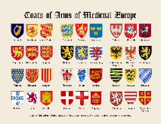 Heralding – Study different coats of arms to learn who
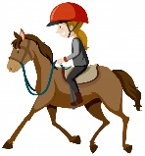 Horses – Practise horse riding for when you are in battle
Weapons practice
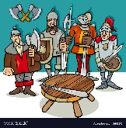 Serve all the knights meals before they go off to fight
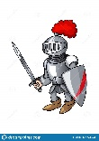 Practice being a knight
Back to bed

