Area
LI: to use non-standard units of measurement to measure area.
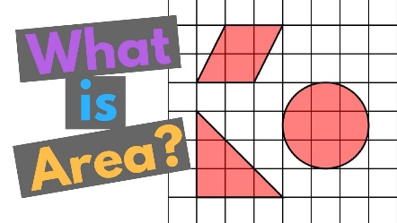
- Make sure you have watched the YouTube video https://www.youtube.com/watch?v=hmvwAUGxbkM

Area is the amount of space taken up by a 2D shape or surface.

- You will need four things to answer these questions - a book, a pillow, a baking tray and your bed. Write the answers in your jotter.

- Lie the book and the pillow flat. Now, put the book on top of the pillow. Which one has the bigger area?
- Put the baking tray on your bed. Which one has the bigger area?
- Put the baking tray on top of the pillow. Which one has the bigger area?
- Put the book on your bed. Which one has the bigger area?

- How many pillows would it take to cover your bed? Ask a grown up to help you count.

- How many books would it take to cover your pillow? Ask a grown up to help you count.

- How many books would it take to cover the baking tray? Ask a grown up to help you count.

