Measuring Length Using Informal Units
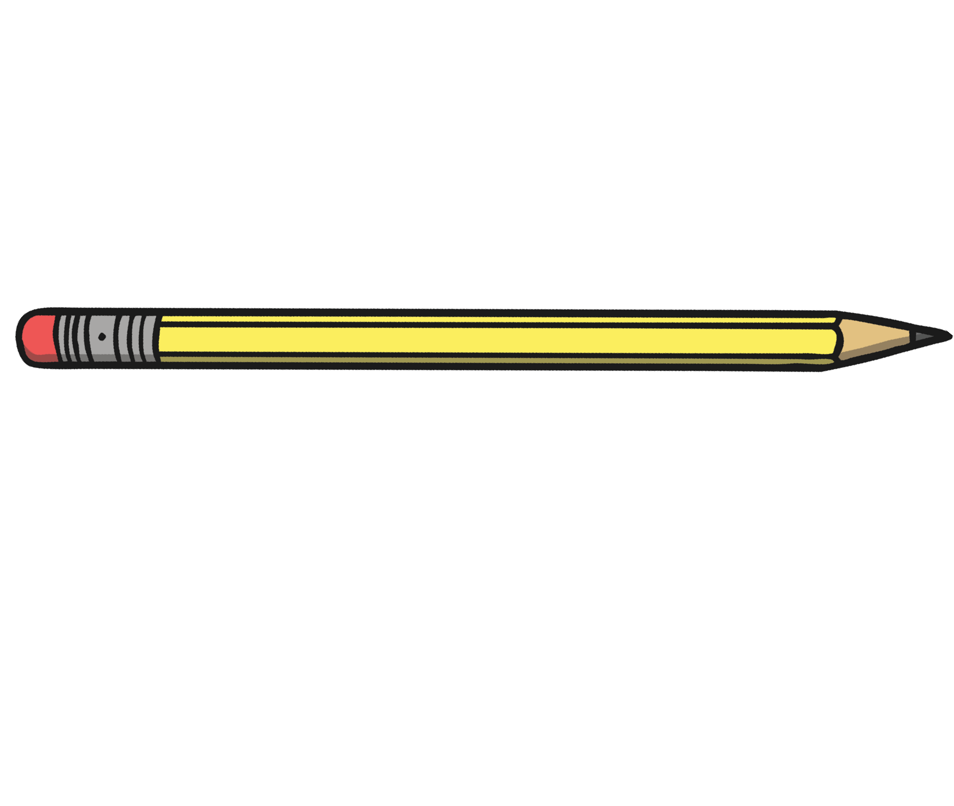

LI: to estimate and measure household items using my hands.

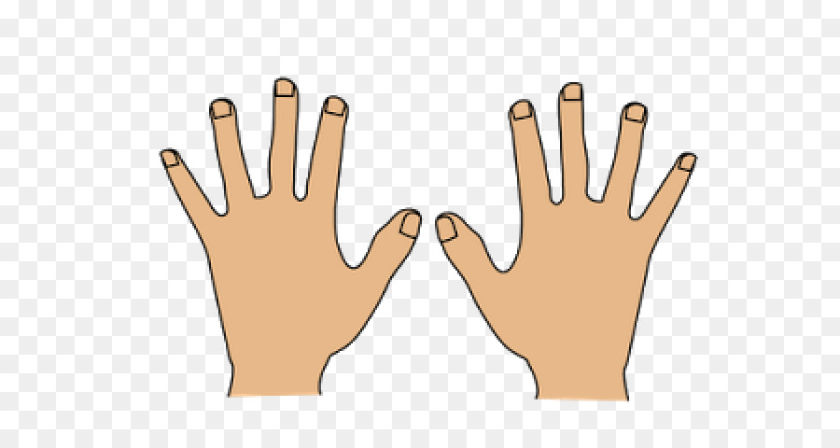

Unit of Measurement | Estimate  (Guess before your measure) | Measurement
Measure how wide your front door is with your hands. | I estimate the door to be hands. | The door is  hands.
Measure how tall your chair is with your hands. | I estimate the chair to be hands. | The chair is  hands.
Measure how wide our fridge is with your hands. | I estimate the fridge to be hands. | The fridge is  hands.
Measure how long your bed is with your hands. | I estimate the bed to be hands. | The bed is  hands.

