Hello,

The following activities are fun, creative and can be done with family and friends.

There are Health & Wellbeing, Topic and Outdoor Learning activities.

There is no set order for these activities, nor is there any expectation to complete them all.

If the children do complete any of these activities – or any other activities you may be doing with them – it would be great to see what they have been doing. You can email me scans, photographs or even videos at:

gw18shawmelissa@glow.sch.uk

Thank you!

*Miss Shaw*

**Health and Wellbeing**

Here are activities to support you and your family’s Health and Wellbeing.

Try some of these fun activities!

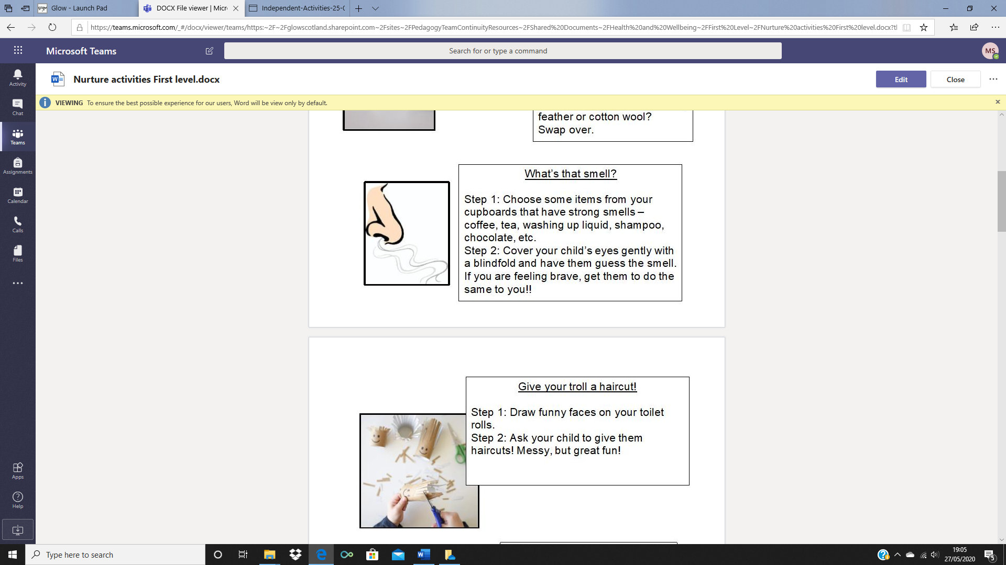

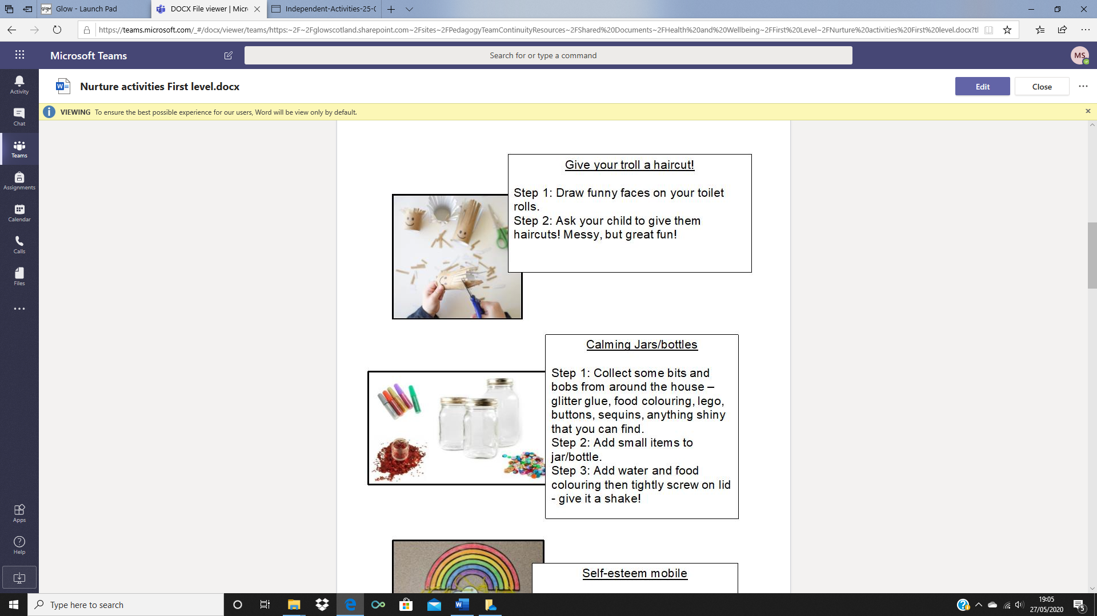

**Get Active**

Here are some activity ideas to get you active!

* Choose a different activity to do every day.
* You can do the same activity more than once and do more than one each day.

|  |  |
| --- | --- |
| Draw a picture of anything you can do to help you keep active. | Draw a picture of you. Talk about/ write words and phrases to describe how being active is good for certain parts of your body. |
| Listen to Disney relaxing music for 15 minutes, or longer.  <https://www.youtube.com/watch?v=GBexfwe-9j0> | |
| Keep busy by doing chores around the house. | Talk to someone about all the things you can do at home to help you keep active. |
| Do some Troll yoga.  <https://www.youtube.com/watch?v=U9Q6FKF12Qs> | |

**Science**

Give this experiment a go.

Take some pictures to show how you got on!

