Threading Fun  Threading activities are good for developing fine motor skills and hand to eye coordination. You can practise threading beads, buttons or pasta shapes onto cord, string or wool to make necklaces, bracelets, worms or caterpillars. You could thread through holes in card or foam to make a shape or pattern  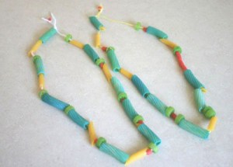 | 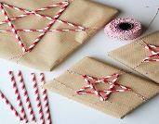  Get Wrapping  Folding, wrapping and unwrapping activities are good – folding paper into shapes or wrapping and unwrapping objects.  Perhaps a toy needs a bandage put on? Fold paper to make a hat or boat or to make a paper snowflake. You could fold napkins for the dinner table, fold clothes to put away or fold dolls/teddies clothes | Fun with Patterns  Pattern activities – Pattern requires good matching skills, plus a bit more attention to detail. You can use toys like Lego to build a simple tower with, for example 4 coloured blocks, and see if your child can make the same. Change the pattern, get your child to make their own pattern and copy it. You can make a pattern with coloured pegs or counters or anything else you can find. Start simply and then you can build on it.  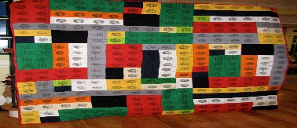 | Spot the Sign/Letter  When you are out and about encourage your child to look at signs and logos. Children very quickly become familiar with the signs for Tesco, Asda, McDonalds etc. encourage them to look for lots of different signs to “read.” Your child may be interested in finding similar letters in these signs. Remember if your child shows an interest in a letter call it by its name and tell the sound it makes. That’s the letter T it makes the sound tt-t (repeat the soft sound). | Flip the coin  Egg box or muffin tin game. You can stick or write letters, or colours or numbers, or whatever you are encouraging your child to learn into egg box, or muffin tin sections. The children can then play at trying to throw, or flip coins or counters into the different sections and see if they can say which section they have landed in e.g. “I’ve landed on red or I’ve landed in rrrr.” A good tip is to start with things the child knows already and just add new things one at a time. So I might put all the colours in because they know them and then the letter from their name plus maybe a new one e.g. m for mum, that way it is fun and not too hard.
Ice Cube Race  Make and freeze ice cubes- add food colouring and have 4 of each colour. Go outside and see who can melt their cubes the fastest. | Oats/Rice/Flour Play  Use a large tub, tray or bucket. Fill with Oats/Rice and flour. Add natural materials like rocks or crystals, household items like spoons, measuring cups | Make a house or shop  Give your child boxes/cardboard. Provide paper/pens.  Encourage them to make a house or shop. Give them things to sell or kitchen utensils such as pots and pans to play with.  (Ensure no sharp objects) | Pizza Time  Children love cooking!!  Use Tortilla wraps. Cover with tomato paste or ketchup. Sprinkle some grated cheese and top with your favourite toppings. An adult should place in the oven for 5-7 mins . Enjoy. | Grass/Petal Letters  Collect grass and petals during your daily walks.  Use glue and outline your child’s initial on paper. Encourage your child to fill with grass and petals.

