Percentage Booklet

Percentage means out of _ _ _.

Below are squares with 100 parts.

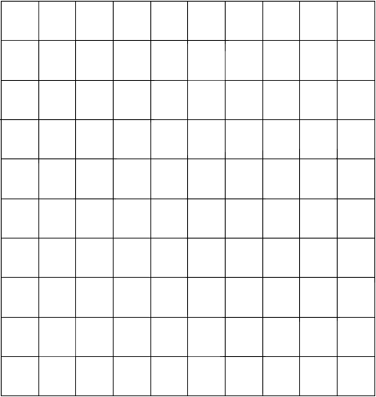
40% have red dots

_ _ % have blue dots.

10 % have __________ dots.

27% have green dots

_ _ % have red dots.

20 % have __________ dots.

_ _% have orange dots.

_ _% have green dots

_ _ % have yellow dots.

30 % have __________ dots.

_ _% have pink dots.

Colour in the dots.

15% have blue dots

30 % have yellow dots

25% have black dots

The rest have red dots.
_ _% have red dots.

32% have black dots

15 % have green dots

28% have grey dots

The rest have red dots.
_ _% have red dots.

19% have grey dots

41% have blue dots

35% have yellow dots

The rest have red dots.
_ _% have red dots.

Reduction means getting _ _ _ _ _ _ _.
Reduce yellow by 8%

Reduce purple by 10%

Reduce grey by 20%

_ _% have green dots

_ _ % have yellow dots.

_ _% have purple dots.

_ _% have grey dots.

_ _% are blank

Reduce orange by 7%
Reduce purple by 20%
Reduce grey by 5%
_ _% have orange dots

_ _ % have yellow dots.

_ _% have purple dots.

_ _% have grey dots.

_ _% are blank

50% = ½ 25% = ¼

Circle 50% of the cubes.

Circle 25% of the cubes.

Circle 50% of the cubes.

Circle 25% of the cubes.

Circle 50% of the cubes.

Circle 25% of the cubes.

Circle 50% of the cubes.

Circle 25% of the cubes.

Increase means the number gets _ _ _ _ _ _.
Increase cubes by 50% (Draw your answer).

Total number of cubes = _______

Increase cubes by 25% (Draw your answer).

Total number of cubes = _______

Increase cubes by 50% (Draw your answer).

Total number of cubes = _______

Increase cubes by 25% (Draw your answer).

Total number of cubes = _______

Increase cubes by 50% (Draw your answer).

Total number of cubes = _______

Increase cubes by 25% (Draw your answer).

Total number of cubes = _______

Increase cubes by 50% (Draw your answer).

Total number of cubes = _______

Increase green cubes by 50% and blue cubes by 50%(Draw your answer).

Total number of cubes = _______

Increase red cubes by 50% and yellow cubes by 25%.(Draw your answer).

Total number of cubes = _______

Increase yellow cubes by 50% and grey cubes by 50%.(Draw your answer).

Total number of cubes = _______

Increase orange cubes by 50% and blue cubes by 25%.(Draw your answer).

Total number of cubes = _______

Increase orange cubes by 50% and yellow cubes by 50%. (Draw your answer).

Total number of cubes = _______

Increase orange cubes by 50% (Draw your answer).

Total number of cubes = _______

Increase grey cubes by 25%, blue cubes by 50% and brown cubes by 50% (Draw your answer).

Total number of cubes = _______

Increase yellow cubes by 50%, green cubes by 25% and red cubes by 50%.(Draw your answer).

Total number of cubes = _______

