Indoor/ Outdoor Balance Beam  Using a long piece of taped line can you walk along this without falling off?  Can you make a taped maze and walk along all the lines??  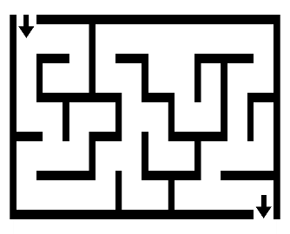 | 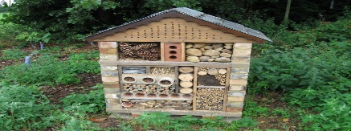  Bug Hotel  You can use old wooden disused pallets, twigs, bark, pines cones, pots, slates, turf.  Make a bug hotel. Fill all the layers using the materials you find. The best bug hotels have lots of small spaces in different shapes. Ideally some should be nice and dry and others more damp. Check your bug hotel daily. | Welly Pots  If you have any old wellies around the house decorate them using acrylic paints and glitter. Cover with watered down PVA glue. Allow to dry.  Fill welly boots with soil and if you have any seed packets ….plant seeds in the boot. Alternatively plant the top of a carrot or a potato in the boot. Be sure to water it!!  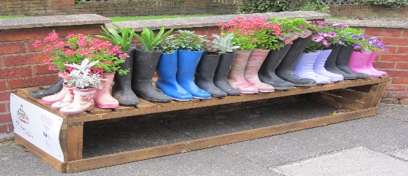 | Milk Bottle watering Can  Get a milk bottle.  An adult will make several holes at the point where you would like to water to spray from.  Use Sharpie pens to decorate. (The ink will not run when you fill with water/water your plants)  Unscrew cap, fill with water. Screw cap on again.  Enjoy watering. | Indoor/ Outdoor Bowling  Line up plastic cups/ toilet tubes into rows or similar to bowling pins.  Use a ball to try and knock them over.  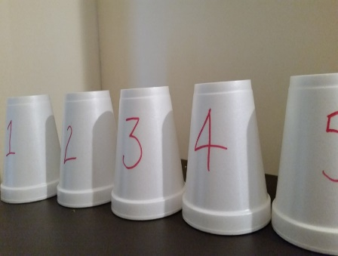
Spot the Rainbows  Go out a walk, ensuring social distancing is adhered to. If you are walking around an estate/street/village look at peoples windows to see how many rainbows you can spot. These are for our wonderful NHS! | Sand Play  Use a large tub, tray or bucket. Fill with sand. Add natural materials like rocks or crystals, household items like spoons, measuring cups and bowls or any little plastic toys your child loves. It is amazing to see the stories children build from sand and a few items. | Scavenger Hunt- Indoor/ Outdoor  Using any theme, such as patterns, letters or colours and hunt around the house/ garden. Make it official with a clipboard and check off items as you go.  Crawl around, reach up high and get down low. | Superhero/Lol Doll/ Dinosaurs  Find all your small world toys and place them around the garden. Play with them amongst the trees and grass. It will be like a huge jungle for them. Have fun!! | Make Gloop  Find a tray. Fill with half a box of cornflour and a little water. This should make gloop. Try to mould and lift it with your hands. What happens?  How does it feel?

