Indoor/ Outdoor Hopscotch  Play a game of hopscotch outside or inside. If you play inside use masking tape and a sock!!!  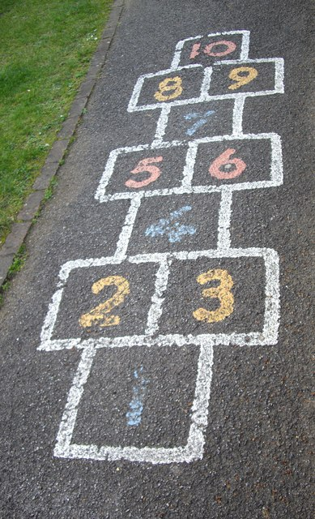 | Shadow drawings:  You don’t need the sun for this. You can use a torch if it’s cloudy or if you want to do it indoors.  Find some of your favourite small toy characters e.g. dinosaurs, super heroes, cars and place onto a sheet of paper. Colour in the small and big shadows. You can even draw around a parent’s shadow. Have Fun! | Self Portraits.  Using a mirror, let your child draw themselves. Point out facial features like eyebrows and eyelashes. If they draw their whole body add in some fashion design!! | Shapes.  Help your child learn their shapes by tracing common household items. Turn over a cup to make circles, trace round your mobile for rectangles. Hunting is part of the fun! Children may want to decorate their shapes. You could help them cut them out and glue onto larger paper for fancy art projects. | Abacus  - String/rope  - Cheerios Cereal  - Scissors  - Cellotape  - Paper  - Use the Cheerio’s to thread through the string/rope in tens.  - Cellotape both ends down onto paper  - Make as many rows as you like.  Play counting games.  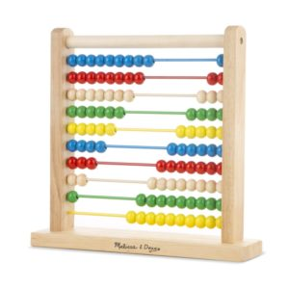
Muffin / Ice Cube Tray Sorting  - Ice Cube Tray/ Muffin Tray  - Small items to sort. E.g. Dried beans, buttons, coins, and marbles.  Encourage your child to sort items by colour, size pattern/ any way they like. Challenge: use tweezers to pick up | Water Play  Use a large tub, tray or bucket. Fill with water. Add natural materials like rocks or crystals, household items like spoons, measuring cups and bowls or any little plastic toys your child loves.  It is amazing to see the stories children build from water and a few items. Enjoy splish splashing!!! | Homemade Shaker for the NHS  - Kitchen/ Toilet tube  - Paper  - Elastic Bands  - Rice/ lentils  Decorate the kitchen/ toilet tube. Draw round mouth of a mug. Cut out circle shape and decorate. Attach to mouth of roll using band. Fill tube with lentils/rice. Repeat circle and band. Shake loud for the NHS! | Create a Collage from old Magazines/ catalogues.  - Magazines  - Catalogues e.g. Argos  Encourage your child to look through magazines/ catalogues. Help them cut out pictures and create a collage. | Reading Time  Encourage your child to pick their favourite story book. Ask them to ‘read’ you the story by looking at the pictures. Ask them questions about the story!! Enjoy.

