Make a den in your garden or in the house using old sheets and covers. Take in your favourite cuddly toys and books. Now time to chillax.  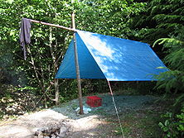 | 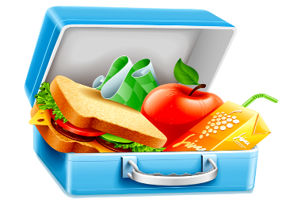  Make a healthy lunch with a grown up.  Set out a blanket in the garden or in the house and have a picnic! | Go on a treasure hunt!! What letter does your name begin with??  See how many things that you can find around your house or in the garden that begin with the first letter of your name.  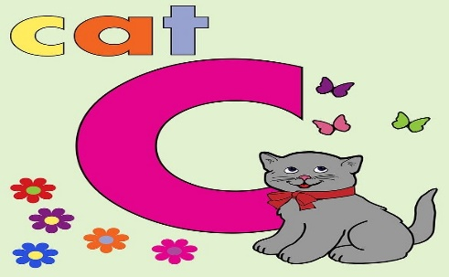 | What is your favourite song?? Why not make up a dance routine to your favourite song.  If you have a brother or sister at home invite them to join you.  Perform for the whole family!!! | Ask an adult to slice apples or potatoes and make into stampers. Using paint to create a picture.  Have Fun!!  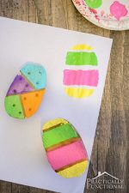
Ask an adult for any old or odd socks!! Use buttons/ paper/ glue.  Make a sock puppet.  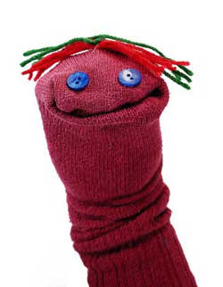 | Go out into the garden or local area (Keeping a safe distance from others.) Collect leaves, twigs and flowers. Create a picture using everything you collect.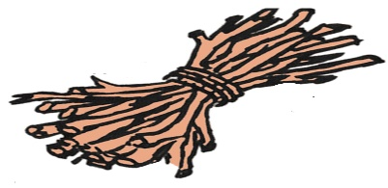 | Ask an adult to spread shaving foam onto a plate or tray. Practice letters, words and numbers.  Have fun!! | Make your own playdough.  You will need  - 8 tbsp plain flour  - 2 tbsp salt  - 60 ml water  - 1tbsp veg oil.  - Food colouring (Optional)  Mix flour and salt together. In a separate bowl mix water, colour and oil.  Mix together. Keep in airtight container.  Have fun! | Ask an adult to fill a bowl with water and use the water and paintbrushes to ‘paint’ a picture on the ground/ patio/ walls.  You can also practice your letters too.  