Chemistry Quiz – Who’ll be ‘Chemist of the Month’?

Section 1 – The Periodic Table
- What does the number of protons in an atom determine?
A Charge of Atom
B Atomic Number
C Mass Number
D Name of Element

- Group 1 in the Periodic Table is called the:
A halogens.
B noble gases.
C alkali metals.
D transition metals.

- Group 7 in the Periodic Table is called the:
A halogens.
B noble gases.
C transition metals.
D alkali metals.

- Elements in the same group in the Periodic Table have the same:
A density.
B number of occupied energy shells.
C number of outer electrons.
D number of protons.

- Elements in the same period in the Periodic Table have the same:
A number of protons.
B density.
C number of outer electrons.
D number of occupied energy shells

Section 2 – Bonding & Structure

- In which of the following compounds do both ions have the same electron arrangement as argon?
A Magnesium oxide
B Sodium sulfide
C Calcium bromide
D Calcium sulfide

- Which element is a solid at room temperature and consists of discrete molecules?
A Boron
B Neon
C Sulfur
D Silicon

- Which of the elements is most likely to have a covalent network structure?

Element | Melting Point (K) | Boiling Point (K) | Density (g cm⁻³) | Conduction When Solid
A | 317 | 553 | 1.82 | No
B | 933 | 2740 | 2.7 | Yes
C | 1683 | 2628 | 2.32 | No
D | 387 | 457 | 4.93 | No

- Which type of structure is found in a substance melting at 1069°C which conducts electricity when molten, but not when solid?
A Ionic
B Metallic
C Covalent (discrete molecules)
D Covalent (network structure)

- Which of the following structures is never found in compounds?
A Covalent Molecular
B Monatomic
C Covalent Network
D Ionic

Section 3 – Periodic Table Trends

11 Menedeleev is famous for producing the Periodic Table on which the modern version is based.
Which of the following statements is true?
A Mendeleev swapped some elements round so that their atomic masses fitted the pattern.
B Mendeleev organised the elements in order of their atomic number.
C Mendeleev left gaps for elements which had not yet been discovered.
D Mendeleev left gaps because some elements did not fit the pattern of reactivity.

- Which of the following equations represents the first ionisation energy of magnesium?
A Mg (g) → Mg²⁺(g) + e⁻
B Mg (g) → Mg⁺(g) + e⁻
C Mg (s) → Mg⁺(g) + e⁻
D Mg (g) → Mg²⁺(g) + 2e⁻

- Which of the following will not affect the first ionisation energy of an element?
A Atomic number
B Screening effect
C Atomic size
D Atomic mass

- Why are no electronegativity values quoted for the Group 0 elements?
A Their electronegativities are too high for the scale.
B They generally do not form bonds with other elements.
C They have a value of zero.
D They are unreactive non-metals.

- Which of the following equations represents the first ionisation energy of fluorine?
A F⁻(g) → F (g) + e⁻
B F₂(g) → F⁺(g) + e⁻
C F (g) + e⁻ → F⁻(g)
D F (g) → F⁺(g) + e⁻

Section 4 – SQA Questions

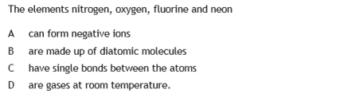
16.

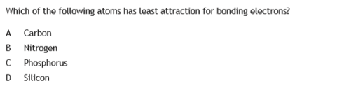
17.

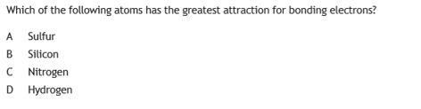
18.

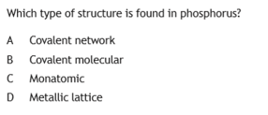
19,

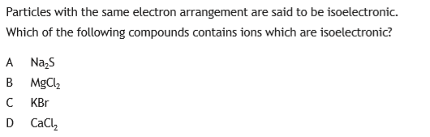
20.

