

**Health and Wellbeing Pupil Profiles**

**Policy Context**

The importance of wellbeing is reflected in its inclusion in a number of national level policies. Curriculum for Excellence (CfE) places importance on health and wellbeing[1]. A key element of this work is ensuring the health and wellbeing of our children is the ‘responsibility of all’:

Everyone within each learning community, whatever their contact with children and young people may be, shares the responsibility for creating a positive ethos and climate of respect and trust – one in which everyone can make a positive contribution to the wellbeing of each individual within the school and the wider community. There are many ways in which establishments can assist young people. These include peer support, buddies, breakfast or lunch clubs, safe areas, mentors, pupil support staff and extended support teams.

(Curriculum for Excellence, 2009, p3)

Understanding learners’ wellbeing can provide an invaluable insight into their motivation and is an integral part of our processes and approaches to ensure we support our children to become resilient, self-directed and lifelong learners. Our Wellbeing Policy and Practices have been developed over the years to support the ongoing monitoring and tracking of the wellbeing of our children. This helps us get to know our children well and informs effective pupil planning that enables us to provide appropriate supports and interventions that improve outcomes for learners.

[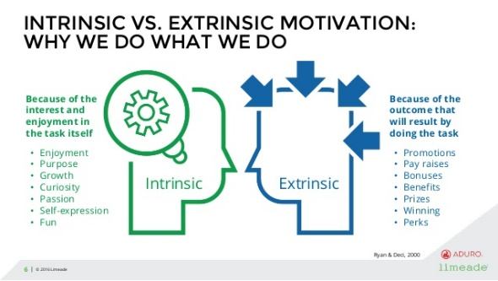](https://www.google.co.uk/url?sa=i&url=https%3A%2F%2Fwww.slideshare.net%2FLimeadeMarketing%2Fthe-connection-between-intrinsic-motivation-and-your-employee-engagement-strategy-81211947&psig=AOvVaw0H3ZXIY8QipGh0MhDMqLAB&ust=1615467763831000&source=images&cd=vfe&ved=0CAIQjRxqFwoTCJD8087kpe8CFQAAAAAdAAAAABAN)Linking with pupils, key adults, and other agencies as appropriate; we use a number of approaches to garner information and data which helps us build a profile of each pupil; enabling and informing meaningful dialogue in relation to evaluating progress in wellbeing and identifying next steps for pupils and staff; supporting the identification of factors that could either facilitate or undermine the intrinsic and extrinsic motivation of pupils[2].

Encompassing a variety of measures and resources including social, emotional, and physical wellbeing activities, addressing needs on an individual basis; links with self-determination theory[3] which studies show[4] can support children themselves to evaluate their own wellbeing in line with the principles of ‘Getting it right for every child’ (GIRFEC).

|  |  |
| --- | --- |
| * Strengths and Difficulties Questionnaire (SDQ) * Wellbeing Webs * Single Agency Assessments/ What I think Tool/ My World Triangle * Pupil Wellbeing Surveys and Dialogues * Boxhall Profile | * Resilience Toolkit * Antecedent Behaviour Consequence (A-B-C) Observations * Leuven Observations * West Partnership Learner Wellbeing Matrix * Glasgow Motivation and Wellbeing Profile (GMWP) |

Resources and Tools that can be used as part of the ongoing assessment process to support and inform pupil profile development within the School GIRFEC Planning and Referral Process may include:

1. The principles and values of health and wellbeing in CfE can be found here: <https://education.gov.scot/Documents/health-and-wellbeing-pp.pdf>
2. <https://www.verywellmind.com/differences-between-extrinsic-and-intrinsic-motivation-2795384>
3. <https://selfdeterminationtheory.org/application-education/>; Richard M. Ryan, Edward L. Deci. Intrinsic and extrinsic motivation from a self-determination theory perspective: Definitions, theory, practices, and future directions, Contemporary Educational Psychology, Vol 61, 2020, 101860, ISSN 0361-476X. <https://doi.org/10.1016/j.cedpsych.2020.101860>.
4. Sebire, S.J., Jago, R., Fox, K.R. *et al.* Testing a self-determination theory model of children’s physical activity motivation: a cross-sectional study. *Int J Behav Nutr Phys Act* **10,** 111 (2013). https://doi.org/10.1186/1479-5868-10-111